SEC Form 3
FORM 3 | UNITED STATES SECURITIES AND EXCHANGE COMMISSION  Washington, D.C. 20549  INITIAL STATEMENT OF BENEFICIAL OWNERSHIP OF SECURITIES  Filed pursuant to Section 16(a) of the Securities Exchange Act of 1934  or Section 30(h) of the Investment Company Act of 1940
  OMB APPROVAL
  OMB Number: | 3235-0104
  Estimated average burden
  hours per response: | 0.5
1. Name and Address of Reporting Person*  (Street) | 2. Date of Event Requiring Statement (Month/Day/Year)  08/05/2026 | 3. Issuer Name and Ticker or Trading Symbol  APOGEE ENTERPRISES, INC. [ APOG ]  Foreign Trading Symbol
  HAYEK JOSEPH B
  (Last) | (First) | (Middle)
  4400 WEST 78TH STREET
  SUITE 520
  MINNEAPOLIS | MN | 55435
  (City) | (State) | (Zip)
 |  | 4. Relationship of Reporting Person(s) to Issuer  (Check all applicable) | 5. If Amendment, Date of Original Filed (Month/Day/Year)
   | Director |  | 10% Owner
   | Officer (give title below) |  | Other (specify below)
6. Individual or Joint/Group Filing (Check Applicable Line)
Form filed by One Reporting Person
Form filed by More than One Reporting Person

Table I - Non-Derivative Securities Beneficially Owned
1. Title of Security (Instr. 4) | 2. Amount of Securities Beneficially Owned (Instr. 4) | 3. Ownership Form: Direct (D) or Indirect (I) (Instr. 5) | 4. Nature of Indirect Beneficial Ownership (Instr. 5)
Common Stock | 0 | D
Table II - Derivative Securities Beneficially Owned
(e.g., puts, calls, warrants, options, convertible securities)
1. Title of Derivative Security (Instr. 4) | 2. Date Exercisable and Expiration Date (Month/Day/Year) |  | 3. Title and Amount of Securities Underlying Derivative Security (Instr. 4) |  | 4. Conversion or Exercise Price of Derivative Security | 5. Ownership Form: Direct (D) or Indirect (I) (Instr. 5) | 6. Nature of Indirect Beneficial Ownership (Instr. 5)
1. Title of Derivative Security (Instr. 4) | Date Exercisable | Expiration Date | Title | Amount or Number of Shares | 4. Conversion or Exercise Price of Derivative Security | 5. Ownership Form: Direct (D) or Indirect (I) (Instr. 5) | 6. Nature of Indirect Beneficial Ownership (Instr. 5)
Explanation of Responses:
Remarks:
Exhibit 24 - Power of Attorney attached.
 | /s/Bryan A. Welp, Attorney-in-Fact for Joseph B. Hayek | 08/06/2026
 | ** Signature of Reporting Person | Date
Reminder: Report on a separate line for each class of securities beneficially owned directly or indirectly.
* If the form is filed by more than one reporting person, see Instruction 5 (b)(v).
** Intentional misstatements or omissions of facts constitute Federal Criminal Violations See 18 U.S.C. 1001 and 15 U.S.C. 78ff(a).
Note: File three copies of this Form, one of which must be manually signed. If space is insufficient, see Instruction 6 for procedure.
Persons who respond to the collection of information contained in this form are not required to respond unless the form displays a currently valid OMB Number.
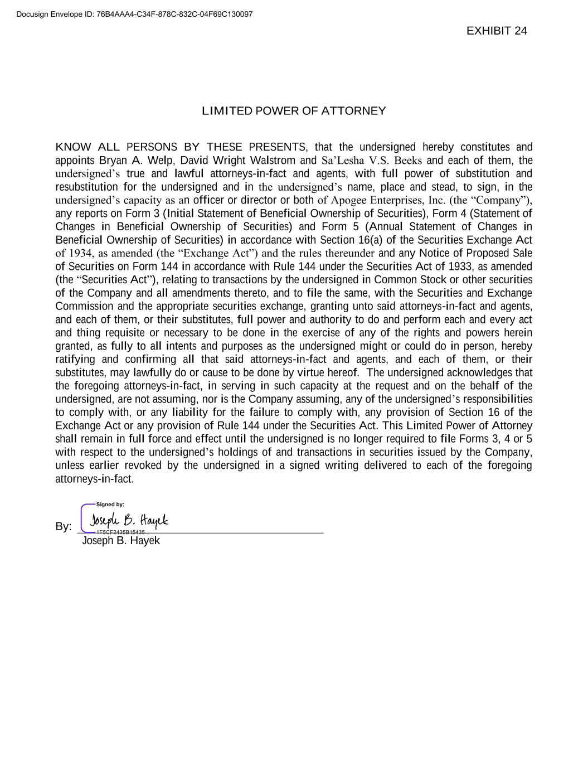
LIMITED POWER OF ATTORNEY KNOW ALL PERSONS BY THESE PRESENTS, that the undersigned hereby constitutes and appoints Bryan A. Welp, David Wright Walstrom and Sa’Lesha V.S. Beeks and each of them, the undersigned’s true and lawful attorneys-in-fact and agents, with full power of substitution and resubstitution for the undersigned and in the undersigned’s name, place and stead, to sign, in the undersigned’s capacity as an officer or director or both of Apogee Enterprises, Inc. (the “Company”), any reports on Form 3 (Initial Statement of Beneficial Ownership of Securities), Form 4 (Statement of Changes in Beneficial Ownership of Securities) and Form 5 (Annual Statement of Changes in Beneficial Ownership of Securities) in accordance with Section 16(a) of the Securities Exchange Act of 1934, as amended (the “Exchange Act”) and the rules thereunder and any Notice of Proposed Sale of Securities on Form 144 in accordance with Rule 144 under the Securities Act of 1933, as amended (the “Securities Act”), relating to transactions by the undersigned in Common Stock or other securities of the Company and all amendments thereto, and to file the same, with the Securities and Exchange Commission and the appropriate securities exchange, granting unto said attorneys-in-fact and agents, and each of them, or their substitutes, full power and authority to do and perform each and every act and thing requisite or necessary to be done in the exercise of any of the rights and powers herein granted, as fully to all intents and purposes as the undersigned might or could do in person, hereby ratifying and confirming all that said attorneys-in-fact and agents, and each of them, or their substitutes, may lawfully do or cause to be done by virtue hereof. The undersigned acknowledges that the foregoing attorneys-in-fact, in serving in such capacity at the request and on the behalf of the undersigned, are not assuming, nor is the Company assuming, any of the undersigned’s responsibilities to comply with, or any liability for the failure to comply with, any provision of Section 16 of the Exchange Act or any provision of Rule 144 under the Securities Act. This Limited Power of Attorney shall remain in full force and effect until the undersigned is no longer required to file Forms 3, 4 or 5 with respect to the undersigned’s holdings of and transactions in securities issued by the Company, unless earlier revoked by the undersigned in a signed writing delivered to each of the foregoing attorneys-in-fact. By: Joseph B. Hayek Docusign Envelope ID: 76B4AAA4-C34F-878C-832C-04F69C130097

