As filed with the Securities and Exchange Commission on August 20, 2026
Registration No. 333-

UNITED STATES
SECURITIES AND EXCHANGE COMMISSION
Washington, DC. 20549
_______________________
FORM S-8
REGISTRATION STATEMENT
UNDER THE SECURITIES ACT OF 1933

As filed with the Securities and Exchange Commission on August 20, 2026
_______________________
APOGEE ENTERPRISES, INC.
(Exact name of Registrant as specified in its charter)
Minnesota |  |  |  |  |  | 41-0919654
(State or other jurisdiction of  incorporation or organization) |  |  |  |  |  | (I.R.S. Employer Identification No.)
4400 West 78th Street, Suite 520  Minneapolis, Minnesota |  |  |  |  |  | 55435
(Address of Principal Executive Offices) |  |  |  |  |  | (Zip Code)
2019 STOCK INCENTIVE PLAN, AS AMENDED AND RESTATED (2026)
(Full title of the plan)
Bryan A. Welp
Vice President, General Counsel and Secretary
Apogee Enterprises, Inc.
4400 West 78th Street, Suite 520
Minneapolis, Minnesota 55435
(Name and address of agent for service)
(952) 487-7594
(Telephone number, including area code, of agent for service)

Indicate by check mark whether the registrant is a larger accelerated filer, an accelerated filer, a non-accelerated filer, a smaller reporting company or an emerging growth company. See the definition of “larger accelerated filler,” “accelerated filer,” “smaller reporting company,” and “emerging growth company” in Rule 12b-2 of the Exchange Act.
Large accelerated filer |  |  | X |  |  |  |  |  | Accelerated filer
Non-accelerated filer |  |  |  |  |  |  |  |  | Smaller reporting company
 |  |  |  |  |  |  |  |  | Emerging growth company
If an emerging growth company, indicate by check mark if the registrant has elected not to use the extended transition period for complying with any new or revised financial accounting standards provided pursuant to Section 7(a)(2)(B) of the Securities Act. ☐

EXPLANATORY NOTE

This Registration Statement on Form S-8 of Apogee Enterprises, Inc. (the “Company”) is being filed pursuant to General Instruction E to Form S-8 under the Securities Act of 1933, as amended, to register an additional 800,000 shares of the Company’s common stock, par value $0.33 1/3 per share (“Common Stock”), issuable pursuant to the Apogee Enterprises, Inc. 2019 Stock Incentive Plan, as Amended and Restated (2026) (the “Plan”). The amendment of the Plan to reserve the additional shares for future issuance thereunder was approved by the Board of Directors (the “Board”) of the Company at a meeting of the Board held on April 23, 2026 and by the shareholders of the Company at our 2026 Annual Meeting held on June 24, 2026. In accordance with Section E of the General Instructions to Form S-8, the Registration Statement on Form S-8 previously filed with the Securities and Exchange Commission relating to the Plan (Registration Statement No 333-257410) is incorporated by reference herein, to the extent not modified or superseded hereby or by any subsequently filed document that is incorporated by reference herein or therein.

PART II
INFORMATION REQUIRED IN THE REGISTRATION STATEMENT
Item 3. Incorporation of Documents by Reference.
The following documents that have been filed with the Commission by the Registrant are incorporated by reference in this Registration Statement:
(a) Registrant’s Annual Report on Form 10-K for the fiscal year ended February 28, 2026, filed on April 24, 2026;
(b) Registrant’s Quarterly Report on Form 10-Q for the fiscal quarter ended May 30, 2026, filed on June 30, 2026;
(c) Registrant’s Current Report on Form 8-K filed on June 26, 2026; June 29, 2026; July 1, 2026; and August 5, 2026; and,
(d) The description of our common stock included as Exhibit 4.2 to our Annual Report on Form 10-K for the fiscal year ended February 28, 2026.
All documents filed by us pursuant to Sections 13(a), 13(c), 14 and 15(d) of the Securities Exchange Act of 1934, as amended (the “Exchange Act”) (other than reports (or portions thereof) on Form 8-K furnished pursuant to Item 2.02 or Item 7.01 of Form 8-K, including any exhibits included with such information, unless otherwise explicitly indicated therein) subsequent to the date hereof and prior to the filing of a post-effective amendment which indicates that all securities offered hereby have been sold or which deregisters all securities remaining unsold, are incorporated by reference herein and are a part hereof from the respective dates of filing of such documents.

Item 8. Exhibits.
4.1 |  |  | Restated Articles of Incorporation of Apogee Enterprises, Inc. (incorporated by reference to Exhibit 3.1 to Apogee’s Annual Report on Form 10-K for the year ended February 28, 2004.
4.2 |  |  | Articles of Amendment to the Restated Articles of Incorporation of Apogee Enterprises, Inc., as filed with the Minnesota Secretary of State on January 15, 2020 (incorporated by reference to Exhibit 3.1 to Apogee’s Current Report on Form 8-K filed on January 16, 2020).
4.3 |  |  | Amended and Restated Bylaws of Apogee Enterprises, Inc. as of April 21, 2021 (incorporated by reference to Exhibit 3.3 to Registrant’s Quarterly Report on Form 10-Q filed on July 1, 2021).
4.4 |  |  | Specimen certificate for shares of common stock of Apogee Enterprises, Inc. (incorporated by reference to Exhibit 4.1 to Registrant's Quarterly Report on Form 10-Q filed on July 1, 2021.)
4.5 |  |  | Apogee Enterprises, Inc. 2019 Stock Incentive Plan, as Amended and Restated (2026)*
5.1 |  |  | Opinion of Dorsey & Whitney LLP*
23.1 |  |  | Consent of Dorsey & Whitney LLP (included in Exhibit 5.1)*
23.2 |  |  | Consent of Independent Registered Public Accounting Firm*
24.1 |  |  | Power of Attorney*
107 |  |  | Calculation of Filing Fee Table*
* Filed herewith.

SIGNATURES

Pursuant to the requirements of the Securities Act, the registrant certifies that it has reasonable grounds to believe that it meets all of the requirements for filing on Form S-8 and has duly caused this registration statement to be signed on its behalf by the undersigned, thereunto duly authorized, in the City of Minneapolis, State of Minnesota, on August 20, 2026.

APOGEE ENTERPRISES, INC.
/s/Donald A. Nolan
Donald A. Nolan
Chief Executive Officer

Pursuant to the requirements of the Securities Act, this registration statement has been signed by the following persons in the capacities indicated on August 20, 2026.

Signatures |  |  | Title
/s/Donald A. Nolan |  |  | Chief Executive Officer and Executive Chair
Donald A. Nolan |  |  | (principal executive officer)
/s/Mark R. Augdahl |  |  | Executive Vice President, Chief Financial Officer
Mark R. Augdahl |  |  | (principal financial and accounting officer)
* |  |  | Director
Christina M. Alvord
* |  |  | Director
Joseph B. Hayek
* |  |  | Director
Suresh Krishna
* |  |  | Director
Elizabeth M. Lilly
* |  |  | Director
Herbert K. Parker
* |  |  | Lead Director
Mark A. Pompa
* |  |  | Director
Patricia K. Wagner

*By: |  |  | /s/Bryan A. Welp
 |  |  | Bryan A. Welp
 |  |  | Attorney-in-Fact

EXHIBIT 107

Calculation of Filing Fee Tables

Form S-8
(Form Type)

Apogee Enterprises, Inc.
(Exact Name of Registrant as Specified in its Charter)

Table 1: Newly Registered Securities

Security  Type |  |  |  | Security Class  Title |  |  | Fee  Calculation  Rule (2) |  |  | Amount Registered (1) |  |  | Proposed  Maximum  Offering Price  Per Unit (2) |  |  | Maximum  Aggregate  Offering Price  (2) |  |  | Fee Rate |  |  | Amount of  Registration  Fee
Equity |  |  |  | Common Stock, $0.33 1/3 Par Value |  |  | Other |  |  | 800,000 |  |  | $42.075 |  |  | $33,660,000 |  |  | 0.0001381 |  |  | $4,648
Total Offering Amounts |  |  |  |  |  |  |  |  |  |  |  |  | $33,660,000 |  |  |  |  |  | 4,648
Total Fee Offsets |  |  |  |  |  |  |  |  |  |  |  |  |  |  |  |  |  |  | —
Net Fee Due |  |  |  |  |  |  |  |  |  |  |  |  |  |  |  |  |  |  | $4,648

(1) |  |  | This Registration Statement covers the issuance of 800,000 shares of common stock of Apogee Enterprises, Inc. (the “Registrant”), par value $.33 1/3 per share (“Common Stock”), to be issued under the Registrant’s 2019 Stock Incentive Plan, as Amended and Restated (2026) (the “Plan”). Pursuant to Rule 416 under the Securities Act of 1933, as amended (the “Securities Act”), this Registration Statement also covers an indeterminate number of additional shares of Common Stock which, to be offered or sold pursuant to the Plan described herein in the event of a stock split, stock dividend or similar transaction.
(2) |  |  | Estimated solely for purposes of calculating the registration fee pursuant to Rules 457(c) and 457(h) under the Securities Act of 1933, as amended, based on the average of the high and low sales prices of the Registrant's common stock as reported on the Nasdaq Global Select Market on August 18, 2026.

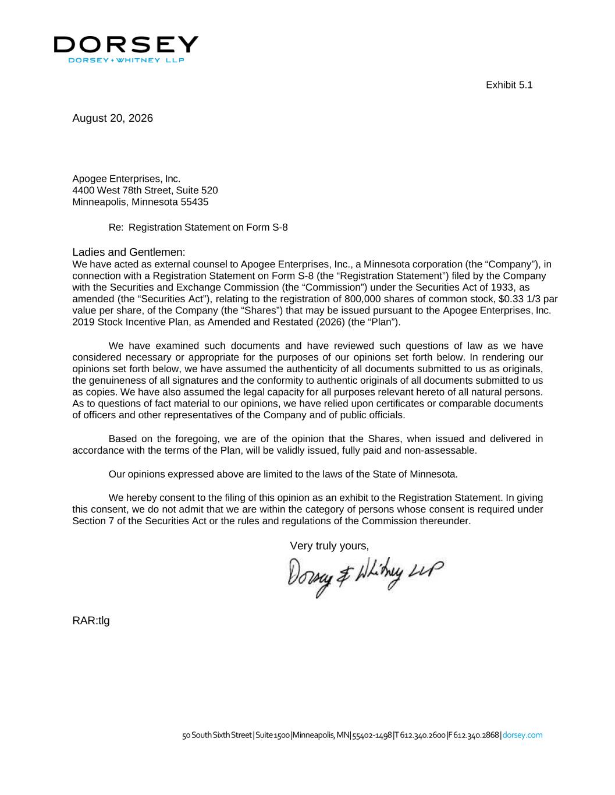

August 20, 2026 50 South Sixth Street | Suite 1500 |Minneapolis, MN| 55402-1498 |T 612.340.2600 |F 612.340.2868 | dorsey.com Exhibit 5.1 Apogee Enterprises, Inc. 4400 West 78th Street, Suite 520 Minneapolis, Minnesota 55435 Re: Registration Statement on Form S-8 Ladies and Gentlemen: We have acted as external counsel to Apogee Enterprises, Inc., a Minnesota corporation (the “Company”), in connection with a Registration Statement on Form S-8 (the “Registration Statement”) filed by the Company with the Securities and Exchange Commission (the “Commission”) under the Securities Act of 1933, as amended (the “Securities Act”), relating to the registration of 800,000 shares of common stock, $0.33 1/3 par value per share, of the Company (the “Shares”) that may be issued pursuant to the Apogee Enterprises, Inc. 2019 Stock Incentive Plan, as Amended and Restated (2026) (the “Plan”). We have examined such documents and have reviewed such questions of law as we have considered necessary or appropriate for the purposes of our opinions set forth below. In rendering our opinions set forth below, we have assumed the authenticity of all documents submitted to us as originals, the genuineness of all signatures and the conformity to authentic originals of all documents submitted to us as copies. We have also assumed the legal capacity for all purposes relevant hereto of all natural persons. As to questions of fact material to our opinions, we have relied upon certificates or comparable documents of officers and other representatives of the Company and of public officials. Based on the foregoing, we are of the opinion that the Shares, when issued and delivered in accordance with the terms of the Plan, will be validly issued, fully paid and non-assessable. Our opinions expressed above are limited to the laws of the State of Minnesota. We hereby consent to the filing of this opinion as an exhibit to the Registration Statement. In giving this consent, we do not admit that we are within the category of persons whose consent is required under Section 7 of the Securities Act or the rules and regulations of the Commission thereunder. Very truly yours, RAR:tlg

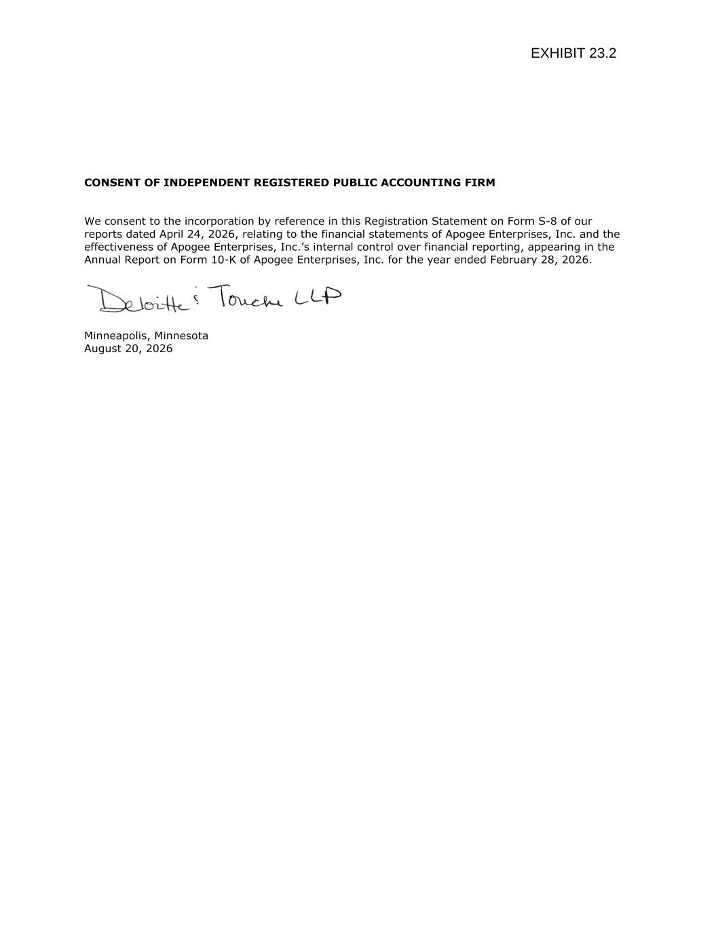
CONSENT OF INDEPENDENT REGISTERED PUBLIC ACCOUNTING FIRM We consent to the incorporation by reference in this Registration Statement on Form S-8 of our reports dated April 24, 2026, relating to the financial statements of Apogee Enterprises, Inc. and the effectiveness of Apogee Enterprises, Inc.’s internal control over financial reporting, appearing in the Annual Report on Form 10-K of Apogee Enterprises, Inc. for the year ended February 28, 2026. Minneapolis, Minnesota August 20, 2026

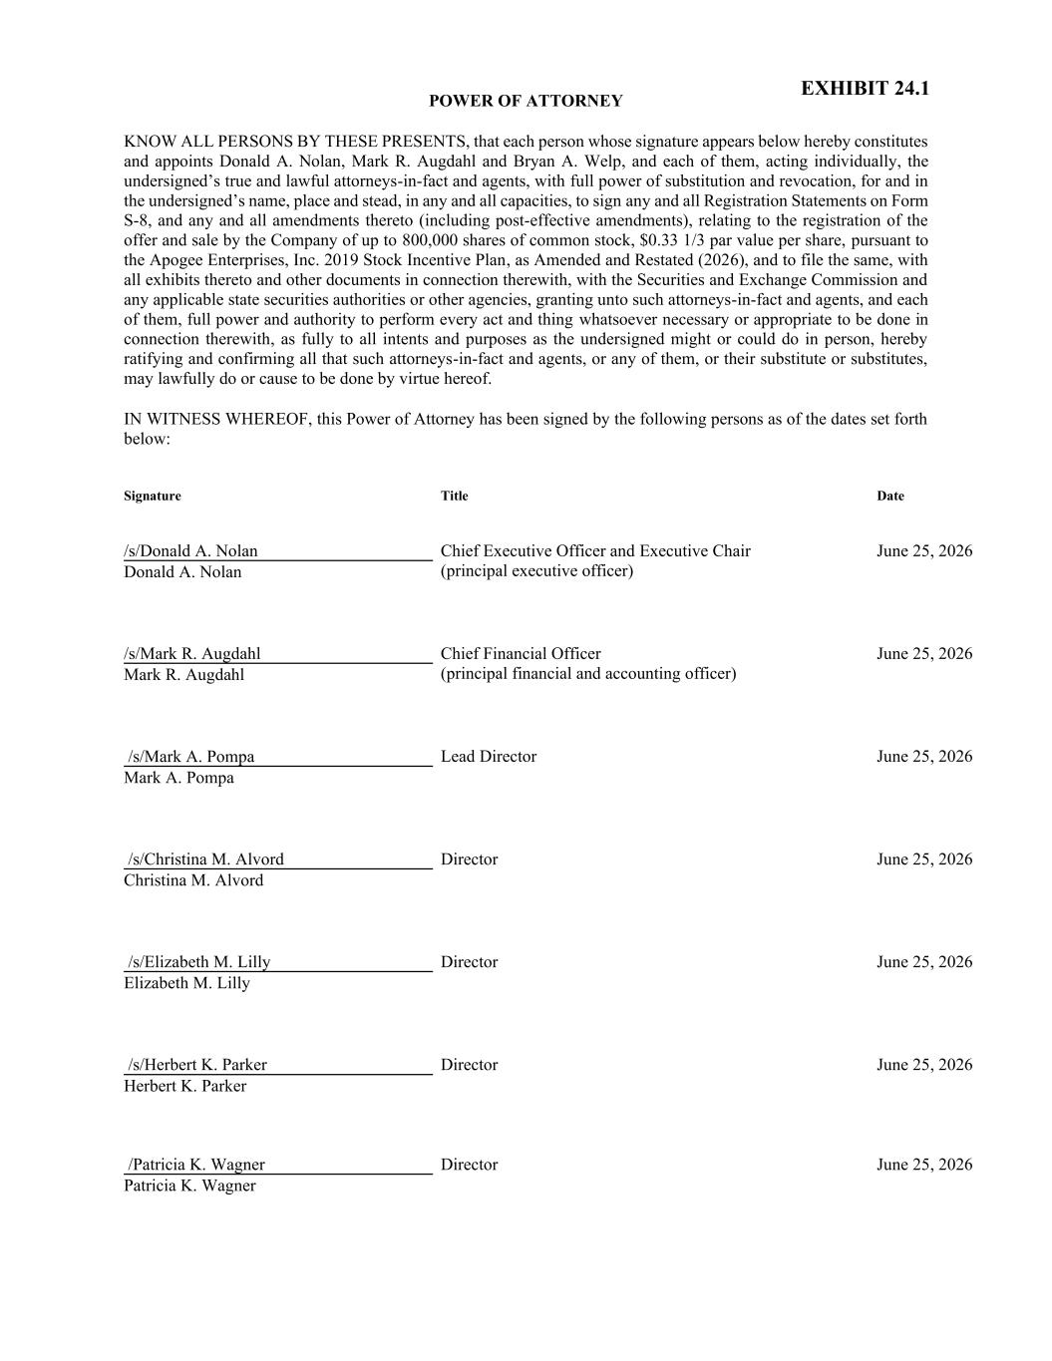
POWER OF ATTORNEY KNOW ALL PERSONS BY THESE PRESENTS, that each person whose signature appears below hereby constitutes and appoints Donald A. Nolan, Mark R. Augdahl and Bryan A. Welp, and each of them, acting individually, the undersigned’s true and lawful attorneys-in-fact and agents, with full power of substitution and revocation, for and in the undersigned’s name, place and stead, in any and all capacities, to sign any and all Registration Statements on Form S-8, and any and all amendments thereto (including post-effective amendments), relating to the registration of the offer and sale by the Company of up to 800,000 shares of common stock, $0.33 1/3 par value per share, pursuant to the Apogee Enterprises, Inc. 2019 Stock Incentive Plan, as Amended and Restated (2026), and to file the same, with all exhibits thereto and other documents in connection therewith, with the Securities and Exchange Commission and any applicable state securities authorities or other agencies, granting unto such attorneys-in-fact and agents, and each of them, full power and authority to perform every act and thing whatsoever necessary or appropriate to be done in connection therewith, as fully to all intents and purposes as the undersigned might or could do in person, hereby ratifying and confirming all that such attorneys-in-fact and agents, or any of them, or their substitute or substitutes, may lawfully do or cause to be done by virtue hereof. IN WITNESS WHEREOF, this Power of Attorney has been signed by the following persons as of the dates set forth below: Signature Title Date /s/Donald A. Nolan Donald A. Nolan Chief Executive Officer and Executive Chair (principal executive officer) June 25, 2026 /s/Mark R. Augdahl Mark R. Augdahl Chief Financial Officer (principal financial and accounting officer) June 25, 2026 /s/Mark A. Pompa Mark A. Pompa Lead Director June 25, 2026 /s/Christina M. Alvord Christina M. Alvord Director June 25, 2026 /s/Elizabeth M. Lilly Elizabeth M. Lilly Director June 25, 2026 /s/Herbert K. Parker Herbert K. Parker Director June 25, 2026 /Patricia K. Wagner Patricia K. Wagner Director June 25, 2026 EXHIBIT 24.1

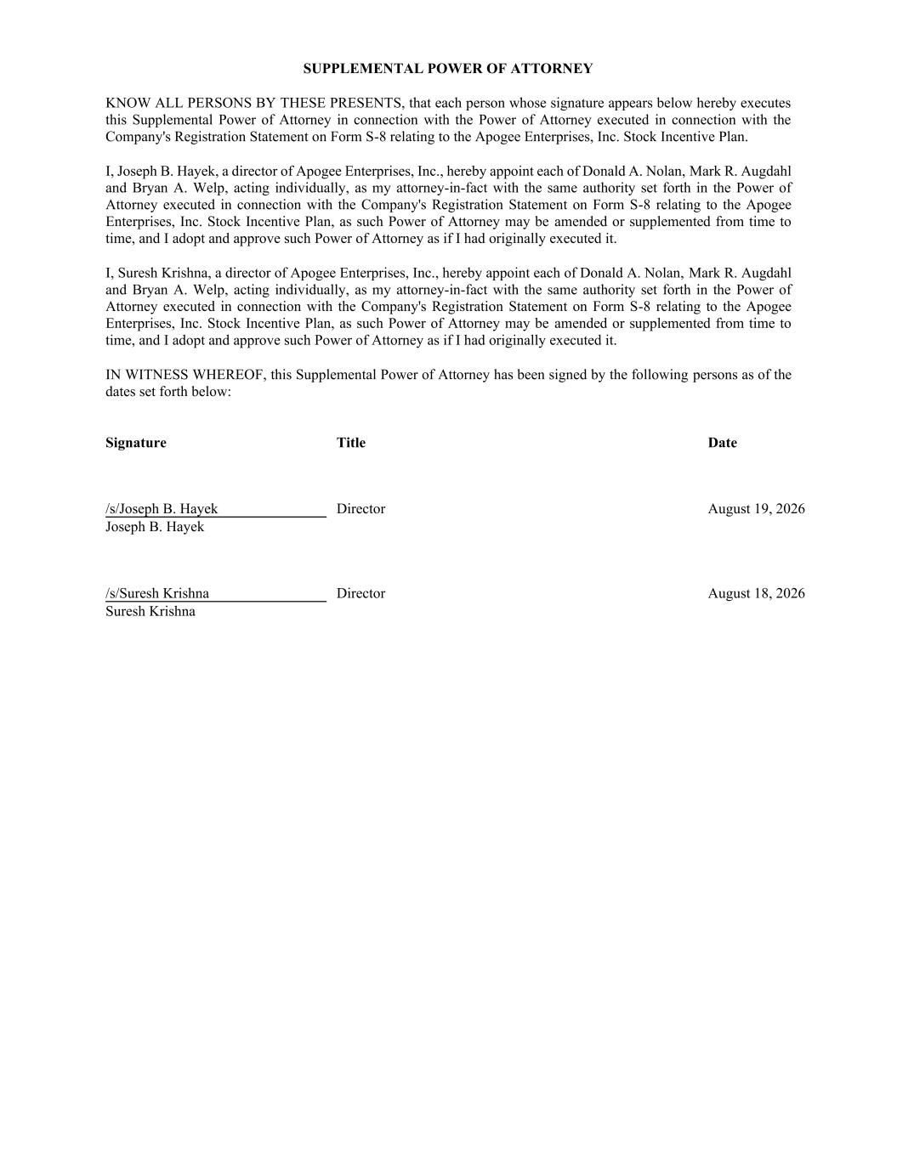
SUPPLEMENTAL POWER OF ATTORNEY KNOW ALL PERSONS BY THESE PRESENTS, that each person whose signature appears below hereby executes this Supplemental Power of Attorney in connection with the Power of Attorney executed in connection with the Company's Registration Statement on Form S-8 relating to the Apogee Enterprises, Inc. Stock Incentive Plan. I, Joseph B. Hayek, a director of Apogee Enterprises, Inc., hereby appoint each of Donald A. Nolan, Mark R. Augdahl and Bryan A. Welp, acting individually, as my attorney-in-fact with the same authority set forth in the Power of Attorney executed in connection with the Company's Registration Statement on Form S-8 relating to the Apogee Enterprises, Inc. Stock Incentive Plan, as such Power of Attorney may be amended or supplemented from time to time, and I adopt and approve such Power of Attorney as if I had originally executed it. I, Suresh Krishna, a director of Apogee Enterprises, Inc., hereby appoint each of Donald A. Nolan, Mark R. Augdahl and Bryan A. Welp, acting individually, as my attorney-in-fact with the same authority set forth in the Power of Attorney executed in connection with the Company's Registration Statement on Form S-8 relating to the Apogee Enterprises, Inc. Stock Incentive Plan, as such Power of Attorney may be amended or supplemented from time to time, and I adopt and approve such Power of Attorney as if I had originally executed it. IN WITNESS WHEREOF, this Supplemental Power of Attorney has been signed by the following persons as of the dates set forth below: Signature Title Date /s/Joseph B. Hayek Joseph B. Hayek Director August 19, 2026 /s/Suresh Krishna Suresh Krishna Director August 18, 2026

