UNITED STATES
SECURITIES AND EXCHANGE COMMISSION
Washington, D.C. 20549

FORM 8-K

CURRENT REPORT
Pursuant to Section 13 or 15(d) of the
Securities Exchange Act of 1934

Date of report (Date of earliest event reported): September 18, 2026

APOGEE ENTERPRISES, INC.
(Exact name of registrant as specified in its charter)

Minnesota |  |  |  |  |  | 0-6365 |  |  |  |  |  | 41-0919654
(State or other jurisdiction of incorporation) |  |  |  |  |  | (Commission File Number) |  |  |  |  |  | (I.R.S. Employer Identification No.)
4400 West 78th Street, Suite 520 |  |  |  |  |  | Minneapolis |  |  |  |  |  | Minnesota |  |  |  |  |  | 55435
(Address of principal executive offices) |  |  |  |  |  |  |  |  |  |  |  |  |  |  |  |  |  | (Zip Code)
Registrant's telephone number, including area code: |  |  |  |  |  |  |  |  | (952) 835-1874
Check the appropriate box below if the Form 8-K filing is intended to simultaneously satisfy the filing obligation of the registrant under any of the following provisions:
☐ |  |  | Written communications pursuant to Rule 425 under the Securities Act (17 CFR 230.425)
☐ |  |  | Soliciting material pursuant to Rule 14a-12 under the Exchange Act (17 CFR 240.14a-12)
☐ |  |  | Pre-commencement communications pursuant to Rule 14d-2(b) under the Exchange Act (17 CFR 240.14d-2(b))
☐ |  |  | Pre-commencement communications pursuant to Rule 13e-4(c) under the Exchange Act (17 CFR 240.13e-4(c))
Securities registered pursuant to Section 12(b) of the Exchange Act:
Title of each class |  |  | Trading Symbol(s) |  |  | Name of each exchange on which registered
Common Stock, $0.33 1/3 Par Value |  |  | APOG |  |  | The Nasdaq Stock Market
Indicate by check mark whether the registrant is an emerging growth company as defined in Rule 405 of the Securities Act of 1933 (Section 230.405 of this chapter) or Rule 12b-2 of the Securities Exchange Act of 1934 (Section 240.12b-2 of this chapter).
☐ Emerging growth company
If an emerging growth company, indicate by check mark if the registrant has elected not to use the extended transition period for complying with any new or revised financial accounting standards provided pursuant to Section 13(a) of the Exchange Act. ☐

Item 2.01 |  |  | Completion of Acquisition or Disposition of Assets.
On September 18, 2026, Apogee Enterprises, Inc. (the “Company”) completed the transaction contemplated by the Share Purchase Agreement, dated September 2, 2026 (the “Purchase Agreement”), pursuant to which Tiger MergeCo SIA, a wholly owned subsidiary of the Company, acquired all of the outstanding equity interests of SIA “Alzette” a Latvian limited liability company, and its subsidiaries, including GroGlass.
Pursuant to the terms and conditions of the Purchase Agreement, the Transaction values GroGlass at approximately €62.5 million on a cash-free, debt-free basis; the final purchase price remains subject to the adjustments set forth in the Purchase Agreement and includes contingent consideration that may become payable following closing based upon the achievement of specified financial performance targets during the three-year period following closing. The maximum contingent consideration payable pursuant to the earnout provisions is €10 million.
The Company funded the acquisition using available cash and borrowings under its existing revolving credit facility.
This report supplements the Company’s announcement of the transaction, which was described in the Company’s Current Report on Form 8-K filed on September 3, 2026 with the U.S. Securities and Exchange Commission (the “SEC”). The foregoing description of the Purchase Agreement and the transactions contemplated thereby does not purport to be complete and is subject to, and qualified in its entirety by, the full text of the Purchase Agreement, a copy of which was filed with the SEC as Exhibit 2.1 to the Company’s Current Report on Form 8-K filed on September 3, 2026 and is incorporated into this Item 2.01 by reference.

Item 7.01 |  |  | Regulation FD Disclosure.
On September 18, 2026, the Company issued a press release announcing the completion of the acquisition described in Item 2.01, a copy of which is filed as Exhibit 99.1 and incorporated into this Item 7.01 by reference.
The information furnished pursuant to this Item 7.01, including Exhibit 99.1, shall not be deemed to be “filed” for purposes of Section 18 of the Securities Exchange Act of 1934, as amended (the “Exchange Act”), or otherwise subject to the liabilities under that section, and shall not be deemed to be incorporated by reference into any filing of the Company under the Securities Act of 1933, as amended, or the Exchange Act, unless specifically identified therein as being incorporated therein by reference.

Item 9.01 |  |  | Financial Statement and Exhibits.
(d) Exhibits.
Exhibit Number |  |  |  |  |  | Description
2.1* |  |  |  |  |  | Share Purchase Agreement between Daugava Finance S.A. and Tiger MergeCo SIA dated September 2, 2026 (incorporated by reference to the Company’s Current Report on Form 8-K filed on September 3, 2026).
99.1 |  |  |  |  |  | Press Release dated September 18, 2026
104 |  |  |  |  |  | Cover page interactive data file (formatted in inline XBRL).
* This filing excludes certain schedules and exhibits pursuant to Item 601(a)(5) of Regulation S-K, which the registrant agrees to furnish supplementally to the U.S. Securities and Exchange Commission upon request by the Commission provided, however, that the registrant may request confidential treatment pursuant to Rule 24b-2 of the Securities Exchange Act of 1934, as amended, for any schedules or exhibits so furnished.

SIGNATURE

Pursuant to the requirements of the Securities Exchange Act of 1934, the registrant has duly caused this report to be signed on its behalf by the undersigned hereunto duly authorized.
 |  |  | APOGEE ENTERPRISES, INC.
 |  |  | By: |  |  | /s/ Bryan A. Welp
 |  |  |  |  |  | Bryan A. Welp
 |  |  |  |  |  | Vice President, General Counsel and Secretary
Date: September 23, 2026

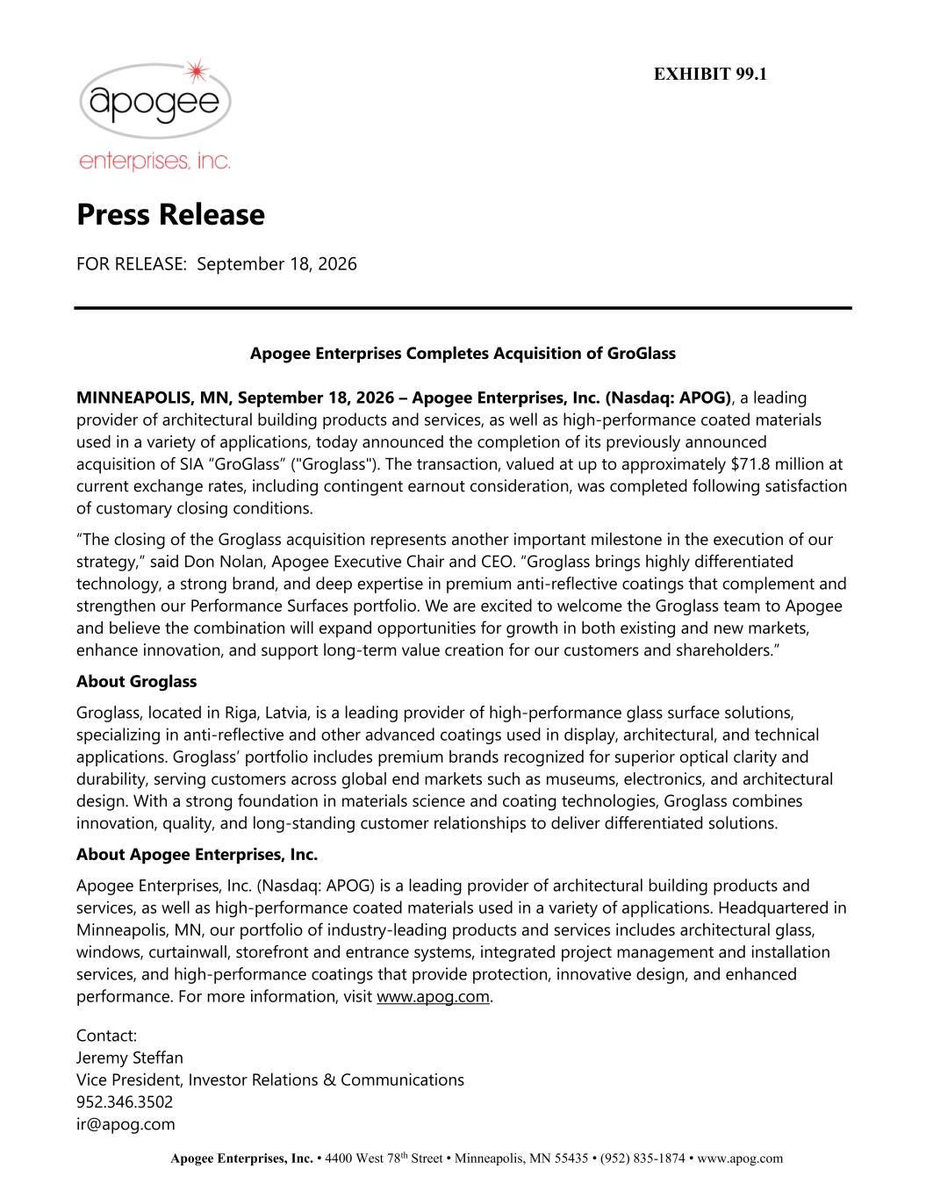

Apogee Enterprises, Inc. • 4400 West 78th Street • Minneapolis, MN 55435 • (952) 835-1874 • www.apog.com Press Release FOR RELEASE: September 18, 2026 Apogee Enterprises Completes Acquisition of GroGlass MINNEAPOLIS, MN, September 18, 2026 – Apogee Enterprises, Inc. (Nasdaq: APOG), a leading provider of architectural building products and services, as well as high-performance coated materials used in a variety of applications, today announced the completion of its previously announced acquisition of SIA “GroGlass” ("Groglass"). The transaction, valued at up to approximately $71.8 million at current exchange rates, including contingent earnout consideration, was completed following satisfaction of customary closing conditions. “The closing of the Groglass acquisition represents another important milestone in the execution of our strategy,” said Don Nolan, Apogee Executive Chair and CEO. “Groglass brings highly differentiated technology, a strong brand, and deep expertise in premium anti-reflective coatings that complement and strengthen our Performance Surfaces portfolio. We are excited to welcome the Groglass team to Apogee and believe the combination will expand opportunities for growth in both existing and new markets, enhance innovation, and support long-term value creation for our customers and shareholders.” About Groglass Groglass, located in Riga, Latvia, is a leading provider of high-performance glass surface solutions, specializing in anti-reflective and other advanced coatings used in display, architectural, and technical applications. Groglass’ portfolio includes premium brands recognized for superior optical clarity and durability, serving customers across global end markets such as museums, electronics, and architectural design. With a strong foundation in materials science and coating technologies, Groglass combines innovation, quality, and long-standing customer relationships to deliver differentiated solutions. About Apogee Enterprises, Inc. Apogee Enterprises, Inc. (Nasdaq: APOG) is a leading provider of architectural building products and services, as well as high-performance coated materials used in a variety of applications. Headquartered in Minneapolis, MN, our portfolio of industry-leading products and services includes architectural glass, windows, curtainwall, storefront and entrance systems, integrated project management and installation services, and high-performance coatings that provide protection, innovative design, and enhanced performance. For more information, visit www.apog.com. Contact: Jeremy Steffan Vice President, Investor Relations & Communications 952.346.3502 ir@apog.com EXHIBIT 99.1

