UNITED STATES
SECURITIES AND EXCHANGE COMMISSION
Washington, D.C. 20549

FORM 8-K

CURRENT REPORT
Pursuant to Section 13 or 15(d) of the
Securities Exchange Act of 1934

Date of report (Date of earliest event reported): September 2, 2026

APOGEE ENTERPRISES, INC.
(Exact name of registrant as specified in its charter)

Minnesota |  |  |  |  |  | 0-6365 |  |  |  |  |  | 41-0919654
(State or other jurisdiction of incorporation) |  |  |  |  |  | (Commission File Number) |  |  |  |  |  | (I.R.S. Employer Identification No.)
4400 West 78th Street, Suite 520 |  |  |  |  |  | Minneapolis |  |  |  |  |  | Minnesota |  |  |  |  |  | 55435
(Address of principal executive offices) |  |  |  |  |  |  |  |  |  |  |  |  |  |  |  |  |  | (Zip Code)
Registrant's telephone number, including area code: |  |  |  |  |  |  |  |  | (952) 835-1874
Check the appropriate box below if the Form 8-K filing is intended to simultaneously satisfy the filing obligation of the registrant under any of the following provisions:
☐ |  |  | Written communications pursuant to Rule 425 under the Securities Act (17 CFR 230.425)
☐ |  |  | Soliciting material pursuant to Rule 14a-12 under the Exchange Act (17 CFR 240.14a-12)
☐ |  |  | Pre-commencement communications pursuant to Rule 14d-2(b) under the Exchange Act (17 CFR 240.14d-2(b))
☐ |  |  | Pre-commencement communications pursuant to Rule 13e-4(c) under the Exchange Act (17 CFR 240.13e-4(c))
Securities registered pursuant to Section 12(b) of the Exchange Act:
Title of each class |  |  | Trading Symbol(s) |  |  | Name of each exchange on which registered
Common Stock, $0.33 1/3 Par Value |  |  | APOG |  |  | The Nasdaq Stock Market
Indicate by check mark whether the registrant is an emerging growth company as defined in Rule 405 of the Securities Act of 1933 (Section 230.405 of this chapter) or Rule 12b-2 of the Securities Exchange Act of 1934 (Section 240.12b-2 of this chapter).
☐ Emerging growth company
If an emerging growth company, indicate by check mark if the registrant has elected not to use the extended transition period for complying with any new or revised financial accounting standards provided pursuant to Section 13(a) of the Exchange Act. ☐

Item 1.01 |  |  | Entry into a Material Definitive Agreement
Share Purchase Agreement
On September 2, 2026, Apogee Enterprises, Inc. (the “Company”) entered into a Share Purchase Agreement (the “Purchase Agreement”) with the sellers party thereto (collectively, the “Sellers”), pursuant to which the Company, through a newly formed, wholly owned subsidiary, agreed to acquire 100% of the issued and outstanding equity interests of SIA “Alzette”, a Latvian limited liability company (“Alzette”) (the “Transaction”). Alzette owns 100% of the equity interests of SIA “GroGlass” (“Groglass”), a Latvia-based provider of high-performance glass surface solutions specializing in anti-reflective and other advanced coating technologies.
Under the terms of the Purchase Agreement, the Transaction values Groglass at approximately €62.5 million on a cash-free, debt-free basis; the final purchase price is subject to the adjustments set forth in the Purchase Agreement and is inclusive of a contingent payment described in the next sentence. A portion of the consideration may become payable following closing based upon the achievement of specified financial performance targets during the three-year period following closing. The maximum contingent consideration payable pursuant to the earnout provisions is €10 million.
The Company intends to finance the cost of the Transaction with cash on hand and borrowings under its existing credit facility.
The Purchase Agreement contains customary representations, warranties, covenants and closing conditions for a transaction of this nature. Closing of the Transaction is subject to the satisfaction or waiver of customary closing conditions and is expected to occur during the Company’s third quarter of fiscal 2027.
In connection with the Transaction, the parties, certain of their affiliates and certain of Groglass’ employees will also enter into certain other ancillary agreements, including employment, consulting and restrictive covenant agreements.
The foregoing description of the Purchase Agreement does not purport to be complete and is subject to, and qualified in its entirety by, the full text of the Purchase Agreement, a copy of which is filed as Exhibit 2.1 to this Current Report on Form 8-K (this “Current Report”) and is incorporated herein by reference. This summary of the principal terms of the Purchase Agreement and the copy of the Purchase Agreement filed as Exhibit 2.1 have been included to provide investors with information regarding its terms. It is not intended to provide any other factual information about the Company, the Sellers, Groglass, Alzette or any of their respective subsidiaries or affiliates. In particular, the assertions embodied in the representations and warranties contained in the Purchase Agreement are qualified by information in confidential disclosure schedules provided by the parties in connection with the signing of the Purchase Agreement. These confidential disclosure schedules contain information that modifies, qualifies and creates exceptions to the representations and warranties and certain covenants set forth in the Purchase Agreement. Moreover, the representations, warranties and covenants in the Purchase Agreement were made as of specific dates, were made solely for the Purchase Agreement and for the purposes of allocating risk between the parties to the Purchase Agreement, rather than establishing matters as facts, are solely for the benefit of such parties, may be subject to qualifications or limitations agreed upon by such parties and may be subject to standards of materiality applicable to such parties that differ from those generally applicable to investors and reports and documents filed with the U.S. Securities and Exchange Commission. Accordingly, investors are not third-party beneficiaries under the Purchase Agreement and the representations, warranties and covenants in the Purchase Agreement, and any descriptions thereof, should not be relied on as characterizations of the actual state of facts or circumstances of the Company, the Sellers, Groglass, Alzette or any of their respective subsidiaries or affiliates. Moreover, information concerning the subject matter of such representations, warranties and

covenants may change after the date of the Purchase Agreement, which subsequent information may or may not be fully reflected in the parties’ public disclosures.

Item 7.01 |  |  | Regulation FD Disclosure.
On September 2, 2026, the Company issued a press release (the “Press Release”) regarding the matters described in Item 1.01 of the Current Report on Form 8-K, a copy of which is filed as Exhibit 99.1 and incorporated into this Item 7.01.
The information furnished pursuant to this Item 7.01, including Exhibit 99.1, shall not be deemed to be “filed” for purposes of Section 18 of the Securities Exchange Act of 1934, as amended (the “Exchange Act”), or otherwise subject to the liabilities under that section, and shall not be deemed to be incorporated by reference into any filing of the Company under the Securities Act of 1933, as amended, or the Exchange Act, unless specifically identified therein as being incorporated therein by reference.

Forward-Looking Statements
This Current Report contains “forward-looking statements” within the meaning of the safe harbor provisions of the U.S. Private Securities Litigation Reform Act of 1995. The words “believe,” “expect,” “anticipate,” “intend,” “estimate,” “forecast,” “project,” “should,” “will” and similar expressions are intended to identify “forward-looking statements”. These statements reflect Apogee management’s expectations or beliefs as of the date of this release. The Company undertakes no obligation to publicly update or revise any forward-looking statements, whether as a result of new information, future events or otherwise. All forward-looking statements are qualified by factors that may affect the results, performance, financial condition, prospects and opportunities of the Company, including the following: (A) the risk of not closing the pending Transaction, or of not closing it on the expected timeline; (B) risks related to integration of the operations and business of Groglass into the Company following the closing of the Transaction; (C) the risk of not achieving projected cost synergies following the closing of the Transaction, or of not achieving them on the projected timeline; and (D) the risk of not achieving our expected revenue, margin and profitability targets in connection with the Transaction. The Company cautions investors that actual future results could differ materially from those described in the forward-looking statements and that other factors may in the future prove to be important in affecting the Company’s results, performance, prospects, or opportunities. New factors emerge from time to time, and it is not possible for management to predict all such factors, nor can it assess the impact of each factor on the business or the extent to which any factor, or a combination of factors, may cause actual results to differ materially from those contained in any forward-looking statements.

Item 9.01 |  |  | Financial Statements and Exhibits.
(d) Exhibits.
Exhibit Number |  |  |  |  |  | Description
2.1* |  |  |  |  |  | Share Purchase Agreement between Daugava Finance S.A. and Tiger MergeCo SIA dated as of September 2, 2026
99.1 |  |  |  |  |  | Press Release of Apogee Enterprises, Inc. issued on September 2, 2026
104 |  |  |  |  |  | Cover page interactive data file (formatted in inline XBRL).
* This filing excludes certain schedules and exhibits pursuant to Item 601(a)(5) of Regulation S-K, which the registrant agrees to furnish supplementally to the U.S. Securities and Exchange Commission upon request by the Commission provided, however, that the registrant may request confidential treatment pursuant to Rule 24b-2 of the Securities Exchange Act of 1934, as amended, for any schedules or exhibits so furnished.

SIGNATURE
Pursuant to the requirements of the Securities Exchange Act of 1934, the registrant has duly caused this report to be signed on its behalf by the undersigned hereunto duly authorized.
 |  |  | APOGEE ENTERPRISES, INC.
 |  |  | By: |  |  | /s/ Bryan A. Welp
 |  |  |  |  |  | Bryan A. Welp
 |  |  |  |  |  | Vice President, General Counsel and Secretary
Date: September 2, 2026
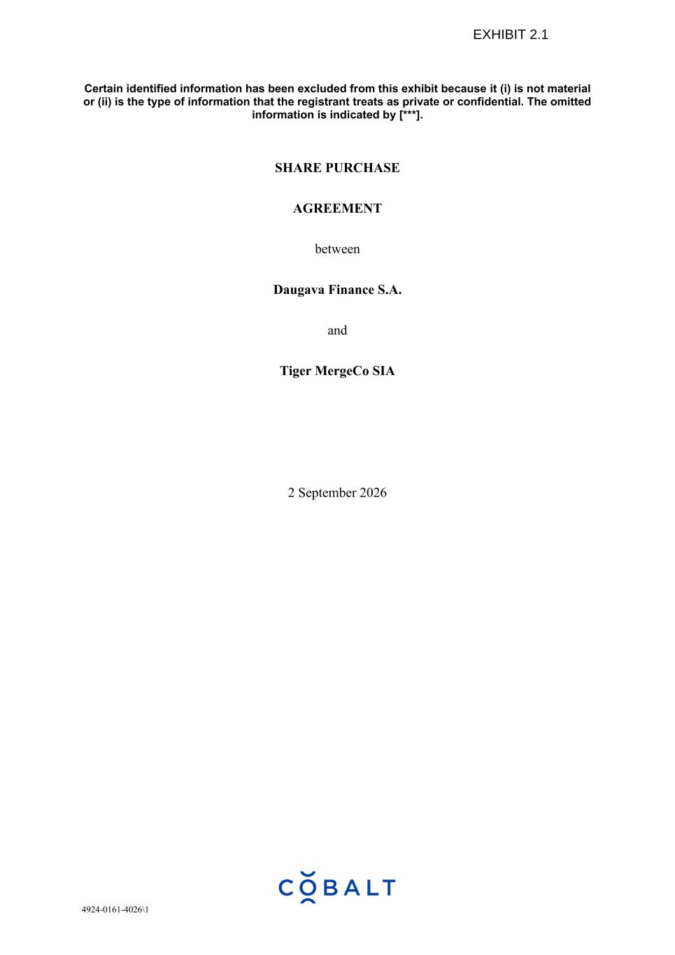

4924-0161-4026\1 Certain identified information has been excluded from this exhibit because it (i) is not material or (ii) is the type of information that the registrant treats as private or confidential. The omitted information is indicated by [***]. SHARE PURCHASE AGREEMENT between Daugava Finance S.A. and Tiger MergeCo SIA 2 September 2026

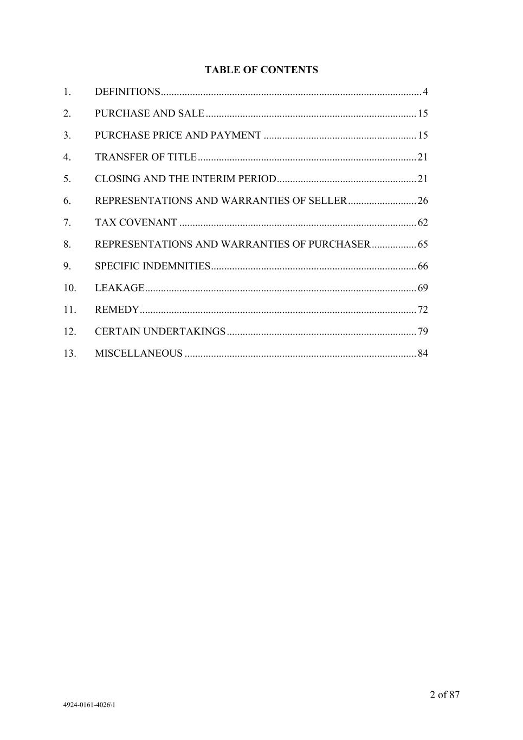
2 of 87 4924-0161-4026\1 TABLE OF CONTENTS 1. DEFINITIONS ................................................................................................... 4 2. PURCHASE AND SALE ................................................................................ 15 3. PURCHASE PRICE AND PAYMENT .......................................................... 15 4. TRANSFER OF TITLE ................................................................................... 21 5. CLOSING AND THE INTERIM PERIOD ..................................................... 21 6. REPRESENTATIONS AND WARRANTIES OF SELLER .......................... 26 7. TAX COVENANT .......................................................................................... 62 8. REPRESENTATIONS AND WARRANTIES OF PURCHASER ................. 65 9. SPECIFIC INDEMNITIES .............................................................................. 66 10. LEAKAGE ....................................................................................................... 69 11. REMEDY ......................................................................................................... 72 12. CERTAIN UNDERTAKINGS ........................................................................ 79 13. MISCELLANEOUS ........................................................................................ 84

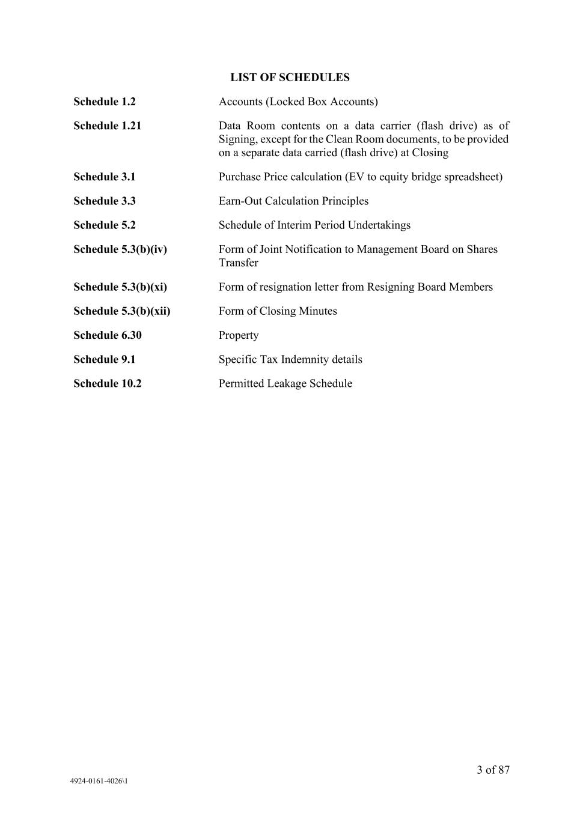
3 of 87 4924-0161-4026\1 LIST OF SCHEDULES Schedule 1.2 Accounts (Locked Box Accounts) Schedule 1.21 Data Room contents on a data carrier (flash drive) as of Signing, except for the Clean Room documents, to be provided on a separate data carried (flash drive) at Closing Schedule 3.1 Purchase Price calculation (EV to equity bridge spreadsheet) Schedule 3.3 Earn-Out Calculation Principles Schedule 5.2 Schedule of Interim Period Undertakings Schedule 5.3(b)(iv) Form of Joint Notification to Management Board on Shares Transfer Schedule 5.3(b)(xi) Form of resignation letter from Resigning Board Members Schedule 5.3(b)(xii) Form of Closing Minutes Schedule 6.30 Property Schedule 9.1 Specific Tax Indemnity details Schedule 10.2 Permitted Leakage Schedule

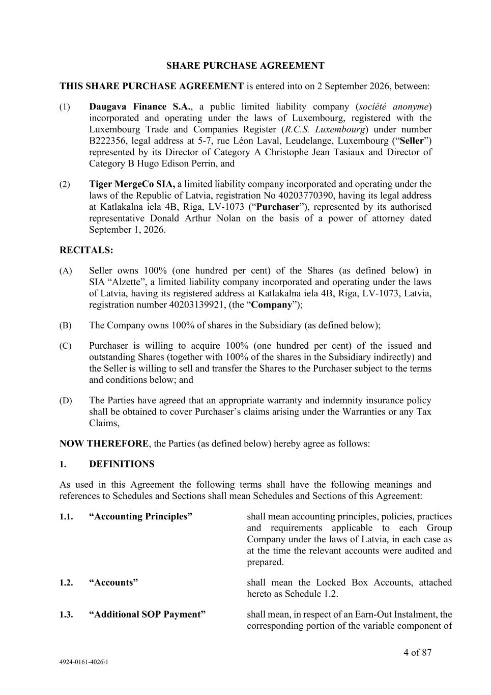
4 of 87 4924-0161-4026\1 SHARE PURCHASE AGREEMENT THIS SHARE PURCHASE AGREEMENT is entered into on 2 September 2026, between: (1) Daugava Finance S.A., a public limited liability company (société anonyme) incorporated and operating under the laws of Luxembourg, registered with the Luxembourg Trade and Companies Register (R.C.S. Luxembourg) under number B222356, legal address at 5-7, rue Léon Laval, Leudelange, Luxembourg (“Seller”) represented by its Director of Category A Christophe Jean Tasiaux and Director of Category B Hugo Edison Perrin, and (2) Tiger MergeCo SIA, a limited liability company incorporated and operating under the laws of the Republic of Latvia, registration No 40203770390, having its legal address at Katlakalna iela 4B, Riga, LV-1073 (“Purchaser”), represented by its authorised representative Donald Arthur Nolan on the basis of a power of attorney dated September 1, 2026. RECITALS: (A) Seller owns 100% (one hundred per cent) of the Shares (as defined below) in SIA “Alzette”, a limited liability company incorporated and operating under the laws of Latvia, having its registered address at Katlakalna iela 4B, Riga, LV-1073, Latvia, registration number 40203139921, (the “Company”); (B) The Company owns 100% of shares in the Subsidiary (as defined below); (C) Purchaser is willing to acquire 100% (one hundred per cent) of the issued and outstanding Shares (together with 100% of the shares in the Subsidiary indirectly) and the Seller is willing to sell and transfer the Shares to the Purchaser subject to the terms and conditions below; and (D) The Parties have agreed that an appropriate warranty and indemnity insurance policy shall be obtained to cover Purchaser’s claims arising under the Warranties or any Tax Claims, NOW THEREFORE, the Parties (as defined below) hereby agree as follows: 1. DEFINITIONS As used in this Agreement the following terms shall have the following meanings and references to Schedules and Sections shall mean Schedules and Sections of this Agreement: 1.1. “Accounting Principles” shall mean accounting principles, policies, practices and requirements applicable to each Group Company under the laws of Latvia, in each case as at the time the relevant accounts were audited and prepared. 1.2. “Accounts” shall mean the Locked Box Accounts, attached hereto as Schedule 1.2. 1.3. “Additional SOP Payment” shall mean, in respect of an Earn-Out Instalment, the corresponding portion of the variable component of

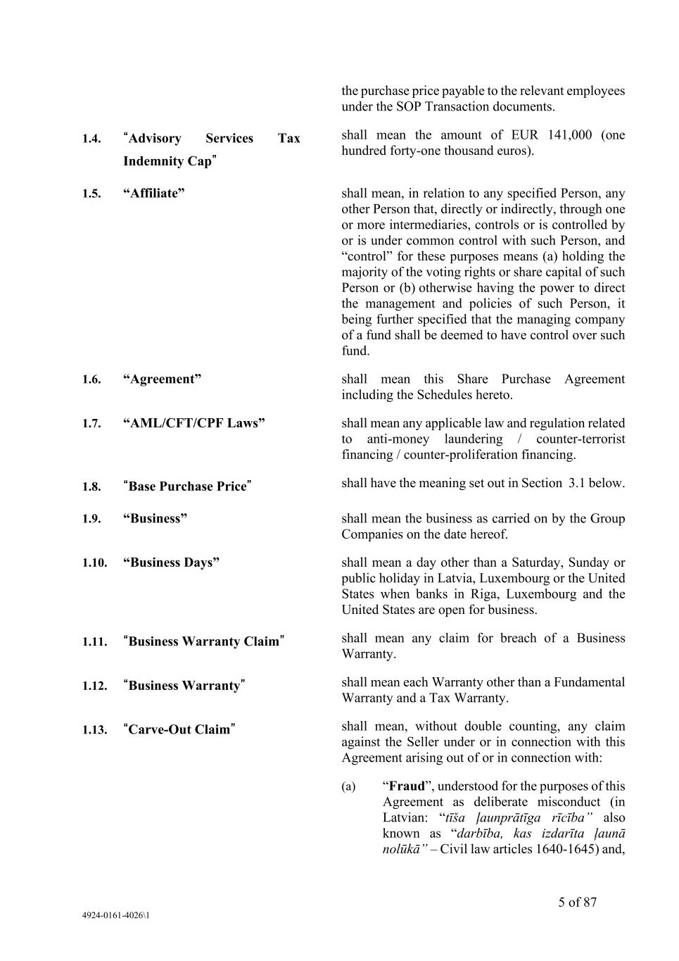
5 of 87 4924-0161-4026\1 the purchase price payable to the relevant employees under the SOP Transaction documents. 1.4. “Advisory Services Tax Indemnity Cap” shall mean the amount of EUR 141,000 (one hundred forty-one thousand euros). 1.5. “Affiliate” shall mean, in relation to any specified Person, any other Person that, directly or indirectly, through one or more intermediaries, controls or is controlled by or is under common control with such Person, and “control” for these purposes means (a) holding the majority of the voting rights or share capital of such Person or (b) otherwise having the power to direct the management and policies of such Person, it being further specified that the managing company of a fund shall be deemed to have control over such fund. 1.6. “Agreement” shall mean this Share Purchase Agreement including the Schedules hereto. 1.7. “AML/CFT/CPF Laws” shall mean any applicable law and regulation related to anti-money laundering / counter-terrorist financing / counter-proliferation financing. 1.8. “Base Purchase Price” shall have the meaning set out in Section 3.1 below. 1.9. “Business” shall mean the business as carried on by the Group Companies on the date hereof. 1.10. “Business Days” shall mean a day other than a Saturday, Sunday or public holiday in Latvia, Luxembourg or the United States when banks in Riga, Luxembourg and the United States are open for business. 1.11. “Business Warranty Claim” shall mean any claim for breach of a Business Warranty. 1.12. “Business Warranty” shall mean each Warranty other than a Fundamental Warranty and a Tax Warranty. 1.13. “Carve-Out Claim” shall mean, without double counting, any claim against the Seller under or in connection with this Agreement arising out of or in connection with: (a) “Fraud”, understood for the purposes of this Agreement as deliberate misconduct (in Latvian: “tīša ļaunprātīga rīcība” also known as “darbība, kas izdarīta ļaunā nolūkā” – Civil law articles 1640-1645) and,

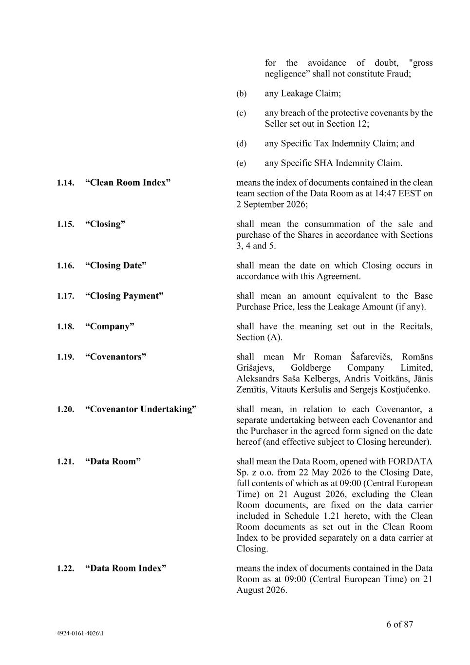
6 of 87 4924-0161-4026\1 for the avoidance of doubt, "gross negligence” shall not constitute Fraud; (b) any Leakage Claim; (c) any breach of the protective covenants by the Seller set out in Section 12; (d) any Specific Tax Indemnity Claim; and (e) any Specific SHA Indemnity Claim. 1.14. “Clean Room Index” means the index of documents contained in the clean team section of the Data Room as at 14:47 EEST on 2 September 2026; 1.15. “Closing” shall mean the consummation of the sale and purchase of the Shares in accordance with Sections 3, 4 and 5. 1.16. “Closing Date” shall mean the date on which Closing occurs in accordance with this Agreement. 1.17. “Closing Payment” shall mean an amount equivalent to the Base Purchase Price, less the Leakage Amount (if any). 1.18. “Company” shall have the meaning set out in the Recitals, Section (A). 1.19. “Covenantors” shall mean Mr Roman Šafarevičs, Romāns Grišajevs, Goldberge Company Limited, Aleksandrs Saša Kelbergs, Andris Voitkāns, Jānis Zemītis, Vitauts Keršulis and Sergejs Kostjučenko. 1.20. “Covenantor Undertaking” shall mean, in relation to each Covenantor, a separate undertaking between each Covenantor and the Purchaser in the agreed form signed on the date hereof (and effective subject to Closing hereunder). 1.21. “Data Room” shall mean the Data Room, opened with FORDATA Sp. z o.o. from 22 May 2026 to the Closing Date, full contents of which as at 09:00 (Central European Time) on 21 August 2026, excluding the Clean Room documents, are fixed on the data carrier included in Schedule 1.21 hereto, with the Clean Room documents as set out in the Clean Room Index to be provided separately on a data carrier at Closing. 1.22. “Data Room Index” means the index of documents contained in the Data Room as at 09:00 (Central European Time) on 21 August 2026.

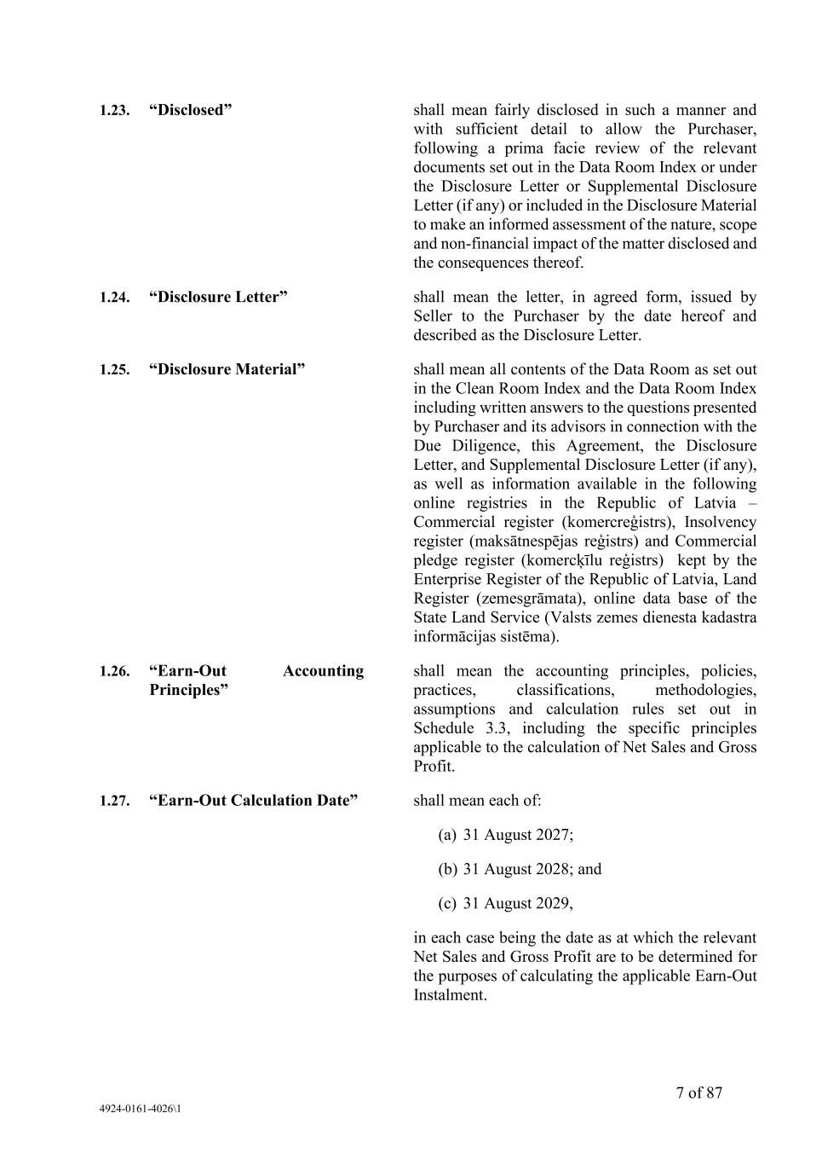
7 of 87 4924-0161-4026\1 1.23. “Disclosed” shall mean fairly disclosed in such a manner and with sufficient detail to allow the Purchaser, following a prima facie review of the relevant documents set out in the Data Room Index or under the Disclosure Letter or Supplemental Disclosure Letter (if any) or included in the Disclosure Material to make an informed assessment of the nature, scope and non-financial impact of the matter disclosed and the consequences thereof. 1.24. “Disclosure Letter” shall mean the letter, in agreed form, issued by Seller to the Purchaser by the date hereof and described as the Disclosure Letter. 1.25. “Disclosure Material” shall mean all contents of the Data Room as set out in the Clean Room Index and the Data Room Index including written answers to the questions presented by Purchaser and its advisors in connection with the Due Diligence, this Agreement, the Disclosure Letter, and Supplemental Disclosure Letter (if any), as well as information available in the following online registries in the Republic of Latvia – Commercial register (komercreģistrs), Insolvency register (maksātnespējas reģistrs) and Commercial pledge register (komercķīlu reģistrs) kept by the Enterprise Register of the Republic of Latvia, Land Register (zemesgrāmata), online data base of the State Land Service (Valsts zemes dienesta kadastra informācijas sistēma). 1.26. “Earn-Out Accounting Principles” shall mean the accounting principles, policies, practices, classifications, methodologies, assumptions and calculation rules set out in Schedule 3.3, including the specific principles applicable to the calculation of Net Sales and Gross Profit. 1.27. “Earn-Out Calculation Date” shall mean each of: (a) 31 August 2027; (b) 31 August 2028; and (c) 31 August 2029, in each case being the date as at which the relevant Net Sales and Gross Profit are to be determined for the purposes of calculating the applicable Earn-Out Instalment.

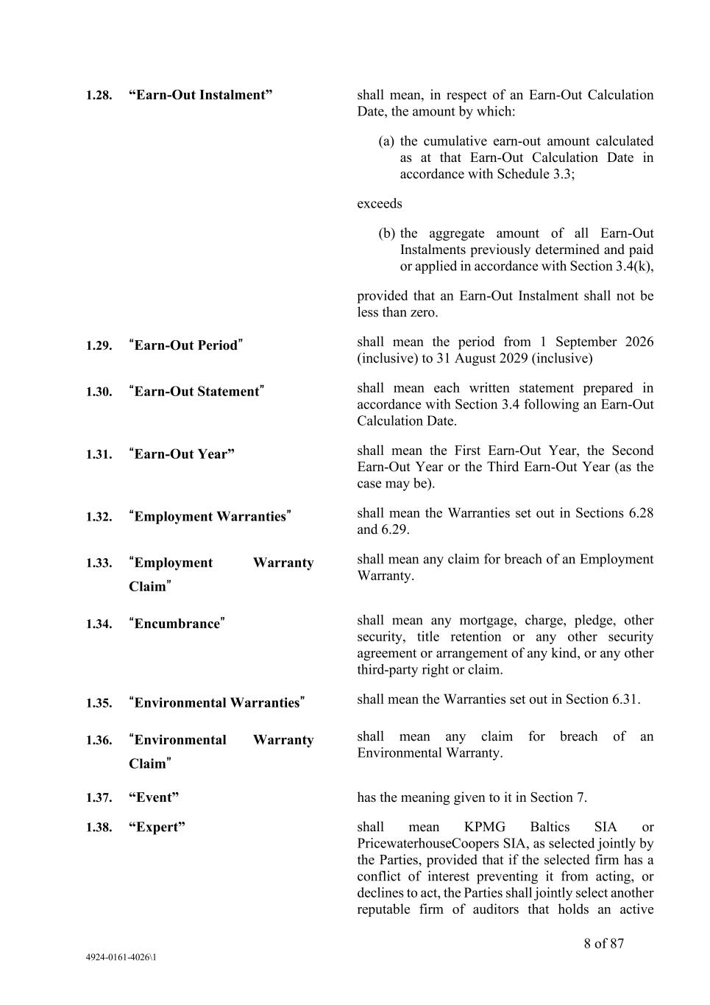
8 of 87 4924-0161-4026\1 1.28. “Earn-Out Instalment” shall mean, in respect of an Earn-Out Calculation Date, the amount by which: (a) the cumulative earn-out amount calculated as at that Earn-Out Calculation Date in accordance with Schedule 3.3; exceeds (b) the aggregate amount of all Earn-Out Instalments previously determined and paid or applied in accordance with Section 3.4(k), provided that an Earn-Out Instalment shall not be less than zero. 1.29. “Earn-Out Period” shall mean the period from 1 September 2026 (inclusive) to 31 August 2029 (inclusive) 1.30. “Earn-Out Statement” shall mean each written statement prepared in accordance with Section 3.4 following an Earn-Out Calculation Date. 1.31. “Earn-Out Year” shall mean the First Earn-Out Year, the Second Earn-Out Year or the Third Earn-Out Year (as the case may be). 1.32. “Employment Warranties” shall mean the Warranties set out in Sections 6.28 and 6.29. 1.33. “Employment Warranty Claim” shall mean any claim for breach of an Employment Warranty. 1.34. “Encumbrance” shall mean any mortgage, charge, pledge, other security, title retention or any other security agreement or arrangement of any kind, or any other third-party right or claim. 1.35. “Environmental Warranties” shall mean the Warranties set out in Section 6.31. 1.36. “Environmental Warranty Claim” shall mean any claim for breach of an Environmental Warranty. 1.37. “Event” has the meaning given to it in Section 7. 1.38. “Expert” shall mean KPMG Baltics SIA or PricewaterhouseCoopers SIA, as selected jointly by the Parties, provided that if the selected firm has a conflict of interest preventing it from acting, or declines to act, the Parties shall jointly select another reputable firm of auditors that holds an active

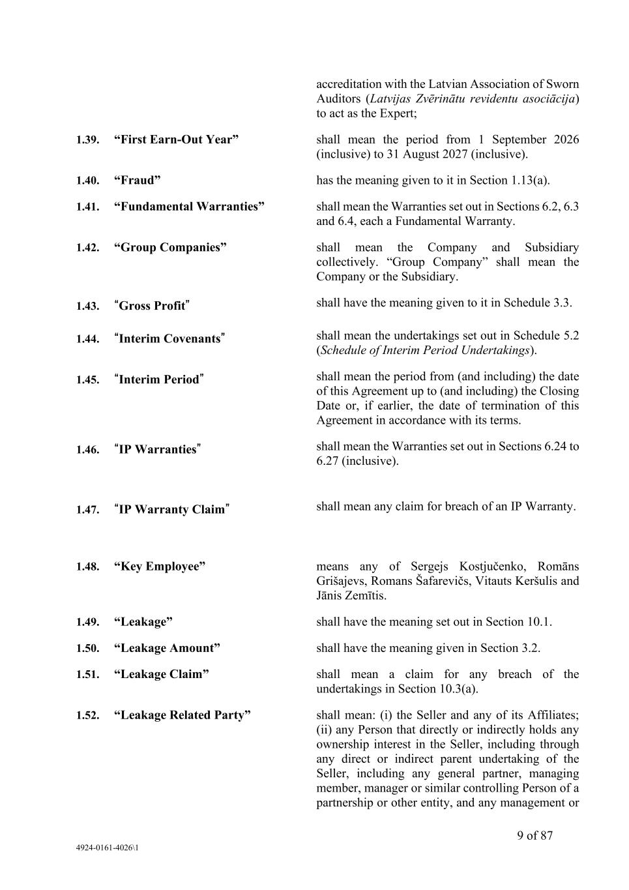
9 of 87 4924-0161-4026\1 accreditation with the Latvian Association of Sworn Auditors (Latvijas Zvērinātu revidentu asociācija) to act as the Expert; 1.39. “First Earn-Out Year” shall mean the period from 1 September 2026 (inclusive) to 31 August 2027 (inclusive). 1.40. “Fraud” has the meaning given to it in Section 1.13(a). 1.41. “Fundamental Warranties” shall mean the Warranties set out in Sections 6.2, 6.3 and 6.4, each a Fundamental Warranty. 1.42. “Group Companies” shall mean the Company and Subsidiary collectively. “Group Company” shall mean the Company or the Subsidiary. 1.43. “Gross Profit” shall have the meaning given to it in Schedule 3.3. 1.44. “Interim Covenants” shall mean the undertakings set out in Schedule 5.2 (Schedule of Interim Period Undertakings). 1.45. “Interim Period” shall mean the period from (and including) the date of this Agreement up to (and including) the Closing Date or, if earlier, the date of termination of this Agreement in accordance with its terms. 1.46. “IP Warranties” shall mean the Warranties set out in Sections 6.24 to 6.27 (inclusive). 1.47. “IP Warranty Claim” shall mean any claim for breach of an IP Warranty. 1.48. “Key Employee” means any of Sergejs Kostjučenko, Romāns Grišajevs, Romans Šafarevičs, Vitauts Keršulis and Jānis Zemītis. 1.49. “Leakage” shall have the meaning set out in Section 10.1. 1.50. “Leakage Amount” shall have the meaning given in Section 3.2. 1.51. “Leakage Claim” shall mean a claim for any breach of the undertakings in Section 10.3(a). 1.52. “Leakage Related Party” shall mean: (i) the Seller and any of its Affiliates; (ii) any Person that directly or indirectly holds any ownership interest in the Seller, including through any direct or indirect parent undertaking of the Seller, including any general partner, managing member, manager or similar controlling Person of a partnership or other entity, and any management or

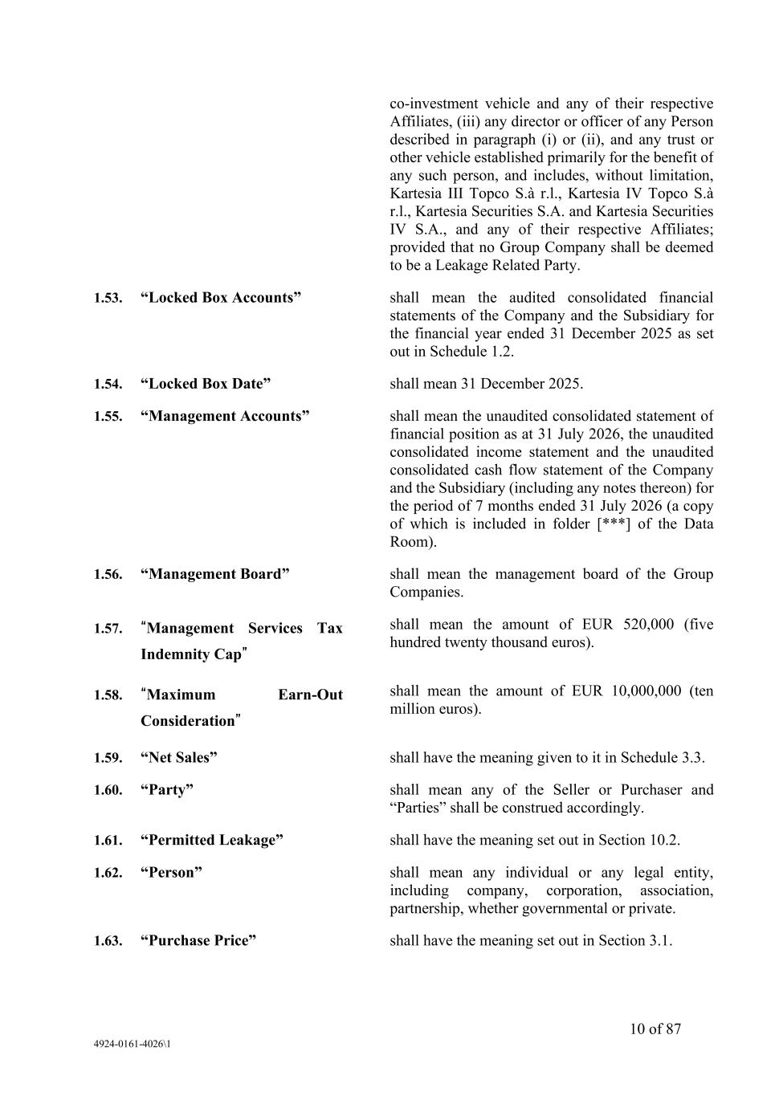
10 of 87 4924-0161-4026\1 co-investment vehicle and any of their respective Affiliates, (iii) any director or officer of any Person described in paragraph (i) or (ii), and any trust or other vehicle established primarily for the benefit of any such person, and includes, without limitation, Kartesia III Topco S.à r.l., Kartesia IV Topco S.à r.l., Kartesia Securities S.A. and Kartesia Securities IV S.A., and any of their respective Affiliates; provided that no Group Company shall be deemed to be a Leakage Related Party. 1.53. “Locked Box Accounts” shall mean the audited consolidated financial statements of the Company and the Subsidiary for the financial year ended 31 December 2025 as set out in Schedule 1.2. 1.54. “Locked Box Date” shall mean 31 December 2025. 1.55. “Management Accounts” shall mean the unaudited consolidated statement of financial position as at 31 July 2026, the unaudited consolidated income statement and the unaudited consolidated cash flow statement of the Company and the Subsidiary (including any notes thereon) for the period of 7 months ended 31 July 2026 (a copy of which is included in folder [***] of the Data Room). 1.56. “Management Board” shall mean the management board of the Group Companies. 1.57. “Management Services Tax Indemnity Cap” shall mean the amount of EUR 520,000 (five hundred twenty thousand euros). 1.58. “Maximum Earn-Out Consideration” shall mean the amount of EUR 10,000,000 (ten million euros). 1.59. “Net Sales” shall have the meaning given to it in Schedule 3.3. 1.60. “Party” shall mean any of the Seller or Purchaser and “Parties” shall be construed accordingly. 1.61. “Permitted Leakage” shall have the meaning set out in Section 10.2. 1.62. “Person” shall mean any individual or any legal entity, including company, corporation, association, partnership, whether governmental or private. 1.63. “Purchase Price” shall have the meaning set out in Section 3.1.

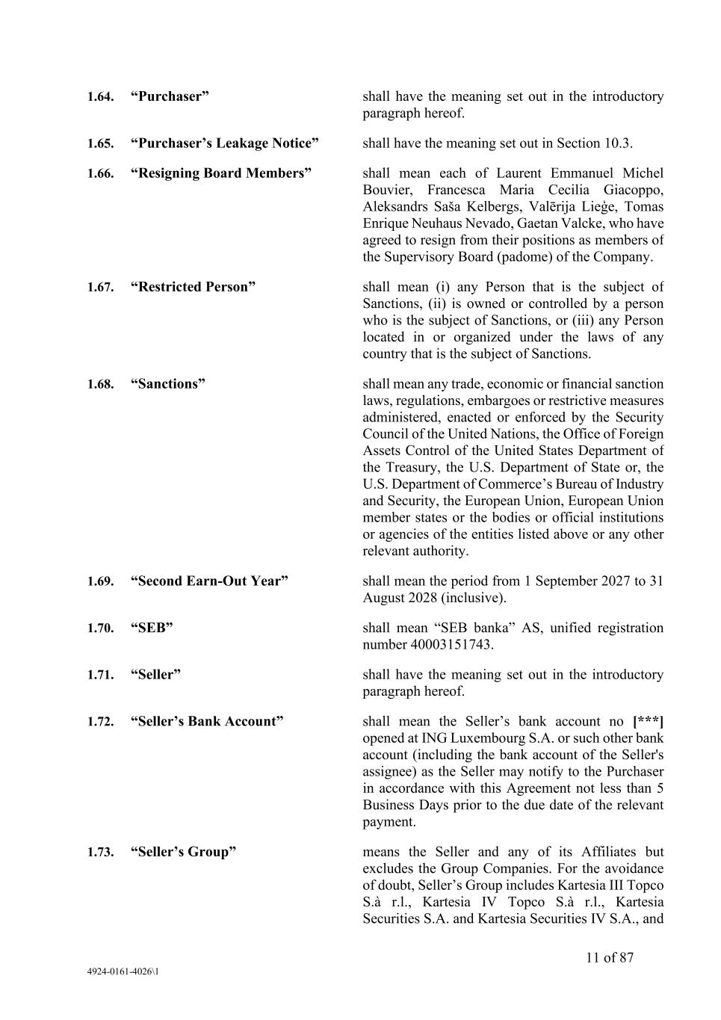
11 of 87 4924-0161-4026\1 1.64. “Purchaser” shall have the meaning set out in the introductory paragraph hereof. 1.65. “Purchaser’s Leakage Notice” shall have the meaning set out in Section 10.3. 1.66. “Resigning Board Members” shall mean each of Laurent Emmanuel Michel Bouvier, Francesca Maria Cecilia Giacoppo, Aleksandrs Saša Kelbergs, Valērija Lieģe, Tomas Enrique Neuhaus Nevado, Gaetan Valcke, who have agreed to resign from their positions as members of the Supervisory Board (padome) of the Company. 1.67. “Restricted Person” shall mean (i) any Person that is the subject of Sanctions, (ii) is owned or controlled by a person who is the subject of Sanctions, or (iii) any Person located in or organized under the laws of any country that is the subject of Sanctions. 1.68. “Sanctions” shall mean any trade, economic or financial sanction laws, regulations, embargoes or restrictive measures administered, enacted or enforced by the Security Council of the United Nations, the Office of Foreign Assets Control of the United States Department of the Treasury, the U.S. Department of State or, the U.S. Department of Commerce’s Bureau of Industry and Security, the European Union, European Union member states or the bodies or official institutions or agencies of the entities listed above or any other relevant authority. 1.69. “Second Earn-Out Year” shall mean the period from 1 September 2027 to 31 August 2028 (inclusive). 1.70. “SEB” shall mean “SEB banka” AS, unified registration number 40003151743. 1.71. “Seller” shall have the meaning set out in the introductory paragraph hereof. 1.72. “Seller’s Bank Account” shall mean the Seller’s bank account no [***] opened at ING Luxembourg S.A. or such other bank account (including the bank account of the Seller's assignee) as the Seller may notify to the Purchaser in accordance with this Agreement not less than 5 Business Days prior to the due date of the relevant payment. 1.73. “Seller’s Group” means the Seller and any of its Affiliates but excludes the Group Companies. For the avoidance of doubt, Seller’s Group includes Kartesia III Topco S.à r.l., Kartesia IV Topco S.à r.l., Kartesia Securities S.A. and Kartesia Securities IV S.A., and

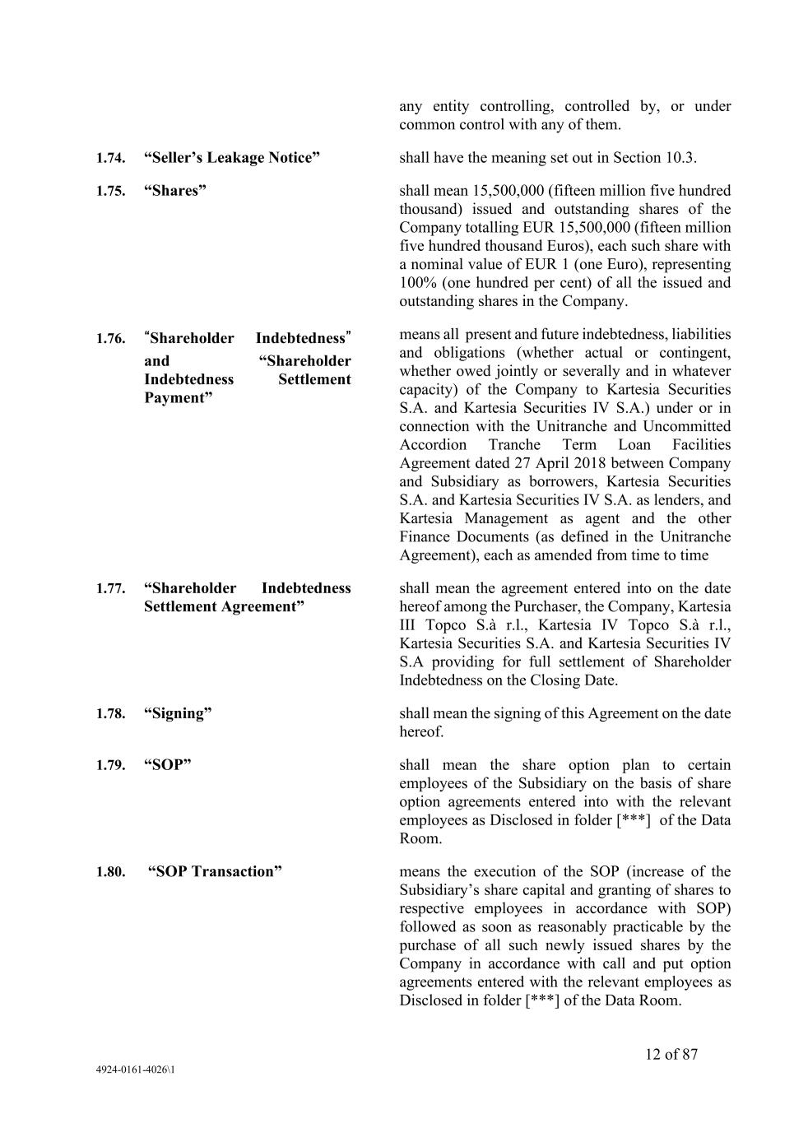
12 of 87 4924-0161-4026\1 any entity controlling, controlled by, or under common control with any of them. 1.74. “Seller’s Leakage Notice” shall have the meaning set out in Section 10.3. 1.75. “Shares” shall mean 15,500,000 (fifteen million five hundred thousand) issued and outstanding shares of the Company totalling EUR 15,500,000 (fifteen million five hundred thousand Euros), each such share with a nominal value of EUR 1 (one Euro), representing 100% (one hundred per cent) of all the issued and outstanding shares in the Company. 1.76. “Shareholder Indebtedness” and “Shareholder Indebtedness Settlement Payment” means all present and future indebtedness, liabilities and obligations (whether actual or contingent, whether owed jointly or severally and in whatever capacity) of the Company to Kartesia Securities S.A. and Kartesia Securities IV S.A.) under or in connection with the Unitranche and Uncommitted Accordion Tranche Term Loan Facilities Agreement dated 27 April 2018 between Company and Subsidiary as borrowers, Kartesia Securities S.A. and Kartesia Securities IV S.A. as lenders, and Kartesia Management as agent and the other Finance Documents (as defined in the Unitranche Agreement), each as amended from time to time 1.77. “Shareholder Indebtedness Settlement Agreement” shall mean the agreement entered into on the date hereof among the Purchaser, the Company, Kartesia III Topco S.à r.l., Kartesia IV Topco S.à r.l., Kartesia Securities S.A. and Kartesia Securities IV S.A providing for full settlement of Shareholder Indebtedness on the Closing Date. 1.78. “Signing” shall mean the signing of this Agreement on the date hereof. 1.79. “SOP” shall mean the share option plan to certain employees of the Subsidiary on the basis of share option agreements entered into with the relevant employees as Disclosed in folder [***] of the Data Room. 1.80. “SOP Transaction” means the execution of the SOP (increase of the Subsidiary’s share capital and granting of shares to respective employees in accordance with SOP) followed as soon as reasonably practicable by the purchase of all such newly issued shares by the Company in accordance with call and put option agreements entered with the relevant employees as Disclosed in folder [***] of the Data Room.

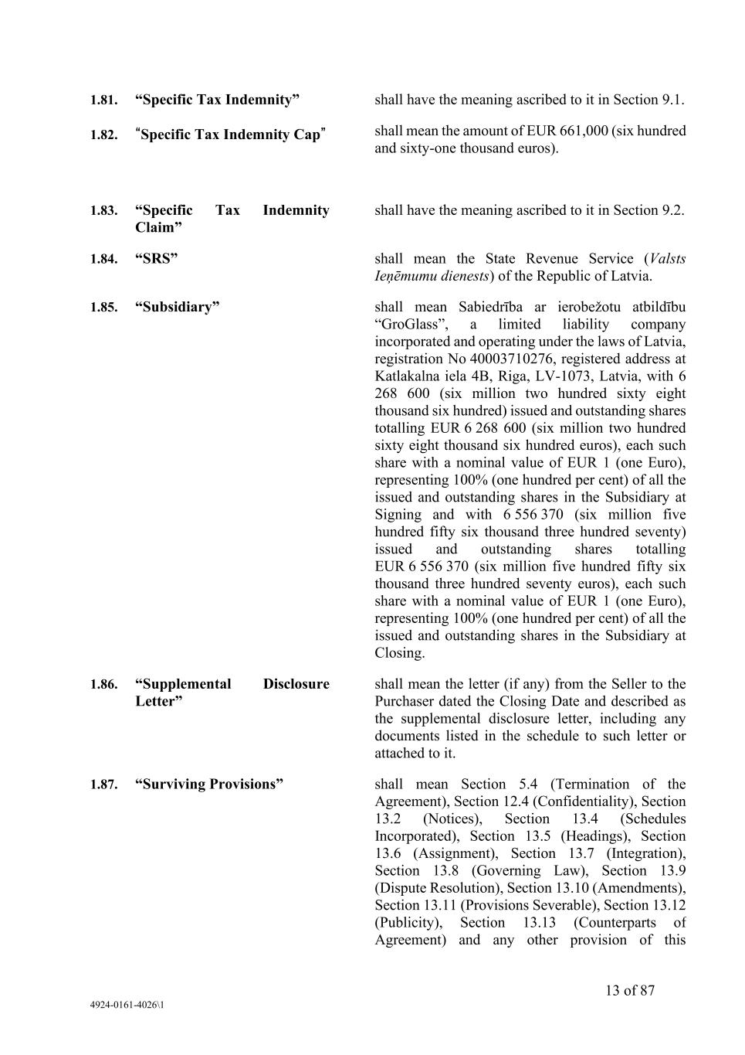
13 of 87 4924-0161-4026\1 1.81. “Specific Tax Indemnity” shall have the meaning ascribed to it in Section 9.1. 1.82. “Specific Tax Indemnity Cap” shall mean the amount of EUR 661,000 (six hundred and sixty-one thousand euros). 1.83. “Specific Tax Indemnity Claim” shall have the meaning ascribed to it in Section 9.2. 1.84. “SRS” shall mean the State Revenue Service (Valsts Ieņēmumu dienests) of the Republic of Latvia. 1.85. “Subsidiary” shall mean Sabiedrība ar ierobežotu atbildību “GroGlass”, a limited liability company incorporated and operating under the laws of Latvia, registration No 40003710276, registered address at Katlakalna iela 4B, Riga, LV-1073, Latvia, with 6 268 600 (six million two hundred sixty eight thousand six hundred) issued and outstanding shares totalling EUR 6 268 600 (six million two hundred sixty eight thousand six hundred euros), each such share with a nominal value of EUR 1 (one Euro), representing 100% (one hundred per cent) of all the issued and outstanding shares in the Subsidiary at Signing and with 6 556 370 (six million five hundred fifty six thousand three hundred seventy) issued and outstanding shares totalling EUR 6 556 370 (six million five hundred fifty six thousand three hundred seventy euros), each such share with a nominal value of EUR 1 (one Euro), representing 100% (one hundred per cent) of all the issued and outstanding shares in the Subsidiary at Closing. 1.86. “Supplemental Disclosure Letter” shall mean the letter (if any) from the Seller to the Purchaser dated the Closing Date and described as the supplemental disclosure letter, including any documents listed in the schedule to such letter or attached to it. 1.87. “Surviving Provisions” shall mean Section 5.4 (Termination of the Agreement), Section 12.4 (Confidentiality), Section 13.2 (Notices), Section 13.4 (Schedules Incorporated), Section 13.5 (Headings), Section 13.6 (Assignment), Section 13.7 (Integration), Section 13.8 (Governing Law), Section 13.9 (Dispute Resolution), Section 13.10 (Amendments), Section 13.11 (Provisions Severable), Section 13.12 (Publicity), Section 13.13 (Counterparts of Agreement) and any other provision of this

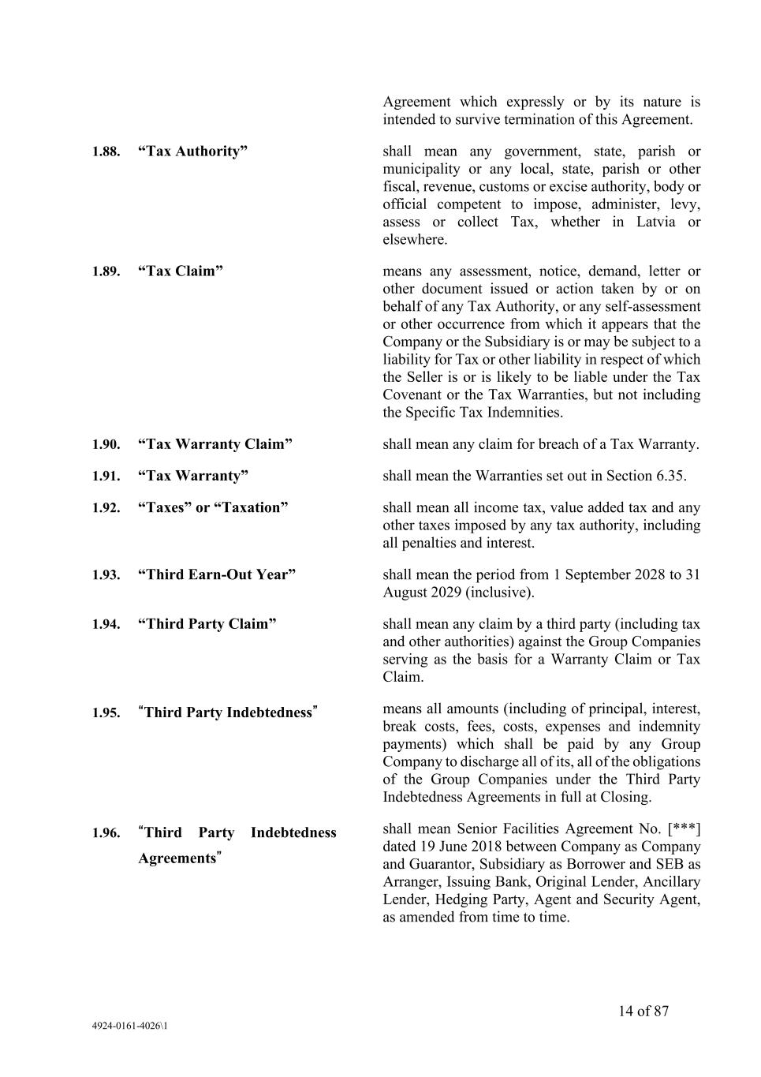
14 of 87 4924-0161-4026\1 Agreement which expressly or by its nature is intended to survive termination of this Agreement. 1.88. “Tax Authority” shall mean any government, state, parish or municipality or any local, state, parish or other fiscal, revenue, customs or excise authority, body or official competent to impose, administer, levy, assess or collect Tax, whether in Latvia or elsewhere. 1.89. “Tax Claim” means any assessment, notice, demand, letter or other document issued or action taken by or on behalf of any Tax Authority, or any self-assessment or other occurrence from which it appears that the Company or the Subsidiary is or may be subject to a liability for Tax or other liability in respect of which the Seller is or is likely to be liable under the Tax Covenant or the Tax Warranties, but not including the Specific Tax Indemnities. 1.90. “Tax Warranty Claim” shall mean any claim for breach of a Tax Warranty. 1.91. “Tax Warranty” shall mean the Warranties set out in Section 6.35. 1.92. “Taxes” or “Taxation” shall mean all income tax, value added tax and any other taxes imposed by any tax authority, including all penalties and interest. 1.93. “Third Earn-Out Year” shall mean the period from 1 September 2028 to 31 August 2029 (inclusive). 1.94. “Third Party Claim” shall mean any claim by a third party (including tax and other authorities) against the Group Companies serving as the basis for a Warranty Claim or Tax Claim. 1.95. “Third Party Indebtedness” means all amounts (including of principal, interest, break costs, fees, costs, expenses and indemnity payments) which shall be paid by any Group Company to discharge all of its, all of the obligations of the Group Companies under the Third Party Indebtedness Agreements in full at Closing. 1.96. “Third Party Indebtedness Agreements” shall mean Senior Facilities Agreement No. [***] dated 19 June 2018 between Company as Company and Guarantor, Subsidiary as Borrower and SEB as Arranger, Issuing Bank, Original Lender, Ancillary Lender, Hedging Party, Agent and Security Agent, as amended from time to time.

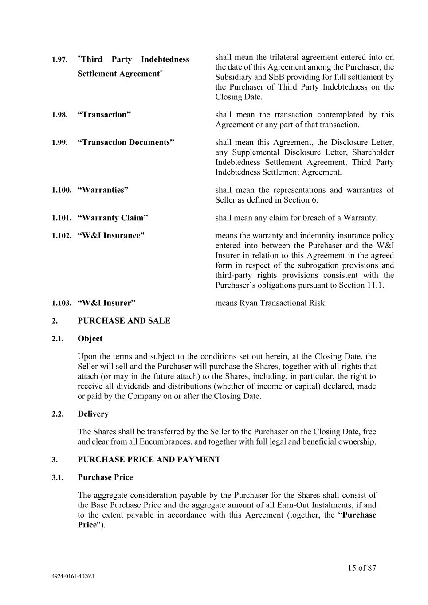
15 of 87 4924-0161-4026\1 1.97. “Third Party Indebtedness Settlement Agreement” shall mean the trilateral agreement entered into on the date of this Agreement among the Purchaser, the Subsidiary and SEB providing for full settlement by the Purchaser of Third Party Indebtedness on the Closing Date. 1.98. “Transaction” shall mean the transaction contemplated by this Agreement or any part of that transaction. 1.99. “Transaction Documents” shall mean this Agreement, the Disclosure Letter, any Supplemental Disclosure Letter, Shareholder Indebtedness Settlement Agreement, Third Party Indebtedness Settlement Agreement. 1.100. “Warranties” shall mean the representations and warranties of Seller as defined in Section 6. 1.101. “Warranty Claim” shall mean any claim for breach of a Warranty. 1.102. “W&I Insurance” means the warranty and indemnity insurance policy entered into between the Purchaser and the W&I Insurer in relation to this Agreement in the agreed form in respect of the subrogation provisions and third-party rights provisions consistent with the Purchaser’s obligations pursuant to Section 11.1. 1.103. “W&I Insurer” means Ryan Transactional Risk. 2. PURCHASE AND SALE 2.1. Object Upon the terms and subject to the conditions set out herein, at the Closing Date, the Seller will sell and the Purchaser will purchase the Shares, together with all rights that attach (or may in the future attach) to the Shares, including, in particular, the right to receive all dividends and distributions (whether of income or capital) declared, made or paid by the Company on or after the Closing Date. 2.2. Delivery The Shares shall be transferred by the Seller to the Purchaser on the Closing Date, free and clear from all Encumbrances, and together with full legal and beneficial ownership. 3. PURCHASE PRICE AND PAYMENT 3.1. Purchase Price The aggregate consideration payable by the Purchaser for the Shares shall consist of the Base Purchase Price and the aggregate amount of all Earn-Out Instalments, if and to the extent payable in accordance with this Agreement (together, the “Purchase Price”).

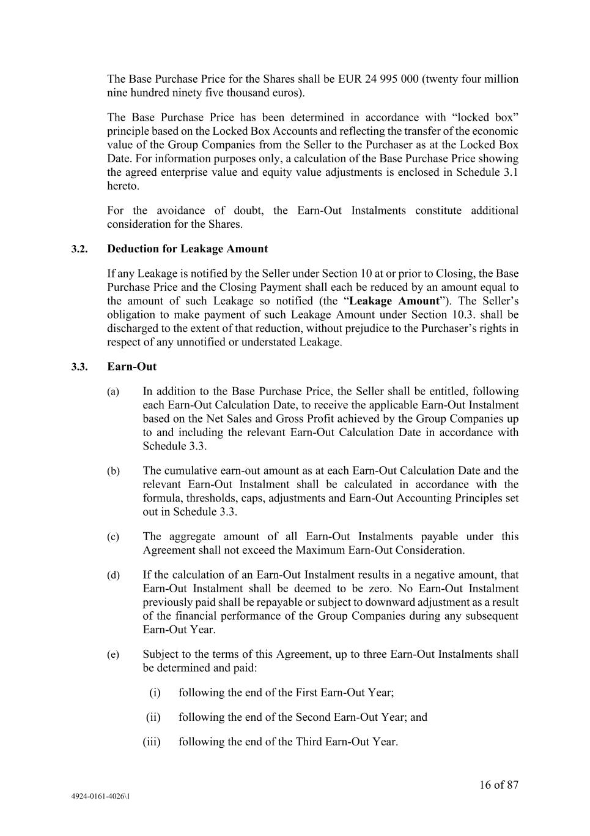
16 of 87 4924-0161-4026\1 The Base Purchase Price for the Shares shall be EUR 24 995 000 (twenty four million nine hundred ninety five thousand euros). The Base Purchase Price has been determined in accordance with “locked box” principle based on the Locked Box Accounts and reflecting the transfer of the economic value of the Group Companies from the Seller to the Purchaser as at the Locked Box Date. For information purposes only, a calculation of the Base Purchase Price showing the agreed enterprise value and equity value adjustments is enclosed in Schedule 3.1 hereto. For the avoidance of doubt, the Earn-Out Instalments constitute additional consideration for the Shares. 3.2. Deduction for Leakage Amount If any Leakage is notified by the Seller under Section 10 at or prior to Closing, the Base Purchase Price and the Closing Payment shall each be reduced by an amount equal to the amount of such Leakage so notified (the “Leakage Amount”). The Seller’s obligation to make payment of such Leakage Amount under Section 10.3. shall be discharged to the extent of that reduction, without prejudice to the Purchaser’s rights in respect of any unnotified or understated Leakage. 3.3. Earn-Out (a) In addition to the Base Purchase Price, the Seller shall be entitled, following each Earn-Out Calculation Date, to receive the applicable Earn-Out Instalment based on the Net Sales and Gross Profit achieved by the Group Companies up to and including the relevant Earn-Out Calculation Date in accordance with Schedule 3.3. (b) The cumulative earn-out amount as at each Earn-Out Calculation Date and the relevant Earn-Out Instalment shall be calculated in accordance with the formula, thresholds, caps, adjustments and Earn-Out Accounting Principles set out in Schedule 3.3. (c) The aggregate amount of all Earn-Out Instalments payable under this Agreement shall not exceed the Maximum Earn-Out Consideration. (d) If the calculation of an Earn-Out Instalment results in a negative amount, that Earn-Out Instalment shall be deemed to be zero. No Earn-Out Instalment previously paid shall be repayable or subject to downward adjustment as a result of the financial performance of the Group Companies during any subsequent Earn-Out Year. (e) Subject to the terms of this Agreement, up to three Earn-Out Instalments shall be determined and paid: (i) following the end of the First Earn-Out Year; (ii) following the end of the Second Earn-Out Year; and (iii) following the end of the Third Earn-Out Year.

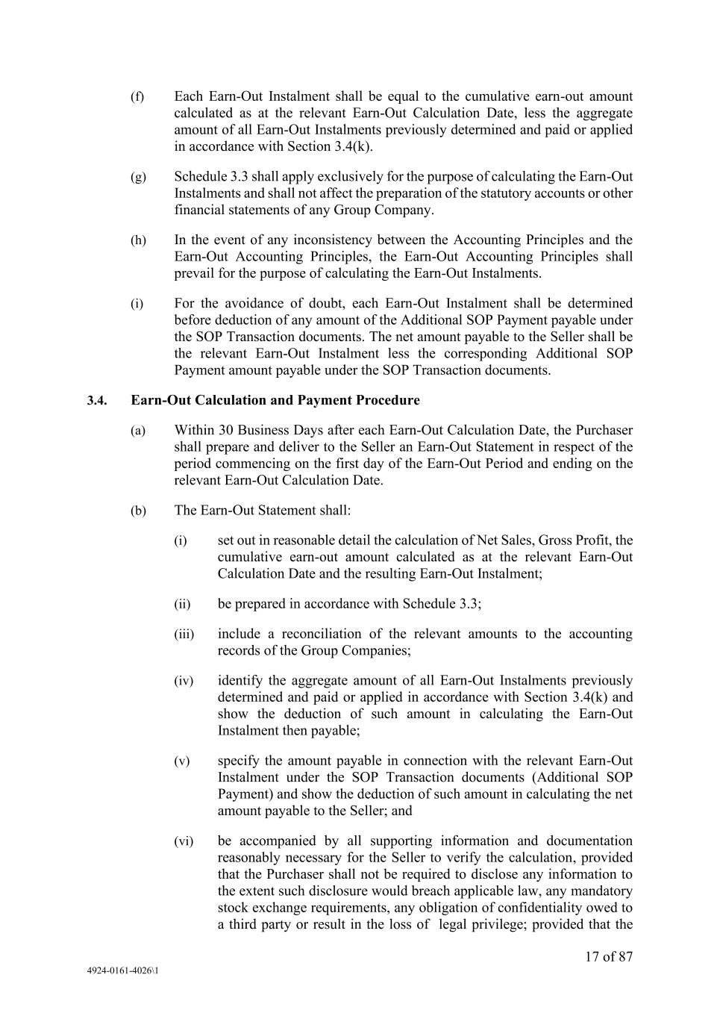
17 of 87 4924-0161-4026\1 (f) Each Earn-Out Instalment shall be equal to the cumulative earn-out amount calculated as at the relevant Earn-Out Calculation Date, less the aggregate amount of all Earn-Out Instalments previously determined and paid or applied in accordance with Section 3.4(k). (g) Schedule 3.3 shall apply exclusively for the purpose of calculating the Earn-Out Instalments and shall not affect the preparation of the statutory accounts or other financial statements of any Group Company. (h) In the event of any inconsistency between the Accounting Principles and the Earn-Out Accounting Principles, the Earn-Out Accounting Principles shall prevail for the purpose of calculating the Earn-Out Instalments. (i) For the avoidance of doubt, each Earn-Out Instalment shall be determined before deduction of any amount of the Additional SOP Payment payable under the SOP Transaction documents. The net amount payable to the Seller shall be the relevant Earn-Out Instalment less the corresponding Additional SOP Payment amount payable under the SOP Transaction documents. 3.4. Earn-Out Calculation and Payment Procedure (a) Within 30 Business Days after each Earn-Out Calculation Date, the Purchaser shall prepare and deliver to the Seller an Earn-Out Statement in respect of the period commencing on the first day of the Earn-Out Period and ending on the relevant Earn-Out Calculation Date. (b) The Earn-Out Statement shall: (i) set out in reasonable detail the calculation of Net Sales, Gross Profit, the cumulative earn-out amount calculated as at the relevant Earn-Out Calculation Date and the resulting Earn-Out Instalment; (ii) be prepared in accordance with Schedule 3.3; (iii) include a reconciliation of the relevant amounts to the accounting records of the Group Companies; (iv) identify the aggregate amount of all Earn-Out Instalments previously determined and paid or applied in accordance with Section 3.4(k) and show the deduction of such amount in calculating the Earn-Out Instalment then payable; (v) specify the amount payable in connection with the relevant Earn-Out Instalment under the SOP Transaction documents (Additional SOP Payment) and show the deduction of such amount in calculating the net amount payable to the Seller; and (vi) be accompanied by all supporting information and documentation reasonably necessary for the Seller to verify the calculation, provided that the Purchaser shall not be required to disclose any information to the extent such disclosure would breach applicable law, any mandatory stock exchange requirements, any obligation of confidentiality owed to a third party or result in the loss of legal privilege; provided that the

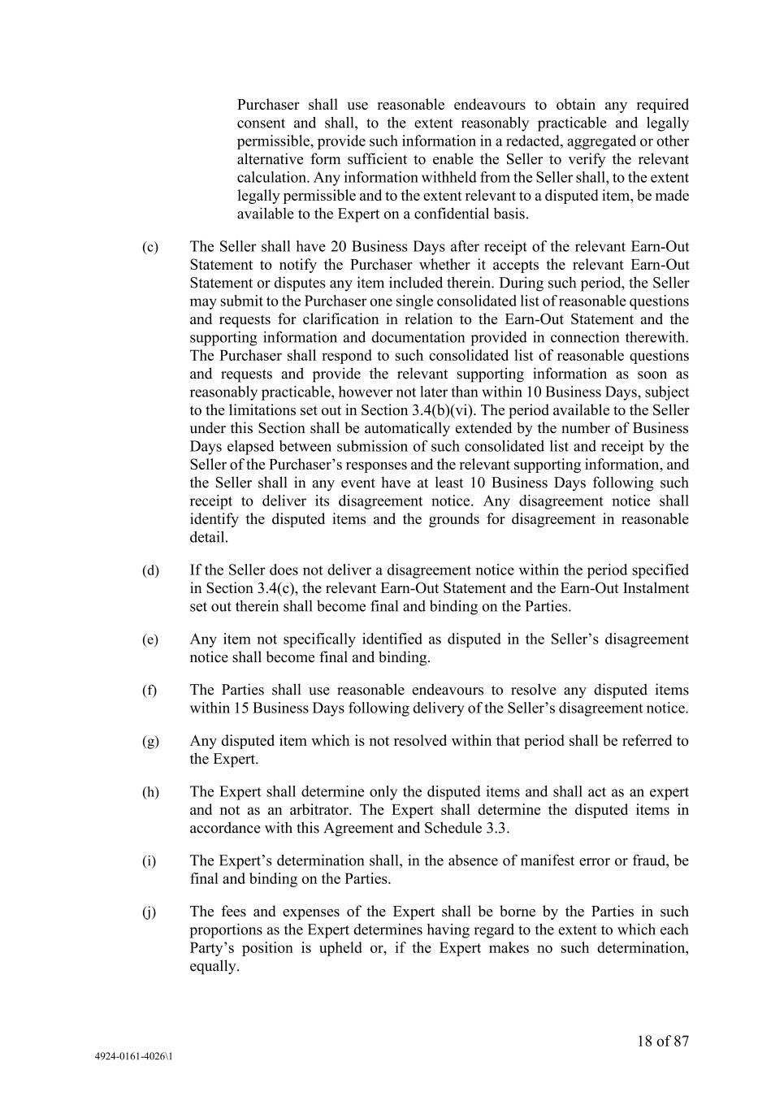
18 of 87 4924-0161-4026\1 Purchaser shall use reasonable endeavours to obtain any required consent and shall, to the extent reasonably practicable and legally permissible, provide such information in a redacted, aggregated or other alternative form sufficient to enable the Seller to verify the relevant calculation. Any information withheld from the Seller shall, to the extent legally permissible and to the extent relevant to a disputed item, be made available to the Expert on a confidential basis. (c) The Seller shall have 20 Business Days after receipt of the relevant Earn-Out Statement to notify the Purchaser whether it accepts the relevant Earn-Out Statement or disputes any item included therein. During such period, the Seller may submit to the Purchaser one single consolidated list of reasonable questions and requests for clarification in relation to the Earn-Out Statement and the supporting information and documentation provided in connection therewith. The Purchaser shall respond to such consolidated list of reasonable questions and requests and provide the relevant supporting information as soon as reasonably practicable, however not later than within 10 Business Days, subject to the limitations set out in Section 3.4(b)(vi). The period available to the Seller under this Section shall be automatically extended by the number of Business Days elapsed between submission of such consolidated list and receipt by the Seller of the Purchaser’s responses and the relevant supporting information, and the Seller shall in any event have at least 10 Business Days following such receipt to deliver its disagreement notice. Any disagreement notice shall identify the disputed items and the grounds for disagreement in reasonable detail. (d) If the Seller does not deliver a disagreement notice within the period specified in Section 3.4(c), the relevant Earn-Out Statement and the Earn-Out Instalment set out therein shall become final and binding on the Parties. (e) Any item not specifically identified as disputed in the Seller’s disagreement notice shall become final and binding. (f) The Parties shall use reasonable endeavours to resolve any disputed items within 15 Business Days following delivery of the Seller’s disagreement notice. (g) Any disputed item which is not resolved within that period shall be referred to the Expert. (h) The Expert shall determine only the disputed items and shall act as an expert and not as an arbitrator. The Expert shall determine the disputed items in accordance with this Agreement and Schedule 3.3. (i) The Expert’s determination shall, in the absence of manifest error or fraud, be final and binding on the Parties. (j) The fees and expenses of the Expert shall be borne by the Parties in such proportions as the Expert determines having regard to the extent to which each Party’s position is upheld or, if the Expert makes no such determination, equally.

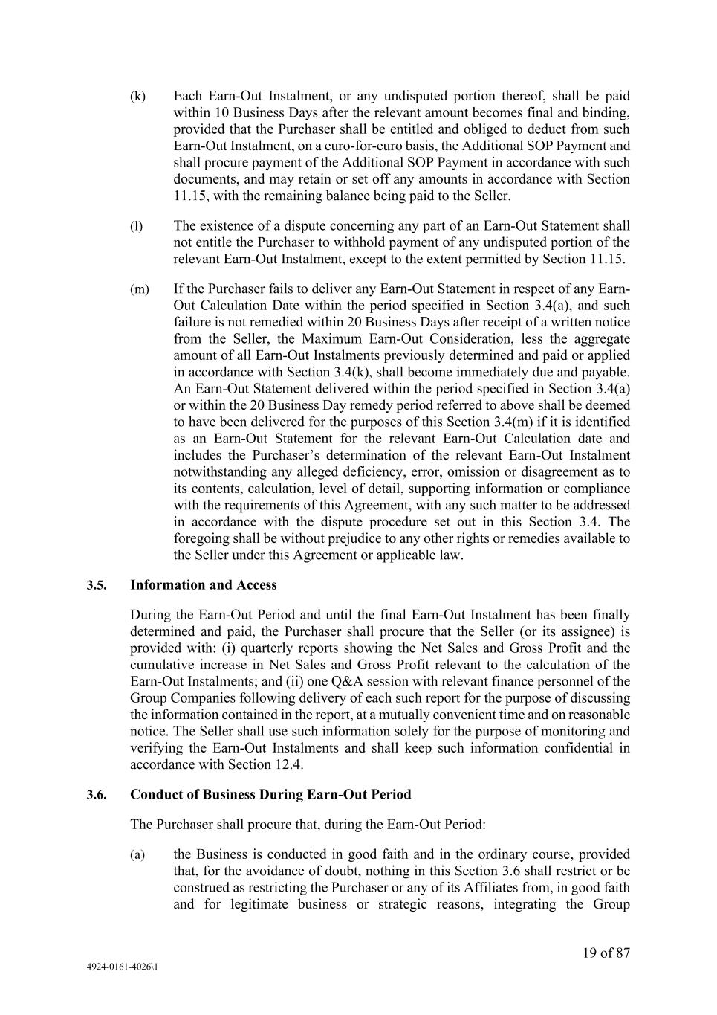
19 of 87 4924-0161-4026\1 (k) Each Earn-Out Instalment, or any undisputed portion thereof, shall be paid within 10 Business Days after the relevant amount becomes final and binding, provided that the Purchaser shall be entitled and obliged to deduct from such Earn-Out Instalment, on a euro-for-euro basis, the Additional SOP Payment and shall procure payment of the Additional SOP Payment in accordance with such documents, and may retain or set off any amounts in accordance with Section 11.15, with the remaining balance being paid to the Seller. (l) The existence of a dispute concerning any part of an Earn-Out Statement shall not entitle the Purchaser to withhold payment of any undisputed portion of the relevant Earn-Out Instalment, except to the extent permitted by Section 11.15. (m) If the Purchaser fails to deliver any Earn-Out Statement in respect of any Earn- Out Calculation Date within the period specified in Section 3.4(a), and such failure is not remedied within 20 Business Days after receipt of a written notice from the Seller, the Maximum Earn-Out Consideration, less the aggregate amount of all Earn-Out Instalments previously determined and paid or applied in accordance with Section 3.4(k), shall become immediately due and payable. An Earn-Out Statement delivered within the period specified in Section 3.4(a) or within the 20 Business Day remedy period referred to above shall be deemed to have been delivered for the purposes of this Section 3.4(m) if it is identified as an Earn-Out Statement for the relevant Earn-Out Calculation date and includes the Purchaser’s determination of the relevant Earn-Out Instalment notwithstanding any alleged deficiency, error, omission or disagreement as to its contents, calculation, level of detail, supporting information or compliance with the requirements of this Agreement, with any such matter to be addressed in accordance with the dispute procedure set out in this Section 3.4. The foregoing shall be without prejudice to any other rights or remedies available to the Seller under this Agreement or applicable law. 3.5. Information and Access During the Earn-Out Period and until the final Earn-Out Instalment has been finally determined and paid, the Purchaser shall procure that the Seller (or its assignee) is provided with: (i) quarterly reports showing the Net Sales and Gross Profit and the cumulative increase in Net Sales and Gross Profit relevant to the calculation of the Earn-Out Instalments; and (ii) one Q&A session with relevant finance personnel of the Group Companies following delivery of each such report for the purpose of discussing the information contained in the report, at a mutually convenient time and on reasonable notice. The Seller shall use such information solely for the purpose of monitoring and verifying the Earn-Out Instalments and shall keep such information confidential in accordance with Section 12.4. 3.6. Conduct of Business During Earn-Out Period The Purchaser shall procure that, during the Earn-Out Period: (a) the Business is conducted in good faith and in the ordinary course, provided that, for the avoidance of doubt, nothing in this Section 3.6 shall restrict or be construed as restricting the Purchaser or any of its Affiliates from, in good faith and for legitimate business or strategic reasons, integrating the Group

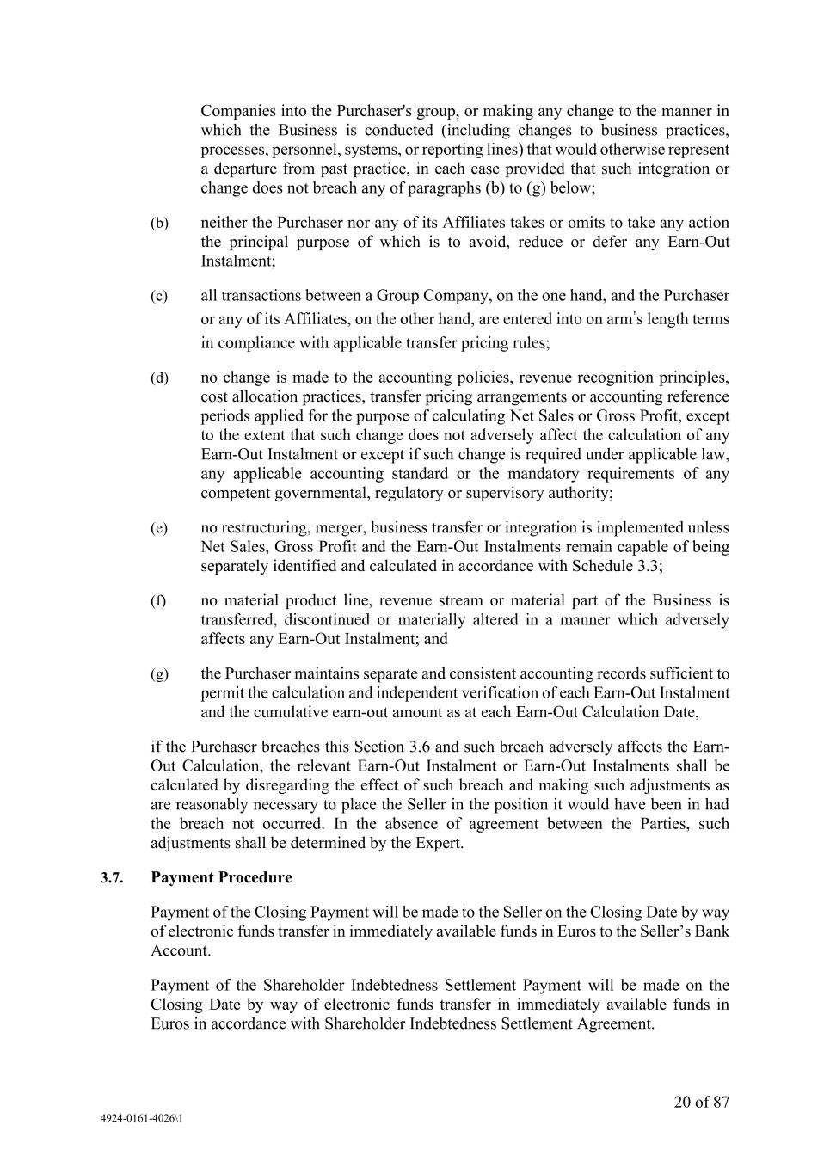
20 of 87 4924-0161-4026\1 Companies into the Purchaser's group, or making any change to the manner in which the Business is conducted (including changes to business practices, processes, personnel, systems, or reporting lines) that would otherwise represent a departure from past practice, in each case provided that such integration or change does not breach any of paragraphs (b) to (g) below; (b) neither the Purchaser nor any of its Affiliates takes or omits to take any action the principal purpose of which is to avoid, reduce or defer any Earn-Out Instalment; (c) all transactions between a Group Company, on the one hand, and the Purchaser or any of its Affiliates, on the other hand, are entered into on arm’s length terms in compliance with applicable transfer pricing rules; (d) no change is made to the accounting policies, revenue recognition principles, cost allocation practices, transfer pricing arrangements or accounting reference periods applied for the purpose of calculating Net Sales or Gross Profit, except to the extent that such change does not adversely affect the calculation of any Earn-Out Instalment or except if such change is required under applicable law, any applicable accounting standard or the mandatory requirements of any competent governmental, regulatory or supervisory authority; (e) no restructuring, merger, business transfer or integration is implemented unless Net Sales, Gross Profit and the Earn-Out Instalments remain capable of being separately identified and calculated in accordance with Schedule 3.3; (f) no material product line, revenue stream or material part of the Business is transferred, discontinued or materially altered in a manner which adversely affects any Earn-Out Instalment; and (g) the Purchaser maintains separate and consistent accounting records sufficient to permit the calculation and independent verification of each Earn-Out Instalment and the cumulative earn-out amount as at each Earn-Out Calculation Date, if the Purchaser breaches this Section 3.6 and such breach adversely affects the Earn- Out Calculation, the relevant Earn-Out Instalment or Earn-Out Instalments shall be calculated by disregarding the effect of such breach and making such adjustments as are reasonably necessary to place the Seller in the position it would have been in had the breach not occurred. In the absence of agreement between the Parties, such adjustments shall be determined by the Expert. 3.7. Payment Procedure Payment of the Closing Payment will be made to the Seller on the Closing Date by way of electronic funds transfer in immediately available funds in Euros to the Seller’s Bank Account. Payment of the Shareholder Indebtedness Settlement Payment will be made on the Closing Date by way of electronic funds transfer in immediately available funds in Euros in accordance with Shareholder Indebtedness Settlement Agreement.

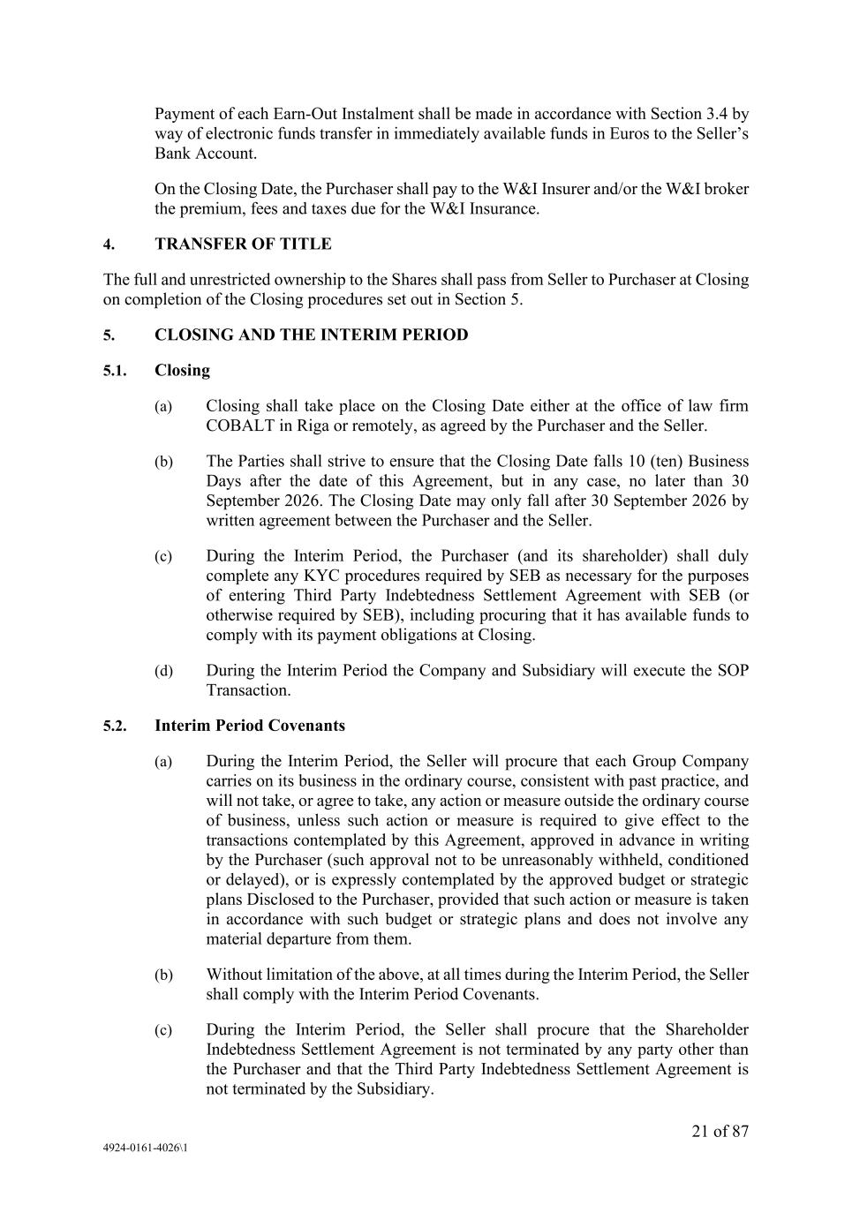
21 of 87 4924-0161-4026\1 Payment of each Earn-Out Instalment shall be made in accordance with Section 3.4 by way of electronic funds transfer in immediately available funds in Euros to the Seller’s Bank Account. On the Closing Date, the Purchaser shall pay to the W&I Insurer and/or the W&I broker the premium, fees and taxes due for the W&I Insurance. 4. TRANSFER OF TITLE The full and unrestricted ownership to the Shares shall pass from Seller to Purchaser at Closing on completion of the Closing procedures set out in Section 5. 5. CLOSING AND THE INTERIM PERIOD 5.1. Closing (a) Closing shall take place on the Closing Date either at the office of law firm COBALT in Riga or remotely, as agreed by the Purchaser and the Seller. (b) The Parties shall strive to ensure that the Closing Date falls 10 (ten) Business Days after the date of this Agreement, but in any case, no later than 30 September 2026. The Closing Date may only fall after 30 September 2026 by written agreement between the Purchaser and the Seller. (c) During the Interim Period, the Purchaser (and its shareholder) shall duly complete any KYC procedures required by SEB as necessary for the purposes of entering Third Party Indebtedness Settlement Agreement with SEB (or otherwise required by SEB), including procuring that it has available funds to comply with its payment obligations at Closing. (d) During the Interim Period the Company and Subsidiary will execute the SOP Transaction. 5.2. Interim Period Covenants (a) During the Interim Period, the Seller will procure that each Group Company carries on its business in the ordinary course, consistent with past practice, and will not take, or agree to take, any action or measure outside the ordinary course of business, unless such action or measure is required to give effect to the transactions contemplated by this Agreement, approved in advance in writing by the Purchaser (such approval not to be unreasonably withheld, conditioned or delayed), or is expressly contemplated by the approved budget or strategic plans Disclosed to the Purchaser, provided that such action or measure is taken in accordance with such budget or strategic plans and does not involve any material departure from them. (b) Without limitation of the above, at all times during the Interim Period, the Seller shall comply with the Interim Period Covenants. (c) During the Interim Period, the Seller shall procure that the Shareholder Indebtedness Settlement Agreement is not terminated by any party other than the Purchaser and that the Third Party Indebtedness Settlement Agreement is not terminated by the Subsidiary.

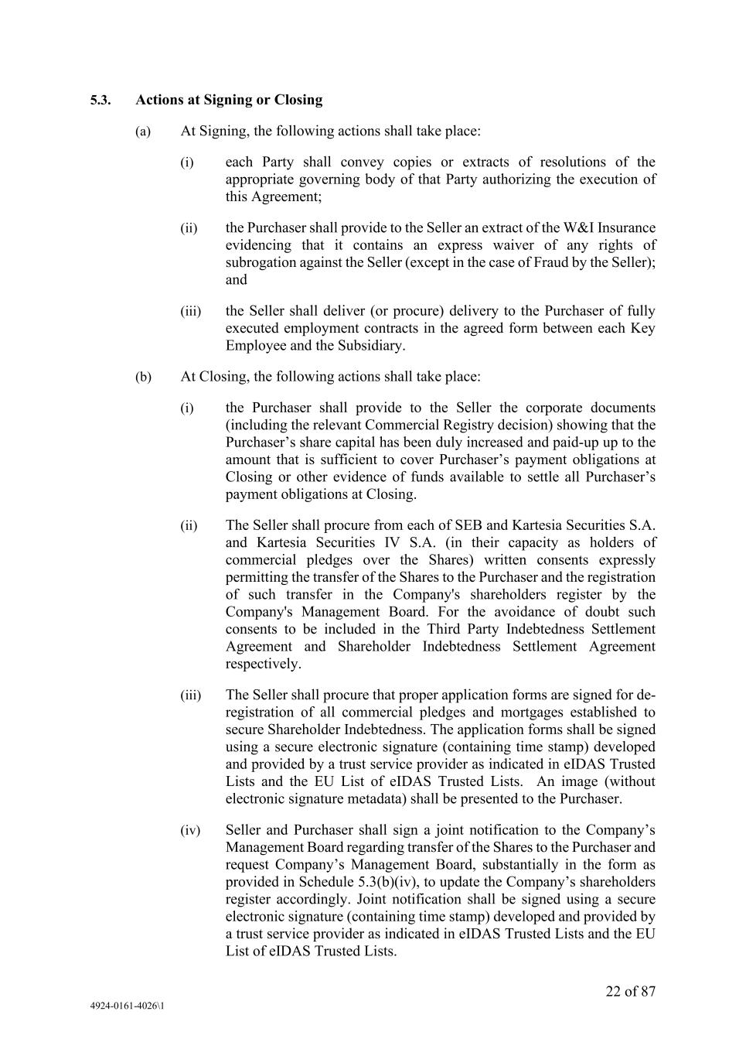
22 of 87 4924-0161-4026\1 5.3. Actions at Signing or Closing (a) At Signing, the following actions shall take place: (i) each Party shall convey copies or extracts of resolutions of the appropriate governing body of that Party authorizing the execution of this Agreement; (ii) the Purchaser shall provide to the Seller an extract of the W&I Insurance evidencing that it contains an express waiver of any rights of subrogation against the Seller (except in the case of Fraud by the Seller); and (iii) the Seller shall deliver (or procure) delivery to the Purchaser of fully executed employment contracts in the agreed form between each Key Employee and the Subsidiary. (b) At Closing, the following actions shall take place: (i) the Purchaser shall provide to the Seller the corporate documents (including the relevant Commercial Registry decision) showing that the Purchaser’s share capital has been duly increased and paid-up up to the amount that is sufficient to cover Purchaser’s payment obligations at Closing or other evidence of funds available to settle all Purchaser’s payment obligations at Closing. (ii) The Seller shall procure from each of SEB and Kartesia Securities S.A. and Kartesia Securities IV S.A. (in their capacity as holders of commercial pledges over the Shares) written consents expressly permitting the transfer of the Shares to the Purchaser and the registration of such transfer in the Company's shareholders register by the Company's Management Board. For the avoidance of doubt such consents to be included in the Third Party Indebtedness Settlement Agreement and Shareholder Indebtedness Settlement Agreement respectively. (iii) The Seller shall procure that proper application forms are signed for de- registration of all commercial pledges and mortgages established to secure Shareholder Indebtedness. The application forms shall be signed using a secure electronic signature (containing time stamp) developed and provided by a trust service provider as indicated in eIDAS Trusted Lists and the EU List of eIDAS Trusted Lists. An image (without electronic signature metadata) shall be presented to the Purchaser. (iv) Seller and Purchaser shall sign a joint notification to the Company’s Management Board regarding transfer of the Shares to the Purchaser and request Company’s Management Board, substantially in the form as provided in Schedule 5.3(b)(iv), to update the Company’s shareholders register accordingly. Joint notification shall be signed using a secure electronic signature (containing time stamp) developed and provided by a trust service provider as indicated in eIDAS Trusted Lists and the EU List of eIDAS Trusted Lists.

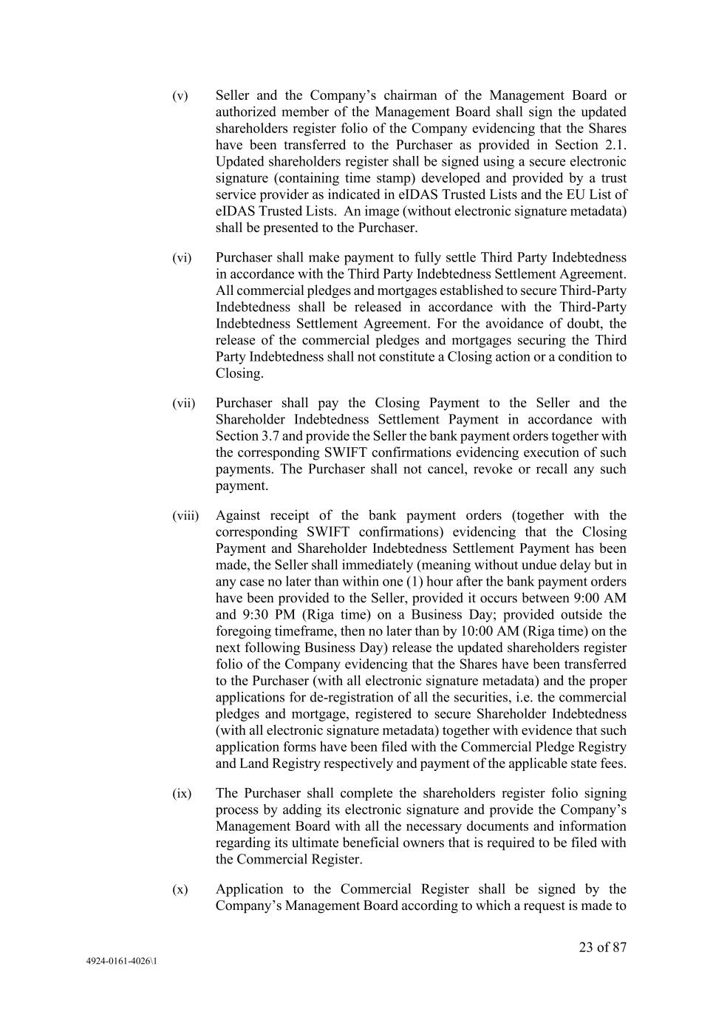
23 of 87 4924-0161-4026\1 (v) Seller and the Company’s chairman of the Management Board or authorized member of the Management Board shall sign the updated shareholders register folio of the Company evidencing that the Shares have been transferred to the Purchaser as provided in Section 2.1. Updated shareholders register shall be signed using a secure electronic signature (containing time stamp) developed and provided by a trust service provider as indicated in eIDAS Trusted Lists and the EU List of eIDAS Trusted Lists. An image (without electronic signature metadata) shall be presented to the Purchaser. (vi) Purchaser shall make payment to fully settle Third Party Indebtedness in accordance with the Third Party Indebtedness Settlement Agreement. All commercial pledges and mortgages established to secure Third-Party Indebtedness shall be released in accordance with the Third-Party Indebtedness Settlement Agreement. For the avoidance of doubt, the release of the commercial pledges and mortgages securing the Third Party Indebtedness shall not constitute a Closing action or a condition to Closing. (vii) Purchaser shall pay the Closing Payment to the Seller and the Shareholder Indebtedness Settlement Payment in accordance with Section 3.7 and provide the Seller the bank payment orders together with the corresponding SWIFT confirmations evidencing execution of such payments. The Purchaser shall not cancel, revoke or recall any such payment. (viii) Against receipt of the bank payment orders (together with the corresponding SWIFT confirmations) evidencing that the Closing Payment and Shareholder Indebtedness Settlement Payment has been made, the Seller shall immediately (meaning without undue delay but in any case no later than within one (1) hour after the bank payment orders have been provided to the Seller, provided it occurs between 9:00 AM and 9:30 PM (Riga time) on a Business Day; provided outside the foregoing timeframe, then no later than by 10:00 AM (Riga time) on the next following Business Day) release the updated shareholders register folio of the Company evidencing that the Shares have been transferred to the Purchaser (with all electronic signature metadata) and the proper applications for de-registration of all the securities, i.e. the commercial pledges and mortgage, registered to secure Shareholder Indebtedness (with all electronic signature metadata) together with evidence that such application forms have been filed with the Commercial Pledge Registry and Land Registry respectively and payment of the applicable state fees. (ix) The Purchaser shall complete the shareholders register folio signing process by adding its electronic signature and provide the Company’s Management Board with all the necessary documents and information regarding its ultimate beneficial owners that is required to be filed with the Commercial Register. (x) Application to the Commercial Register shall be signed by the Company’s Management Board according to which a request is made to

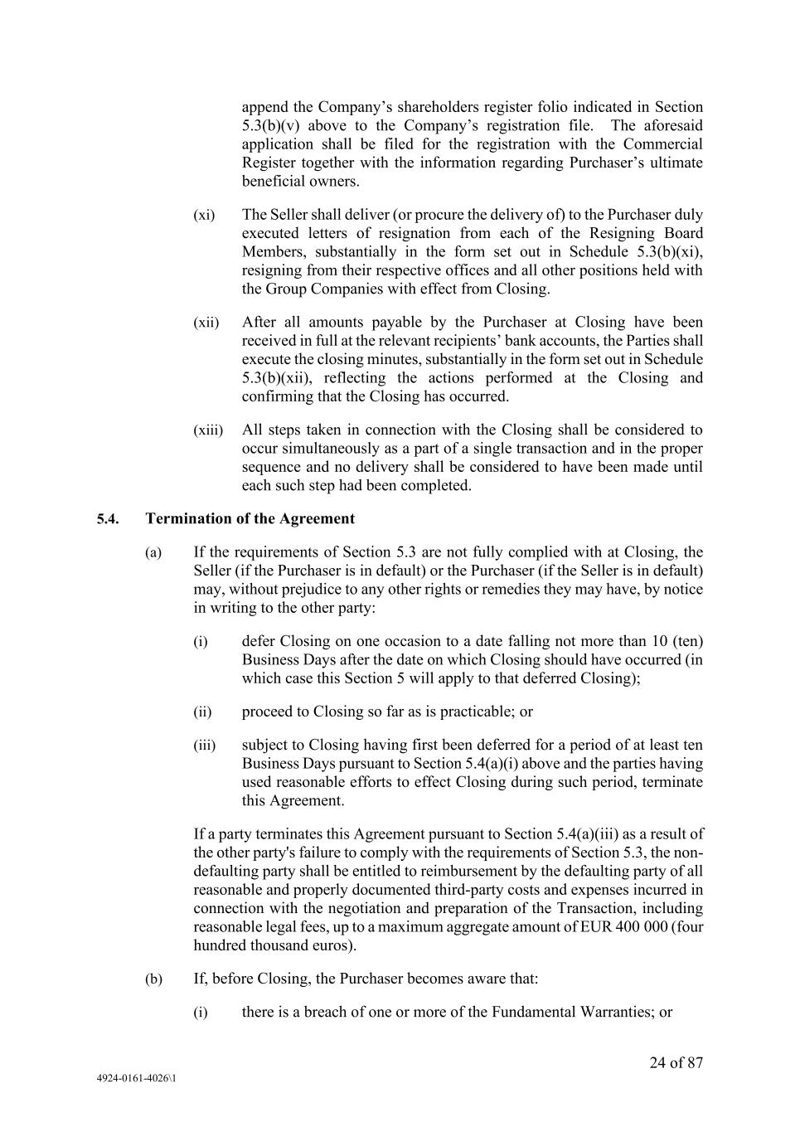
24 of 87 4924-0161-4026\1 append the Company’s shareholders register folio indicated in Section 5.3(b)(v) above to the Company’s registration file. The aforesaid application shall be filed for the registration with the Commercial Register together with the information regarding Purchaser’s ultimate beneficial owners. (xi) The Seller shall deliver (or procure the delivery of) to the Purchaser duly executed letters of resignation from each of the Resigning Board Members, substantially in the form set out in Schedule 5.3(b)(xi), resigning from their respective offices and all other positions held with the Group Companies with effect from Closing. (xii) After all amounts payable by the Purchaser at Closing have been received in full at the relevant recipients’ bank accounts, the Parties shall execute the closing minutes, substantially in the form set out in Schedule 5.3(b)(xii), reflecting the actions performed at the Closing and confirming that the Closing has occurred. (xiii) All steps taken in connection with the Closing shall be considered to occur simultaneously as a part of a single transaction and in the proper sequence and no delivery shall be considered to have been made until each such step had been completed. 5.4. Termination of the Agreement (a) If the requirements of Section 5.3 are not fully complied with at Closing, the Seller (if the Purchaser is in default) or the Purchaser (if the Seller is in default) may, without prejudice to any other rights or remedies they may have, by notice in writing to the other party: (i) defer Closing on one occasion to a date falling not more than 10 (ten) Business Days after the date on which Closing should have occurred (in which case this Section 5 will apply to that deferred Closing); (ii) proceed to Closing so far as is practicable; or (iii) subject to Closing having first been deferred for a period of at least ten Business Days pursuant to Section 5.4(a)(i) above and the parties having used reasonable efforts to effect Closing during such period, terminate this Agreement. If a party terminates this Agreement pursuant to Section 5.4(a)(iii) as a result of the other party's failure to comply with the requirements of Section 5.3, the non- defaulting party shall be entitled to reimbursement by the defaulting party of all reasonable and properly documented third-party costs and expenses incurred in connection with the negotiation and preparation of the Transaction, including reasonable legal fees, up to a maximum aggregate amount of EUR 400 000 (four hundred thousand euros). (b) If, before Closing, the Purchaser becomes aware that: (i) there is a breach of one or more of the Fundamental Warranties; or

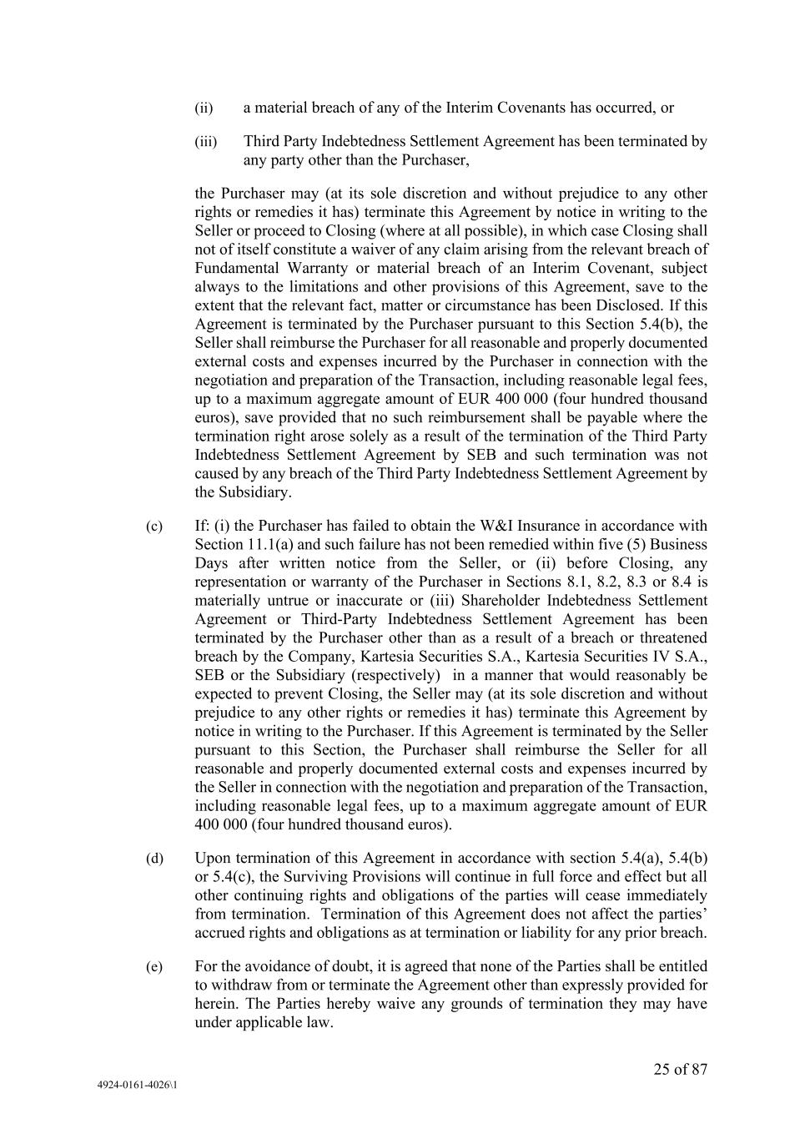
25 of 87 4924-0161-4026\1 (ii) a material breach of any of the Interim Covenants has occurred, or (iii) Third Party Indebtedness Settlement Agreement has been terminated by any party other than the Purchaser, the Purchaser may (at its sole discretion and without prejudice to any other rights or remedies it has) terminate this Agreement by notice in writing to the Seller or proceed to Closing (where at all possible), in which case Closing shall not of itself constitute a waiver of any claim arising from the relevant breach of Fundamental Warranty or material breach of an Interim Covenant, subject always to the limitations and other provisions of this Agreement, save to the extent that the relevant fact, matter or circumstance has been Disclosed. If this Agreement is terminated by the Purchaser pursuant to this Section 5.4(b), the Seller shall reimburse the Purchaser for all reasonable and properly documented external costs and expenses incurred by the Purchaser in connection with the negotiation and preparation of the Transaction, including reasonable legal fees, up to a maximum aggregate amount of EUR 400 000 (four hundred thousand euros), save provided that no such reimbursement shall be payable where the termination right arose solely as a result of the termination of the Third Party Indebtedness Settlement Agreement by SEB and such termination was not caused by any breach of the Third Party Indebtedness Settlement Agreement by the Subsidiary. (c) If: (i) the Purchaser has failed to obtain the W&I Insurance in accordance with Section 11.1(a) and such failure has not been remedied within five (5) Business Days after written notice from the Seller, or (ii) before Closing, any representation or warranty of the Purchaser in Sections 8.1, 8.2, 8.3 or 8.4 is materially untrue or inaccurate or (iii) Shareholder Indebtedness Settlement Agreement or Third-Party Indebtedness Settlement Agreement has been terminated by the Purchaser other than as a result of a breach or threatened breach by the Company, Kartesia Securities S.A., Kartesia Securities IV S.A., SEB or the Subsidiary (respectively) in a manner that would reasonably be expected to prevent Closing, the Seller may (at its sole discretion and without prejudice to any other rights or remedies it has) terminate this Agreement by notice in writing to the Purchaser. If this Agreement is terminated by the Seller pursuant to this Section, the Purchaser shall reimburse the Seller for all reasonable and properly documented external costs and expenses incurred by the Seller in connection with the negotiation and preparation of the Transaction, including reasonable legal fees, up to a maximum aggregate amount of EUR 400 000 (four hundred thousand euros). (d) Upon termination of this Agreement in accordance with section 5.4(a), 5.4(b) or 5.4(c), the Surviving Provisions will continue in full force and effect but all other continuing rights and obligations of the parties will cease immediately from termination. Termination of this Agreement does not affect the parties’ accrued rights and obligations as at termination or liability for any prior breach. (e) For the avoidance of doubt, it is agreed that none of the Parties shall be entitled to withdraw from or terminate the Agreement other than expressly provided for herein. The Parties hereby waive any grounds of termination they may have under applicable law.

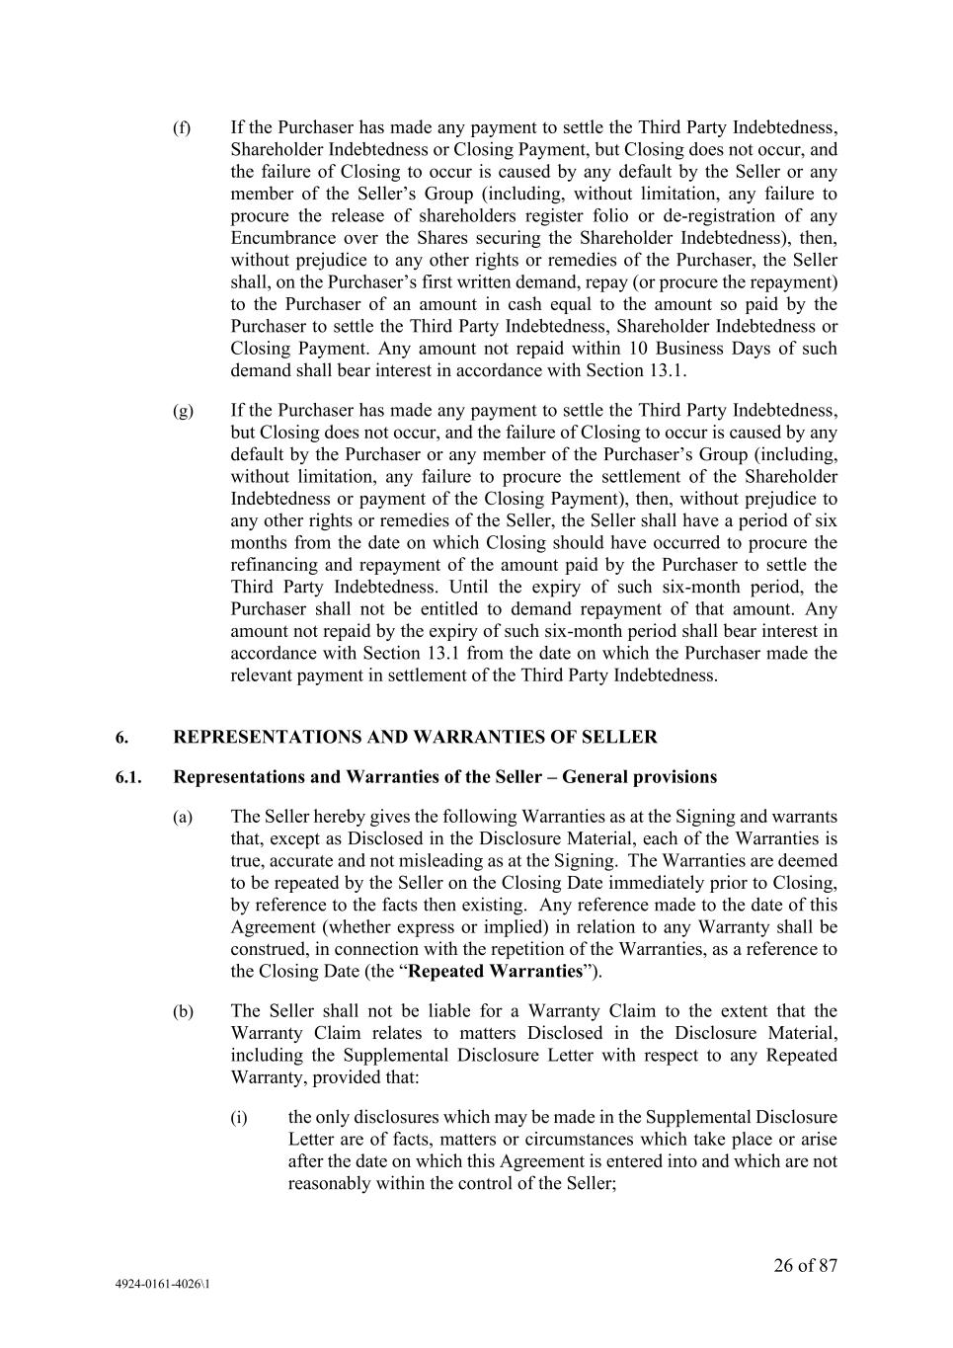
26 of 87 4924-0161-4026\1 (f) If the Purchaser has made any payment to settle the Third Party Indebtedness, Shareholder Indebtedness or Closing Payment, but Closing does not occur, and the failure of Closing to occur is caused by any default by the Seller or any member of the Seller’s Group (including, without limitation, any failure to procure the release of shareholders register folio or de-registration of any Encumbrance over the Shares securing the Shareholder Indebtedness), then, without prejudice to any other rights or remedies of the Purchaser, the Seller shall, on the Purchaser’s first written demand, repay (or procure the repayment) to the Purchaser of an amount in cash equal to the amount so paid by the Purchaser to settle the Third Party Indebtedness, Shareholder Indebtedness or Closing Payment. Any amount not repaid within 10 Business Days of such demand shall bear interest in accordance with Section 13.1. (g) If the Purchaser has made any payment to settle the Third Party Indebtedness, but Closing does not occur, and the failure of Closing to occur is caused by any default by the Purchaser or any member of the Purchaser’s Group (including, without limitation, any failure to procure the settlement of the Shareholder Indebtedness or payment of the Closing Payment), then, without prejudice to any other rights or remedies of the Seller, the Seller shall have a period of six months from the date on which Closing should have occurred to procure the refinancing and repayment of the amount paid by the Purchaser to settle the Third Party Indebtedness. Until the expiry of such six-month period, the Purchaser shall not be entitled to demand repayment of that amount. Any amount not repaid by the expiry of such six-month period shall bear interest in accordance with Section 13.1 from the date on which the Purchaser made the relevant payment in settlement of the Third Party Indebtedness. 6. REPRESENTATIONS AND WARRANTIES OF SELLER 6.1. Representations and Warranties of the Seller – General provisions (a) The Seller hereby gives the following Warranties as at the Signing and warrants that, except as Disclosed in the Disclosure Material, each of the Warranties is true, accurate and not misleading as at the Signing. The Warranties are deemed to be repeated by the Seller on the Closing Date immediately prior to Closing, by reference to the facts then existing. Any reference made to the date of this Agreement (whether express or implied) in relation to any Warranty shall be construed, in connection with the repetition of the Warranties, as a reference to the Closing Date (the “Repeated Warranties”). (b) The Seller shall not be liable for a Warranty Claim to the extent that the Warranty Claim relates to matters Disclosed in the Disclosure Material, including the Supplemental Disclosure Letter with respect to any Repeated Warranty, provided that: (i) the only disclosures which may be made in the Supplemental Disclosure Letter are of facts, matters or circumstances which take place or arise after the date on which this Agreement is entered into and which are not reasonably within the control of the Seller;

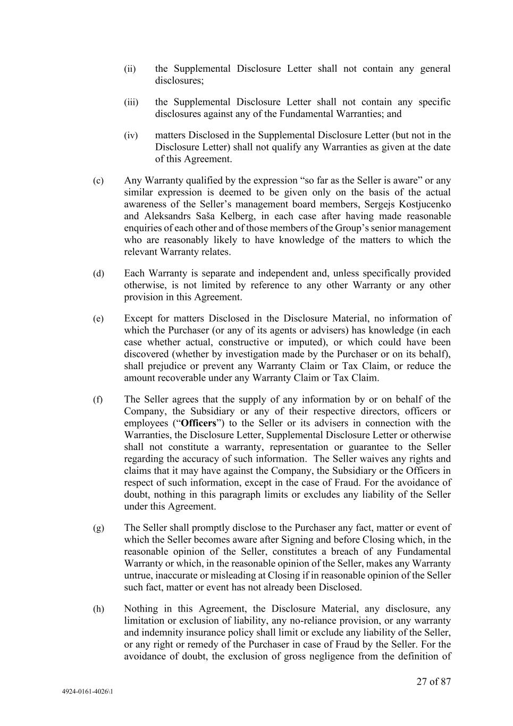
27 of 87 4924-0161-4026\1 (ii) the Supplemental Disclosure Letter shall not contain any general disclosures; (iii) the Supplemental Disclosure Letter shall not contain any specific disclosures against any of the Fundamental Warranties; and (iv) matters Disclosed in the Supplemental Disclosure Letter (but not in the Disclosure Letter) shall not qualify any Warranties as given at the date of this Agreement. (c) Any Warranty qualified by the expression “so far as the Seller is aware” or any similar expression is deemed to be given only on the basis of the actual awareness of the Seller’s management board members, Sergejs Kostjucenko and Aleksandrs Saša Kelberg, in each case after having made reasonable enquiries of each other and of those members of the Group’s senior management who are reasonably likely to have knowledge of the matters to which the relevant Warranty relates. (d) Each Warranty is separate and independent and, unless specifically provided otherwise, is not limited by reference to any other Warranty or any other provision in this Agreement. (e) Except for matters Disclosed in the Disclosure Material, no information of which the Purchaser (or any of its agents or advisers) has knowledge (in each case whether actual, constructive or imputed), or which could have been discovered (whether by investigation made by the Purchaser or on its behalf), shall prejudice or prevent any Warranty Claim or Tax Claim, or reduce the amount recoverable under any Warranty Claim or Tax Claim. (f) The Seller agrees that the supply of any information by or on behalf of the Company, the Subsidiary or any of their respective directors, officers or employees (“Officers”) to the Seller or its advisers in connection with the Warranties, the Disclosure Letter, Supplemental Disclosure Letter or otherwise shall not constitute a warranty, representation or guarantee to the Seller regarding the accuracy of such information. The Seller waives any rights and claims that it may have against the Company, the Subsidiary or the Officers in respect of such information, except in the case of Fraud. For the avoidance of doubt, nothing in this paragraph limits or excludes any liability of the Seller under this Agreement. (g) The Seller shall promptly disclose to the Purchaser any fact, matter or event of which the Seller becomes aware after Signing and before Closing which, in the reasonable opinion of the Seller, constitutes a breach of any Fundamental Warranty or which, in the reasonable opinion of the Seller, makes any Warranty untrue, inaccurate or misleading at Closing if in reasonable opinion of the Seller such fact, matter or event has not already been Disclosed. (h) Nothing in this Agreement, the Disclosure Material, any disclosure, any limitation or exclusion of liability, any no-reliance provision, or any warranty and indemnity insurance policy shall limit or exclude any liability of the Seller, or any right or remedy of the Purchaser in case of Fraud by the Seller. For the avoidance of doubt, the exclusion of gross negligence from the definition of

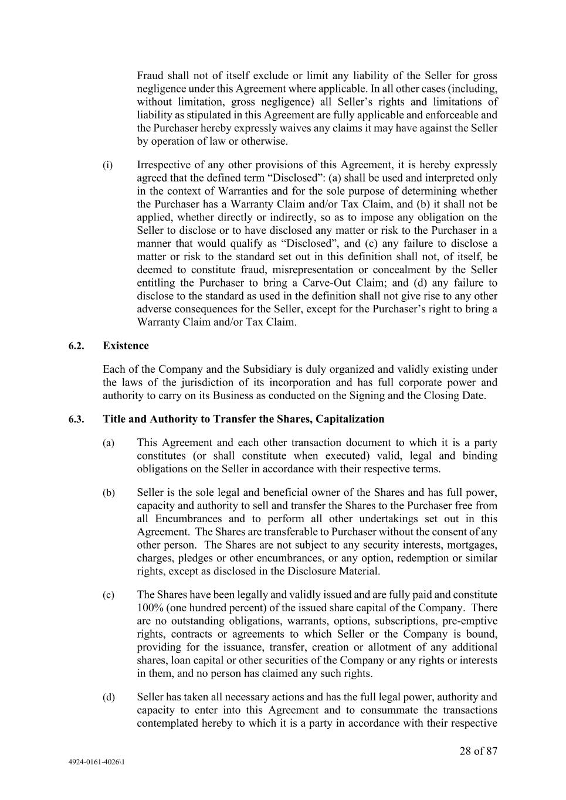
28 of 87 4924-0161-4026\1 Fraud shall not of itself exclude or limit any liability of the Seller for gross negligence under this Agreement where applicable. In all other cases (including, without limitation, gross negligence) all Seller’s rights and limitations of liability as stipulated in this Agreement are fully applicable and enforceable and the Purchaser hereby expressly waives any claims it may have against the Seller by operation of law or otherwise. (i) Irrespective of any other provisions of this Agreement, it is hereby expressly agreed that the defined term “Disclosed”: (a) shall be used and interpreted only in the context of Warranties and for the sole purpose of determining whether the Purchaser has a Warranty Claim and/or Tax Claim, and (b) it shall not be applied, whether directly or indirectly, so as to impose any obligation on the Seller to disclose or to have disclosed any matter or risk to the Purchaser in a manner that would qualify as “Disclosed”, and (c) any failure to disclose a matter or risk to the standard set out in this definition shall not, of itself, be deemed to constitute fraud, misrepresentation or concealment by the Seller entitling the Purchaser to bring a Carve-Out Claim; and (d) any failure to disclose to the standard as used in the definition shall not give rise to any other adverse consequences for the Seller, except for the Purchaser’s right to bring a Warranty Claim and/or Tax Claim. 6.2. Existence Each of the Company and the Subsidiary is duly organized and validly existing under the laws of the jurisdiction of its incorporation and has full corporate power and authority to carry on its Business as conducted on the Signing and the Closing Date. 6.3. Title and Authority to Transfer the Shares, Capitalization (a) This Agreement and each other transaction document to which it is a party constitutes (or shall constitute when executed) valid, legal and binding obligations on the Seller in accordance with their respective terms. (b) Seller is the sole legal and beneficial owner of the Shares and has full power, capacity and authority to sell and transfer the Shares to the Purchaser free from all Encumbrances and to perform all other undertakings set out in this Agreement. The Shares are transferable to Purchaser without the consent of any other person. The Shares are not subject to any security interests, mortgages, charges, pledges or other encumbrances, or any option, redemption or similar rights, except as disclosed in the Disclosure Material. (c) The Shares have been legally and validly issued and are fully paid and constitute 100% (one hundred percent) of the issued share capital of the Company. There are no outstanding obligations, warrants, options, subscriptions, pre-emptive rights, contracts or agreements to which Seller or the Company is bound, providing for the issuance, transfer, creation or allotment of any additional shares, loan capital or other securities of the Company or any rights or interests in them, and no person has claimed any such rights. (d) Seller has taken all necessary actions and has the full legal power, authority and capacity to enter into this Agreement and to consummate the transactions contemplated hereby to which it is a party in accordance with their respective

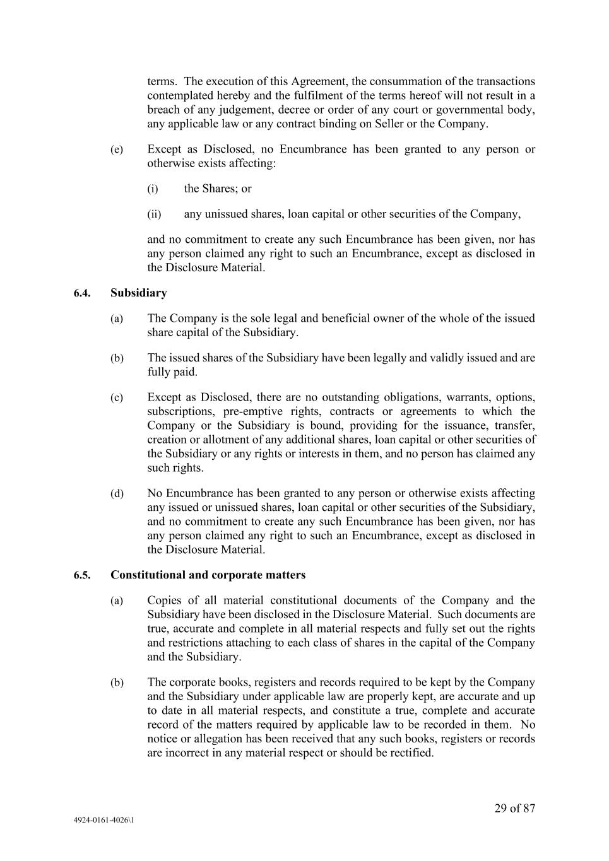
29 of 87 4924-0161-4026\1 terms. The execution of this Agreement, the consummation of the transactions contemplated hereby and the fulfilment of the terms hereof will not result in a breach of any judgement, decree or order of any court or governmental body, any applicable law or any contract binding on Seller or the Company. (e) Except as Disclosed, no Encumbrance has been granted to any person or otherwise exists affecting: (i) the Shares; or (ii) any unissued shares, loan capital or other securities of the Company, and no commitment to create any such Encumbrance has been given, nor has any person claimed any right to such an Encumbrance, except as disclosed in the Disclosure Material. 6.4. Subsidiary (a) The Company is the sole legal and beneficial owner of the whole of the issued share capital of the Subsidiary. (b) The issued shares of the Subsidiary have been legally and validly issued and are fully paid. (c) Except as Disclosed, there are no outstanding obligations, warrants, options, subscriptions, pre-emptive rights, contracts or agreements to which the Company or the Subsidiary is bound, providing for the issuance, transfer, creation or allotment of any additional shares, loan capital or other securities of the Subsidiary or any rights or interests in them, and no person has claimed any such rights. (d) No Encumbrance has been granted to any person or otherwise exists affecting any issued or unissued shares, loan capital or other securities of the Subsidiary, and no commitment to create any such Encumbrance has been given, nor has any person claimed any right to such an Encumbrance, except as disclosed in the Disclosure Material. 6.5. Constitutional and corporate matters (a) Copies of all material constitutional documents of the Company and the Subsidiary have been disclosed in the Disclosure Material. Such documents are true, accurate and complete in all material respects and fully set out the rights and restrictions attaching to each class of shares in the capital of the Company and the Subsidiary. (b) The corporate books, registers and records required to be kept by the Company and the Subsidiary under applicable law are properly kept, are accurate and up to date in all material respects, and constitute a true, complete and accurate record of the matters required by applicable law to be recorded in them. No notice or allegation has been received that any such books, registers or records are incorrect in any material respect or should be rectified.

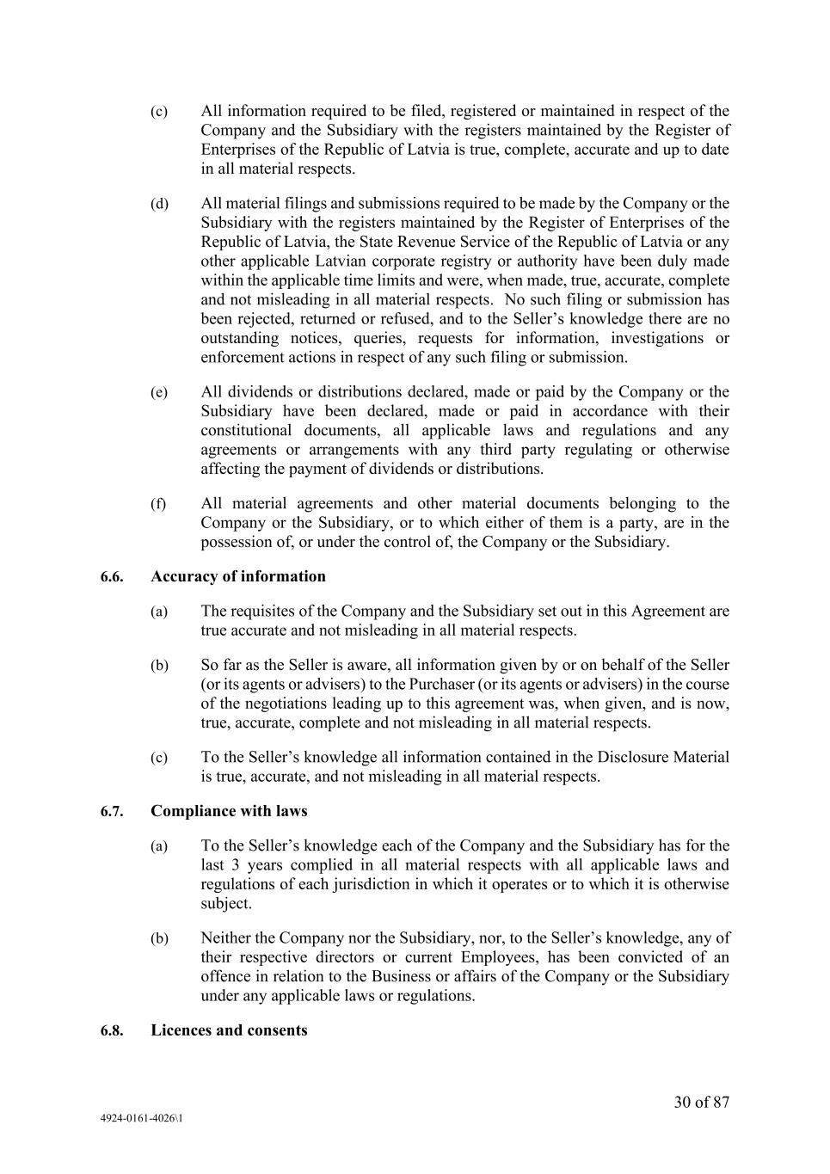
30 of 87 4924-0161-4026\1 (c) All information required to be filed, registered or maintained in respect of the Company and the Subsidiary with the registers maintained by the Register of Enterprises of the Republic of Latvia is true, complete, accurate and up to date in all material respects. (d) All material filings and submissions required to be made by the Company or the Subsidiary with the registers maintained by the Register of Enterprises of the Republic of Latvia, the State Revenue Service of the Republic of Latvia or any other applicable Latvian corporate registry or authority have been duly made within the applicable time limits and were, when made, true, accurate, complete and not misleading in all material respects. No such filing or submission has been rejected, returned or refused, and to the Seller’s knowledge there are no outstanding notices, queries, requests for information, investigations or enforcement actions in respect of any such filing or submission. (e) All dividends or distributions declared, made or paid by the Company or the Subsidiary have been declared, made or paid in accordance with their constitutional documents, all applicable laws and regulations and any agreements or arrangements with any third party regulating or otherwise affecting the payment of dividends or distributions. (f) All material agreements and other material documents belonging to the Company or the Subsidiary, or to which either of them is a party, are in the possession of, or under the control of, the Company or the Subsidiary. 6.6. Accuracy of information (a) The requisites of the Company and the Subsidiary set out in this Agreement are true accurate and not misleading in all material respects. (b) So far as the Seller is aware, all information given by or on behalf of the Seller (or its agents or advisers) to the Purchaser (or its agents or advisers) in the course of the negotiations leading up to this agreement was, when given, and is now, true, accurate, complete and not misleading in all material respects. (c) To the Seller’s knowledge all information contained in the Disclosure Material is true, accurate, and not misleading in all material respects. 6.7. Compliance with laws (a) To the Seller’s knowledge each of the Company and the Subsidiary has for the last 3 years complied in all material respects with all applicable laws and regulations of each jurisdiction in which it operates or to which it is otherwise subject. (b) Neither the Company nor the Subsidiary, nor, to the Seller’s knowledge, any of their respective directors or current Employees, has been convicted of an offence in relation to the Business or affairs of the Company or the Subsidiary under any applicable laws or regulations. 6.8. Licences and consents

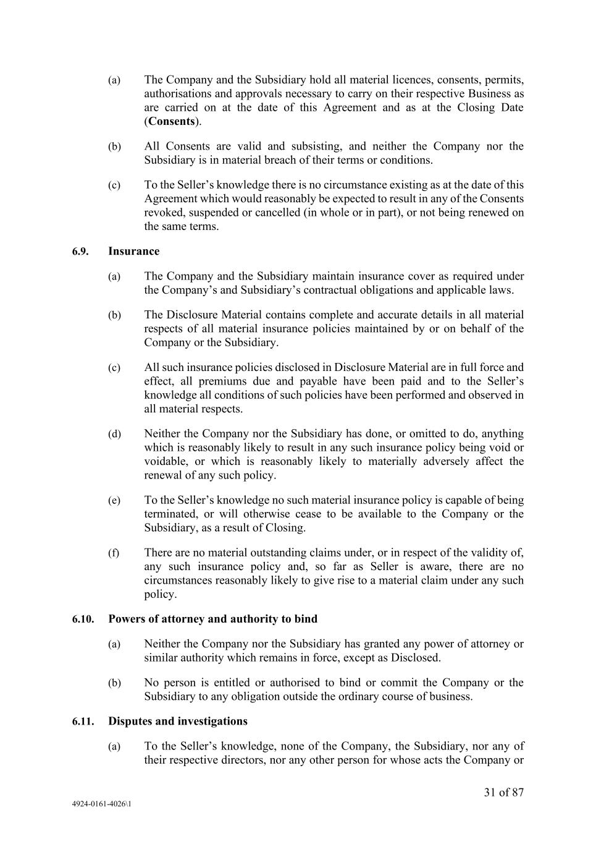
31 of 87 4924-0161-4026\1 (a) The Company and the Subsidiary hold all material licences, consents, permits, authorisations and approvals necessary to carry on their respective Business as are carried on at the date of this Agreement and as at the Closing Date (Consents). (b) All Consents are valid and subsisting, and neither the Company nor the Subsidiary is in material breach of their terms or conditions. (c) To the Seller’s knowledge there is no circumstance existing as at the date of this Agreement which would reasonably be expected to result in any of the Consents revoked, suspended or cancelled (in whole or in part), or not being renewed on the same terms. 6.9. Insurance (a) The Company and the Subsidiary maintain insurance cover as required under the Company’s and Subsidiary’s contractual obligations and applicable laws. (b) The Disclosure Material contains complete and accurate details in all material respects of all material insurance policies maintained by or on behalf of the Company or the Subsidiary. (c) All such insurance policies disclosed in Disclosure Material are in full force and effect, all premiums due and payable have been paid and to the Seller’s knowledge all conditions of such policies have been performed and observed in all material respects. (d) Neither the Company nor the Subsidiary has done, or omitted to do, anything which is reasonably likely to result in any such insurance policy being void or voidable, or which is reasonably likely to materially adversely affect the renewal of any such policy. (e) To the Seller’s knowledge no such material insurance policy is capable of being terminated, or will otherwise cease to be available to the Company or the Subsidiary, as a result of Closing. (f) There are no material outstanding claims under, or in respect of the validity of, any such insurance policy and, so far as Seller is aware, there are no circumstances reasonably likely to give rise to a material claim under any such policy. 6.10. Powers of attorney and authority to bind (a) Neither the Company nor the Subsidiary has granted any power of attorney or similar authority which remains in force, except as Disclosed. (b) No person is entitled or authorised to bind or commit the Company or the Subsidiary to any obligation outside the ordinary course of business. 6.11. Disputes and investigations (a) To the Seller’s knowledge, none of the Company, the Subsidiary, nor any of their respective directors, nor any other person for whose acts the Company or

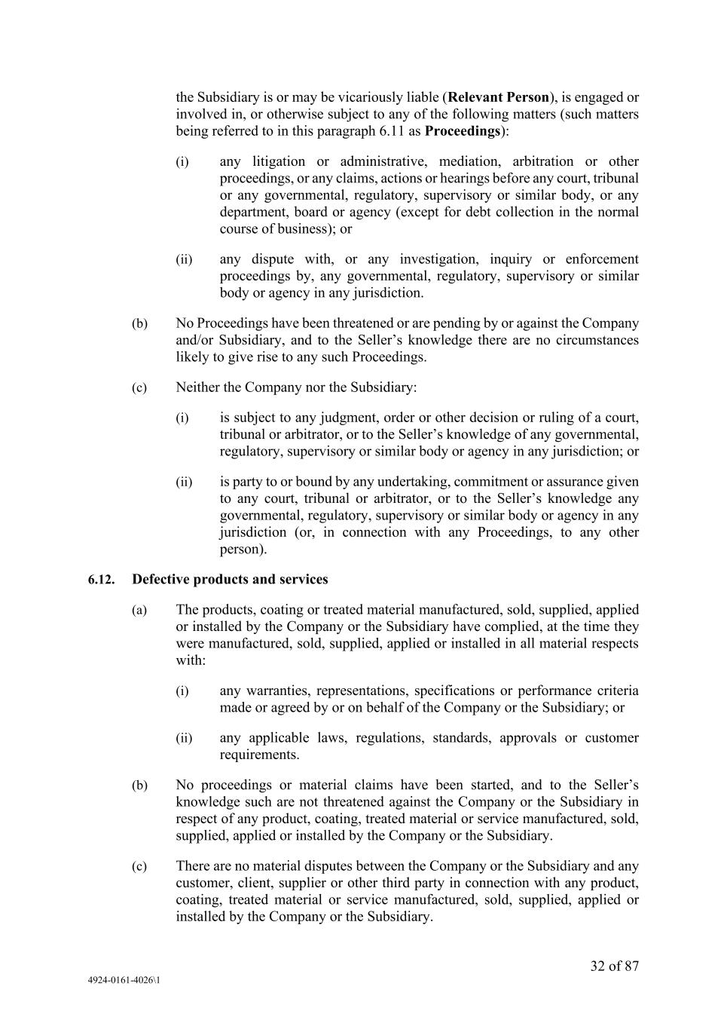
32 of 87 4924-0161-4026\1 the Subsidiary is or may be vicariously liable (Relevant Person), is engaged or involved in, or otherwise subject to any of the following matters (such matters being referred to in this paragraph 6.11 as Proceedings): (i) any litigation or administrative, mediation, arbitration or other proceedings, or any claims, actions or hearings before any court, tribunal or any governmental, regulatory, supervisory or similar body, or any department, board or agency (except for debt collection in the normal course of business); or (ii) any dispute with, or any investigation, inquiry or enforcement proceedings by, any governmental, regulatory, supervisory or similar body or agency in any jurisdiction. (b) No Proceedings have been threatened or are pending by or against the Company and/or Subsidiary, and to the Seller’s knowledge there are no circumstances likely to give rise to any such Proceedings. (c) Neither the Company nor the Subsidiary: (i) is subject to any judgment, order or other decision or ruling of a court, tribunal or arbitrator, or to the Seller’s knowledge of any governmental, regulatory, supervisory or similar body or agency in any jurisdiction; or (ii) is party to or bound by any undertaking, commitment or assurance given to any court, tribunal or arbitrator, or to the Seller’s knowledge any governmental, regulatory, supervisory or similar body or agency in any jurisdiction (or, in connection with any Proceedings, to any other person). 6.12. Defective products and services (a) The products, coating or treated material manufactured, sold, supplied, applied or installed by the Company or the Subsidiary have complied, at the time they were manufactured, sold, supplied, applied or installed in all material respects with: (i) any warranties, representations, specifications or performance criteria made or agreed by or on behalf of the Company or the Subsidiary; or (ii) any applicable laws, regulations, standards, approvals or customer requirements. (b) No proceedings or material claims have been started, and to the Seller’s knowledge such are not threatened against the Company or the Subsidiary in respect of any product, coating, treated material or service manufactured, sold, supplied, applied or installed by the Company or the Subsidiary. (c) There are no material disputes between the Company or the Subsidiary and any customer, client, supplier or other third party in connection with any product, coating, treated material or service manufactured, sold, supplied, applied or installed by the Company or the Subsidiary.

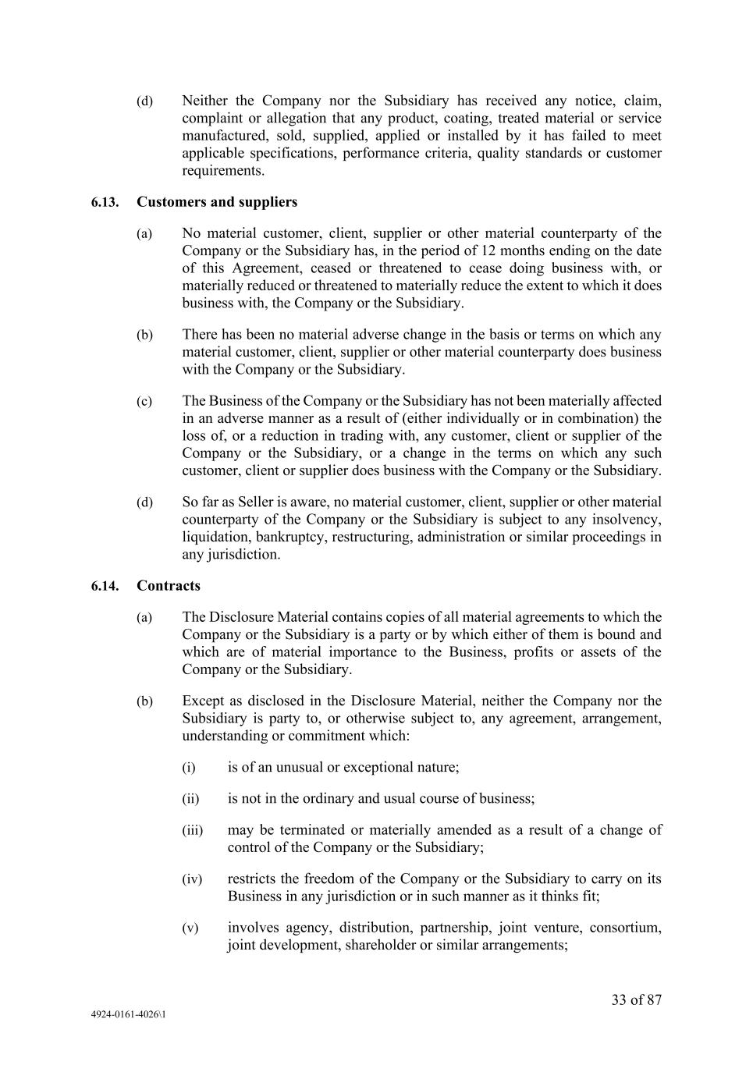
33 of 87 4924-0161-4026\1 (d) Neither the Company nor the Subsidiary has received any notice, claim, complaint or allegation that any product, coating, treated material or service manufactured, sold, supplied, applied or installed by it has failed to meet applicable specifications, performance criteria, quality standards or customer requirements. 6.13. Customers and suppliers (a) No material customer, client, supplier or other material counterparty of the Company or the Subsidiary has, in the period of 12 months ending on the date of this Agreement, ceased or threatened to cease doing business with, or materially reduced or threatened to materially reduce the extent to which it does business with, the Company or the Subsidiary. (b) There has been no material adverse change in the basis or terms on which any material customer, client, supplier or other material counterparty does business with the Company or the Subsidiary. (c) The Business of the Company or the Subsidiary has not been materially affected in an adverse manner as a result of (either individually or in combination) the loss of, or a reduction in trading with, any customer, client or supplier of the Company or the Subsidiary, or a change in the terms on which any such customer, client or supplier does business with the Company or the Subsidiary. (d) So far as Seller is aware, no material customer, client, supplier or other material counterparty of the Company or the Subsidiary is subject to any insolvency, liquidation, bankruptcy, restructuring, administration or similar proceedings in any jurisdiction. 6.14. Contracts (a) The Disclosure Material contains copies of all material agreements to which the Company or the Subsidiary is a party or by which either of them is bound and which are of material importance to the Business, profits or assets of the Company or the Subsidiary. (b) Except as disclosed in the Disclosure Material, neither the Company nor the Subsidiary is party to, or otherwise subject to, any agreement, arrangement, understanding or commitment which: (i) is of an unusual or exceptional nature; (ii) is not in the ordinary and usual course of business; (iii) may be terminated or materially amended as a result of a change of control of the Company or the Subsidiary; (iv) restricts the freedom of the Company or the Subsidiary to carry on its Business in any jurisdiction or in such manner as it thinks fit; (v) involves agency, distribution, partnership, joint venture, consortium, joint development, shareholder or similar arrangements;

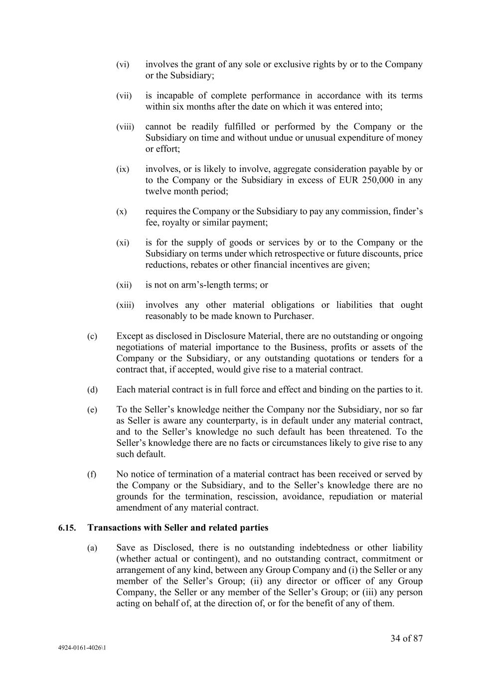
34 of 87 4924-0161-4026\1 (vi) involves the grant of any sole or exclusive rights by or to the Company or the Subsidiary; (vii) is incapable of complete performance in accordance with its terms within six months after the date on which it was entered into; (viii) cannot be readily fulfilled or performed by the Company or the Subsidiary on time and without undue or unusual expenditure of money or effort; (ix) involves, or is likely to involve, aggregate consideration payable by or to the Company or the Subsidiary in excess of EUR 250,000 in any twelve month period; (x) requires the Company or the Subsidiary to pay any commission, finder’s fee, royalty or similar payment; (xi) is for the supply of goods or services by or to the Company or the Subsidiary on terms under which retrospective or future discounts, price reductions, rebates or other financial incentives are given; (xii) is not on arm’s-length terms; or (xiii) involves any other material obligations or liabilities that ought reasonably to be made known to Purchaser. (c) Except as disclosed in Disclosure Material, there are no outstanding or ongoing negotiations of material importance to the Business, profits or assets of the Company or the Subsidiary, or any outstanding quotations or tenders for a contract that, if accepted, would give rise to a material contract. (d) Each material contract is in full force and effect and binding on the parties to it. (e) To the Seller’s knowledge neither the Company nor the Subsidiary, nor so far as Seller is aware any counterparty, is in default under any material contract, and to the Seller’s knowledge no such default has been threatened. To the Seller’s knowledge there are no facts or circumstances likely to give rise to any such default. (f) No notice of termination of a material contract has been received or served by the Company or the Subsidiary, and to the Seller’s knowledge there are no grounds for the termination, rescission, avoidance, repudiation or material amendment of any material contract. 6.15. Transactions with Seller and related parties (a) Save as Disclosed, there is no outstanding indebtedness or other liability (whether actual or contingent), and no outstanding contract, commitment or arrangement of any kind, between any Group Company and (i) the Seller or any member of the Seller’s Group; (ii) any director or officer of any Group Company, the Seller or any member of the Seller’s Group; or (iii) any person acting on behalf of, at the direction of, or for the benefit of any of them.

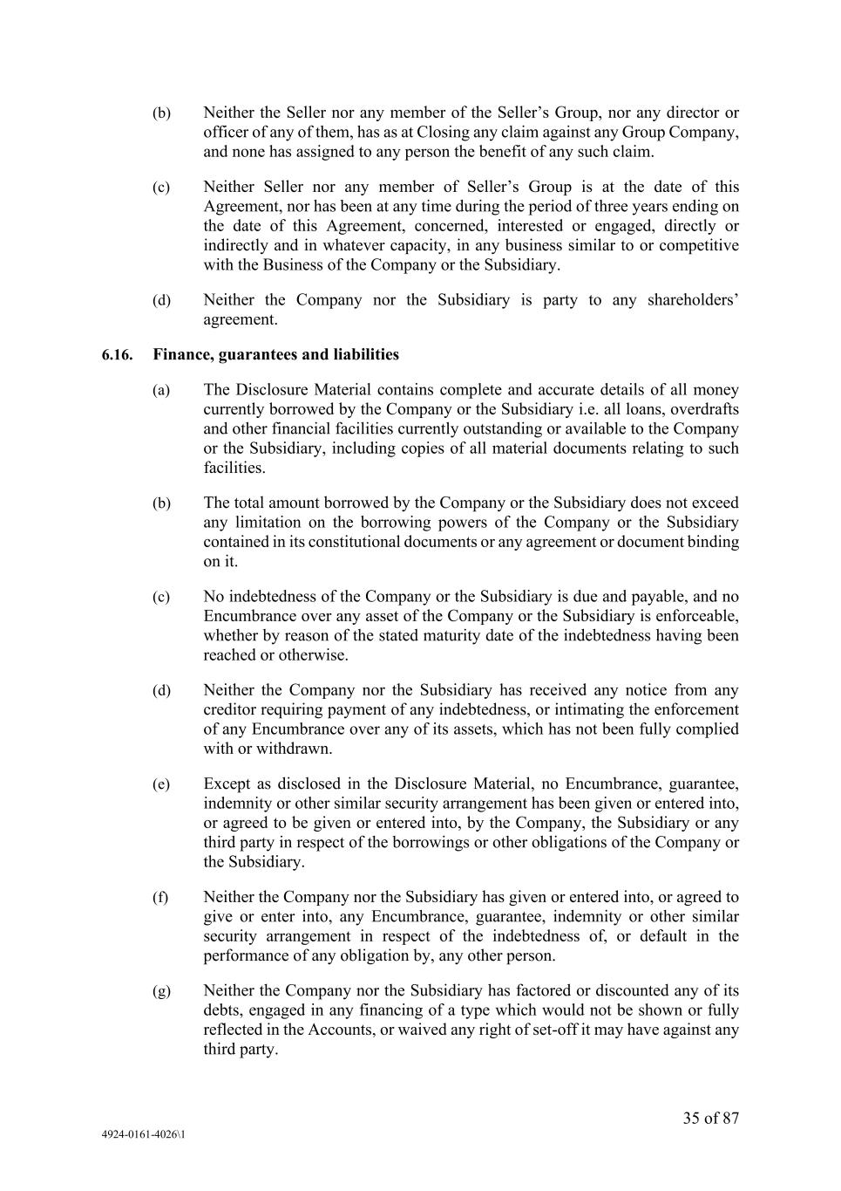
35 of 87 4924-0161-4026\1 (b) Neither the Seller nor any member of the Seller’s Group, nor any director or officer of any of them, has as at Closing any claim against any Group Company, and none has assigned to any person the benefit of any such claim. (c) Neither Seller nor any member of Seller’s Group is at the date of this Agreement, nor has been at any time during the period of three years ending on the date of this Agreement, concerned, interested or engaged, directly or indirectly and in whatever capacity, in any business similar to or competitive with the Business of the Company or the Subsidiary. (d) Neither the Company nor the Subsidiary is party to any shareholders’ agreement. 6.16. Finance, guarantees and liabilities (a) The Disclosure Material contains complete and accurate details of all money currently borrowed by the Company or the Subsidiary i.e. all loans, overdrafts and other financial facilities currently outstanding or available to the Company or the Subsidiary, including copies of all material documents relating to such facilities. (b) The total amount borrowed by the Company or the Subsidiary does not exceed any limitation on the borrowing powers of the Company or the Subsidiary contained in its constitutional documents or any agreement or document binding on it. (c) No indebtedness of the Company or the Subsidiary is due and payable, and no Encumbrance over any asset of the Company or the Subsidiary is enforceable, whether by reason of the stated maturity date of the indebtedness having been reached or otherwise. (d) Neither the Company nor the Subsidiary has received any notice from any creditor requiring payment of any indebtedness, or intimating the enforcement of any Encumbrance over any of its assets, which has not been fully complied with or withdrawn. (e) Except as disclosed in the Disclosure Material, no Encumbrance, guarantee, indemnity or other similar security arrangement has been given or entered into, or agreed to be given or entered into, by the Company, the Subsidiary or any third party in respect of the borrowings or other obligations of the Company or the Subsidiary. (f) Neither the Company nor the Subsidiary has given or entered into, or agreed to give or enter into, any Encumbrance, guarantee, indemnity or other similar security arrangement in respect of the indebtedness of, or default in the performance of any obligation by, any other person. (g) Neither the Company nor the Subsidiary has factored or discounted any of its debts, engaged in any financing of a type which would not be shown or fully reflected in the Accounts, or waived any right of set-off it may have against any third party.

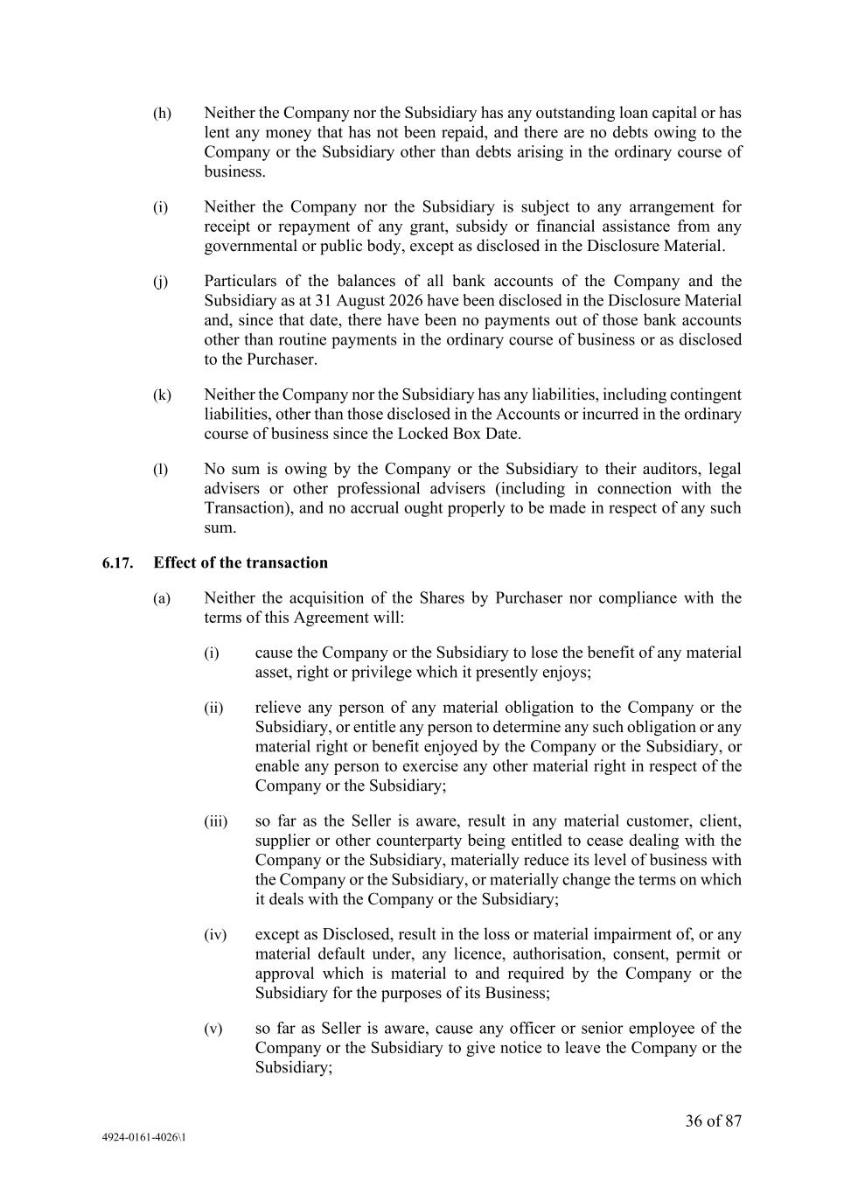
36 of 87 4924-0161-4026\1 (h) Neither the Company nor the Subsidiary has any outstanding loan capital or has lent any money that has not been repaid, and there are no debts owing to the Company or the Subsidiary other than debts arising in the ordinary course of business. (i) Neither the Company nor the Subsidiary is subject to any arrangement for receipt or repayment of any grant, subsidy or financial assistance from any governmental or public body, except as disclosed in the Disclosure Material. (j) Particulars of the balances of all bank accounts of the Company and the Subsidiary as at 31 August 2026 have been disclosed in the Disclosure Material and, since that date, there have been no payments out of those bank accounts other than routine payments in the ordinary course of business or as disclosed to the Purchaser. (k) Neither the Company nor the Subsidiary has any liabilities, including contingent liabilities, other than those disclosed in the Accounts or incurred in the ordinary course of business since the Locked Box Date. (l) No sum is owing by the Company or the Subsidiary to their auditors, legal advisers or other professional advisers (including in connection with the Transaction), and no accrual ought properly to be made in respect of any such sum. 6.17. Effect of the transaction (a) Neither the acquisition of the Shares by Purchaser nor compliance with the terms of this Agreement will: (i) cause the Company or the Subsidiary to lose the benefit of any material asset, right or privilege which it presently enjoys; (ii) relieve any person of any material obligation to the Company or the Subsidiary, or entitle any person to determine any such obligation or any material right or benefit enjoyed by the Company or the Subsidiary, or enable any person to exercise any other material right in respect of the Company or the Subsidiary; (iii) so far as the Seller is aware, result in any material customer, client, supplier or other counterparty being entitled to cease dealing with the Company or the Subsidiary, materially reduce its level of business with the Company or the Subsidiary, or materially change the terms on which it deals with the Company or the Subsidiary; (iv) except as Disclosed, result in the loss or material impairment of, or any material default under, any licence, authorisation, consent, permit or approval which is material to and required by the Company or the Subsidiary for the purposes of its Business; (v) so far as Seller is aware, cause any officer or senior employee of the Company or the Subsidiary to give notice to leave the Company or the Subsidiary;

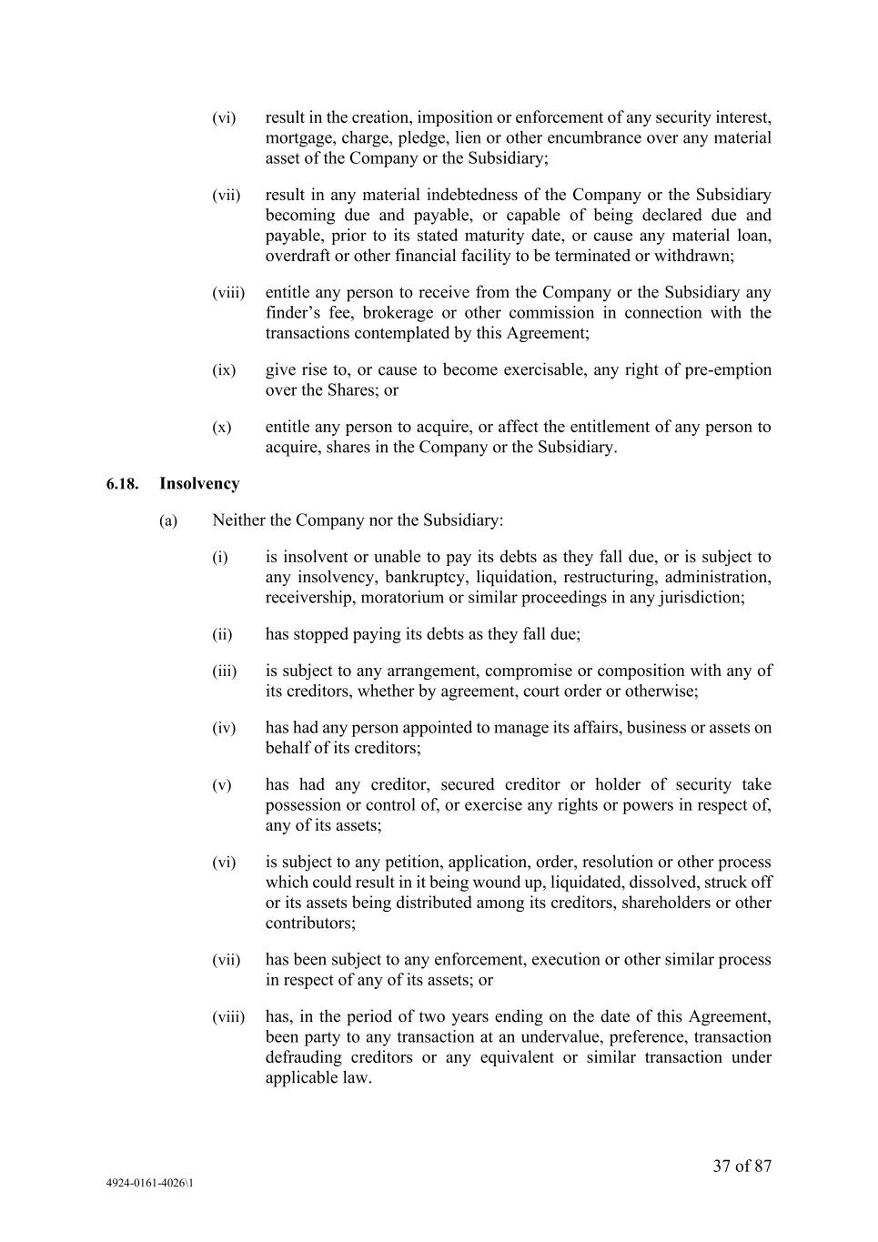
37 of 87 4924-0161-4026\1 (vi) result in the creation, imposition or enforcement of any security interest, mortgage, charge, pledge, lien or other encumbrance over any material asset of the Company or the Subsidiary; (vii) result in any material indebtedness of the Company or the Subsidiary becoming due and payable, or capable of being declared due and payable, prior to its stated maturity date, or cause any material loan, overdraft or other financial facility to be terminated or withdrawn; (viii) entitle any person to receive from the Company or the Subsidiary any finder’s fee, brokerage or other commission in connection with the transactions contemplated by this Agreement; (ix) give rise to, or cause to become exercisable, any right of pre-emption over the Shares; or (x) entitle any person to acquire, or affect the entitlement of any person to acquire, shares in the Company or the Subsidiary. 6.18. Insolvency (a) Neither the Company nor the Subsidiary: (i) is insolvent or unable to pay its debts as they fall due, or is subject to any insolvency, bankruptcy, liquidation, restructuring, administration, receivership, moratorium or similar proceedings in any jurisdiction; (ii) has stopped paying its debts as they fall due; (iii) is subject to any arrangement, compromise or composition with any of its creditors, whether by agreement, court order or otherwise; (iv) has had any person appointed to manage its affairs, business or assets on behalf of its creditors; (v) has had any creditor, secured creditor or holder of security take possession or control of, or exercise any rights or powers in respect of, any of its assets; (vi) is subject to any petition, application, order, resolution or other process which could result in it being wound up, liquidated, dissolved, struck off or its assets being distributed among its creditors, shareholders or other contributors; (vii) has been subject to any enforcement, execution or other similar process in respect of any of its assets; or (viii) has, in the period of two years ending on the date of this Agreement, been party to any transaction at an undervalue, preference, transaction defrauding creditors or any equivalent or similar transaction under applicable law.

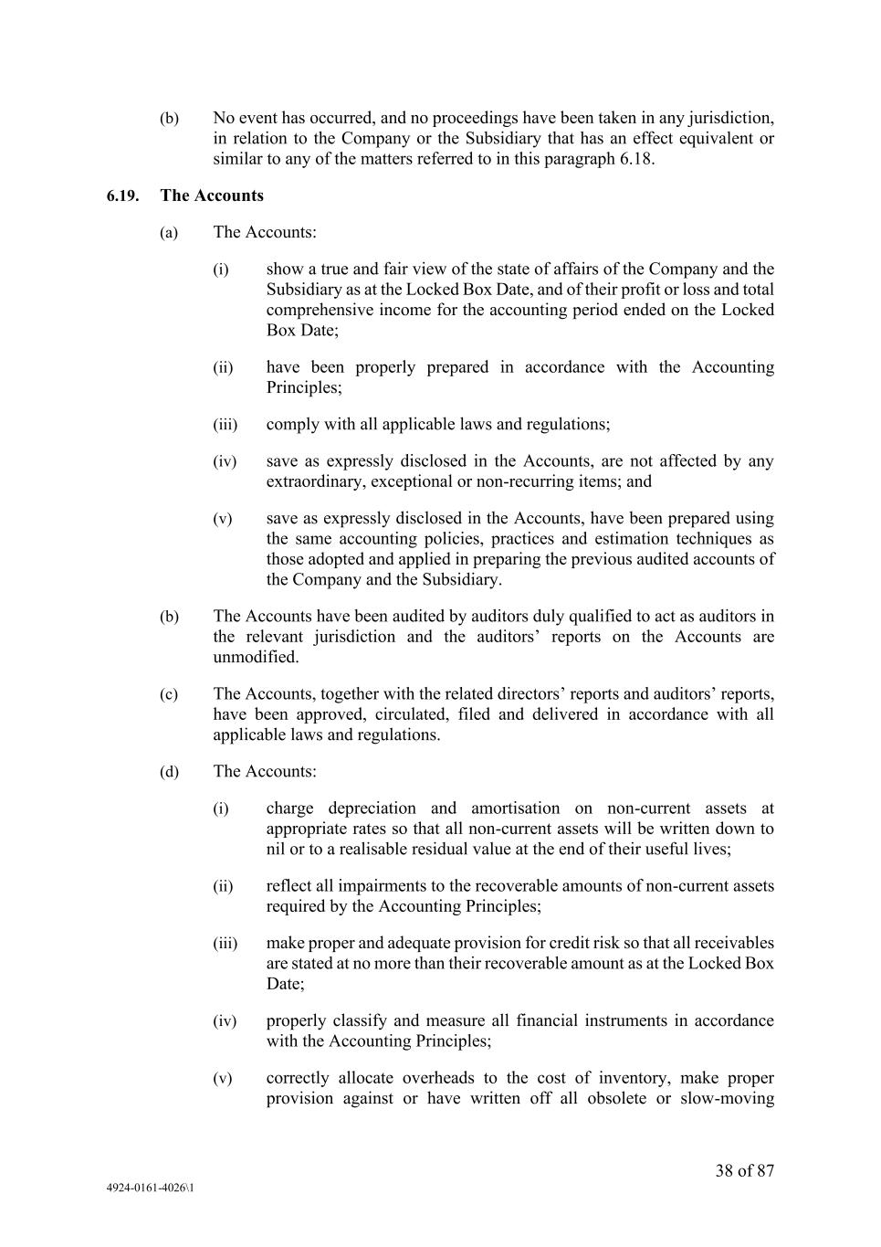
38 of 87 4924-0161-4026\1 (b) No event has occurred, and no proceedings have been taken in any jurisdiction, in relation to the Company or the Subsidiary that has an effect equivalent or similar to any of the matters referred to in this paragraph 6.18. 6.19. The Accounts (a) The Accounts: (i) show a true and fair view of the state of affairs of the Company and the Subsidiary as at the Locked Box Date, and of their profit or loss and total comprehensive income for the accounting period ended on the Locked Box Date; (ii) have been properly prepared in accordance with the Accounting Principles; (iii) comply with all applicable laws and regulations; (iv) save as expressly disclosed in the Accounts, are not affected by any extraordinary, exceptional or non-recurring items; and (v) save as expressly disclosed in the Accounts, have been prepared using the same accounting policies, practices and estimation techniques as those adopted and applied in preparing the previous audited accounts of the Company and the Subsidiary. (b) The Accounts have been audited by auditors duly qualified to act as auditors in the relevant jurisdiction and the auditors’ reports on the Accounts are unmodified. (c) The Accounts, together with the related directors’ reports and auditors’ reports, have been approved, circulated, filed and delivered in accordance with all applicable laws and regulations. (d) The Accounts: (i) charge depreciation and amortisation on non-current assets at appropriate rates so that all non-current assets will be written down to nil or to a realisable residual value at the end of their useful lives; (ii) reflect all impairments to the recoverable amounts of non-current assets required by the Accounting Principles; (iii) make proper and adequate provision for credit risk so that all receivables are stated at no more than their recoverable amount as at the Locked Box Date; (iv) properly classify and measure all financial instruments in accordance with the Accounting Principles; (v) correctly allocate overheads to the cost of inventory, make proper provision against or have written off all obsolete or slow-moving

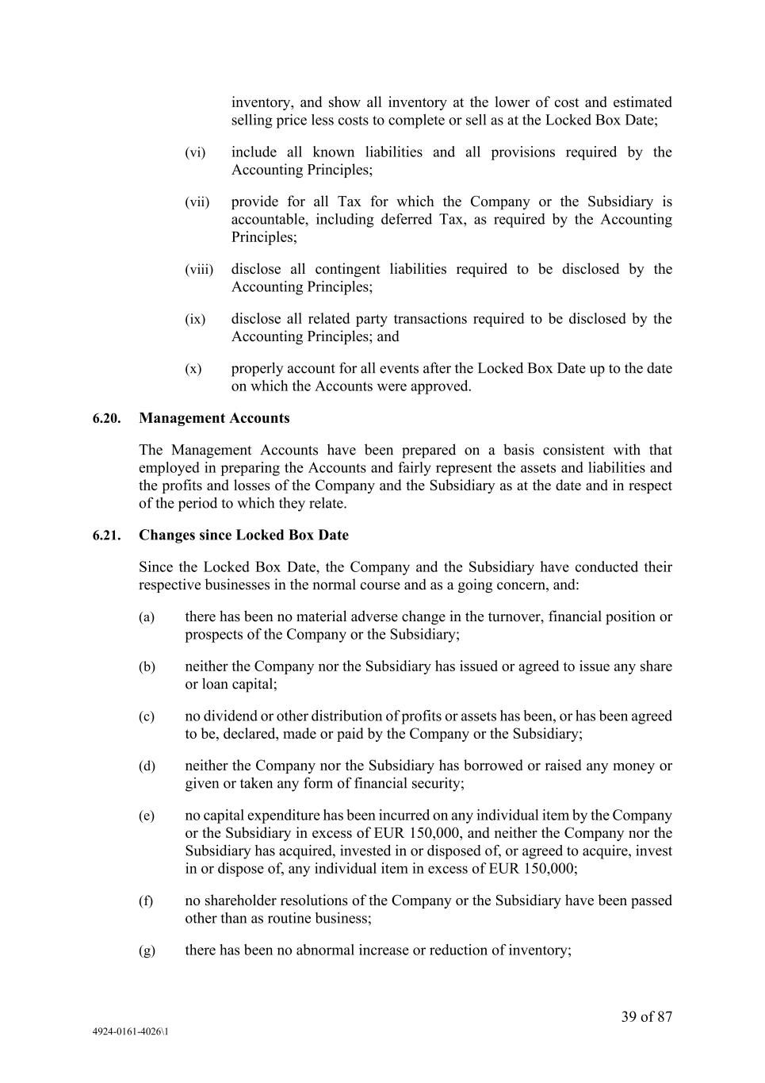
39 of 87 4924-0161-4026\1 inventory, and show all inventory at the lower of cost and estimated selling price less costs to complete or sell as at the Locked Box Date; (vi) include all known liabilities and all provisions required by the Accounting Principles; (vii) provide for all Tax for which the Company or the Subsidiary is accountable, including deferred Tax, as required by the Accounting Principles; (viii) disclose all contingent liabilities required to be disclosed by the Accounting Principles; (ix) disclose all related party transactions required to be disclosed by the Accounting Principles; and (x) properly account for all events after the Locked Box Date up to the date on which the Accounts were approved. 6.20. Management Accounts The Management Accounts have been prepared on a basis consistent with that employed in preparing the Accounts and fairly represent the assets and liabilities and the profits and losses of the Company and the Subsidiary as at the date and in respect of the period to which they relate. 6.21. Changes since Locked Box Date Since the Locked Box Date, the Company and the Subsidiary have conducted their respective businesses in the normal course and as a going concern, and: (a) there has been no material adverse change in the turnover, financial position or prospects of the Company or the Subsidiary; (b) neither the Company nor the Subsidiary has issued or agreed to issue any share or loan capital; (c) no dividend or other distribution of profits or assets has been, or has been agreed to be, declared, made or paid by the Company or the Subsidiary; (d) neither the Company nor the Subsidiary has borrowed or raised any money or given or taken any form of financial security; (e) no capital expenditure has been incurred on any individual item by the Company or the Subsidiary in excess of EUR 150,000, and neither the Company nor the Subsidiary has acquired, invested in or disposed of, or agreed to acquire, invest in or dispose of, any individual item in excess of EUR 150,000; (f) no shareholder resolutions of the Company or the Subsidiary have been passed other than as routine business; (g) there has been no abnormal increase or reduction of inventory;

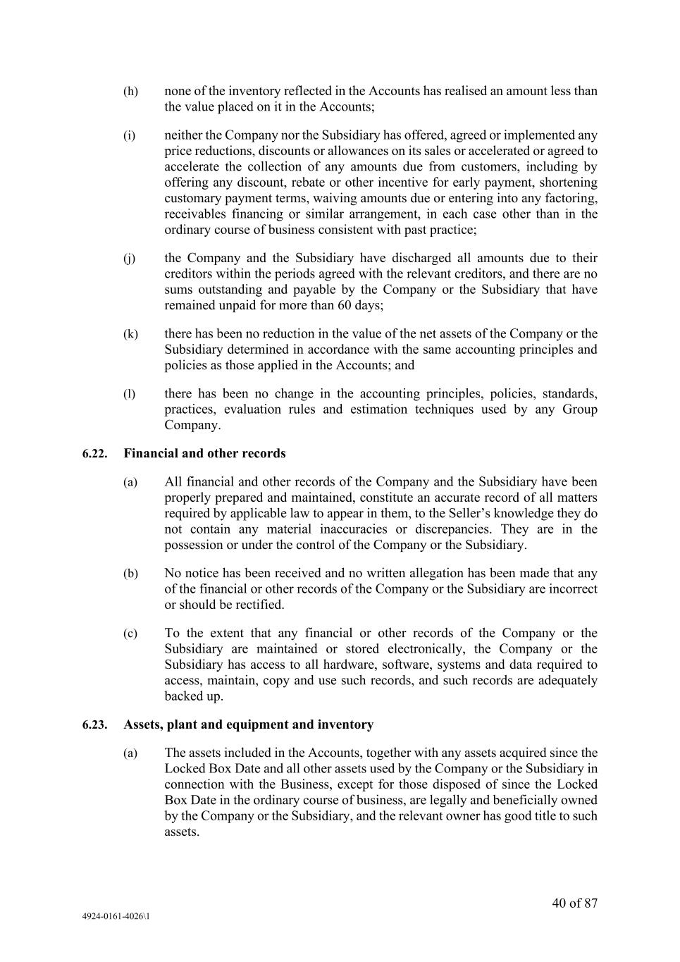
40 of 87 4924-0161-4026\1 (h) none of the inventory reflected in the Accounts has realised an amount less than the value placed on it in the Accounts; (i) neither the Company nor the Subsidiary has offered, agreed or implemented any price reductions, discounts or allowances on its sales or accelerated or agreed to accelerate the collection of any amounts due from customers, including by offering any discount, rebate or other incentive for early payment, shortening customary payment terms, waiving amounts due or entering into any factoring, receivables financing or similar arrangement, in each case other than in the ordinary course of business consistent with past practice; (j) the Company and the Subsidiary have discharged all amounts due to their creditors within the periods agreed with the relevant creditors, and there are no sums outstanding and payable by the Company or the Subsidiary that have remained unpaid for more than 60 days; (k) there has been no reduction in the value of the net assets of the Company or the Subsidiary determined in accordance with the same accounting principles and policies as those applied in the Accounts; and (l) there has been no change in the accounting principles, policies, standards, practices, evaluation rules and estimation techniques used by any Group Company. 6.22. Financial and other records (a) All financial and other records of the Company and the Subsidiary have been properly prepared and maintained, constitute an accurate record of all matters required by applicable law to appear in them, to the Seller’s knowledge they do not contain any material inaccuracies or discrepancies. They are in the possession or under the control of the Company or the Subsidiary. (b) No notice has been received and no written allegation has been made that any of the financial or other records of the Company or the Subsidiary are incorrect or should be rectified. (c) To the extent that any financial or other records of the Company or the Subsidiary are maintained or stored electronically, the Company or the Subsidiary has access to all hardware, software, systems and data required to access, maintain, copy and use such records, and such records are adequately backed up. 6.23. Assets, plant and equipment and inventory (a) The assets included in the Accounts, together with any assets acquired since the Locked Box Date and all other assets used by the Company or the Subsidiary in connection with the Business, except for those disposed of since the Locked Box Date in the ordinary course of business, are legally and beneficially owned by the Company or the Subsidiary, and the relevant owner has good title to such assets.

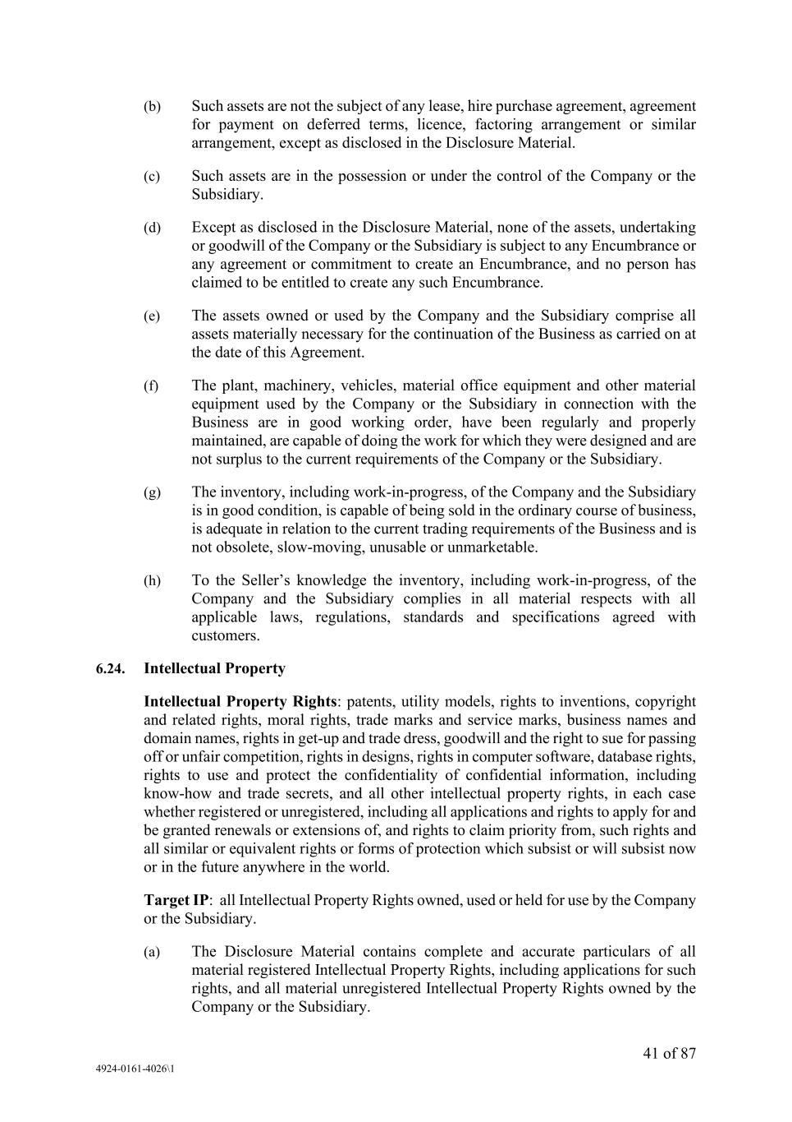
41 of 87 4924-0161-4026\1 (b) Such assets are not the subject of any lease, hire purchase agreement, agreement for payment on deferred terms, licence, factoring arrangement or similar arrangement, except as disclosed in the Disclosure Material. (c) Such assets are in the possession or under the control of the Company or the Subsidiary. (d) Except as disclosed in the Disclosure Material, none of the assets, undertaking or goodwill of the Company or the Subsidiary is subject to any Encumbrance or any agreement or commitment to create an Encumbrance, and no person has claimed to be entitled to create any such Encumbrance. (e) The assets owned or used by the Company and the Subsidiary comprise all assets materially necessary for the continuation of the Business as carried on at the date of this Agreement. (f) The plant, machinery, vehicles, material office equipment and other material equipment used by the Company or the Subsidiary in connection with the Business are in good working order, have been regularly and properly maintained, are capable of doing the work for which they were designed and are not surplus to the current requirements of the Company or the Subsidiary. (g) The inventory, including work-in-progress, of the Company and the Subsidiary is in good condition, is capable of being sold in the ordinary course of business, is adequate in relation to the current trading requirements of the Business and is not obsolete, slow-moving, unusable or unmarketable. (h) To the Seller’s knowledge the inventory, including work-in-progress, of the Company and the Subsidiary complies in all material respects with all applicable laws, regulations, standards and specifications agreed with customers. 6.24. Intellectual Property Intellectual Property Rights: patents, utility models, rights to inventions, copyright and related rights, moral rights, trade marks and service marks, business names and domain names, rights in get-up and trade dress, goodwill and the right to sue for passing off or unfair competition, rights in designs, rights in computer software, database rights, rights to use and protect the confidentiality of confidential information, including know-how and trade secrets, and all other intellectual property rights, in each case whether registered or unregistered, including all applications and rights to apply for and be granted renewals or extensions of, and rights to claim priority from, such rights and all similar or equivalent rights or forms of protection which subsist or will subsist now or in the future anywhere in the world. Target IP: all Intellectual Property Rights owned, used or held for use by the Company or the Subsidiary. (a) The Disclosure Material contains complete and accurate particulars of all material registered Intellectual Property Rights, including applications for such rights, and all material unregistered Intellectual Property Rights owned by the Company or the Subsidiary.

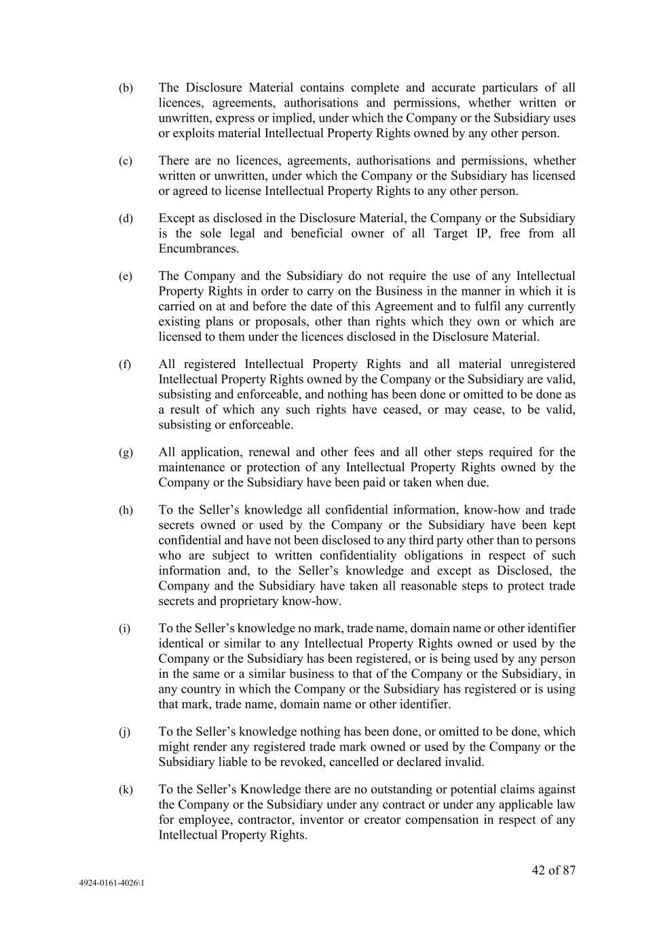
42 of 87 4924-0161-4026\1 (b) The Disclosure Material contains complete and accurate particulars of all licences, agreements, authorisations and permissions, whether written or unwritten, express or implied, under which the Company or the Subsidiary uses or exploits material Intellectual Property Rights owned by any other person. (c) There are no licences, agreements, authorisations and permissions, whether written or unwritten, under which the Company or the Subsidiary has licensed or agreed to license Intellectual Property Rights to any other person. (d) Except as disclosed in the Disclosure Material, the Company or the Subsidiary is the sole legal and beneficial owner of all Target IP, free from all Encumbrances. (e) The Company and the Subsidiary do not require the use of any Intellectual Property Rights in order to carry on the Business in the manner in which it is carried on at and before the date of this Agreement and to fulfil any currently existing plans or proposals, other than rights which they own or which are licensed to them under the licences disclosed in the Disclosure Material. (f) All registered Intellectual Property Rights and all material unregistered Intellectual Property Rights owned by the Company or the Subsidiary are valid, subsisting and enforceable, and nothing has been done or omitted to be done as a result of which any such rights have ceased, or may cease, to be valid, subsisting or enforceable. (g) All application, renewal and other fees and all other steps required for the maintenance or protection of any Intellectual Property Rights owned by the Company or the Subsidiary have been paid or taken when due. (h) To the Seller’s knowledge all confidential information, know-how and trade secrets owned or used by the Company or the Subsidiary have been kept confidential and have not been disclosed to any third party other than to persons who are subject to written confidentiality obligations in respect of such information and, to the Seller’s knowledge and except as Disclosed, the Company and the Subsidiary have taken all reasonable steps to protect trade secrets and proprietary know-how. (i) To the Seller’s knowledge no mark, trade name, domain name or other identifier identical or similar to any Intellectual Property Rights owned or used by the Company or the Subsidiary has been registered, or is being used by any person in the same or a similar business to that of the Company or the Subsidiary, in any country in which the Company or the Subsidiary has registered or is using that mark, trade name, domain name or other identifier. (j) To the Seller’s knowledge nothing has been done, or omitted to be done, which might render any registered trade mark owned or used by the Company or the Subsidiary liable to be revoked, cancelled or declared invalid. (k) To the Seller’s Knowledge there are no outstanding or potential claims against the Company or the Subsidiary under any contract or under any applicable law for employee, contractor, inventor or creator compensation in respect of any Intellectual Property Rights.

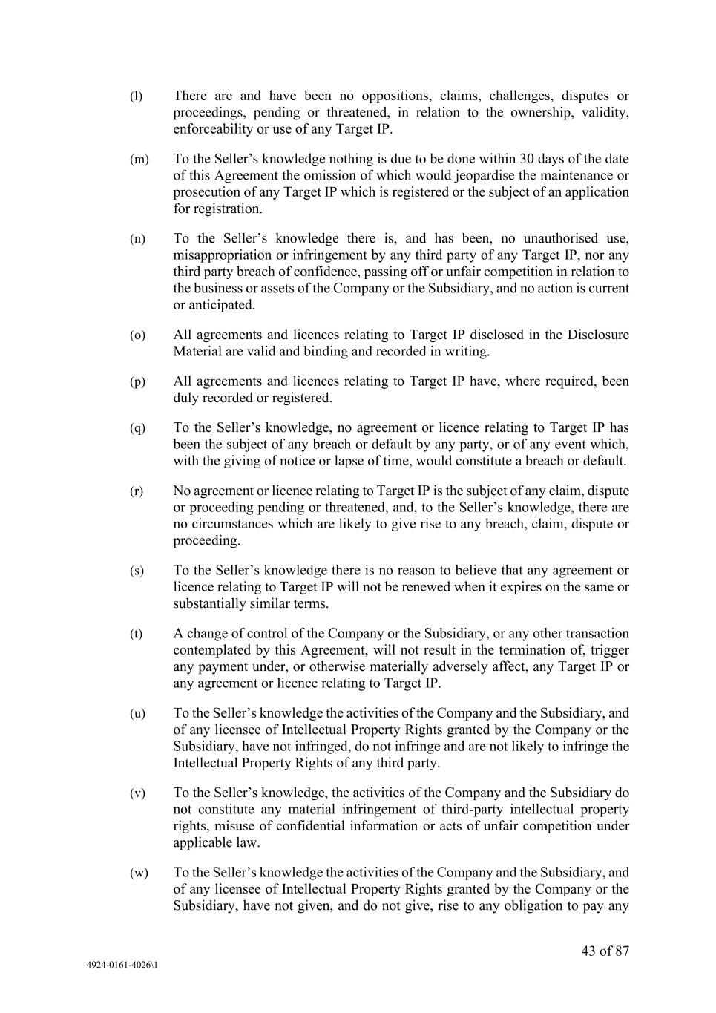
43 of 87 4924-0161-4026\1 (l) There are and have been no oppositions, claims, challenges, disputes or proceedings, pending or threatened, in relation to the ownership, validity, enforceability or use of any Target IP. (m) To the Seller’s knowledge nothing is due to be done within 30 days of the date of this Agreement the omission of which would jeopardise the maintenance or prosecution of any Target IP which is registered or the subject of an application for registration. (n) To the Seller’s knowledge there is, and has been, no unauthorised use, misappropriation or infringement by any third party of any Target IP, nor any third party breach of confidence, passing off or unfair competition in relation to the business or assets of the Company or the Subsidiary, and no action is current or anticipated. (o) All agreements and licences relating to Target IP disclosed in the Disclosure Material are valid and binding and recorded in writing. (p) All agreements and licences relating to Target IP have, where required, been duly recorded or registered. (q) To the Seller’s knowledge, no agreement or licence relating to Target IP has been the subject of any breach or default by any party, or of any event which, with the giving of notice or lapse of time, would constitute a breach or default. (r) No agreement or licence relating to Target IP is the subject of any claim, dispute or proceeding pending or threatened, and, to the Seller’s knowledge, there are no circumstances which are likely to give rise to any breach, claim, dispute or proceeding. (s) To the Seller’s knowledge there is no reason to believe that any agreement or licence relating to Target IP will not be renewed when it expires on the same or substantially similar terms. (t) A change of control of the Company or the Subsidiary, or any other transaction contemplated by this Agreement, will not result in the termination of, trigger any payment under, or otherwise materially adversely affect, any Target IP or any agreement or licence relating to Target IP. (u) To the Seller’s knowledge the activities of the Company and the Subsidiary, and of any licensee of Intellectual Property Rights granted by the Company or the Subsidiary, have not infringed, do not infringe and are not likely to infringe the Intellectual Property Rights of any third party. (v) To the Seller’s knowledge, the activities of the Company and the Subsidiary do not constitute any material infringement of third-party intellectual property rights, misuse of confidential information or acts of unfair competition under applicable law. (w) To the Seller’s knowledge the activities of the Company and the Subsidiary, and of any licensee of Intellectual Property Rights granted by the Company or the Subsidiary, have not given, and do not give, rise to any obligation to pay any

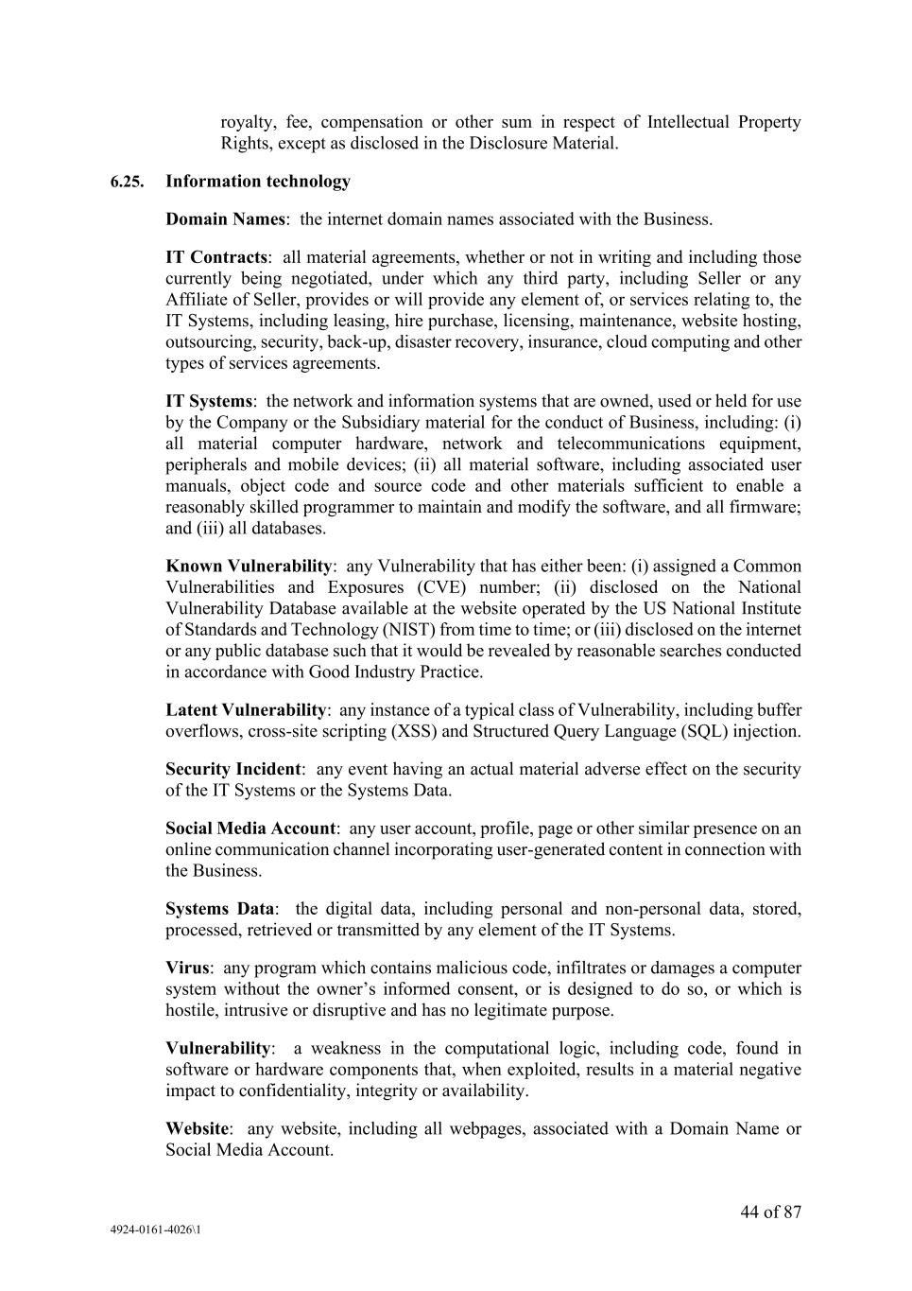
44 of 87 4924-0161-4026\1 royalty, fee, compensation or other sum in respect of Intellectual Property Rights, except as disclosed in the Disclosure Material. 6.25. Information technology Domain Names: the internet domain names associated with the Business. IT Contracts: all material agreements, whether or not in writing and including those currently being negotiated, under which any third party, including Seller or any Affiliate of Seller, provides or will provide any element of, or services relating to, the IT Systems, including leasing, hire purchase, licensing, maintenance, website hosting, outsourcing, security, back-up, disaster recovery, insurance, cloud computing and other types of services agreements. IT Systems: the network and information systems that are owned, used or held for use by the Company or the Subsidiary material for the conduct of Business, including: (i) all material computer hardware, network and telecommunications equipment, peripherals and mobile devices; (ii) all material software, including associated user manuals, object code and source code and other materials sufficient to enable a reasonably skilled programmer to maintain and modify the software, and all firmware; and (iii) all databases. Known Vulnerability: any Vulnerability that has either been: (i) assigned a Common Vulnerabilities and Exposures (CVE) number; (ii) disclosed on the National Vulnerability Database available at the website operated by the US National Institute of Standards and Technology (NIST) from time to time; or (iii) disclosed on the internet or any public database such that it would be revealed by reasonable searches conducted in accordance with Good Industry Practice. Latent Vulnerability: any instance of a typical class of Vulnerability, including buffer overflows, cross-site scripting (XSS) and Structured Query Language (SQL) injection. Security Incident: any event having an actual material adverse effect on the security of the IT Systems or the Systems Data. Social Media Account: any user account, profile, page or other similar presence on an online communication channel incorporating user-generated content in connection with the Business. Systems Data: the digital data, including personal and non-personal data, stored, processed, retrieved or transmitted by any element of the IT Systems. Virus: any program which contains malicious code, infiltrates or damages a computer system without the owner’s informed consent, or is designed to do so, or which is hostile, intrusive or disruptive and has no legitimate purpose. Vulnerability: a weakness in the computational logic, including code, found in software or hardware components that, when exploited, results in a material negative impact to confidentiality, integrity or availability. Website: any website, including all webpages, associated with a Domain Name or Social Media Account.

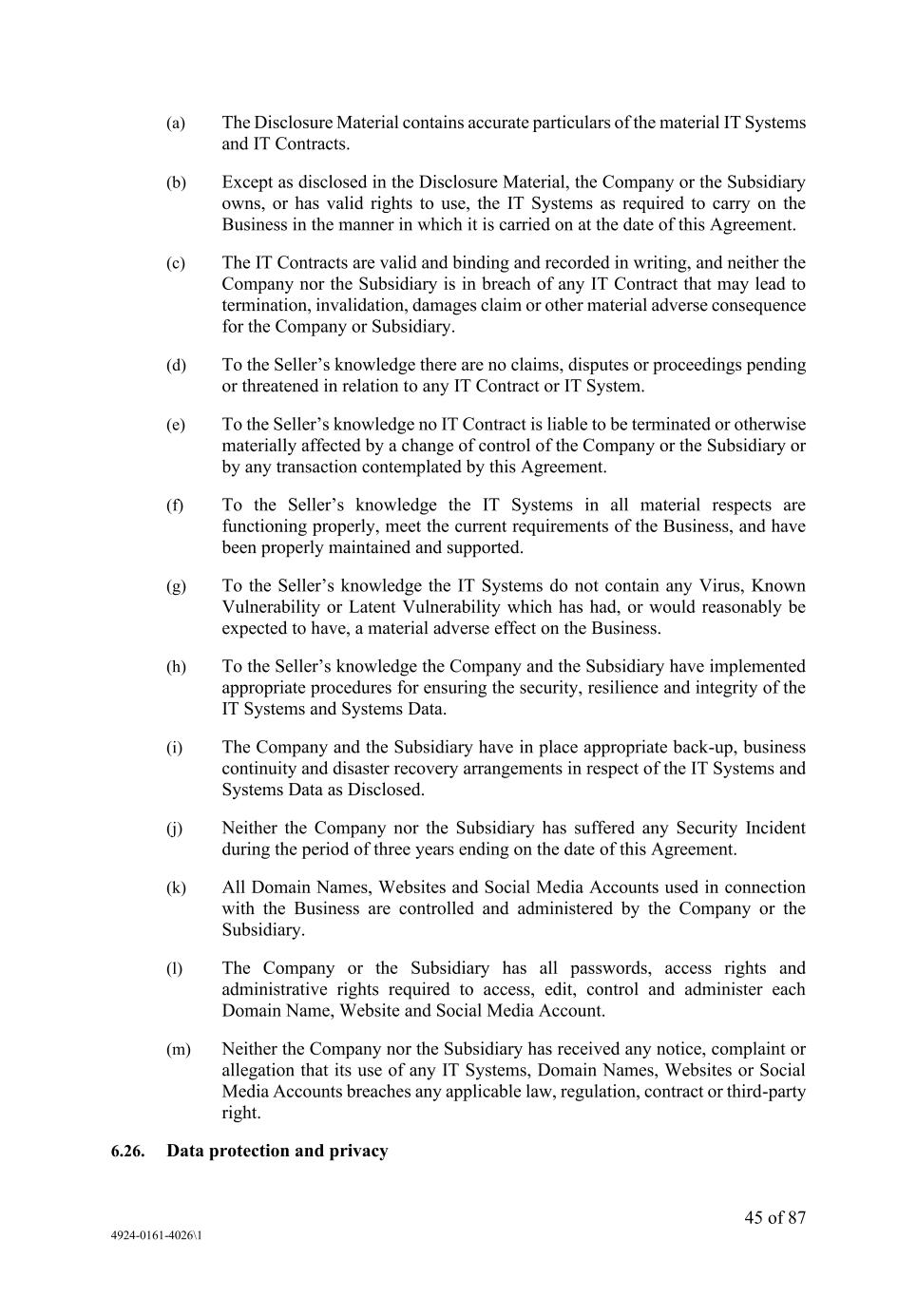
45 of 87 4924-0161-4026\1 (a) The Disclosure Material contains accurate particulars of the material IT Systems and IT Contracts. (b) Except as disclosed in the Disclosure Material, the Company or the Subsidiary owns, or has valid rights to use, the IT Systems as required to carry on the Business in the manner in which it is carried on at the date of this Agreement. (c) The IT Contracts are valid and binding and recorded in writing, and neither the Company nor the Subsidiary is in breach of any IT Contract that may lead to termination, invalidation, damages claim or other material adverse consequence for the Company or Subsidiary. (d) To the Seller’s knowledge there are no claims, disputes or proceedings pending or threatened in relation to any IT Contract or IT System. (e) To the Seller’s knowledge no IT Contract is liable to be terminated or otherwise materially affected by a change of control of the Company or the Subsidiary or by any transaction contemplated by this Agreement. (f) To the Seller’s knowledge the IT Systems in all material respects are functioning properly, meet the current requirements of the Business, and have been properly maintained and supported. (g) To the Seller’s knowledge the IT Systems do not contain any Virus, Known Vulnerability or Latent Vulnerability which has had, or would reasonably be expected to have, a material adverse effect on the Business. (h) To the Seller’s knowledge the Company and the Subsidiary have implemented appropriate procedures for ensuring the security, resilience and integrity of the IT Systems and Systems Data. (i) The Company and the Subsidiary have in place appropriate back-up, business continuity and disaster recovery arrangements in respect of the IT Systems and Systems Data as Disclosed. (j) Neither the Company nor the Subsidiary has suffered any Security Incident during the period of three years ending on the date of this Agreement. (k) All Domain Names, Websites and Social Media Accounts used in connection with the Business are controlled and administered by the Company or the Subsidiary. (l) The Company or the Subsidiary has all passwords, access rights and administrative rights required to access, edit, control and administer each Domain Name, Website and Social Media Account. (m) Neither the Company nor the Subsidiary has received any notice, complaint or allegation that its use of any IT Systems, Domain Names, Websites or Social Media Accounts breaches any applicable law, regulation, contract or third-party right. 6.26. Data protection and privacy

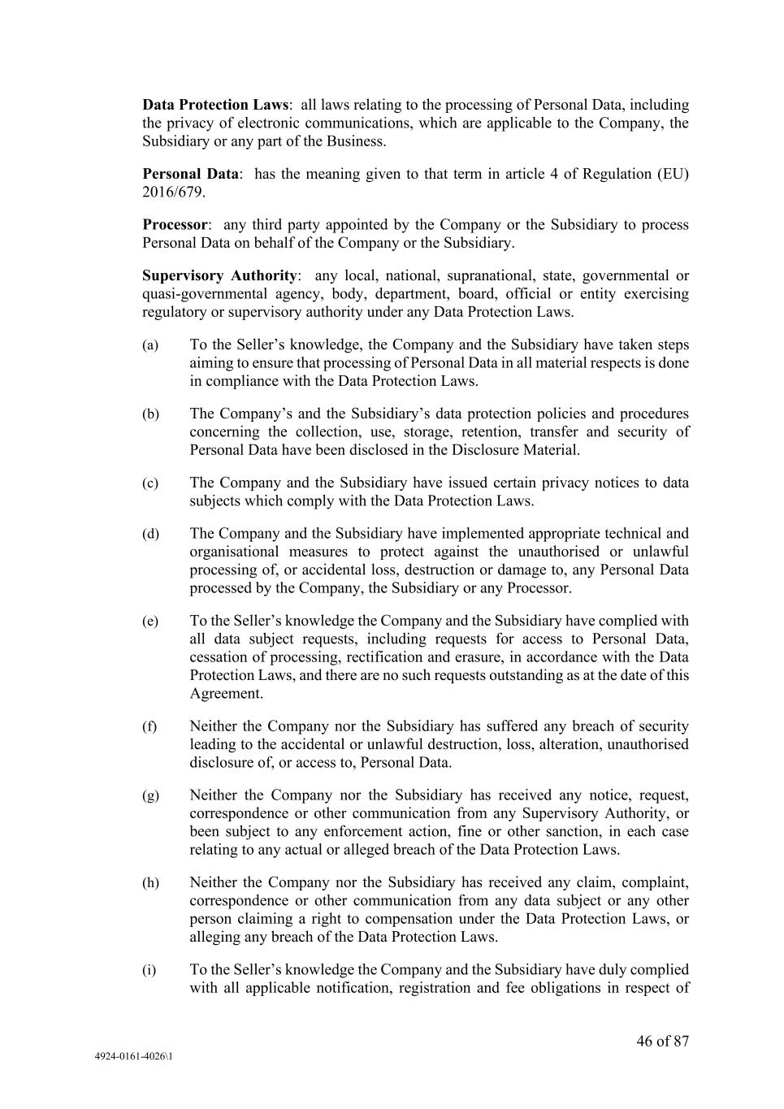
46 of 87 4924-0161-4026\1 Data Protection Laws: all laws relating to the processing of Personal Data, including the privacy of electronic communications, which are applicable to the Company, the Subsidiary or any part of the Business. Personal Data: has the meaning given to that term in article 4 of Regulation (EU) 2016/679. Processor: any third party appointed by the Company or the Subsidiary to process Personal Data on behalf of the Company or the Subsidiary. Supervisory Authority: any local, national, supranational, state, governmental or quasi-governmental agency, body, department, board, official or entity exercising regulatory or supervisory authority under any Data Protection Laws. (a) To the Seller’s knowledge, the Company and the Subsidiary have taken steps aiming to ensure that processing of Personal Data in all material respects is done in compliance with the Data Protection Laws. (b) The Company’s and the Subsidiary’s data protection policies and procedures concerning the collection, use, storage, retention, transfer and security of Personal Data have been disclosed in the Disclosure Material. (c) The Company and the Subsidiary have issued certain privacy notices to data subjects which comply with the Data Protection Laws. (d) The Company and the Subsidiary have implemented appropriate technical and organisational measures to protect against the unauthorised or unlawful processing of, or accidental loss, destruction or damage to, any Personal Data processed by the Company, the Subsidiary or any Processor. (e) To the Seller’s knowledge the Company and the Subsidiary have complied with all data subject requests, including requests for access to Personal Data, cessation of processing, rectification and erasure, in accordance with the Data Protection Laws, and there are no such requests outstanding as at the date of this Agreement. (f) Neither the Company nor the Subsidiary has suffered any breach of security leading to the accidental or unlawful destruction, loss, alteration, unauthorised disclosure of, or access to, Personal Data. (g) Neither the Company nor the Subsidiary has received any notice, request, correspondence or other communication from any Supervisory Authority, or been subject to any enforcement action, fine or other sanction, in each case relating to any actual or alleged breach of the Data Protection Laws. (h) Neither the Company nor the Subsidiary has received any claim, complaint, correspondence or other communication from any data subject or any other person claiming a right to compensation under the Data Protection Laws, or alleging any breach of the Data Protection Laws. (i) To the Seller’s knowledge the Company and the Subsidiary have duly complied with all applicable notification, registration and fee obligations in respect of

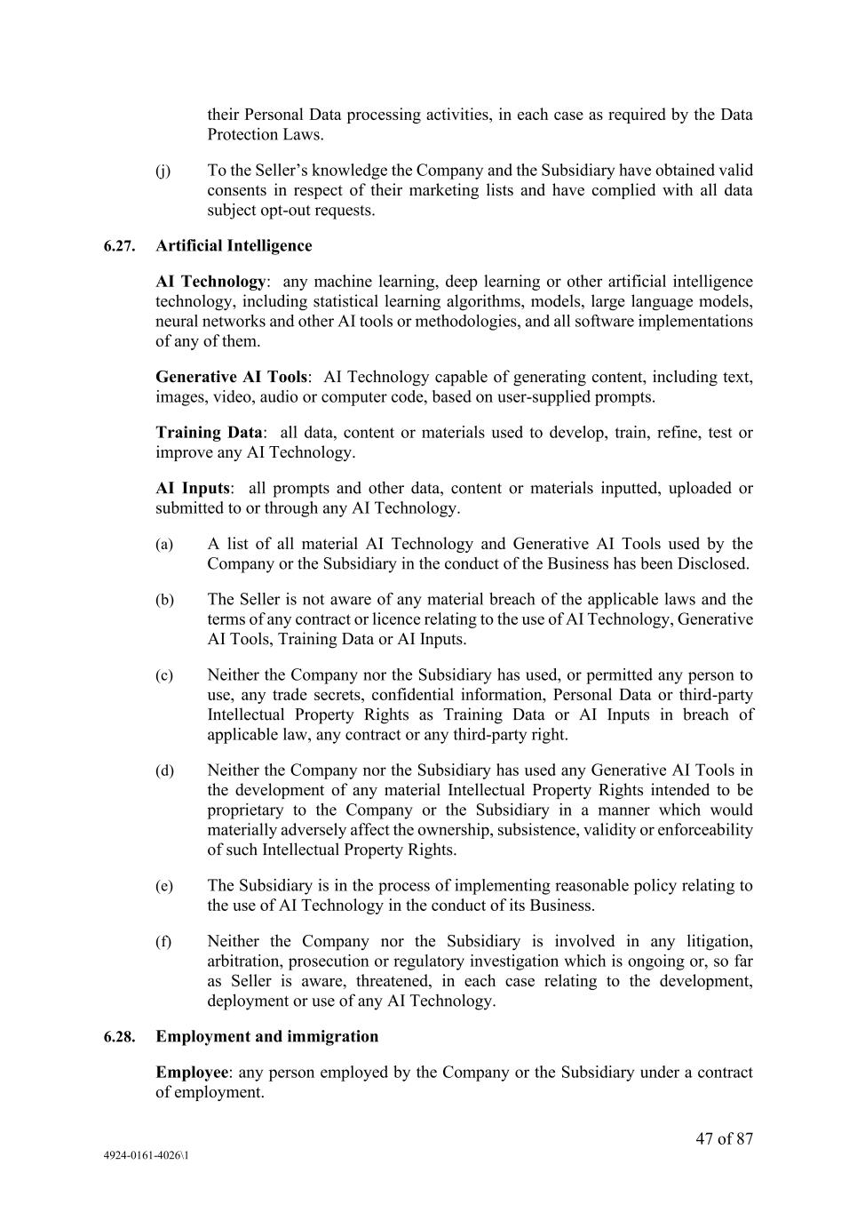
47 of 87 4924-0161-4026\1 their Personal Data processing activities, in each case as required by the Data Protection Laws. (j) To the Seller’s knowledge the Company and the Subsidiary have obtained valid consents in respect of their marketing lists and have complied with all data subject opt-out requests. 6.27. Artificial Intelligence AI Technology: any machine learning, deep learning or other artificial intelligence technology, including statistical learning algorithms, models, large language models, neural networks and other AI tools or methodologies, and all software implementations of any of them. Generative AI Tools: AI Technology capable of generating content, including text, images, video, audio or computer code, based on user-supplied prompts. Training Data: all data, content or materials used to develop, train, refine, test or improve any AI Technology. AI Inputs: all prompts and other data, content or materials inputted, uploaded or submitted to or through any AI Technology. (a) A list of all material AI Technology and Generative AI Tools used by the Company or the Subsidiary in the conduct of the Business has been Disclosed. (b) The Seller is not aware of any material breach of the applicable laws and the terms of any contract or licence relating to the use of AI Technology, Generative AI Tools, Training Data or AI Inputs. (c) Neither the Company nor the Subsidiary has used, or permitted any person to use, any trade secrets, confidential information, Personal Data or third-party Intellectual Property Rights as Training Data or AI Inputs in breach of applicable law, any contract or any third-party right. (d) Neither the Company nor the Subsidiary has used any Generative AI Tools in the development of any material Intellectual Property Rights intended to be proprietary to the Company or the Subsidiary in a manner which would materially adversely affect the ownership, subsistence, validity or enforceability of such Intellectual Property Rights. (e) The Subsidiary is in the process of implementing reasonable policy relating to the use of AI Technology in the conduct of its Business. (f) Neither the Company nor the Subsidiary is involved in any litigation, arbitration, prosecution or regulatory investigation which is ongoing or, so far as Seller is aware, threatened, in each case relating to the development, deployment or use of any AI Technology. 6.28. Employment and immigration Employee: any person employed by the Company or the Subsidiary under a contract of employment.

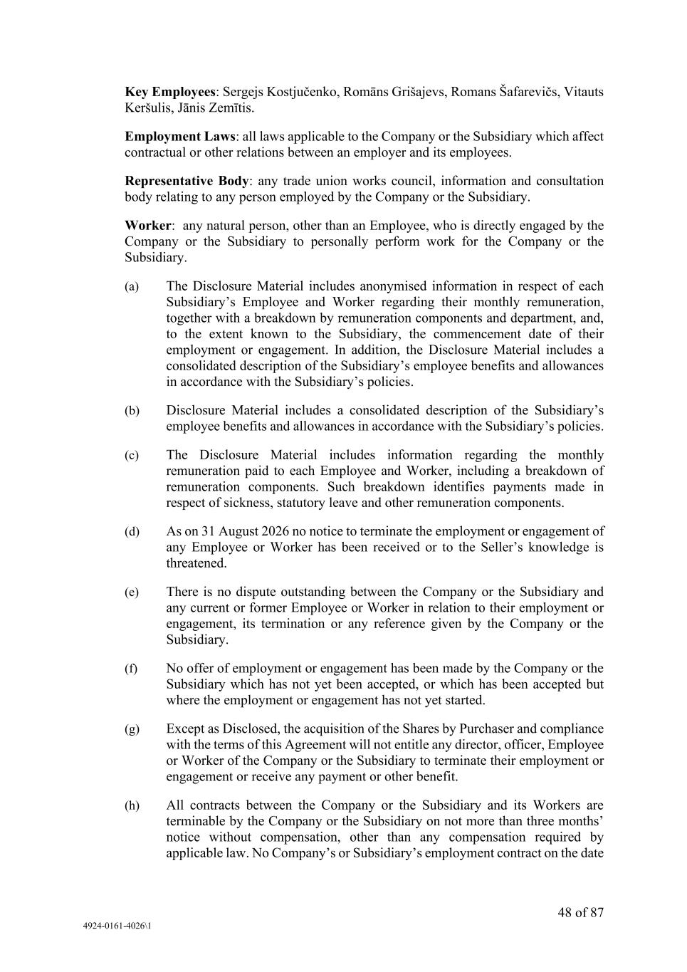
48 of 87 4924-0161-4026\1 Key Employees: Sergejs Kostjučenko, Romāns Grišajevs, Romans Šafarevičs, Vitauts Keršulis, Jānis Zemītis. Employment Laws: all laws applicable to the Company or the Subsidiary which affect contractual or other relations between an employer and its employees. Representative Body: any trade union works council, information and consultation body relating to any person employed by the Company or the Subsidiary. Worker: any natural person, other than an Employee, who is directly engaged by the Company or the Subsidiary to personally perform work for the Company or the Subsidiary. (a) The Disclosure Material includes anonymised information in respect of each Subsidiary’s Employee and Worker regarding their monthly remuneration, together with a breakdown by remuneration components and department, and, to the extent known to the Subsidiary, the commencement date of their employment or engagement. In addition, the Disclosure Material includes a consolidated description of the Subsidiary’s employee benefits and allowances in accordance with the Subsidiary’s policies. (b) Disclosure Material includes a consolidated description of the Subsidiary’s employee benefits and allowances in accordance with the Subsidiary’s policies. (c) The Disclosure Material includes information regarding the monthly remuneration paid to each Employee and Worker, including a breakdown of remuneration components. Such breakdown identifies payments made in respect of sickness, statutory leave and other remuneration components. (d) As on 31 August 2026 no notice to terminate the employment or engagement of any Employee or Worker has been received or to the Seller’s knowledge is threatened. (e) There is no dispute outstanding between the Company or the Subsidiary and any current or former Employee or Worker in relation to their employment or engagement, its termination or any reference given by the Company or the Subsidiary. (f) No offer of employment or engagement has been made by the Company or the Subsidiary which has not yet been accepted, or which has been accepted but where the employment or engagement has not yet started. (g) Except as Disclosed, the acquisition of the Shares by Purchaser and compliance with the terms of this Agreement will not entitle any director, officer, Employee or Worker of the Company or the Subsidiary to terminate their employment or engagement or receive any payment or other benefit. (h) All contracts between the Company or the Subsidiary and its Workers are terminable by the Company or the Subsidiary on not more than three months’ notice without compensation, other than any compensation required by applicable law. No Company’s or Subsidiary’s employment contract on the date

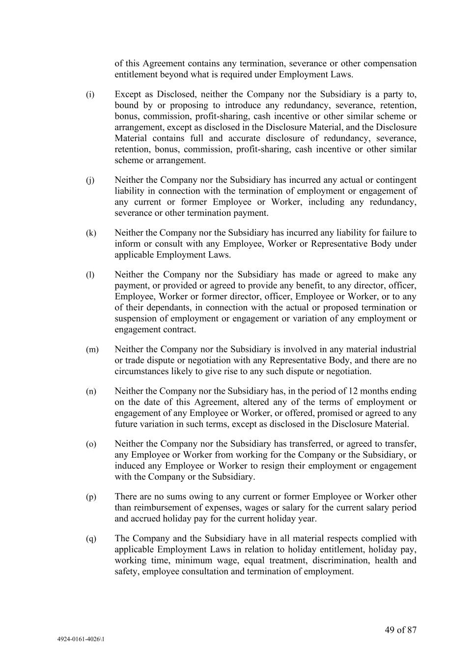
49 of 87 4924-0161-4026\1 of this Agreement contains any termination, severance or other compensation entitlement beyond what is required under Employment Laws. (i) Except as Disclosed, neither the Company nor the Subsidiary is a party to, bound by or proposing to introduce any redundancy, severance, retention, bonus, commission, profit-sharing, cash incentive or other similar scheme or arrangement, except as disclosed in the Disclosure Material, and the Disclosure Material contains full and accurate disclosure of redundancy, severance, retention, bonus, commission, profit-sharing, cash incentive or other similar scheme or arrangement. (j) Neither the Company nor the Subsidiary has incurred any actual or contingent liability in connection with the termination of employment or engagement of any current or former Employee or Worker, including any redundancy, severance or other termination payment. (k) Neither the Company nor the Subsidiary has incurred any liability for failure to inform or consult with any Employee, Worker or Representative Body under applicable Employment Laws. (l) Neither the Company nor the Subsidiary has made or agreed to make any payment, or provided or agreed to provide any benefit, to any director, officer, Employee, Worker or former director, officer, Employee or Worker, or to any of their dependants, in connection with the actual or proposed termination or suspension of employment or engagement or variation of any employment or engagement contract. (m) Neither the Company nor the Subsidiary is involved in any material industrial or trade dispute or negotiation with any Representative Body, and there are no circumstances likely to give rise to any such dispute or negotiation. (n) Neither the Company nor the Subsidiary has, in the period of 12 months ending on the date of this Agreement, altered any of the terms of employment or engagement of any Employee or Worker, or offered, promised or agreed to any future variation in such terms, except as disclosed in the Disclosure Material. (o) Neither the Company nor the Subsidiary has transferred, or agreed to transfer, any Employee or Worker from working for the Company or the Subsidiary, or induced any Employee or Worker to resign their employment or engagement with the Company or the Subsidiary. (p) There are no sums owing to any current or former Employee or Worker other than reimbursement of expenses, wages or salary for the current salary period and accrued holiday pay for the current holiday year. (q) The Company and the Subsidiary have in all material respects complied with applicable Employment Laws in relation to holiday entitlement, holiday pay, working time, minimum wage, equal treatment, discrimination, health and safety, employee consultation and termination of employment.

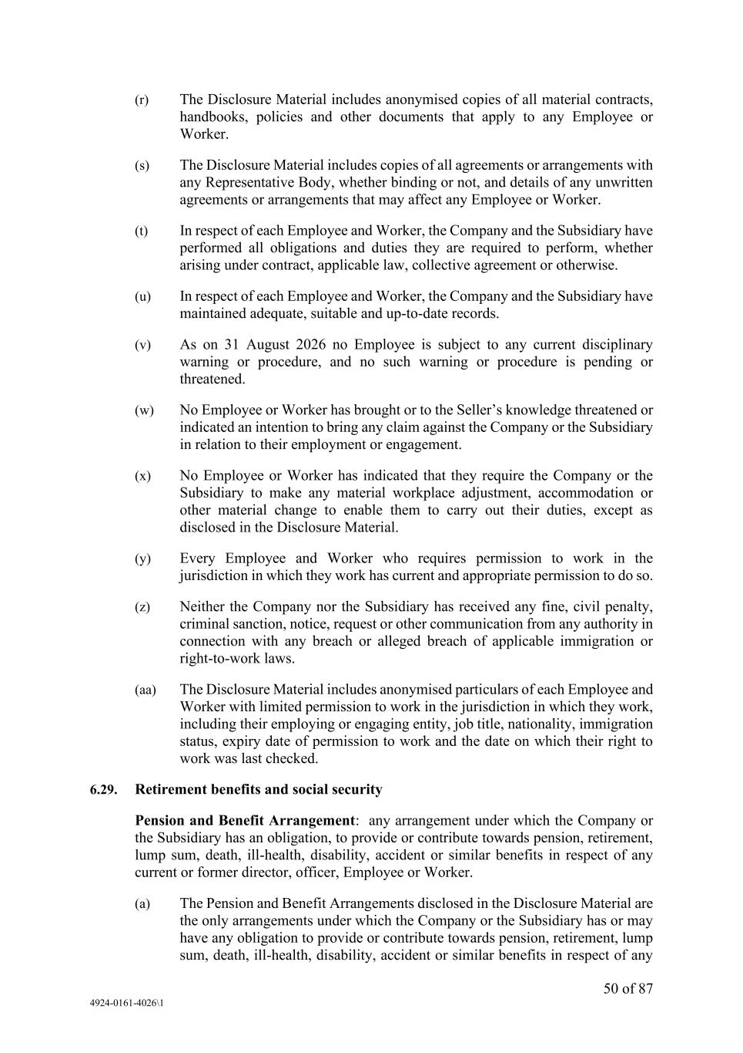
50 of 87 4924-0161-4026\1 (r) The Disclosure Material includes anonymised copies of all material contracts, handbooks, policies and other documents that apply to any Employee or Worker. (s) The Disclosure Material includes copies of all agreements or arrangements with any Representative Body, whether binding or not, and details of any unwritten agreements or arrangements that may affect any Employee or Worker. (t) In respect of each Employee and Worker, the Company and the Subsidiary have performed all obligations and duties they are required to perform, whether arising under contract, applicable law, collective agreement or otherwise. (u) In respect of each Employee and Worker, the Company and the Subsidiary have maintained adequate, suitable and up-to-date records. (v) As on 31 August 2026 no Employee is subject to any current disciplinary warning or procedure, and no such warning or procedure is pending or threatened. (w) No Employee or Worker has brought or to the Seller’s knowledge threatened or indicated an intention to bring any claim against the Company or the Subsidiary in relation to their employment or engagement. (x) No Employee or Worker has indicated that they require the Company or the Subsidiary to make any material workplace adjustment, accommodation or other material change to enable them to carry out their duties, except as disclosed in the Disclosure Material. (y) Every Employee and Worker who requires permission to work in the jurisdiction in which they work has current and appropriate permission to do so. (z) Neither the Company nor the Subsidiary has received any fine, civil penalty, criminal sanction, notice, request or other communication from any authority in connection with any breach or alleged breach of applicable immigration or right-to-work laws. (aa) The Disclosure Material includes anonymised particulars of each Employee and Worker with limited permission to work in the jurisdiction in which they work, including their employing or engaging entity, job title, nationality, immigration status, expiry date of permission to work and the date on which their right to work was last checked. 6.29. Retirement benefits and social security Pension and Benefit Arrangement: any arrangement under which the Company or the Subsidiary has an obligation, to provide or contribute towards pension, retirement, lump sum, death, ill-health, disability, accident or similar benefits in respect of any current or former director, officer, Employee or Worker. (a) The Pension and Benefit Arrangements disclosed in the Disclosure Material are the only arrangements under which the Company or the Subsidiary has or may have any obligation to provide or contribute towards pension, retirement, lump sum, death, ill-health, disability, accident or similar benefits in respect of any

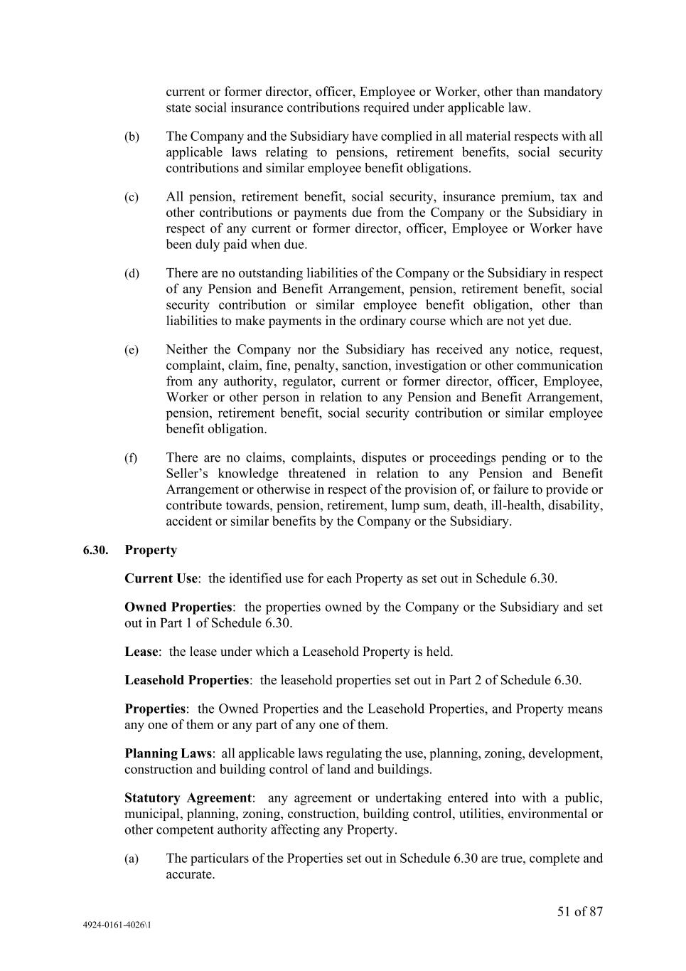
51 of 87 4924-0161-4026\1 current or former director, officer, Employee or Worker, other than mandatory state social insurance contributions required under applicable law. (b) The Company and the Subsidiary have complied in all material respects with all applicable laws relating to pensions, retirement benefits, social security contributions and similar employee benefit obligations. (c) All pension, retirement benefit, social security, insurance premium, tax and other contributions or payments due from the Company or the Subsidiary in respect of any current or former director, officer, Employee or Worker have been duly paid when due. (d) There are no outstanding liabilities of the Company or the Subsidiary in respect of any Pension and Benefit Arrangement, pension, retirement benefit, social security contribution or similar employee benefit obligation, other than liabilities to make payments in the ordinary course which are not yet due. (e) Neither the Company nor the Subsidiary has received any notice, request, complaint, claim, fine, penalty, sanction, investigation or other communication from any authority, regulator, current or former director, officer, Employee, Worker or other person in relation to any Pension and Benefit Arrangement, pension, retirement benefit, social security contribution or similar employee benefit obligation. (f) There are no claims, complaints, disputes or proceedings pending or to the Seller’s knowledge threatened in relation to any Pension and Benefit Arrangement or otherwise in respect of the provision of, or failure to provide or contribute towards, pension, retirement, lump sum, death, ill-health, disability, accident or similar benefits by the Company or the Subsidiary. 6.30. Property Current Use: the identified use for each Property as set out in Schedule 6.30. Owned Properties: the properties owned by the Company or the Subsidiary and set out in Part 1 of Schedule 6.30. Lease: the lease under which a Leasehold Property is held. Leasehold Properties: the leasehold properties set out in Part 2 of Schedule 6.30. Properties: the Owned Properties and the Leasehold Properties, and Property means any one of them or any part of any one of them. Planning Laws: all applicable laws regulating the use, planning, zoning, development, construction and building control of land and buildings. Statutory Agreement: any agreement or undertaking entered into with a public, municipal, planning, zoning, construction, building control, utilities, environmental or other competent authority affecting any Property. (a) The particulars of the Properties set out in Schedule 6.30 are true, complete and accurate.

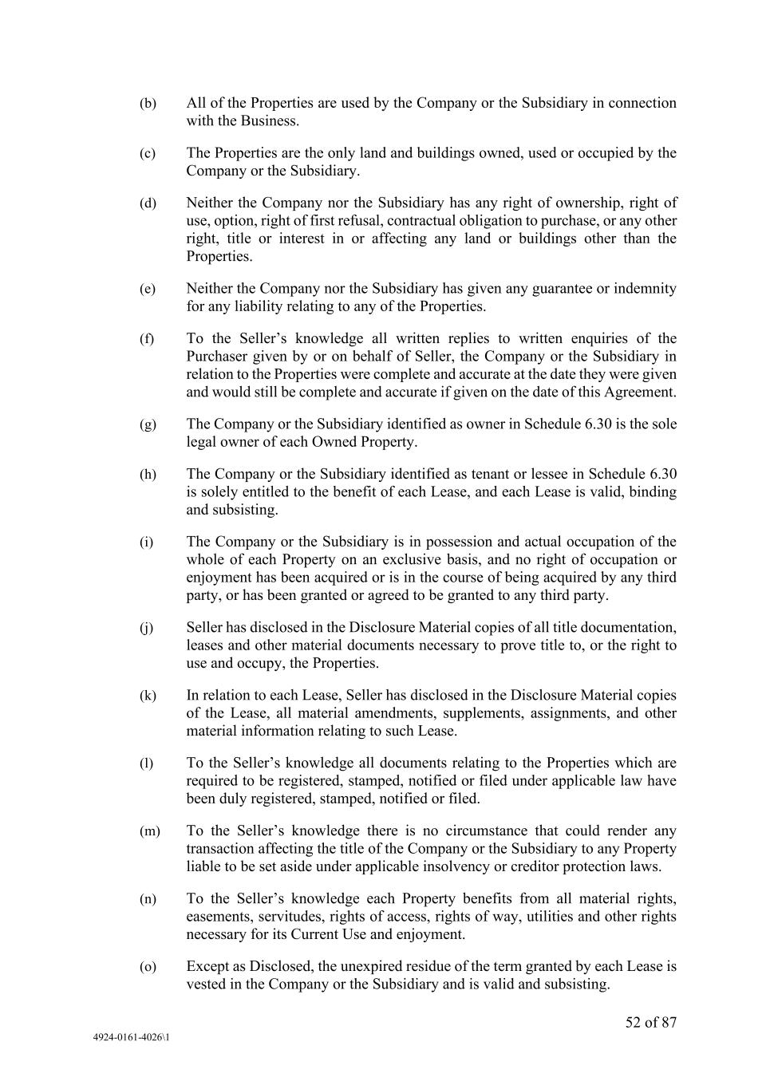
52 of 87 4924-0161-4026\1 (b) All of the Properties are used by the Company or the Subsidiary in connection with the Business. (c) The Properties are the only land and buildings owned, used or occupied by the Company or the Subsidiary. (d) Neither the Company nor the Subsidiary has any right of ownership, right of use, option, right of first refusal, contractual obligation to purchase, or any other right, title or interest in or affecting any land or buildings other than the Properties. (e) Neither the Company nor the Subsidiary has given any guarantee or indemnity for any liability relating to any of the Properties. (f) To the Seller’s knowledge all written replies to written enquiries of the Purchaser given by or on behalf of Seller, the Company or the Subsidiary in relation to the Properties were complete and accurate at the date they were given and would still be complete and accurate if given on the date of this Agreement. (g) The Company or the Subsidiary identified as owner in Schedule 6.30 is the sole legal owner of each Owned Property. (h) The Company or the Subsidiary identified as tenant or lessee in Schedule 6.30 is solely entitled to the benefit of each Lease, and each Lease is valid, binding and subsisting. (i) The Company or the Subsidiary is in possession and actual occupation of the whole of each Property on an exclusive basis, and no right of occupation or enjoyment has been acquired or is in the course of being acquired by any third party, or has been granted or agreed to be granted to any third party. (j) Seller has disclosed in the Disclosure Material copies of all title documentation, leases and other material documents necessary to prove title to, or the right to use and occupy, the Properties. (k) In relation to each Lease, Seller has disclosed in the Disclosure Material copies of the Lease, all material amendments, supplements, assignments, and other material information relating to such Lease. (l) To the Seller’s knowledge all documents relating to the Properties which are required to be registered, stamped, notified or filed under applicable law have been duly registered, stamped, notified or filed. (m) To the Seller’s knowledge there is no circumstance that could render any transaction affecting the title of the Company or the Subsidiary to any Property liable to be set aside under applicable insolvency or creditor protection laws. (n) To the Seller’s knowledge each Property benefits from all material rights, easements, servitudes, rights of access, rights of way, utilities and other rights necessary for its Current Use and enjoyment. (o) Except as Disclosed, the unexpired residue of the term granted by each Lease is vested in the Company or the Subsidiary and is valid and subsisting.

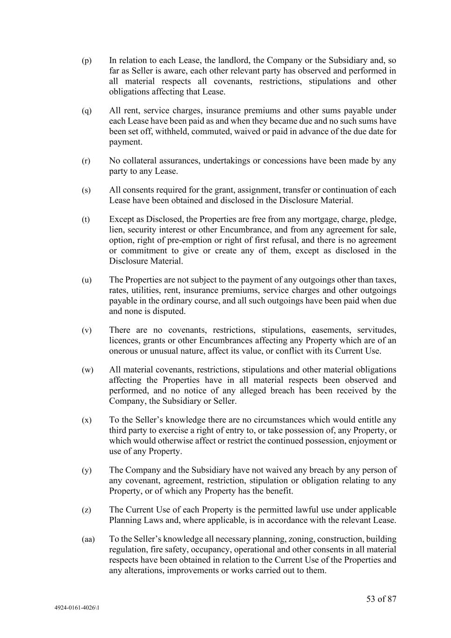
53 of 87 4924-0161-4026\1 (p) In relation to each Lease, the landlord, the Company or the Subsidiary and, so far as Seller is aware, each other relevant party has observed and performed in all material respects all covenants, restrictions, stipulations and other obligations affecting that Lease. (q) All rent, service charges, insurance premiums and other sums payable under each Lease have been paid as and when they became due and no such sums have been set off, withheld, commuted, waived or paid in advance of the due date for payment. (r) No collateral assurances, undertakings or concessions have been made by any party to any Lease. (s) All consents required for the grant, assignment, transfer or continuation of each Lease have been obtained and disclosed in the Disclosure Material. (t) Except as Disclosed, the Properties are free from any mortgage, charge, pledge, lien, security interest or other Encumbrance, and from any agreement for sale, option, right of pre-emption or right of first refusal, and there is no agreement or commitment to give or create any of them, except as disclosed in the Disclosure Material. (u) The Properties are not subject to the payment of any outgoings other than taxes, rates, utilities, rent, insurance premiums, service charges and other outgoings payable in the ordinary course, and all such outgoings have been paid when due and none is disputed. (v) There are no covenants, restrictions, stipulations, easements, servitudes, licences, grants or other Encumbrances affecting any Property which are of an onerous or unusual nature, affect its value, or conflict with its Current Use. (w) All material covenants, restrictions, stipulations and other material obligations affecting the Properties have in all material respects been observed and performed, and no notice of any alleged breach has been received by the Company, the Subsidiary or Seller. (x) To the Seller’s knowledge there are no circumstances which would entitle any third party to exercise a right of entry to, or take possession of, any Property, or which would otherwise affect or restrict the continued possession, enjoyment or use of any Property. (y) The Company and the Subsidiary have not waived any breach by any person of any covenant, agreement, restriction, stipulation or obligation relating to any Property, or of which any Property has the benefit. (z) The Current Use of each Property is the permitted lawful use under applicable Planning Laws and, where applicable, is in accordance with the relevant Lease. (aa) To the Seller’s knowledge all necessary planning, zoning, construction, building regulation, fire safety, occupancy, operational and other consents in all material respects have been obtained in relation to the Current Use of the Properties and any alterations, improvements or works carried out to them.

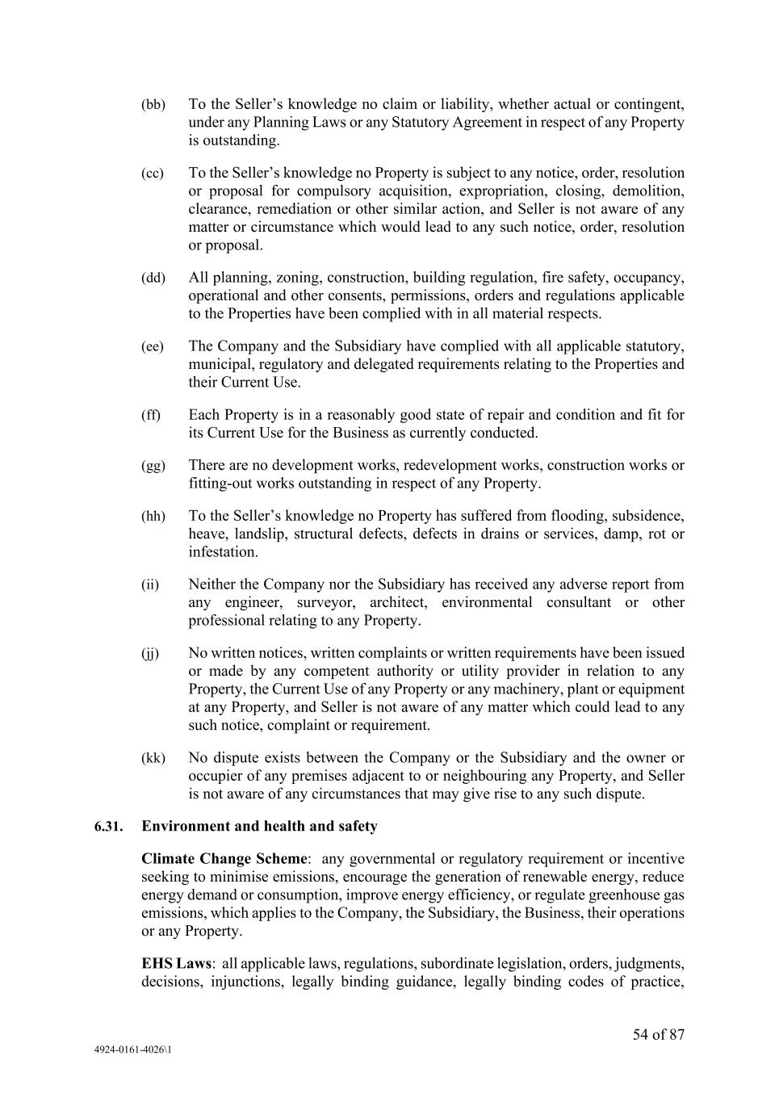
54 of 87 4924-0161-4026\1 (bb) To the Seller’s knowledge no claim or liability, whether actual or contingent, under any Planning Laws or any Statutory Agreement in respect of any Property is outstanding. (cc) To the Seller’s knowledge no Property is subject to any notice, order, resolution or proposal for compulsory acquisition, expropriation, closing, demolition, clearance, remediation or other similar action, and Seller is not aware of any matter or circumstance which would lead to any such notice, order, resolution or proposal. (dd) All planning, zoning, construction, building regulation, fire safety, occupancy, operational and other consents, permissions, orders and regulations applicable to the Properties have been complied with in all material respects. (ee) The Company and the Subsidiary have complied with all applicable statutory, municipal, regulatory and delegated requirements relating to the Properties and their Current Use. (ff) Each Property is in a reasonably good state of repair and condition and fit for its Current Use for the Business as currently conducted. (gg) There are no development works, redevelopment works, construction works or fitting-out works outstanding in respect of any Property. (hh) To the Seller’s knowledge no Property has suffered from flooding, subsidence, heave, landslip, structural defects, defects in drains or services, damp, rot or infestation. (ii) Neither the Company nor the Subsidiary has received any adverse report from any engineer, surveyor, architect, environmental consultant or other professional relating to any Property. (jj) No written notices, written complaints or written requirements have been issued or made by any competent authority or utility provider in relation to any Property, the Current Use of any Property or any machinery, plant or equipment at any Property, and Seller is not aware of any matter which could lead to any such notice, complaint or requirement. (kk) No dispute exists between the Company or the Subsidiary and the owner or occupier of any premises adjacent to or neighbouring any Property, and Seller is not aware of any circumstances that may give rise to any such dispute. 6.31. Environment and health and safety Climate Change Scheme: any governmental or regulatory requirement or incentive seeking to minimise emissions, encourage the generation of renewable energy, reduce energy demand or consumption, improve energy efficiency, or regulate greenhouse gas emissions, which applies to the Company, the Subsidiary, the Business, their operations or any Property. EHS Laws: all applicable laws, regulations, subordinate legislation, orders, judgments, decisions, injunctions, legally binding guidance, legally binding codes of practice,

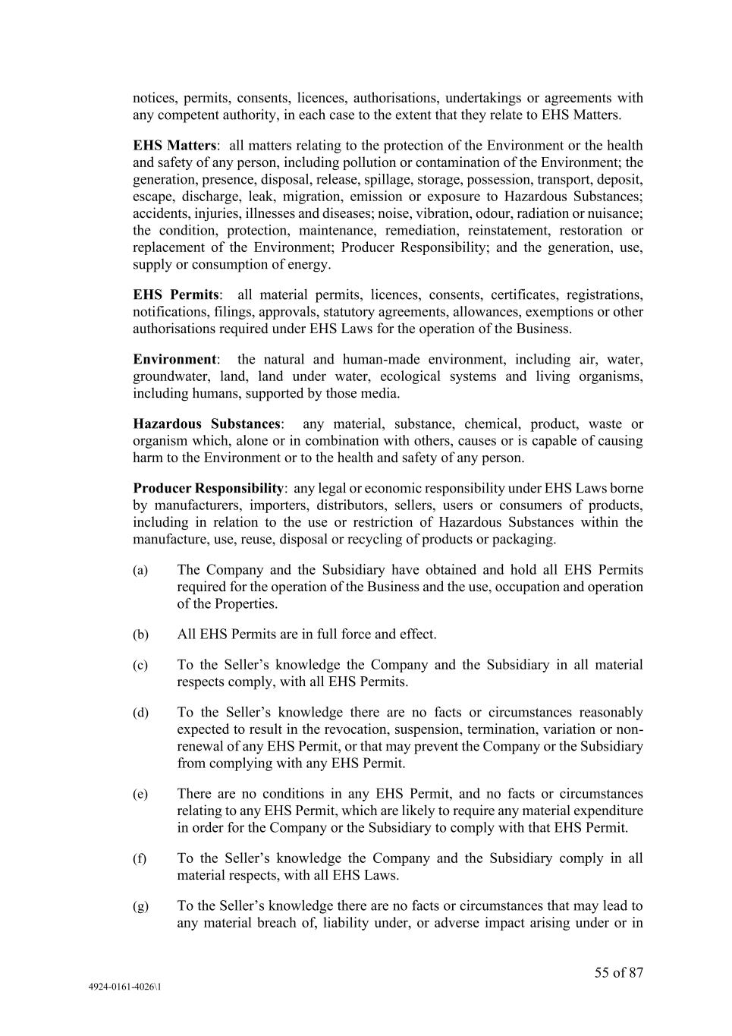
55 of 87 4924-0161-4026\1 notices, permits, consents, licences, authorisations, undertakings or agreements with any competent authority, in each case to the extent that they relate to EHS Matters. EHS Matters: all matters relating to the protection of the Environment or the health and safety of any person, including pollution or contamination of the Environment; the generation, presence, disposal, release, spillage, storage, possession, transport, deposit, escape, discharge, leak, migration, emission or exposure to Hazardous Substances; accidents, injuries, illnesses and diseases; noise, vibration, odour, radiation or nuisance; the condition, protection, maintenance, remediation, reinstatement, restoration or replacement of the Environment; Producer Responsibility; and the generation, use, supply or consumption of energy. EHS Permits: all material permits, licences, consents, certificates, registrations, notifications, filings, approvals, statutory agreements, allowances, exemptions or other authorisations required under EHS Laws for the operation of the Business. Environment: the natural and human-made environment, including air, water, groundwater, land, land under water, ecological systems and living organisms, including humans, supported by those media. Hazardous Substances: any material, substance, chemical, product, waste or organism which, alone or in combination with others, causes or is capable of causing harm to the Environment or to the health and safety of any person. Producer Responsibility: any legal or economic responsibility under EHS Laws borne by manufacturers, importers, distributors, sellers, users or consumers of products, including in relation to the use or restriction of Hazardous Substances within the manufacture, use, reuse, disposal or recycling of products or packaging. (a) The Company and the Subsidiary have obtained and hold all EHS Permits required for the operation of the Business and the use, occupation and operation of the Properties. (b) All EHS Permits are in full force and effect. (c) To the Seller’s knowledge the Company and the Subsidiary in all material respects comply, with all EHS Permits. (d) To the Seller’s knowledge there are no facts or circumstances reasonably expected to result in the revocation, suspension, termination, variation or non- renewal of any EHS Permit, or that may prevent the Company or the Subsidiary from complying with any EHS Permit. (e) There are no conditions in any EHS Permit, and no facts or circumstances relating to any EHS Permit, which are likely to require any material expenditure in order for the Company or the Subsidiary to comply with that EHS Permit. (f) To the Seller’s knowledge the Company and the Subsidiary comply in all material respects, with all EHS Laws. (g) To the Seller’s knowledge there are no facts or circumstances that may lead to any material breach of, liability under, or adverse impact arising under or in

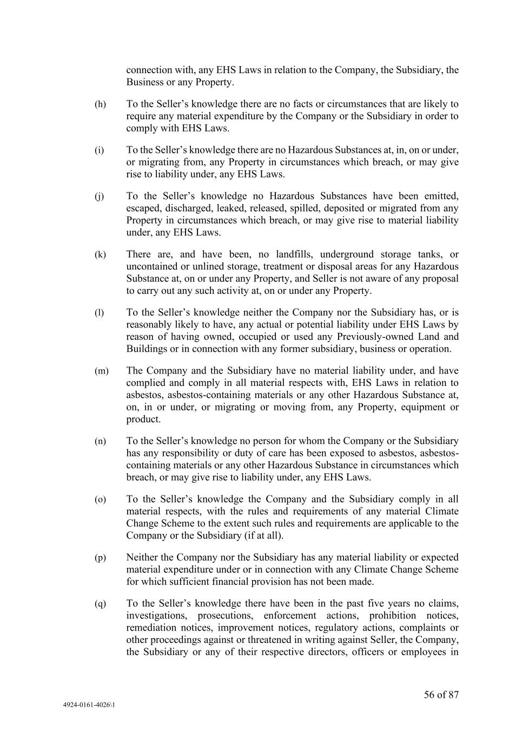
56 of 87 4924-0161-4026\1 connection with, any EHS Laws in relation to the Company, the Subsidiary, the Business or any Property. (h) To the Seller’s knowledge there are no facts or circumstances that are likely to require any material expenditure by the Company or the Subsidiary in order to comply with EHS Laws. (i) To the Seller’s knowledge there are no Hazardous Substances at, in, on or under, or migrating from, any Property in circumstances which breach, or may give rise to liability under, any EHS Laws. (j) To the Seller’s knowledge no Hazardous Substances have been emitted, escaped, discharged, leaked, released, spilled, deposited or migrated from any Property in circumstances which breach, or may give rise to material liability under, any EHS Laws. (k) There are, and have been, no landfills, underground storage tanks, or uncontained or unlined storage, treatment or disposal areas for any Hazardous Substance at, on or under any Property, and Seller is not aware of any proposal to carry out any such activity at, on or under any Property. (l) To the Seller’s knowledge neither the Company nor the Subsidiary has, or is reasonably likely to have, any actual or potential liability under EHS Laws by reason of having owned, occupied or used any Previously-owned Land and Buildings or in connection with any former subsidiary, business or operation. (m) The Company and the Subsidiary have no material liability under, and have complied and comply in all material respects with, EHS Laws in relation to asbestos, asbestos-containing materials or any other Hazardous Substance at, on, in or under, or migrating or moving from, any Property, equipment or product. (n) To the Seller’s knowledge no person for whom the Company or the Subsidiary has any responsibility or duty of care has been exposed to asbestos, asbestos- containing materials or any other Hazardous Substance in circumstances which breach, or may give rise to liability under, any EHS Laws. (o) To the Seller’s knowledge the Company and the Subsidiary comply in all material respects, with the rules and requirements of any material Climate Change Scheme to the extent such rules and requirements are applicable to the Company or the Subsidiary (if at all). (p) Neither the Company nor the Subsidiary has any material liability or expected material expenditure under or in connection with any Climate Change Scheme for which sufficient financial provision has not been made. (q) To the Seller’s knowledge there have been in the past five years no claims, investigations, prosecutions, enforcement actions, prohibition notices, remediation notices, improvement notices, regulatory actions, complaints or other proceedings against or threatened in writing against Seller, the Company, the Subsidiary or any of their respective directors, officers or employees in

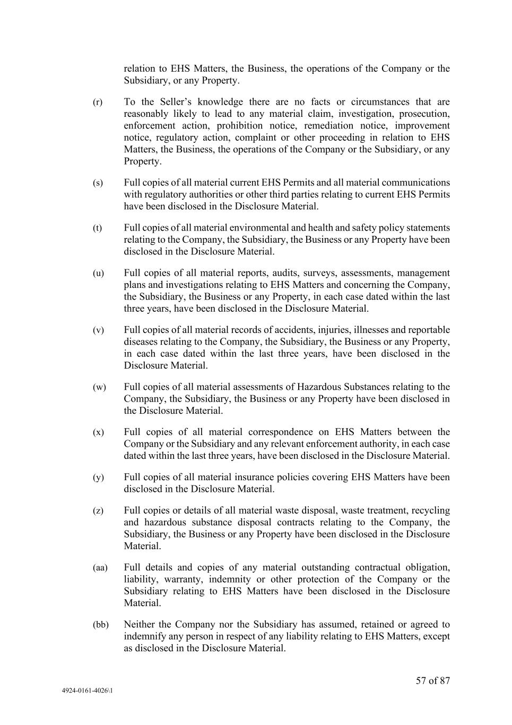
57 of 87 4924-0161-4026\1 relation to EHS Matters, the Business, the operations of the Company or the Subsidiary, or any Property. (r) To the Seller’s knowledge there are no facts or circumstances that are reasonably likely to lead to any material claim, investigation, prosecution, enforcement action, prohibition notice, remediation notice, improvement notice, regulatory action, complaint or other proceeding in relation to EHS Matters, the Business, the operations of the Company or the Subsidiary, or any Property. (s) Full copies of all material current EHS Permits and all material communications with regulatory authorities or other third parties relating to current EHS Permits have been disclosed in the Disclosure Material. (t) Full copies of all material environmental and health and safety policy statements relating to the Company, the Subsidiary, the Business or any Property have been disclosed in the Disclosure Material. (u) Full copies of all material reports, audits, surveys, assessments, management plans and investigations relating to EHS Matters and concerning the Company, the Subsidiary, the Business or any Property, in each case dated within the last three years, have been disclosed in the Disclosure Material. (v) Full copies of all material records of accidents, injuries, illnesses and reportable diseases relating to the Company, the Subsidiary, the Business or any Property, in each case dated within the last three years, have been disclosed in the Disclosure Material. (w) Full copies of all material assessments of Hazardous Substances relating to the Company, the Subsidiary, the Business or any Property have been disclosed in the Disclosure Material. (x) Full copies of all material correspondence on EHS Matters between the Company or the Subsidiary and any relevant enforcement authority, in each case dated within the last three years, have been disclosed in the Disclosure Material. (y) Full copies of all material insurance policies covering EHS Matters have been disclosed in the Disclosure Material. (z) Full copies or details of all material waste disposal, waste treatment, recycling and hazardous substance disposal contracts relating to the Company, the Subsidiary, the Business or any Property have been disclosed in the Disclosure Material. (aa) Full details and copies of any material outstanding contractual obligation, liability, warranty, indemnity or other protection of the Company or the Subsidiary relating to EHS Matters have been disclosed in the Disclosure Material. (bb) Neither the Company nor the Subsidiary has assumed, retained or agreed to indemnify any person in respect of any liability relating to EHS Matters, except as disclosed in the Disclosure Material.

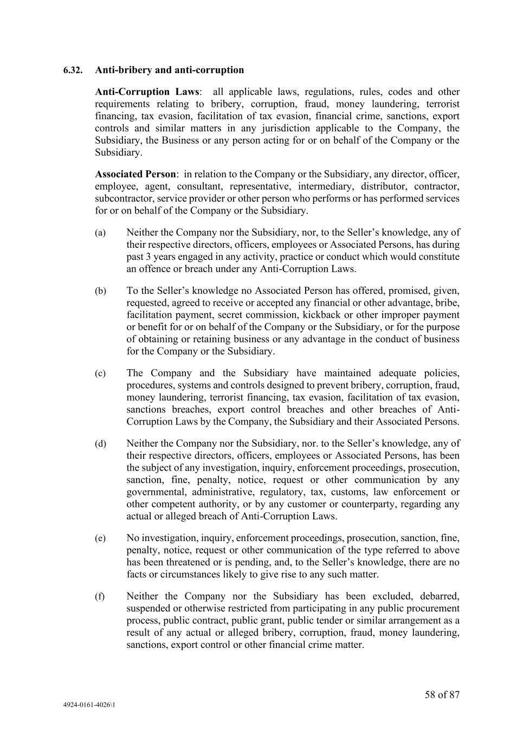
58 of 87 4924-0161-4026\1 6.32. Anti-bribery and anti-corruption Anti-Corruption Laws: all applicable laws, regulations, rules, codes and other requirements relating to bribery, corruption, fraud, money laundering, terrorist financing, tax evasion, facilitation of tax evasion, financial crime, sanctions, export controls and similar matters in any jurisdiction applicable to the Company, the Subsidiary, the Business or any person acting for or on behalf of the Company or the Subsidiary. Associated Person: in relation to the Company or the Subsidiary, any director, officer, employee, agent, consultant, representative, intermediary, distributor, contractor, subcontractor, service provider or other person who performs or has performed services for or on behalf of the Company or the Subsidiary. (a) Neither the Company nor the Subsidiary, nor, to the Seller’s knowledge, any of their respective directors, officers, employees or Associated Persons, has during past 3 years engaged in any activity, practice or conduct which would constitute an offence or breach under any Anti-Corruption Laws. (b) To the Seller’s knowledge no Associated Person has offered, promised, given, requested, agreed to receive or accepted any financial or other advantage, bribe, facilitation payment, secret commission, kickback or other improper payment or benefit for or on behalf of the Company or the Subsidiary, or for the purpose of obtaining or retaining business or any advantage in the conduct of business for the Company or the Subsidiary. (c) The Company and the Subsidiary have maintained adequate policies, procedures, systems and controls designed to prevent bribery, corruption, fraud, money laundering, terrorist financing, tax evasion, facilitation of tax evasion, sanctions breaches, export control breaches and other breaches of Anti- Corruption Laws by the Company, the Subsidiary and their Associated Persons. (d) Neither the Company nor the Subsidiary, nor. to the Seller’s knowledge, any of their respective directors, officers, employees or Associated Persons, has been the subject of any investigation, inquiry, enforcement proceedings, prosecution, sanction, fine, penalty, notice, request or other communication by any governmental, administrative, regulatory, tax, customs, law enforcement or other competent authority, or by any customer or counterparty, regarding any actual or alleged breach of Anti-Corruption Laws. (e) No investigation, inquiry, enforcement proceedings, prosecution, sanction, fine, penalty, notice, request or other communication of the type referred to above has been threatened or is pending, and, to the Seller’s knowledge, there are no facts or circumstances likely to give rise to any such matter. (f) Neither the Company nor the Subsidiary has been excluded, debarred, suspended or otherwise restricted from participating in any public procurement process, public contract, public grant, public tender or similar arrangement as a result of any actual or alleged bribery, corruption, fraud, money laundering, sanctions, export control or other financial crime matter.

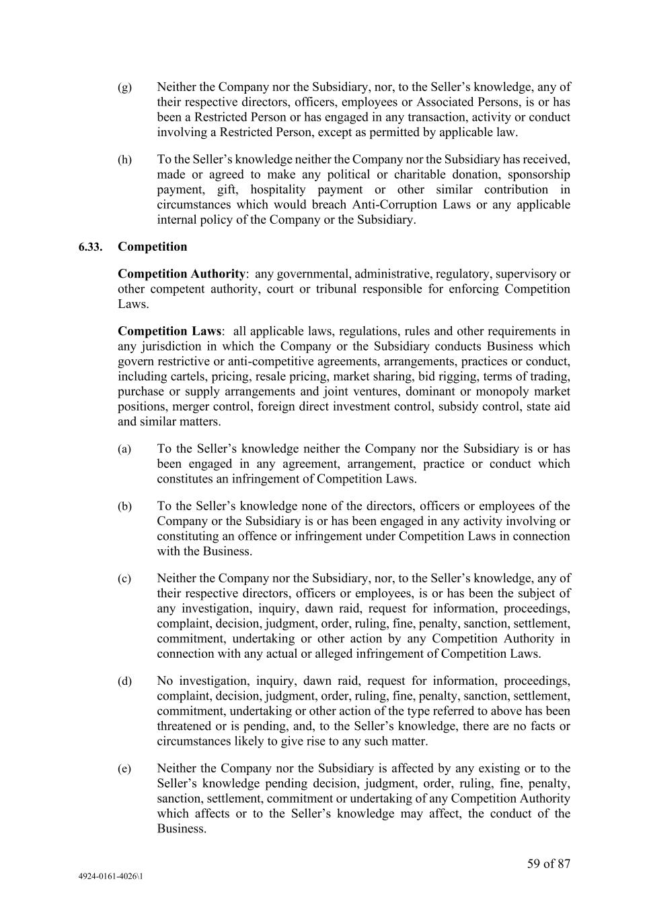
59 of 87 4924-0161-4026\1 (g) Neither the Company nor the Subsidiary, nor, to the Seller’s knowledge, any of their respective directors, officers, employees or Associated Persons, is or has been a Restricted Person or has engaged in any transaction, activity or conduct involving a Restricted Person, except as permitted by applicable law. (h) To the Seller’s knowledge neither the Company nor the Subsidiary has received, made or agreed to make any political or charitable donation, sponsorship payment, gift, hospitality payment or other similar contribution in circumstances which would breach Anti-Corruption Laws or any applicable internal policy of the Company or the Subsidiary. 6.33. Competition Competition Authority: any governmental, administrative, regulatory, supervisory or other competent authority, court or tribunal responsible for enforcing Competition Laws. Competition Laws: all applicable laws, regulations, rules and other requirements in any jurisdiction in which the Company or the Subsidiary conducts Business which govern restrictive or anti-competitive agreements, arrangements, practices or conduct, including cartels, pricing, resale pricing, market sharing, bid rigging, terms of trading, purchase or supply arrangements and joint ventures, dominant or monopoly market positions, merger control, foreign direct investment control, subsidy control, state aid and similar matters. (a) To the Seller’s knowledge neither the Company nor the Subsidiary is or has been engaged in any agreement, arrangement, practice or conduct which constitutes an infringement of Competition Laws. (b) To the Seller’s knowledge none of the directors, officers or employees of the Company or the Subsidiary is or has been engaged in any activity involving or constituting an offence or infringement under Competition Laws in connection with the Business. (c) Neither the Company nor the Subsidiary, nor, to the Seller’s knowledge, any of their respective directors, officers or employees, is or has been the subject of any investigation, inquiry, dawn raid, request for information, proceedings, complaint, decision, judgment, order, ruling, fine, penalty, sanction, settlement, commitment, undertaking or other action by any Competition Authority in connection with any actual or alleged infringement of Competition Laws. (d) No investigation, inquiry, dawn raid, request for information, proceedings, complaint, decision, judgment, order, ruling, fine, penalty, sanction, settlement, commitment, undertaking or other action of the type referred to above has been threatened or is pending, and, to the Seller’s knowledge, there are no facts or circumstances likely to give rise to any such matter. (e) Neither the Company nor the Subsidiary is affected by any existing or to the Seller’s knowledge pending decision, judgment, order, ruling, fine, penalty, sanction, settlement, commitment or undertaking of any Competition Authority which affects or to the Seller’s knowledge may affect, the conduct of the Business.

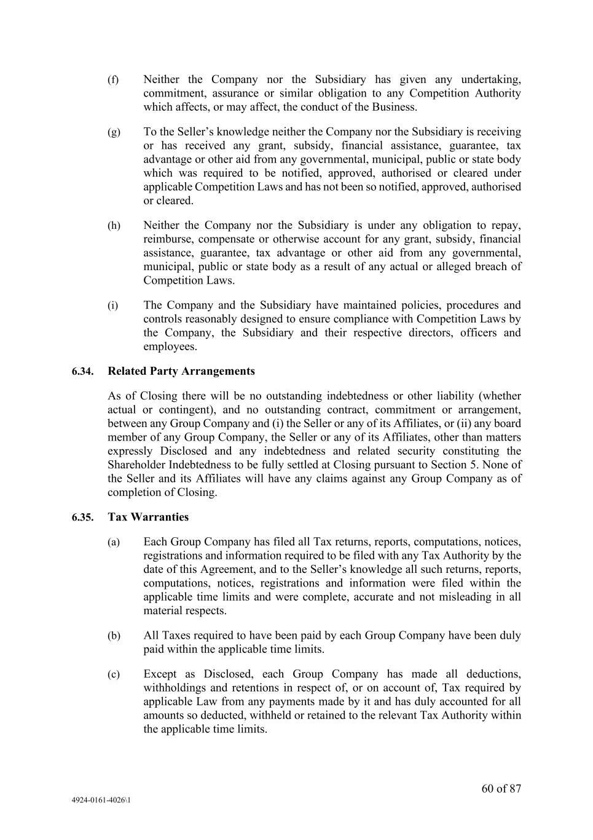
60 of 87 4924-0161-4026\1 (f) Neither the Company nor the Subsidiary has given any undertaking, commitment, assurance or similar obligation to any Competition Authority which affects, or may affect, the conduct of the Business. (g) To the Seller’s knowledge neither the Company nor the Subsidiary is receiving or has received any grant, subsidy, financial assistance, guarantee, tax advantage or other aid from any governmental, municipal, public or state body which was required to be notified, approved, authorised or cleared under applicable Competition Laws and has not been so notified, approved, authorised or cleared. (h) Neither the Company nor the Subsidiary is under any obligation to repay, reimburse, compensate or otherwise account for any grant, subsidy, financial assistance, guarantee, tax advantage or other aid from any governmental, municipal, public or state body as a result of any actual or alleged breach of Competition Laws. (i) The Company and the Subsidiary have maintained policies, procedures and controls reasonably designed to ensure compliance with Competition Laws by the Company, the Subsidiary and their respective directors, officers and employees. 6.34. Related Party Arrangements As of Closing there will be no outstanding indebtedness or other liability (whether actual or contingent), and no outstanding contract, commitment or arrangement, between any Group Company and (i) the Seller or any of its Affiliates, or (ii) any board member of any Group Company, the Seller or any of its Affiliates, other than matters expressly Disclosed and any indebtedness and related security constituting the Shareholder Indebtedness to be fully settled at Closing pursuant to Section 5. None of the Seller and its Affiliates will have any claims against any Group Company as of completion of Closing. 6.35. Tax Warranties (a) Each Group Company has filed all Tax returns, reports, computations, notices, registrations and information required to be filed with any Tax Authority by the date of this Agreement, and to the Seller’s knowledge all such returns, reports, computations, notices, registrations and information were filed within the applicable time limits and were complete, accurate and not misleading in all material respects. (b) All Taxes required to have been paid by each Group Company have been duly paid within the applicable time limits. (c) Except as Disclosed, each Group Company has made all deductions, withholdings and retentions in respect of, or on account of, Tax required by applicable Law from any payments made by it and has duly accounted for all amounts so deducted, withheld or retained to the relevant Tax Authority within the applicable time limits.

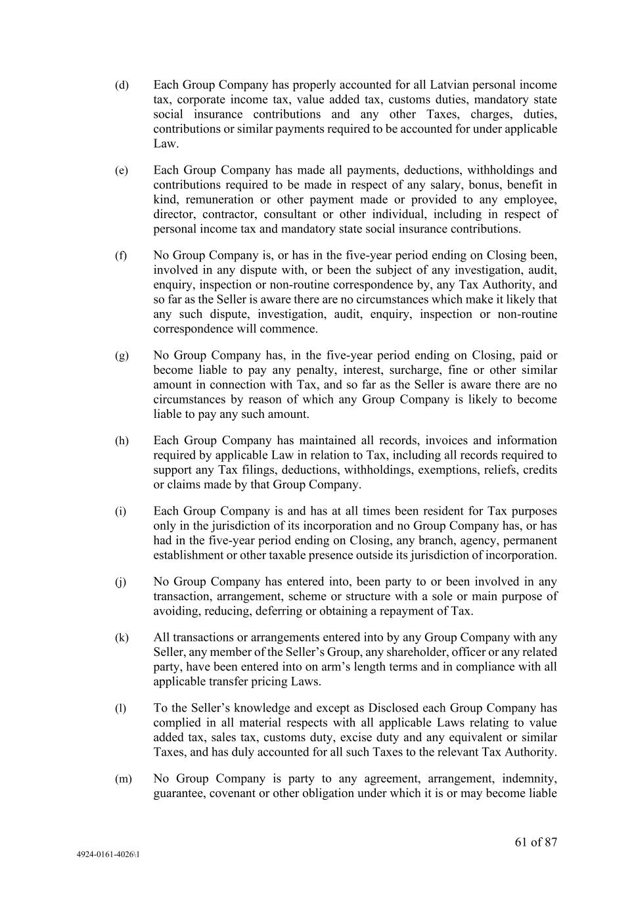
61 of 87 4924-0161-4026\1 (d) Each Group Company has properly accounted for all Latvian personal income tax, corporate income tax, value added tax, customs duties, mandatory state social insurance contributions and any other Taxes, charges, duties, contributions or similar payments required to be accounted for under applicable Law. (e) Each Group Company has made all payments, deductions, withholdings and contributions required to be made in respect of any salary, bonus, benefit in kind, remuneration or other payment made or provided to any employee, director, contractor, consultant or other individual, including in respect of personal income tax and mandatory state social insurance contributions. (f) No Group Company is, or has in the five-year period ending on Closing been, involved in any dispute with, or been the subject of any investigation, audit, enquiry, inspection or non-routine correspondence by, any Tax Authority, and so far as the Seller is aware there are no circumstances which make it likely that any such dispute, investigation, audit, enquiry, inspection or non-routine correspondence will commence. (g) No Group Company has, in the five-year period ending on Closing, paid or become liable to pay any penalty, interest, surcharge, fine or other similar amount in connection with Tax, and so far as the Seller is aware there are no circumstances by reason of which any Group Company is likely to become liable to pay any such amount. (h) Each Group Company has maintained all records, invoices and information required by applicable Law in relation to Tax, including all records required to support any Tax filings, deductions, withholdings, exemptions, reliefs, credits or claims made by that Group Company. (i) Each Group Company is and has at all times been resident for Tax purposes only in the jurisdiction of its incorporation and no Group Company has, or has had in the five-year period ending on Closing, any branch, agency, permanent establishment or other taxable presence outside its jurisdiction of incorporation. (j) No Group Company has entered into, been party to or been involved in any transaction, arrangement, scheme or structure with a sole or main purpose of avoiding, reducing, deferring or obtaining a repayment of Tax. (k) All transactions or arrangements entered into by any Group Company with any Seller, any member of the Seller’s Group, any shareholder, officer or any related party, have been entered into on arm’s length terms and in compliance with all applicable transfer pricing Laws. (l) To the Seller’s knowledge and except as Disclosed each Group Company has complied in all material respects with all applicable Laws relating to value added tax, sales tax, customs duty, excise duty and any equivalent or similar Taxes, and has duly accounted for all such Taxes to the relevant Tax Authority. (m) No Group Company is party to any agreement, arrangement, indemnity, guarantee, covenant or other obligation under which it is or may become liable

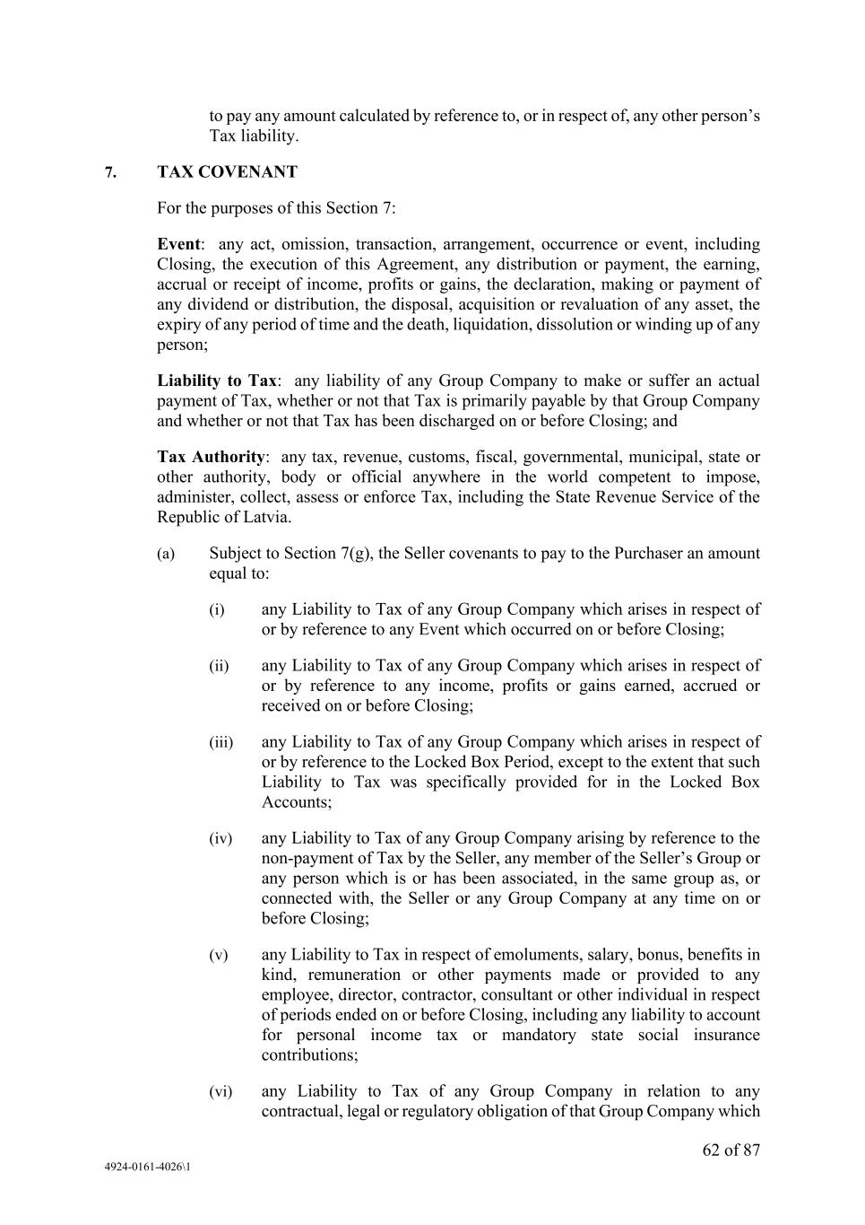
62 of 87 4924-0161-4026\1 to pay any amount calculated by reference to, or in respect of, any other person’s Tax liability. 7. TAX COVENANT For the purposes of this Section 7: Event: any act, omission, transaction, arrangement, occurrence or event, including Closing, the execution of this Agreement, any distribution or payment, the earning, accrual or receipt of income, profits or gains, the declaration, making or payment of any dividend or distribution, the disposal, acquisition or revaluation of any asset, the expiry of any period of time and the death, liquidation, dissolution or winding up of any person; Liability to Tax: any liability of any Group Company to make or suffer an actual payment of Tax, whether or not that Tax is primarily payable by that Group Company and whether or not that Tax has been discharged on or before Closing; and Tax Authority: any tax, revenue, customs, fiscal, governmental, municipal, state or other authority, body or official anywhere in the world competent to impose, administer, collect, assess or enforce Tax, including the State Revenue Service of the Republic of Latvia. (a) Subject to Section 7(g), the Seller covenants to pay to the Purchaser an amount equal to: (i) any Liability to Tax of any Group Company which arises in respect of or by reference to any Event which occurred on or before Closing; (ii) any Liability to Tax of any Group Company which arises in respect of or by reference to any income, profits or gains earned, accrued or received on or before Closing; (iii) any Liability to Tax of any Group Company which arises in respect of or by reference to the Locked Box Period, except to the extent that such Liability to Tax was specifically provided for in the Locked Box Accounts; (iv) any Liability to Tax of any Group Company arising by reference to the non-payment of Tax by the Seller, any member of the Seller’s Group or any person which is or has been associated, in the same group as, or connected with, the Seller or any Group Company at any time on or before Closing; (v) any Liability to Tax in respect of emoluments, salary, bonus, benefits in kind, remuneration or other payments made or provided to any employee, director, contractor, consultant or other individual in respect of periods ended on or before Closing, including any liability to account for personal income tax or mandatory state social insurance contributions; (vi) any Liability to Tax of any Group Company in relation to any contractual, legal or regulatory obligation of that Group Company which

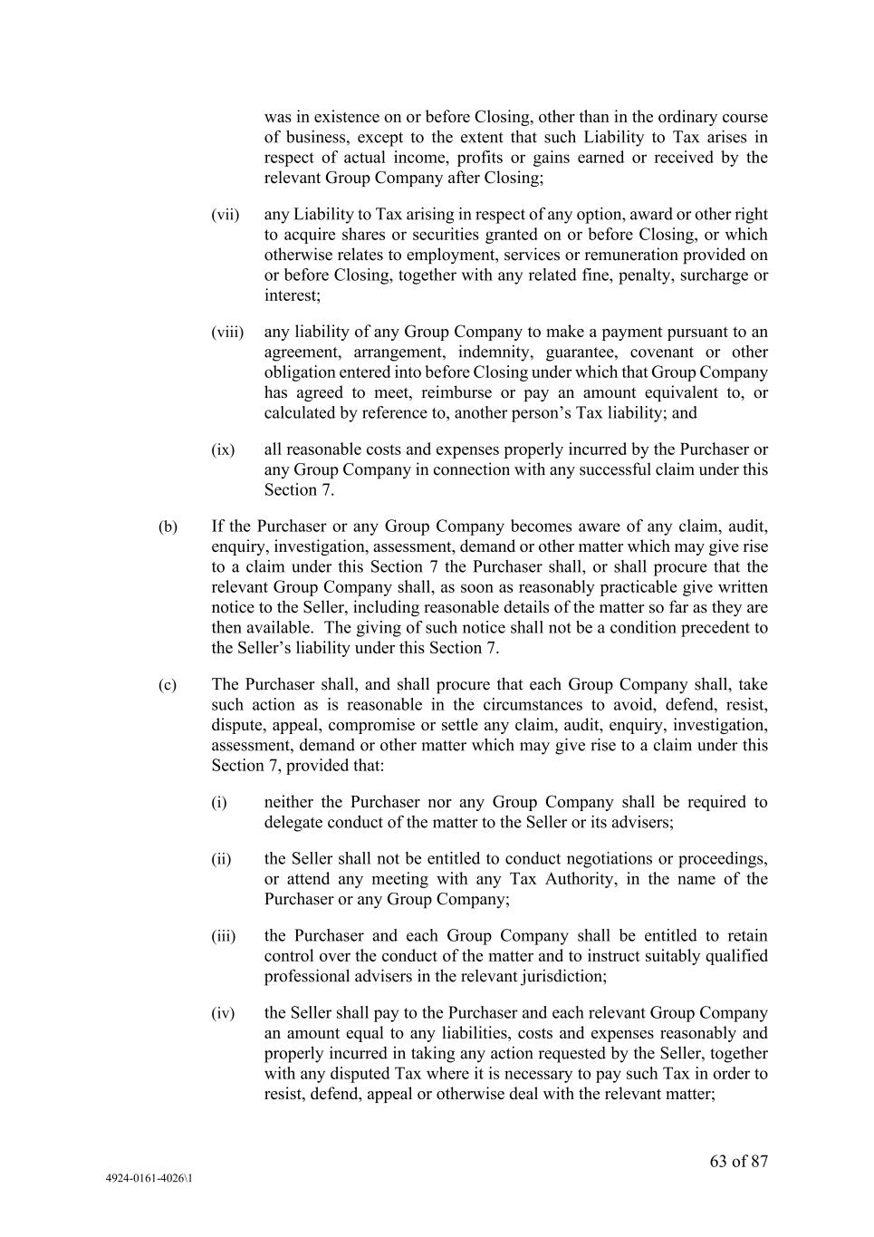
63 of 87 4924-0161-4026\1 was in existence on or before Closing, other than in the ordinary course of business, except to the extent that such Liability to Tax arises in respect of actual income, profits or gains earned or received by the relevant Group Company after Closing; (vii) any Liability to Tax arising in respect of any option, award or other right to acquire shares or securities granted on or before Closing, or which otherwise relates to employment, services or remuneration provided on or before Closing, together with any related fine, penalty, surcharge or interest; (viii) any liability of any Group Company to make a payment pursuant to an agreement, arrangement, indemnity, guarantee, covenant or other obligation entered into before Closing under which that Group Company has agreed to meet, reimburse or pay an amount equivalent to, or calculated by reference to, another person’s Tax liability; and (ix) all reasonable costs and expenses properly incurred by the Purchaser or any Group Company in connection with any successful claim under this Section 7. (b) If the Purchaser or any Group Company becomes aware of any claim, audit, enquiry, investigation, assessment, demand or other matter which may give rise to a claim under this Section 7 the Purchaser shall, or shall procure that the relevant Group Company shall, as soon as reasonably practicable give written notice to the Seller, including reasonable details of the matter so far as they are then available. The giving of such notice shall not be a condition precedent to the Seller’s liability under this Section 7. (c) The Purchaser shall, and shall procure that each Group Company shall, take such action as is reasonable in the circumstances to avoid, defend, resist, dispute, appeal, compromise or settle any claim, audit, enquiry, investigation, assessment, demand or other matter which may give rise to a claim under this Section 7, provided that: (i) neither the Purchaser nor any Group Company shall be required to delegate conduct of the matter to the Seller or its advisers; (ii) the Seller shall not be entitled to conduct negotiations or proceedings, or attend any meeting with any Tax Authority, in the name of the Purchaser or any Group Company; (iii) the Purchaser and each Group Company shall be entitled to retain control over the conduct of the matter and to instruct suitably qualified professional advisers in the relevant jurisdiction; (iv) the Seller shall pay to the Purchaser and each relevant Group Company an amount equal to any liabilities, costs and expenses reasonably and properly incurred in taking any action requested by the Seller, together with any disputed Tax where it is necessary to pay such Tax in order to resist, defend, appeal or otherwise deal with the relevant matter;

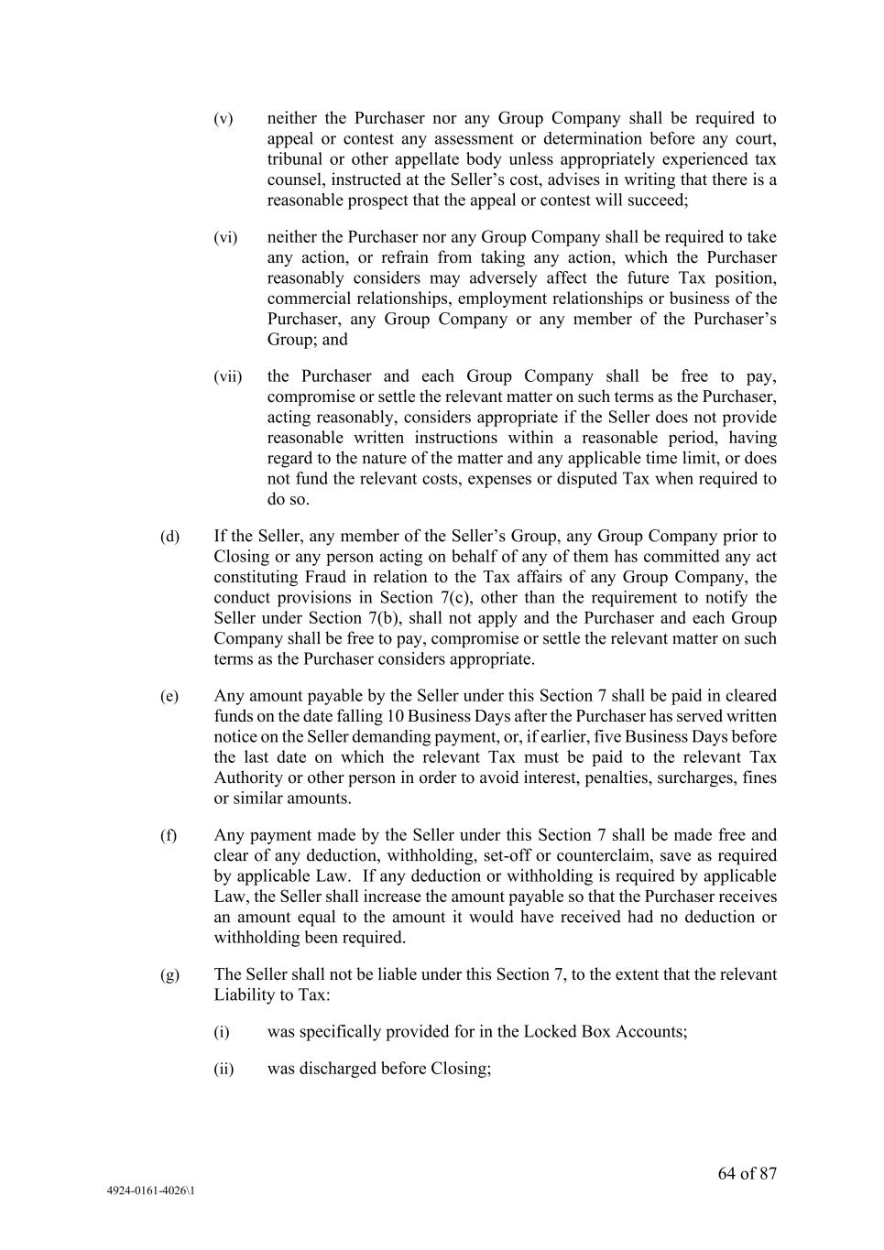
64 of 87 4924-0161-4026\1 (v) neither the Purchaser nor any Group Company shall be required to appeal or contest any assessment or determination before any court, tribunal or other appellate body unless appropriately experienced tax counsel, instructed at the Seller’s cost, advises in writing that there is a reasonable prospect that the appeal or contest will succeed; (vi) neither the Purchaser nor any Group Company shall be required to take any action, or refrain from taking any action, which the Purchaser reasonably considers may adversely affect the future Tax position, commercial relationships, employment relationships or business of the Purchaser, any Group Company or any member of the Purchaser’s Group; and (vii) the Purchaser and each Group Company shall be free to pay, compromise or settle the relevant matter on such terms as the Purchaser, acting reasonably, considers appropriate if the Seller does not provide reasonable written instructions within a reasonable period, having regard to the nature of the matter and any applicable time limit, or does not fund the relevant costs, expenses or disputed Tax when required to do so. (d) If the Seller, any member of the Seller’s Group, any Group Company prior to Closing or any person acting on behalf of any of them has committed any act constituting Fraud in relation to the Tax affairs of any Group Company, the conduct provisions in Section 7(c), other than the requirement to notify the Seller under Section 7(b), shall not apply and the Purchaser and each Group Company shall be free to pay, compromise or settle the relevant matter on such terms as the Purchaser considers appropriate. (e) Any amount payable by the Seller under this Section 7 shall be paid in cleared funds on the date falling 10 Business Days after the Purchaser has served written notice on the Seller demanding payment, or, if earlier, five Business Days before the last date on which the relevant Tax must be paid to the relevant Tax Authority or other person in order to avoid interest, penalties, surcharges, fines or similar amounts. (f) Any payment made by the Seller under this Section 7 shall be made free and clear of any deduction, withholding, set-off or counterclaim, save as required by applicable Law. If any deduction or withholding is required by applicable Law, the Seller shall increase the amount payable so that the Purchaser receives an amount equal to the amount it would have received had no deduction or withholding been required. (g) The Seller shall not be liable under this Section 7, to the extent that the relevant Liability to Tax: (i) was specifically provided for in the Locked Box Accounts; (ii) was discharged before Closing;

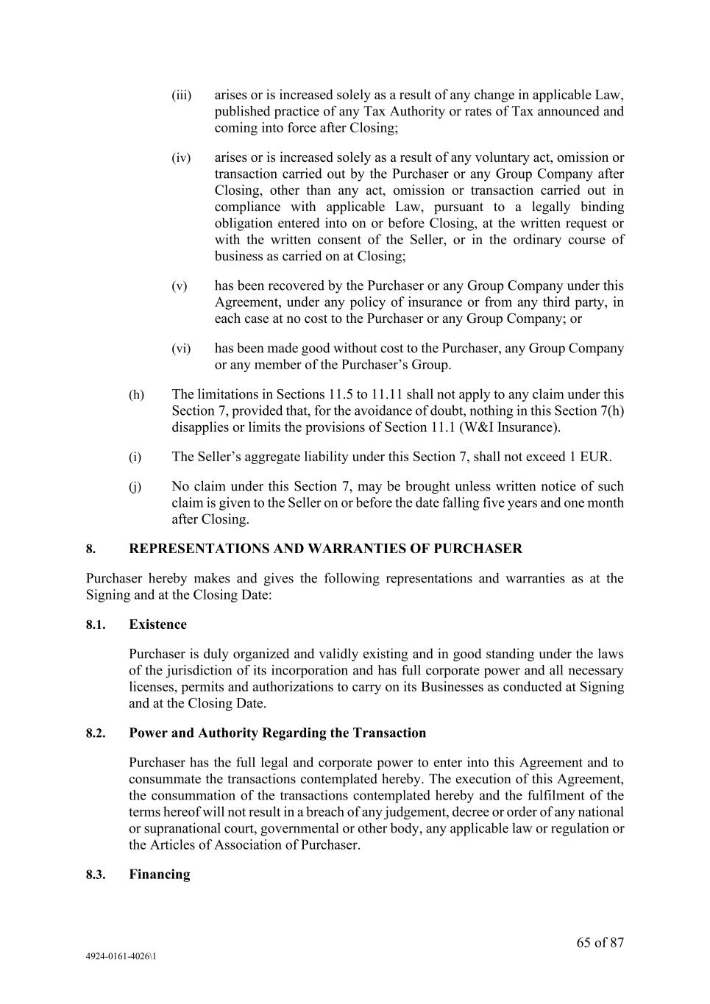
65 of 87 4924-0161-4026\1 (iii) arises or is increased solely as a result of any change in applicable Law, published practice of any Tax Authority or rates of Tax announced and coming into force after Closing; (iv) arises or is increased solely as a result of any voluntary act, omission or transaction carried out by the Purchaser or any Group Company after Closing, other than any act, omission or transaction carried out in compliance with applicable Law, pursuant to a legally binding obligation entered into on or before Closing, at the written request or with the written consent of the Seller, or in the ordinary course of business as carried on at Closing; (v) has been recovered by the Purchaser or any Group Company under this Agreement, under any policy of insurance or from any third party, in each case at no cost to the Purchaser or any Group Company; or (vi) has been made good without cost to the Purchaser, any Group Company or any member of the Purchaser’s Group. (h) The limitations in Sections 11.5 to 11.11 shall not apply to any claim under this Section 7, provided that, for the avoidance of doubt, nothing in this Section 7(h) disapplies or limits the provisions of Section 11.1 (W&I Insurance). (i) The Seller’s aggregate liability under this Section 7, shall not exceed 1 EUR. (j) No claim under this Section 7, may be brought unless written notice of such claim is given to the Seller on or before the date falling five years and one month after Closing. 8. REPRESENTATIONS AND WARRANTIES OF PURCHASER Purchaser hereby makes and gives the following representations and warranties as at the Signing and at the Closing Date: 8.1. Existence Purchaser is duly organized and validly existing and in good standing under the laws of the jurisdiction of its incorporation and has full corporate power and all necessary licenses, permits and authorizations to carry on its Businesses as conducted at Signing and at the Closing Date. 8.2. Power and Authority Regarding the Transaction Purchaser has the full legal and corporate power to enter into this Agreement and to consummate the transactions contemplated hereby. The execution of this Agreement, the consummation of the transactions contemplated hereby and the fulfilment of the terms hereof will not result in a breach of any judgement, decree or order of any national or supranational court, governmental or other body, any applicable law or regulation or the Articles of Association of Purchaser. 8.3. Financing

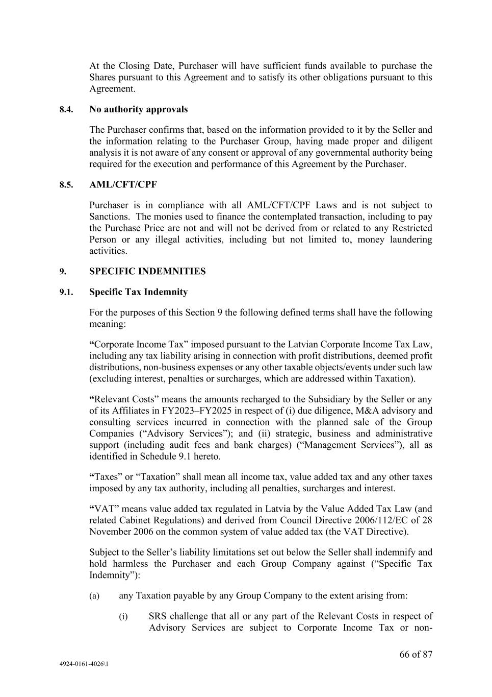
66 of 87 4924-0161-4026\1 At the Closing Date, Purchaser will have sufficient funds available to purchase the Shares pursuant to this Agreement and to satisfy its other obligations pursuant to this Agreement. 8.4. No authority approvals The Purchaser confirms that, based on the information provided to it by the Seller and the information relating to the Purchaser Group, having made proper and diligent analysis it is not aware of any consent or approval of any governmental authority being required for the execution and performance of this Agreement by the Purchaser. 8.5. AML/CFT/CPF Purchaser is in compliance with all AML/CFT/CPF Laws and is not subject to Sanctions. The monies used to finance the contemplated transaction, including to pay the Purchase Price are not and will not be derived from or related to any Restricted Person or any illegal activities, including but not limited to, money laundering activities. 9. SPECIFIC INDEMNITIES 9.1. Specific Tax Indemnity For the purposes of this Section 9 the following defined terms shall have the following meaning: “Corporate Income Tax” imposed pursuant to the Latvian Corporate Income Tax Law, including any tax liability arising in connection with profit distributions, deemed profit distributions, non-business expenses or any other taxable objects/events under such law (excluding interest, penalties or surcharges, which are addressed within Taxation). “Relevant Costs” means the amounts recharged to the Subsidiary by the Seller or any of its Affiliates in FY2023–FY2025 in respect of (i) due diligence, M&A advisory and consulting services incurred in connection with the planned sale of the Group Companies (“Advisory Services”); and (ii) strategic, business and administrative support (including audit fees and bank charges) (“Management Services”), all as identified in Schedule 9.1 hereto. “Taxes” or “Taxation” shall mean all income tax, value added tax and any other taxes imposed by any tax authority, including all penalties, surcharges and interest. “VAT” means value added tax regulated in Latvia by the Value Added Tax Law (and related Cabinet Regulations) and derived from Council Directive 2006/112/EC of 28 November 2006 on the common system of value added tax (the VAT Directive). Subject to the Seller’s liability limitations set out below the Seller shall indemnify and hold harmless the Purchaser and each Group Company against (“Specific Tax Indemnity”): (a) any Taxation payable by any Group Company to the extent arising from: (i) SRS challenge that all or any part of the Relevant Costs in respect of Advisory Services are subject to Corporate Income Tax or non-

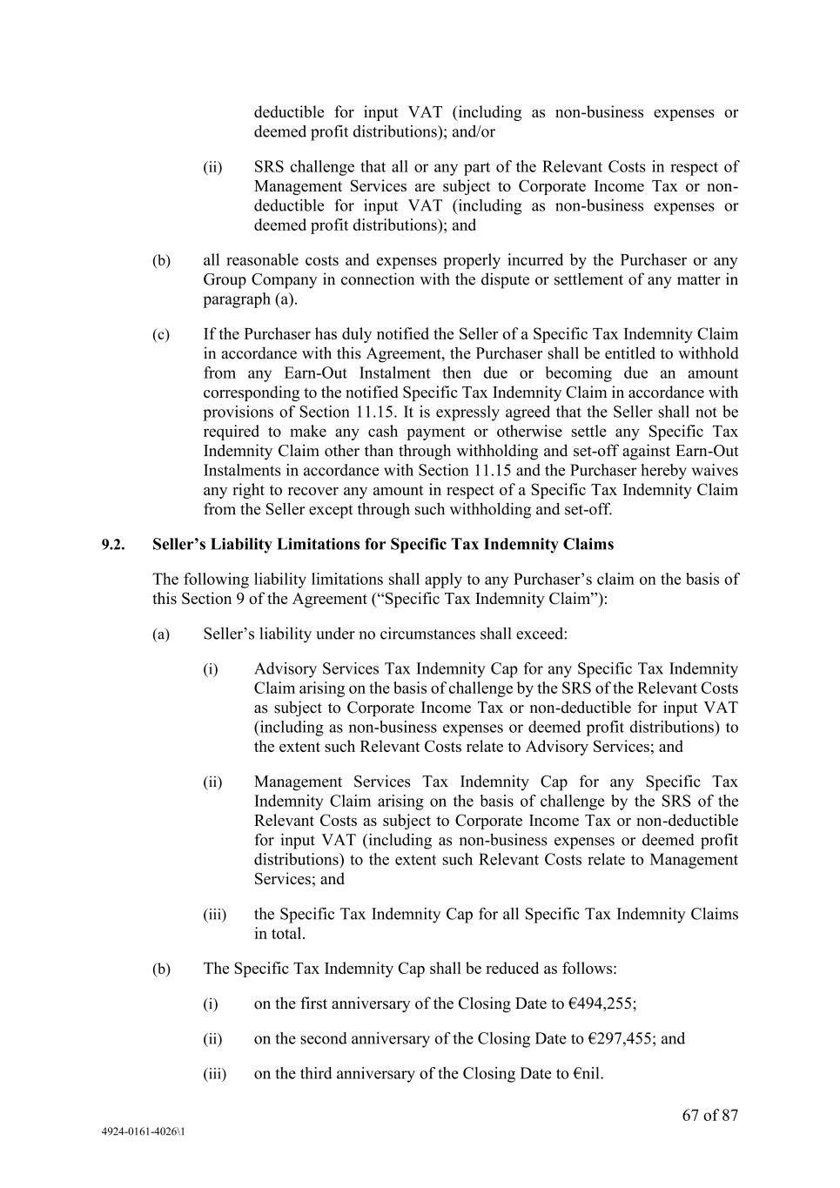
67 of 87 4924-0161-4026\1 deductible for input VAT (including as non-business expenses or deemed profit distributions); and/or (ii) SRS challenge that all or any part of the Relevant Costs in respect of Management Services are subject to Corporate Income Tax or non- deductible for input VAT (including as non-business expenses or deemed profit distributions); and (b) all reasonable costs and expenses properly incurred by the Purchaser or any Group Company in connection with the dispute or settlement of any matter in paragraph (a). (c) If the Purchaser has duly notified the Seller of a Specific Tax Indemnity Claim in accordance with this Agreement, the Purchaser shall be entitled to withhold from any Earn-Out Instalment then due or becoming due an amount corresponding to the notified Specific Tax Indemnity Claim in accordance with provisions of Section 11.15. It is expressly agreed that the Seller shall not be required to make any cash payment or otherwise settle any Specific Tax Indemnity Claim other than through withholding and set-off against Earn-Out Instalments in accordance with Section 11.15 and the Purchaser hereby waives any right to recover any amount in respect of a Specific Tax Indemnity Claim from the Seller except through such withholding and set-off. 9.2. Seller’s Liability Limitations for Specific Tax Indemnity Claims The following liability limitations shall apply to any Purchaser’s claim on the basis of this Section 9 of the Agreement (“Specific Tax Indemnity Claim”): (a) Seller’s liability under no circumstances shall exceed: (i) Advisory Services Tax Indemnity Cap for any Specific Tax Indemnity Claim arising on the basis of challenge by the SRS of the Relevant Costs as subject to Corporate Income Tax or non-deductible for input VAT (including as non-business expenses or deemed profit distributions) to the extent such Relevant Costs relate to Advisory Services; and (ii) Management Services Tax Indemnity Cap for any Specific Tax Indemnity Claim arising on the basis of challenge by the SRS of the Relevant Costs as subject to Corporate Income Tax or non-deductible for input VAT (including as non-business expenses or deemed profit distributions) to the extent such Relevant Costs relate to Management Services; and (iii) the Specific Tax Indemnity Cap for all Specific Tax Indemnity Claims in total. (b) The Specific Tax Indemnity Cap shall be reduced as follows: (i) on the first anniversary of the Closing Date to €494,255; (ii) on the second anniversary of the Closing Date to €297,455; and (iii) on the third anniversary of the Closing Date to €nil.

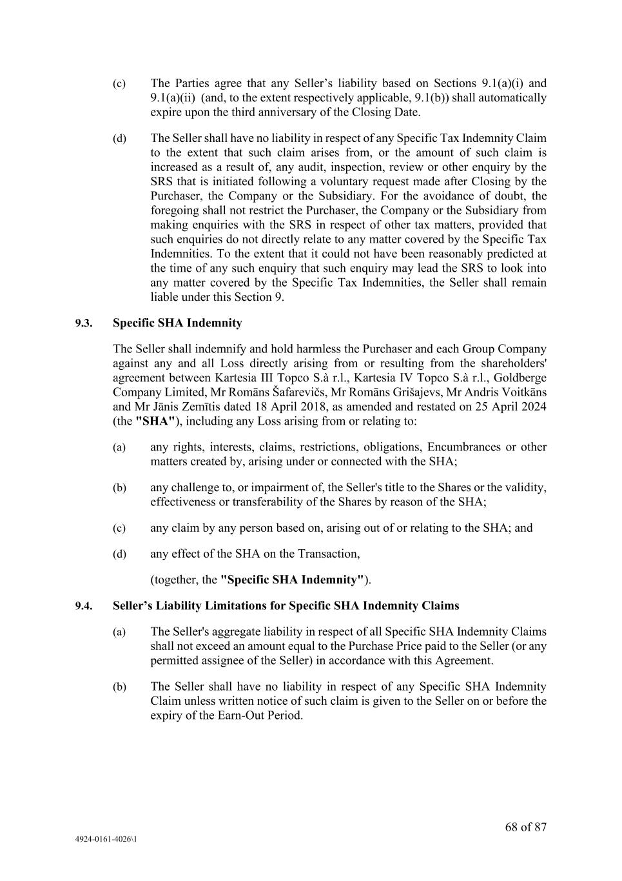
68 of 87 4924-0161-4026\1 (c) The Parties agree that any Seller’s liability based on Sections 9.1(a)(i) and 9.1(a)(ii) (and, to the extent respectively applicable, 9.1(b)) shall automatically expire upon the third anniversary of the Closing Date. (d) The Seller shall have no liability in respect of any Specific Tax Indemnity Claim to the extent that such claim arises from, or the amount of such claim is increased as a result of, any audit, inspection, review or other enquiry by the SRS that is initiated following a voluntary request made after Closing by the Purchaser, the Company or the Subsidiary. For the avoidance of doubt, the foregoing shall not restrict the Purchaser, the Company or the Subsidiary from making enquiries with the SRS in respect of other tax matters, provided that such enquiries do not directly relate to any matter covered by the Specific Tax Indemnities. To the extent that it could not have been reasonably predicted at the time of any such enquiry that such enquiry may lead the SRS to look into any matter covered by the Specific Tax Indemnities, the Seller shall remain liable under this Section 9. 9.3. Specific SHA Indemnity The Seller shall indemnify and hold harmless the Purchaser and each Group Company against any and all Loss directly arising from or resulting from the shareholders' agreement between Kartesia III Topco S.à r.l., Kartesia IV Topco S.à r.l., Goldberge Company Limited, Mr Romāns Šafarevičs, Mr Romāns Grišajevs, Mr Andris Voitkāns and Mr Jānis Zemītis dated 18 April 2018, as amended and restated on 25 April 2024 (the "SHA"), including any Loss arising from or relating to: (a) any rights, interests, claims, restrictions, obligations, Encumbrances or other matters created by, arising under or connected with the SHA; (b) any challenge to, or impairment of, the Seller's title to the Shares or the validity, effectiveness or transferability of the Shares by reason of the SHA; (c) any claim by any person based on, arising out of or relating to the SHA; and (d) any effect of the SHA on the Transaction, (together, the "Specific SHA Indemnity"). 9.4. Seller’s Liability Limitations for Specific SHA Indemnity Claims (a) The Seller's aggregate liability in respect of all Specific SHA Indemnity Claims shall not exceed an amount equal to the Purchase Price paid to the Seller (or any permitted assignee of the Seller) in accordance with this Agreement. (b) The Seller shall have no liability in respect of any Specific SHA Indemnity Claim unless written notice of such claim is given to the Seller on or before the expiry of the Earn-Out Period.

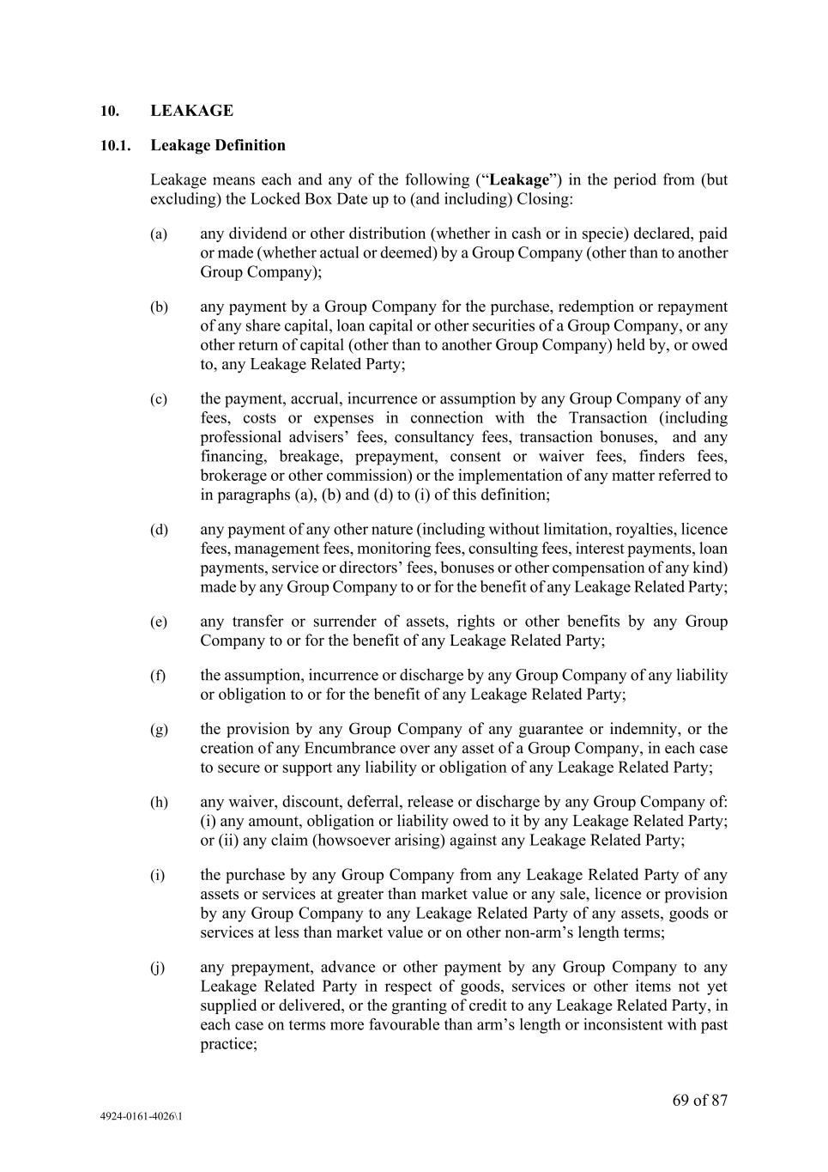
69 of 87 4924-0161-4026\1 10. LEAKAGE 10.1. Leakage Definition Leakage means each and any of the following (“Leakage”) in the period from (but excluding) the Locked Box Date up to (and including) Closing: (a) any dividend or other distribution (whether in cash or in specie) declared, paid or made (whether actual or deemed) by a Group Company (other than to another Group Company); (b) any payment by a Group Company for the purchase, redemption or repayment of any share capital, loan capital or other securities of a Group Company, or any other return of capital (other than to another Group Company) held by, or owed to, any Leakage Related Party; (c) the payment, accrual, incurrence or assumption by any Group Company of any fees, costs or expenses in connection with the Transaction (including professional advisers’ fees, consultancy fees, transaction bonuses, and any financing, breakage, prepayment, consent or waiver fees, finders fees, brokerage or other commission) or the implementation of any matter referred to in paragraphs (a), (b) and (d) to (i) of this definition; (d) any payment of any other nature (including without limitation, royalties, licence fees, management fees, monitoring fees, consulting fees, interest payments, loan payments, service or directors’ fees, bonuses or other compensation of any kind) made by any Group Company to or for the benefit of any Leakage Related Party; (e) any transfer or surrender of assets, rights or other benefits by any Group Company to or for the benefit of any Leakage Related Party; (f) the assumption, incurrence or discharge by any Group Company of any liability or obligation to or for the benefit of any Leakage Related Party; (g) the provision by any Group Company of any guarantee or indemnity, or the creation of any Encumbrance over any asset of a Group Company, in each case to secure or support any liability or obligation of any Leakage Related Party; (h) any waiver, discount, deferral, release or discharge by any Group Company of: (i) any amount, obligation or liability owed to it by any Leakage Related Party; or (ii) any claim (howsoever arising) against any Leakage Related Party; (i) the purchase by any Group Company from any Leakage Related Party of any assets or services at greater than market value or any sale, licence or provision by any Group Company to any Leakage Related Party of any assets, goods or services at less than market value or on other non-arm’s length terms; (j) any prepayment, advance or other payment by any Group Company to any Leakage Related Party in respect of goods, services or other items not yet supplied or delivered, or the granting of credit to any Leakage Related Party, in each case on terms more favourable than arm’s length or inconsistent with past practice;

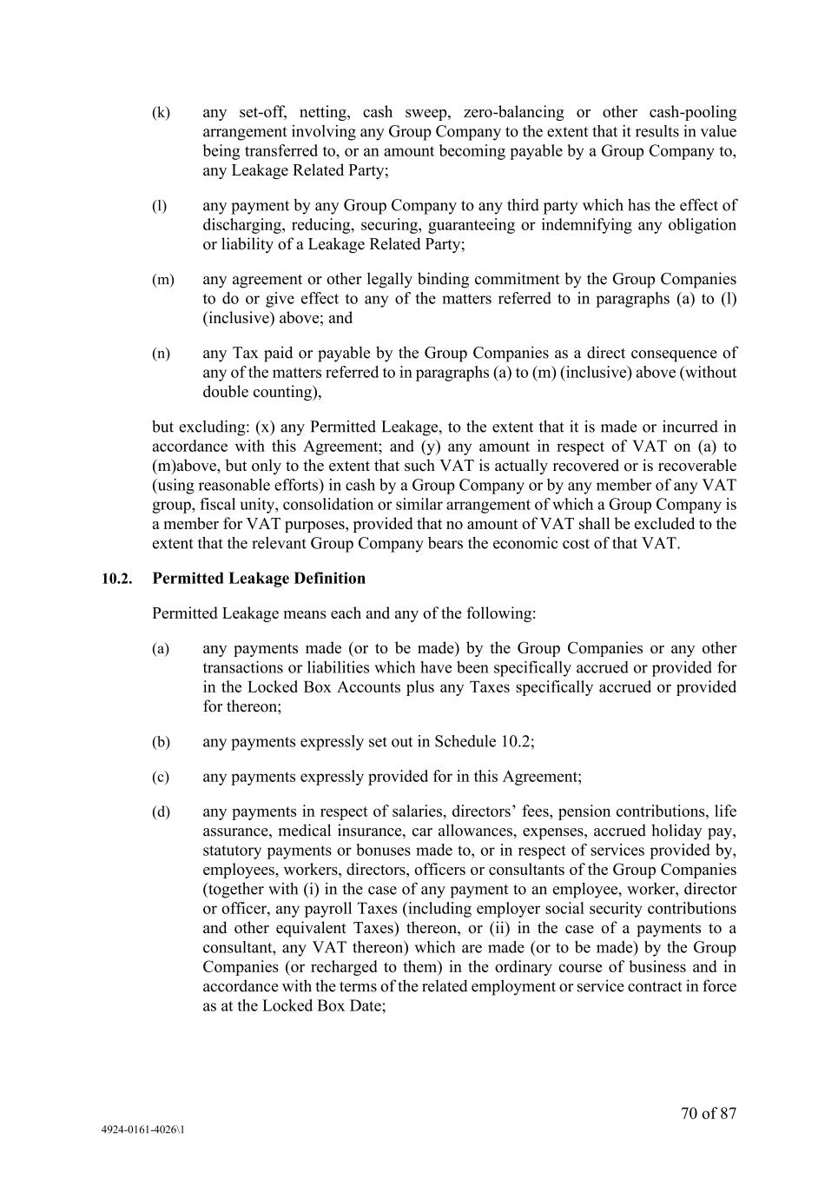
70 of 87 4924-0161-4026\1 (k) any set-off, netting, cash sweep, zero-balancing or other cash-pooling arrangement involving any Group Company to the extent that it results in value being transferred to, or an amount becoming payable by a Group Company to, any Leakage Related Party; (l) any payment by any Group Company to any third party which has the effect of discharging, reducing, securing, guaranteeing or indemnifying any obligation or liability of a Leakage Related Party; (m) any agreement or other legally binding commitment by the Group Companies to do or give effect to any of the matters referred to in paragraphs (a) to (l) (inclusive) above; and (n) any Tax paid or payable by the Group Companies as a direct consequence of any of the matters referred to in paragraphs (a) to (m) (inclusive) above (without double counting), but excluding: (x) any Permitted Leakage, to the extent that it is made or incurred in accordance with this Agreement; and (y) any amount in respect of VAT on (a) to (m)above, but only to the extent that such VAT is actually recovered or is recoverable (using reasonable efforts) in cash by a Group Company or by any member of any VAT group, fiscal unity, consolidation or similar arrangement of which a Group Company is a member for VAT purposes, provided that no amount of VAT shall be excluded to the extent that the relevant Group Company bears the economic cost of that VAT. 10.2. Permitted Leakage Definition Permitted Leakage means each and any of the following: (a) any payments made (or to be made) by the Group Companies or any other transactions or liabilities which have been specifically accrued or provided for in the Locked Box Accounts plus any Taxes specifically accrued or provided for thereon; (b) any payments expressly set out in Schedule 10.2; (c) any payments expressly provided for in this Agreement; (d) any payments in respect of salaries, directors’ fees, pension contributions, life assurance, medical insurance, car allowances, expenses, accrued holiday pay, statutory payments or bonuses made to, or in respect of services provided by, employees, workers, directors, officers or consultants of the Group Companies (together with (i) in the case of any payment to an employee, worker, director or officer, any payroll Taxes (including employer social security contributions and other equivalent Taxes) thereon, or (ii) in the case of a payments to a consultant, any VAT thereon) which are made (or to be made) by the Group Companies (or recharged to them) in the ordinary course of business and in accordance with the terms of the related employment or service contract in force as at the Locked Box Date;

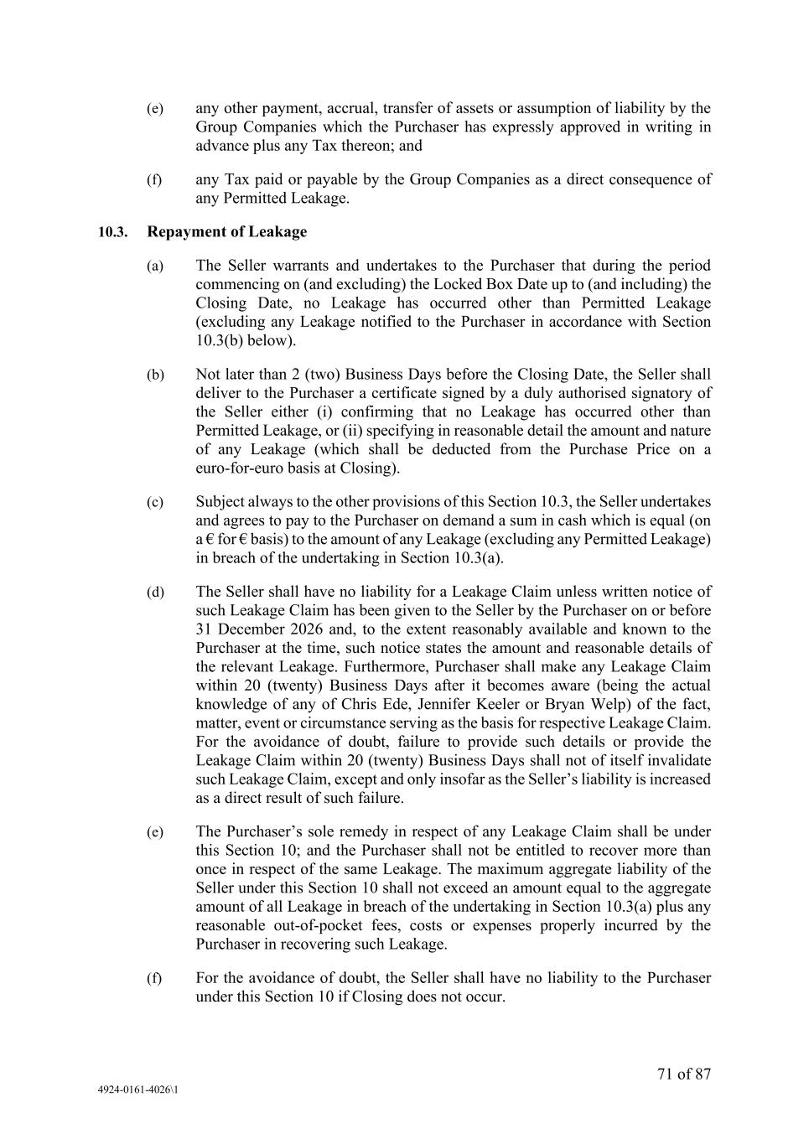
71 of 87 4924-0161-4026\1 (e) any other payment, accrual, transfer of assets or assumption of liability by the Group Companies which the Purchaser has expressly approved in writing in advance plus any Tax thereon; and (f) any Tax paid or payable by the Group Companies as a direct consequence of any Permitted Leakage. 10.3. Repayment of Leakage (a) The Seller warrants and undertakes to the Purchaser that during the period commencing on (and excluding) the Locked Box Date up to (and including) the Closing Date, no Leakage has occurred other than Permitted Leakage (excluding any Leakage notified to the Purchaser in accordance with Section 10.3(b) below). (b) Not later than 2 (two) Business Days before the Closing Date, the Seller shall deliver to the Purchaser a certificate signed by a duly authorised signatory of the Seller either (i) confirming that no Leakage has occurred other than Permitted Leakage, or (ii) specifying in reasonable detail the amount and nature of any Leakage (which shall be deducted from the Purchase Price on a euro-for-euro basis at Closing). (c) Subject always to the other provisions of this Section 10.3, the Seller undertakes and agrees to pay to the Purchaser on demand a sum in cash which is equal (on a € for € basis) to the amount of any Leakage (excluding any Permitted Leakage) in breach of the undertaking in Section 10.3(a). (d) The Seller shall have no liability for a Leakage Claim unless written notice of such Leakage Claim has been given to the Seller by the Purchaser on or before 31 December 2026 and, to the extent reasonably available and known to the Purchaser at the time, such notice states the amount and reasonable details of the relevant Leakage. Furthermore, Purchaser shall make any Leakage Claim within 20 (twenty) Business Days after it becomes aware (being the actual knowledge of any of Chris Ede, Jennifer Keeler or Bryan Welp) of the fact, matter, event or circumstance serving as the basis for respective Leakage Claim. For the avoidance of doubt, failure to provide such details or provide the Leakage Claim within 20 (twenty) Business Days shall not of itself invalidate such Leakage Claim, except and only insofar as the Seller’s liability is increased as a direct result of such failure. (e) The Purchaser’s sole remedy in respect of any Leakage Claim shall be under this Section 10; and the Purchaser shall not be entitled to recover more than once in respect of the same Leakage. The maximum aggregate liability of the Seller under this Section 10 shall not exceed an amount equal to the aggregate amount of all Leakage in breach of the undertaking in Section 10.3(a) plus any reasonable out-of-pocket fees, costs or expenses properly incurred by the Purchaser in recovering such Leakage. (f) For the avoidance of doubt, the Seller shall have no liability to the Purchaser under this Section 10 if Closing does not occur.

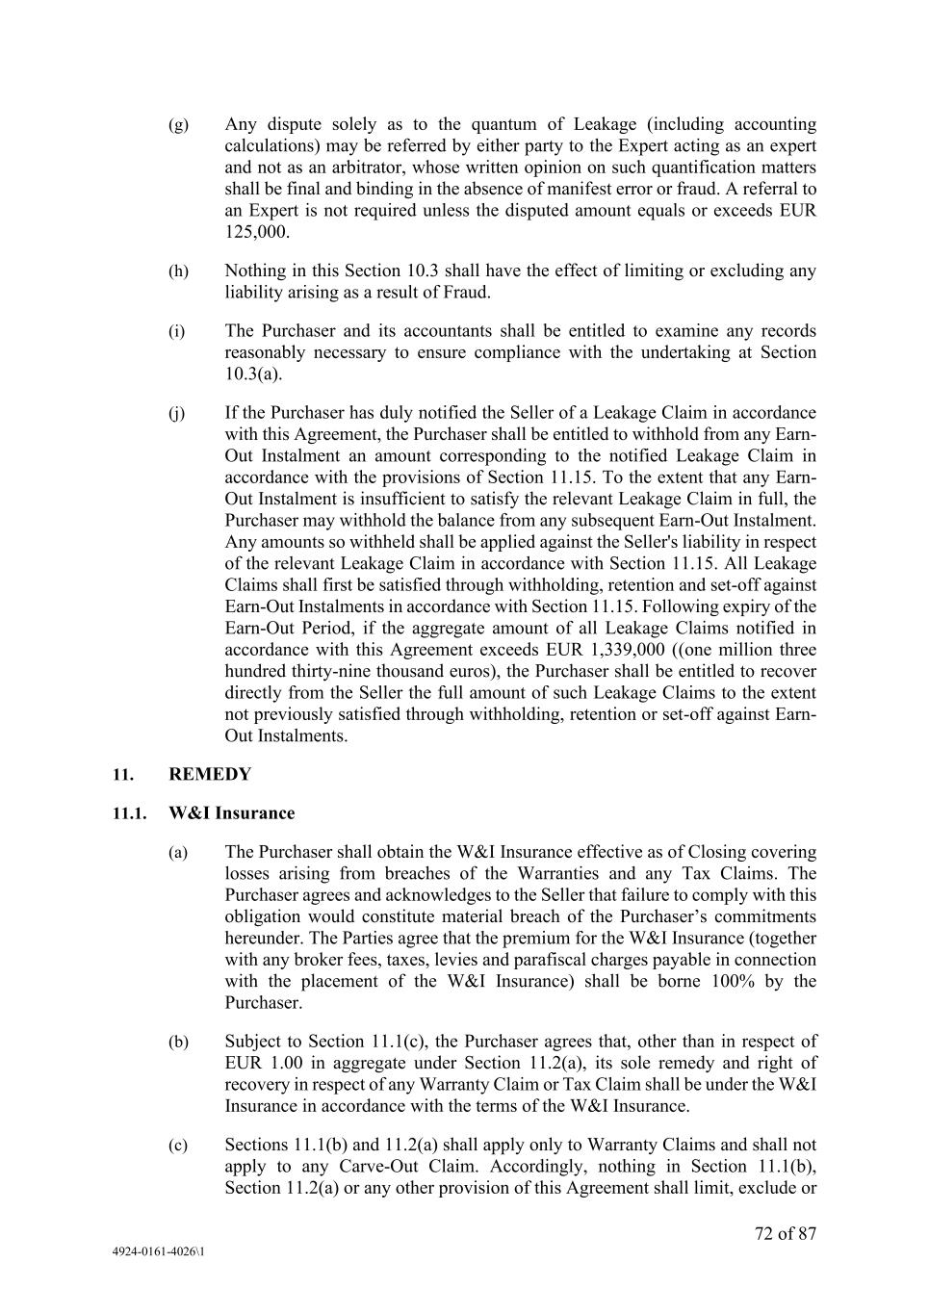
72 of 87 4924-0161-4026\1 (g) Any dispute solely as to the quantum of Leakage (including accounting calculations) may be referred by either party to the Expert acting as an expert and not as an arbitrator, whose written opinion on such quantification matters shall be final and binding in the absence of manifest error or fraud. A referral to an Expert is not required unless the disputed amount equals or exceeds EUR 125,000. (h) Nothing in this Section 10.3 shall have the effect of limiting or excluding any liability arising as a result of Fraud. (i) The Purchaser and its accountants shall be entitled to examine any records reasonably necessary to ensure compliance with the undertaking at Section 10.3(a). (j) If the Purchaser has duly notified the Seller of a Leakage Claim in accordance with this Agreement, the Purchaser shall be entitled to withhold from any Earn- Out Instalment an amount corresponding to the notified Leakage Claim in accordance with the provisions of Section 11.15. To the extent that any Earn- Out Instalment is insufficient to satisfy the relevant Leakage Claim in full, the Purchaser may withhold the balance from any subsequent Earn-Out Instalment. Any amounts so withheld shall be applied against the Seller's liability in respect of the relevant Leakage Claim in accordance with Section 11.15. All Leakage Claims shall first be satisfied through withholding, retention and set-off against Earn-Out Instalments in accordance with Section 11.15. Following expiry of the Earn-Out Period, if the aggregate amount of all Leakage Claims notified in accordance with this Agreement exceeds EUR 1,339,000 ((one million three hundred thirty-nine thousand euros), the Purchaser shall be entitled to recover directly from the Seller the full amount of such Leakage Claims to the extent not previously satisfied through withholding, retention or set-off against Earn- Out Instalments. 11. REMEDY 11.1. W&I Insurance (a) The Purchaser shall obtain the W&I Insurance effective as of Closing covering losses arising from breaches of the Warranties and any Tax Claims. The Purchaser agrees and acknowledges to the Seller that failure to comply with this obligation would constitute material breach of the Purchaser’s commitments hereunder. The Parties agree that the premium for the W&I Insurance (together with any broker fees, taxes, levies and parafiscal charges payable in connection with the placement of the W&I Insurance) shall be borne 100% by the Purchaser. (b) Subject to Section 11.1(c), the Purchaser agrees that, other than in respect of EUR 1.00 in aggregate under Section 11.2(a), its sole remedy and right of recovery in respect of any Warranty Claim or Tax Claim shall be under the W&I Insurance in accordance with the terms of the W&I Insurance. (c) Sections 11.1(b) and 11.2(a) shall apply only to Warranty Claims and shall not apply to any Carve-Out Claim. Accordingly, nothing in Section 11.1(b), Section 11.2(a) or any other provision of this Agreement shall limit, exclude or

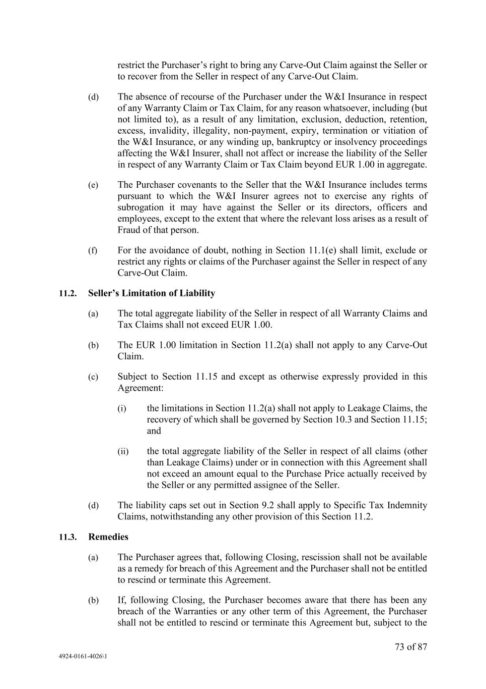
73 of 87 4924-0161-4026\1 restrict the Purchaser’s right to bring any Carve-Out Claim against the Seller or to recover from the Seller in respect of any Carve-Out Claim. (d) The absence of recourse of the Purchaser under the W&I Insurance in respect of any Warranty Claim or Tax Claim, for any reason whatsoever, including (but not limited to), as a result of any limitation, exclusion, deduction, retention, excess, invalidity, illegality, non-payment, expiry, termination or vitiation of the W&I Insurance, or any winding up, bankruptcy or insolvency proceedings affecting the W&I Insurer, shall not affect or increase the liability of the Seller in respect of any Warranty Claim or Tax Claim beyond EUR 1.00 in aggregate. (e) The Purchaser covenants to the Seller that the W&I Insurance includes terms pursuant to which the W&I Insurer agrees not to exercise any rights of subrogation it may have against the Seller or its directors, officers and employees, except to the extent that where the relevant loss arises as a result of Fraud of that person. (f) For the avoidance of doubt, nothing in Section 11.1(e) shall limit, exclude or restrict any rights or claims of the Purchaser against the Seller in respect of any Carve-Out Claim. 11.2. Seller’s Limitation of Liability (a) The total aggregate liability of the Seller in respect of all Warranty Claims and Tax Claims shall not exceed EUR 1.00. (b) The EUR 1.00 limitation in Section 11.2(a) shall not apply to any Carve-Out Claim. (c) Subject to Section 11.15 and except as otherwise expressly provided in this Agreement: (i) the limitations in Section 11.2(a) shall not apply to Leakage Claims, the recovery of which shall be governed by Section 10.3 and Section 11.15; and (ii) the total aggregate liability of the Seller in respect of all claims (other than Leakage Claims) under or in connection with this Agreement shall not exceed an amount equal to the Purchase Price actually received by the Seller or any permitted assignee of the Seller. (d) The liability caps set out in Section 9.2 shall apply to Specific Tax Indemnity Claims, notwithstanding any other provision of this Section 11.2. 11.3. Remedies (a) The Purchaser agrees that, following Closing, rescission shall not be available as a remedy for breach of this Agreement and the Purchaser shall not be entitled to rescind or terminate this Agreement. (b) If, following Closing, the Purchaser becomes aware that there has been any breach of the Warranties or any other term of this Agreement, the Purchaser shall not be entitled to rescind or terminate this Agreement but, subject to the

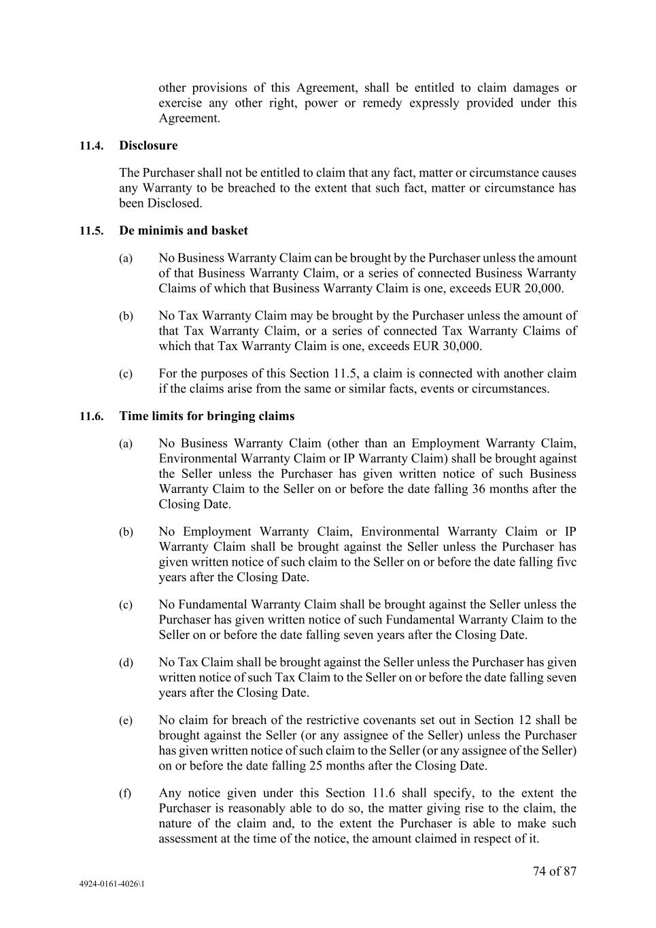
74 of 87 4924-0161-4026\1 other provisions of this Agreement, shall be entitled to claim damages or exercise any other right, power or remedy expressly provided under this Agreement. 11.4. Disclosure The Purchaser shall not be entitled to claim that any fact, matter or circumstance causes any Warranty to be breached to the extent that such fact, matter or circumstance has been Disclosed. 11.5. De minimis and basket (a) No Business Warranty Claim can be brought by the Purchaser unless the amount of that Business Warranty Claim, or a series of connected Business Warranty Claims of which that Business Warranty Claim is one, exceeds EUR 20,000. (b) No Tax Warranty Claim may be brought by the Purchaser unless the amount of that Tax Warranty Claim, or a series of connected Tax Warranty Claims of which that Tax Warranty Claim is one, exceeds EUR 30,000. (c) For the purposes of this Section 11.5, a claim is connected with another claim if the claims arise from the same or similar facts, events or circumstances. 11.6. Time limits for bringing claims (a) No Business Warranty Claim (other than an Employment Warranty Claim, Environmental Warranty Claim or IP Warranty Claim) shall be brought against the Seller unless the Purchaser has given written notice of such Business Warranty Claim to the Seller on or before the date falling 36 months after the Closing Date. (b) No Employment Warranty Claim, Environmental Warranty Claim or IP Warranty Claim shall be brought against the Seller unless the Purchaser has given written notice of such claim to the Seller on or before the date falling fivc years after the Closing Date. (c) No Fundamental Warranty Claim shall be brought against the Seller unless the Purchaser has given written notice of such Fundamental Warranty Claim to the Seller on or before the date falling seven years after the Closing Date. (d) No Tax Claim shall be brought against the Seller unless the Purchaser has given written notice of such Tax Claim to the Seller on or before the date falling seven years after the Closing Date. (e) No claim for breach of the restrictive covenants set out in Section 12 shall be brought against the Seller (or any assignee of the Seller) unless the Purchaser has given written notice of such claim to the Seller (or any assignee of the Seller) on or before the date falling 25 months after the Closing Date. (f) Any notice given under this Section 11.6 shall specify, to the extent the Purchaser is reasonably able to do so, the matter giving rise to the claim, the nature of the claim and, to the extent the Purchaser is able to make such assessment at the time of the notice, the amount claimed in respect of it.

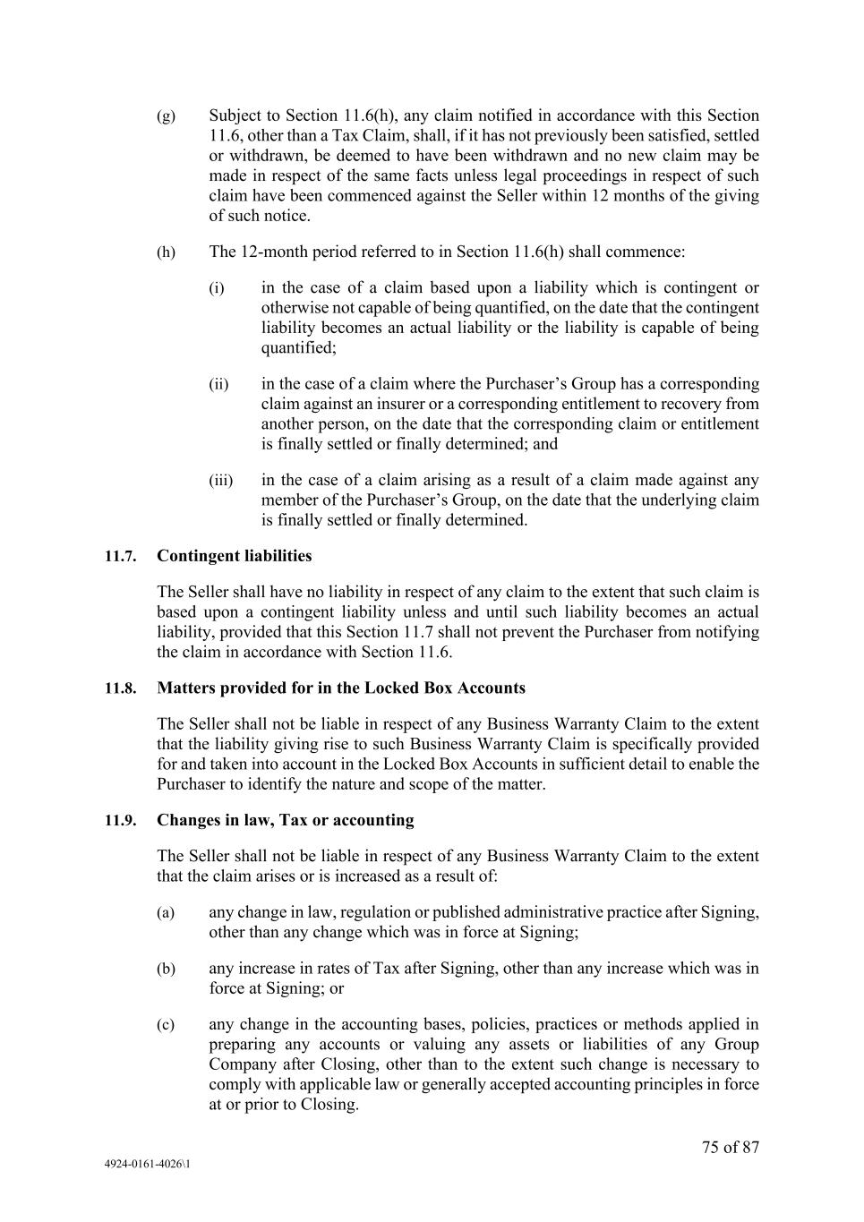
75 of 87 4924-0161-4026\1 (g) Subject to Section 11.6(h), any claim notified in accordance with this Section 11.6, other than a Tax Claim, shall, if it has not previously been satisfied, settled or withdrawn, be deemed to have been withdrawn and no new claim may be made in respect of the same facts unless legal proceedings in respect of such claim have been commenced against the Seller within 12 months of the giving of such notice. (h) The 12-month period referred to in Section 11.6(h) shall commence: (i) in the case of a claim based upon a liability which is contingent or otherwise not capable of being quantified, on the date that the contingent liability becomes an actual liability or the liability is capable of being quantified; (ii) in the case of a claim where the Purchaser’s Group has a corresponding claim against an insurer or a corresponding entitlement to recovery from another person, on the date that the corresponding claim or entitlement is finally settled or finally determined; and (iii) in the case of a claim arising as a result of a claim made against any member of the Purchaser’s Group, on the date that the underlying claim is finally settled or finally determined. 11.7. Contingent liabilities The Seller shall have no liability in respect of any claim to the extent that such claim is based upon a contingent liability unless and until such liability becomes an actual liability, provided that this Section 11.7 shall not prevent the Purchaser from notifying the claim in accordance with Section 11.6. 11.8. Matters provided for in the Locked Box Accounts The Seller shall not be liable in respect of any Business Warranty Claim to the extent that the liability giving rise to such Business Warranty Claim is specifically provided for and taken into account in the Locked Box Accounts in sufficient detail to enable the Purchaser to identify the nature and scope of the matter. 11.9. Changes in law, Tax or accounting The Seller shall not be liable in respect of any Business Warranty Claim to the extent that the claim arises or is increased as a result of: (a) any change in law, regulation or published administrative practice after Signing, other than any change which was in force at Signing; (b) any increase in rates of Tax after Signing, other than any increase which was in force at Signing; or (c) any change in the accounting bases, policies, practices or methods applied in preparing any accounts or valuing any assets or liabilities of any Group Company after Closing, other than to the extent such change is necessary to comply with applicable law or generally accepted accounting principles in force at or prior to Closing.

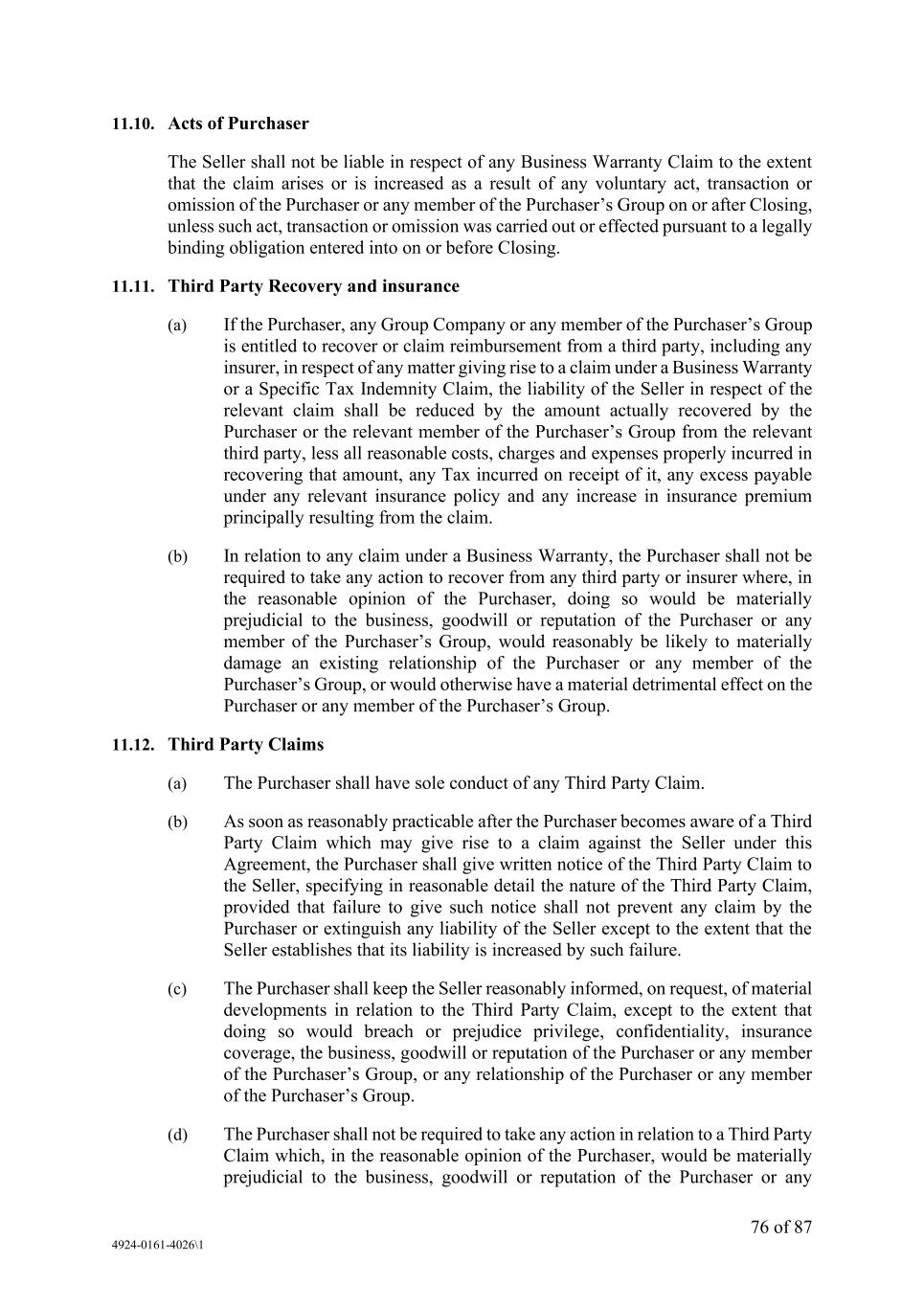
76 of 87 4924-0161-4026\1 11.10. Acts of Purchaser The Seller shall not be liable in respect of any Business Warranty Claim to the extent that the claim arises or is increased as a result of any voluntary act, transaction or omission of the Purchaser or any member of the Purchaser’s Group on or after Closing, unless such act, transaction or omission was carried out or effected pursuant to a legally binding obligation entered into on or before Closing. 11.11. Third Party Recovery and insurance (a) If the Purchaser, any Group Company or any member of the Purchaser’s Group is entitled to recover or claim reimbursement from a third party, including any insurer, in respect of any matter giving rise to a claim under a Business Warranty or a Specific Tax Indemnity Claim, the liability of the Seller in respect of the relevant claim shall be reduced by the amount actually recovered by the Purchaser or the relevant member of the Purchaser’s Group from the relevant third party, less all reasonable costs, charges and expenses properly incurred in recovering that amount, any Tax incurred on receipt of it, any excess payable under any relevant insurance policy and any increase in insurance premium principally resulting from the claim. (b) In relation to any claim under a Business Warranty, the Purchaser shall not be required to take any action to recover from any third party or insurer where, in the reasonable opinion of the Purchaser, doing so would be materially prejudicial to the business, goodwill or reputation of the Purchaser or any member of the Purchaser’s Group, would reasonably be likely to materially damage an existing relationship of the Purchaser or any member of the Purchaser’s Group, or would otherwise have a material detrimental effect on the Purchaser or any member of the Purchaser’s Group. 11.12. Third Party Claims (a) The Purchaser shall have sole conduct of any Third Party Claim. (b) As soon as reasonably practicable after the Purchaser becomes aware of a Third Party Claim which may give rise to a claim against the Seller under this Agreement, the Purchaser shall give written notice of the Third Party Claim to the Seller, specifying in reasonable detail the nature of the Third Party Claim, provided that failure to give such notice shall not prevent any claim by the Purchaser or extinguish any liability of the Seller except to the extent that the Seller establishes that its liability is increased by such failure. (c) The Purchaser shall keep the Seller reasonably informed, on request, of material developments in relation to the Third Party Claim, except to the extent that doing so would breach or prejudice privilege, confidentiality, insurance coverage, the business, goodwill or reputation of the Purchaser or any member of the Purchaser’s Group, or any relationship of the Purchaser or any member of the Purchaser’s Group. (d) The Purchaser shall not be required to take any action in relation to a Third Party Claim which, in the reasonable opinion of the Purchaser, would be materially prejudicial to the business, goodwill or reputation of the Purchaser or any

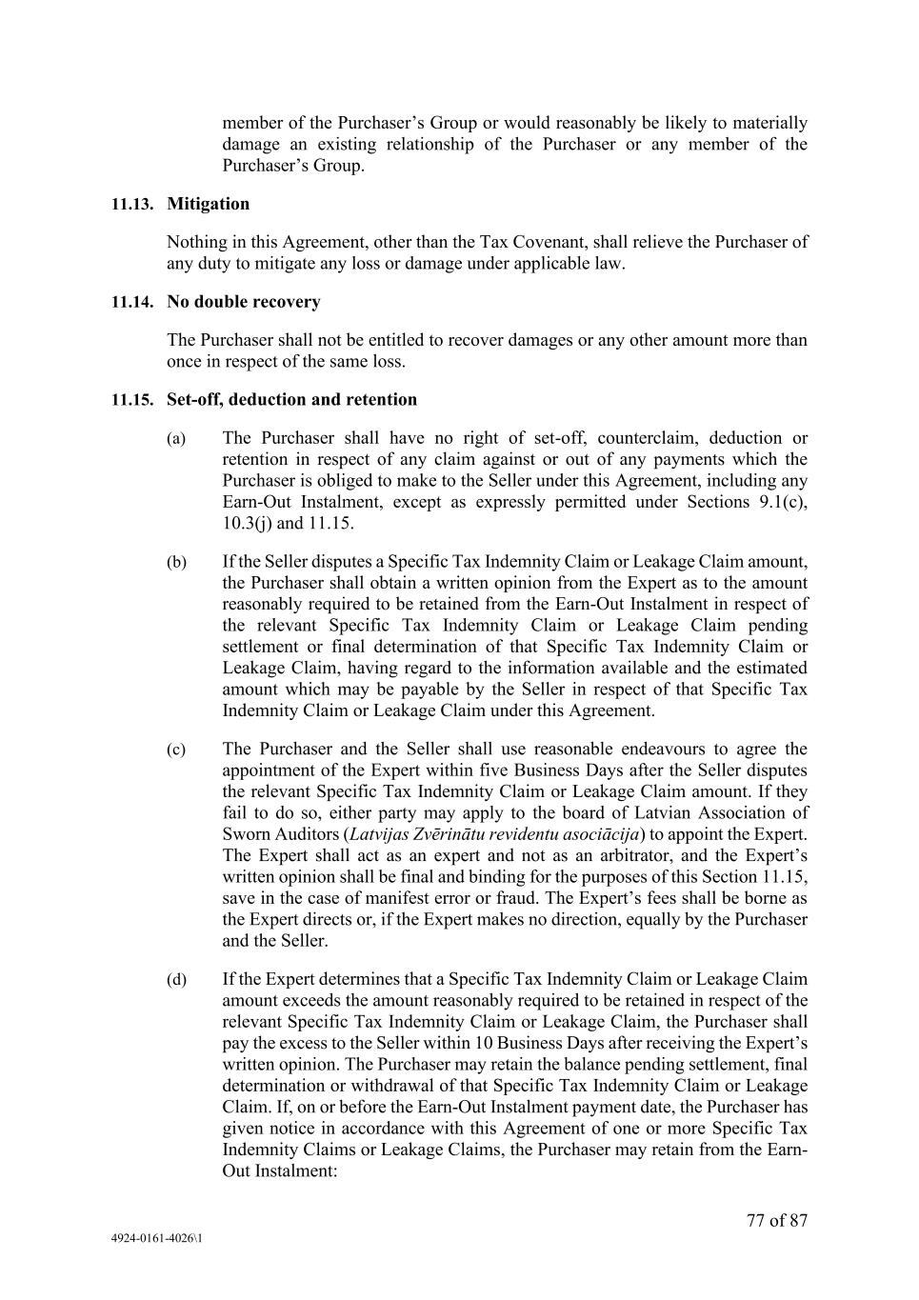
77 of 87 4924-0161-4026\1 member of the Purchaser’s Group or would reasonably be likely to materially damage an existing relationship of the Purchaser or any member of the Purchaser’s Group. 11.13. Mitigation Nothing in this Agreement, other than the Tax Covenant, shall relieve the Purchaser of any duty to mitigate any loss or damage under applicable law. 11.14. No double recovery The Purchaser shall not be entitled to recover damages or any other amount more than once in respect of the same loss. 11.15. Set-off, deduction and retention (a) The Purchaser shall have no right of set-off, counterclaim, deduction or retention in respect of any claim against or out of any payments which the Purchaser is obliged to make to the Seller under this Agreement, including any Earn-Out Instalment, except as expressly permitted under Sections 9.1(c), 10.3(j) and 11.15. (b) If the Seller disputes a Specific Tax Indemnity Claim or Leakage Claim amount, the Purchaser shall obtain a written opinion from the Expert as to the amount reasonably required to be retained from the Earn-Out Instalment in respect of the relevant Specific Tax Indemnity Claim or Leakage Claim pending settlement or final determination of that Specific Tax Indemnity Claim or Leakage Claim, having regard to the information available and the estimated amount which may be payable by the Seller in respect of that Specific Tax Indemnity Claim or Leakage Claim under this Agreement. (c) The Purchaser and the Seller shall use reasonable endeavours to agree the appointment of the Expert within five Business Days after the Seller disputes the relevant Specific Tax Indemnity Claim or Leakage Claim amount. If they fail to do so, either party may apply to the board of Latvian Association of Sworn Auditors (Latvijas Zvērinātu revidentu asociācija) to appoint the Expert. The Expert shall act as an expert and not as an arbitrator, and the Expert’s written opinion shall be final and binding for the purposes of this Section 11.15, save in the case of manifest error or fraud. The Expert’s fees shall be borne as the Expert directs or, if the Expert makes no direction, equally by the Purchaser and the Seller. (d) If the Expert determines that a Specific Tax Indemnity Claim or Leakage Claim amount exceeds the amount reasonably required to be retained in respect of the relevant Specific Tax Indemnity Claim or Leakage Claim, the Purchaser shall pay the excess to the Seller within 10 Business Days after receiving the Expert’s written opinion. The Purchaser may retain the balance pending settlement, final determination or withdrawal of that Specific Tax Indemnity Claim or Leakage Claim. If, on or before the Earn-Out Instalment payment date, the Purchaser has given notice in accordance with this Agreement of one or more Specific Tax Indemnity Claims or Leakage Claims, the Purchaser may retain from the Earn- Out Instalment:

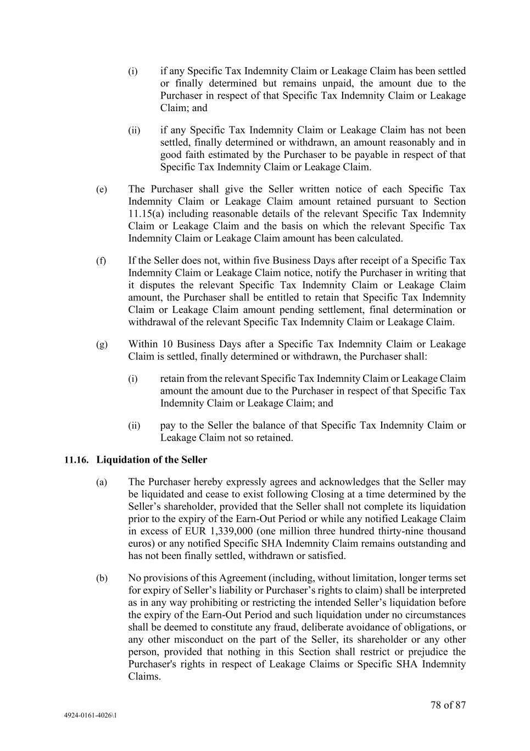
78 of 87 4924-0161-4026\1 (i) if any Specific Tax Indemnity Claim or Leakage Claim has been settled or finally determined but remains unpaid, the amount due to the Purchaser in respect of that Specific Tax Indemnity Claim or Leakage Claim; and (ii) if any Specific Tax Indemnity Claim or Leakage Claim has not been settled, finally determined or withdrawn, an amount reasonably and in good faith estimated by the Purchaser to be payable in respect of that Specific Tax Indemnity Claim or Leakage Claim. (e) The Purchaser shall give the Seller written notice of each Specific Tax Indemnity Claim or Leakage Claim amount retained pursuant to Section 11.15(a) including reasonable details of the relevant Specific Tax Indemnity Claim or Leakage Claim and the basis on which the relevant Specific Tax Indemnity Claim or Leakage Claim amount has been calculated. (f) If the Seller does not, within five Business Days after receipt of a Specific Tax Indemnity Claim or Leakage Claim notice, notify the Purchaser in writing that it disputes the relevant Specific Tax Indemnity Claim or Leakage Claim amount, the Purchaser shall be entitled to retain that Specific Tax Indemnity Claim or Leakage Claim amount pending settlement, final determination or withdrawal of the relevant Specific Tax Indemnity Claim or Leakage Claim. (g) Within 10 Business Days after a Specific Tax Indemnity Claim or Leakage Claim is settled, finally determined or withdrawn, the Purchaser shall: (i) retain from the relevant Specific Tax Indemnity Claim or Leakage Claim amount the amount due to the Purchaser in respect of that Specific Tax Indemnity Claim or Leakage Claim; and (ii) pay to the Seller the balance of that Specific Tax Indemnity Claim or Leakage Claim not so retained. 11.16. Liquidation of the Seller (a) The Purchaser hereby expressly agrees and acknowledges that the Seller may be liquidated and cease to exist following Closing at a time determined by the Seller’s shareholder, provided that the Seller shall not complete its liquidation prior to the expiry of the Earn-Out Period or while any notified Leakage Claim in excess of EUR 1,339,000 (one million three hundred thirty-nine thousand euros) or any notified Specific SHA Indemnity Claim remains outstanding and has not been finally settled, withdrawn or satisfied. (b) No provisions of this Agreement (including, without limitation, longer terms set for expiry of Seller’s liability or Purchaser’s rights to claim) shall be interpreted as in any way prohibiting or restricting the intended Seller’s liquidation before the expiry of the Earn-Out Period and such liquidation under no circumstances shall be deemed to constitute any fraud, deliberate avoidance of obligations, or any other misconduct on the part of the Seller, its shareholder or any other person, provided that nothing in this Section shall restrict or prejudice the Purchaser's rights in respect of Leakage Claims or Specific SHA Indemnity Claims.

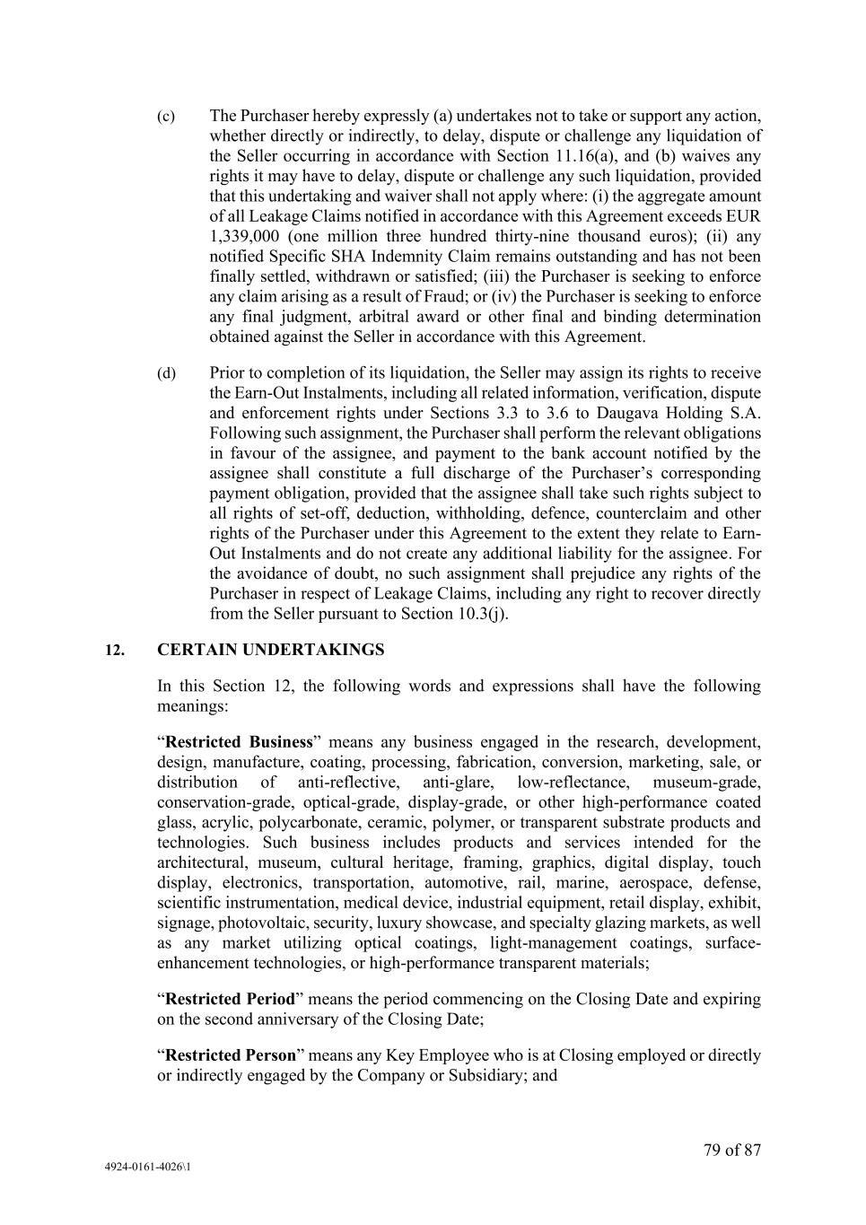
79 of 87 4924-0161-4026\1 (c) The Purchaser hereby expressly (a) undertakes not to take or support any action, whether directly or indirectly, to delay, dispute or challenge any liquidation of the Seller occurring in accordance with Section 11.16(a), and (b) waives any rights it may have to delay, dispute or challenge any such liquidation, provided that this undertaking and waiver shall not apply where: (i) the aggregate amount of all Leakage Claims notified in accordance with this Agreement exceeds EUR 1,339,000 (one million three hundred thirty-nine thousand euros); (ii) any notified Specific SHA Indemnity Claim remains outstanding and has not been finally settled, withdrawn or satisfied; (iii) the Purchaser is seeking to enforce any claim arising as a result of Fraud; or (iv) the Purchaser is seeking to enforce any final judgment, arbitral award or other final and binding determination obtained against the Seller in accordance with this Agreement. (d) Prior to completion of its liquidation, the Seller may assign its rights to receive the Earn-Out Instalments, including all related information, verification, dispute and enforcement rights under Sections 3.3 to 3.6 to Daugava Holding S.A. Following such assignment, the Purchaser shall perform the relevant obligations in favour of the assignee, and payment to the bank account notified by the assignee shall constitute a full discharge of the Purchaser’s corresponding payment obligation, provided that the assignee shall take such rights subject to all rights of set-off, deduction, withholding, defence, counterclaim and other rights of the Purchaser under this Agreement to the extent they relate to Earn- Out Instalments and do not create any additional liability for the assignee. For the avoidance of doubt, no such assignment shall prejudice any rights of the Purchaser in respect of Leakage Claims, including any right to recover directly from the Seller pursuant to Section 10.3(j). 12. CERTAIN UNDERTAKINGS In this Section 12, the following words and expressions shall have the following meanings: “Restricted Business” means any business engaged in the research, development, design, manufacture, coating, processing, fabrication, conversion, marketing, sale, or distribution of anti-reflective, anti-glare, low-reflectance, museum-grade, conservation-grade, optical-grade, display-grade, or other high-performance coated glass, acrylic, polycarbonate, ceramic, polymer, or transparent substrate products and technologies. Such business includes products and services intended for the architectural, museum, cultural heritage, framing, graphics, digital display, touch display, electronics, transportation, automotive, rail, marine, aerospace, defense, scientific instrumentation, medical device, industrial equipment, retail display, exhibit, signage, photovoltaic, security, luxury showcase, and specialty glazing markets, as well as any market utilizing optical coatings, light-management coatings, surface- enhancement technologies, or high-performance transparent materials; “Restricted Period” means the period commencing on the Closing Date and expiring on the second anniversary of the Closing Date; “Restricted Person” means any Key Employee who is at Closing employed or directly or indirectly engaged by the Company or Subsidiary; and

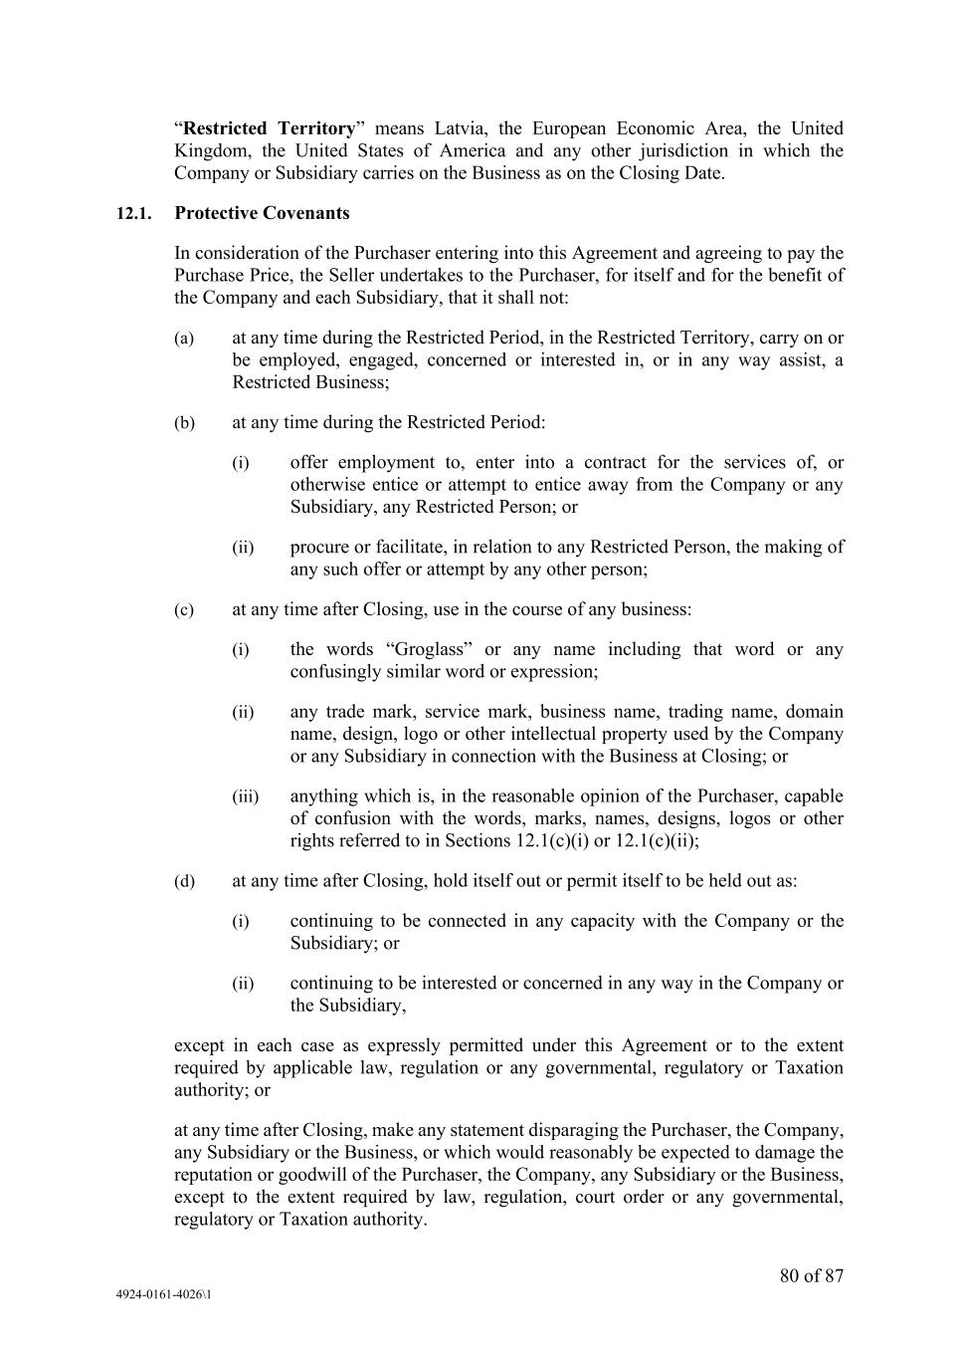
80 of 87 4924-0161-4026\1 “Restricted Territory” means Latvia, the European Economic Area, the United Kingdom, the United States of America and any other jurisdiction in which the Company or Subsidiary carries on the Business as on the Closing Date. 12.1. Protective Covenants In consideration of the Purchaser entering into this Agreement and agreeing to pay the Purchase Price, the Seller undertakes to the Purchaser, for itself and for the benefit of the Company and each Subsidiary, that it shall not: (a) at any time during the Restricted Period, in the Restricted Territory, carry on or be employed, engaged, concerned or interested in, or in any way assist, a Restricted Business; (b) at any time during the Restricted Period: (i) offer employment to, enter into a contract for the services of, or otherwise entice or attempt to entice away from the Company or any Subsidiary, any Restricted Person; or (ii) procure or facilitate, in relation to any Restricted Person, the making of any such offer or attempt by any other person; (c) at any time after Closing, use in the course of any business: (i) the words “Groglass” or any name including that word or any confusingly similar word or expression; (ii) any trade mark, service mark, business name, trading name, domain name, design, logo or other intellectual property used by the Company or any Subsidiary in connection with the Business at Closing; or (iii) anything which is, in the reasonable opinion of the Purchaser, capable of confusion with the words, marks, names, designs, logos or other rights referred to in Sections 12.1(c)(i) or 12.1(c)(ii); (d) at any time after Closing, hold itself out or permit itself to be held out as: (i) continuing to be connected in any capacity with the Company or the Subsidiary; or (ii) continuing to be interested or concerned in any way in the Company or the Subsidiary, except in each case as expressly permitted under this Agreement or to the extent required by applicable law, regulation or any governmental, regulatory or Taxation authority; or at any time after Closing, make any statement disparaging the Purchaser, the Company, any Subsidiary or the Business, or which would reasonably be expected to damage the reputation or goodwill of the Purchaser, the Company, any Subsidiary or the Business, except to the extent required by law, regulation, court order or any governmental, regulatory or Taxation authority.

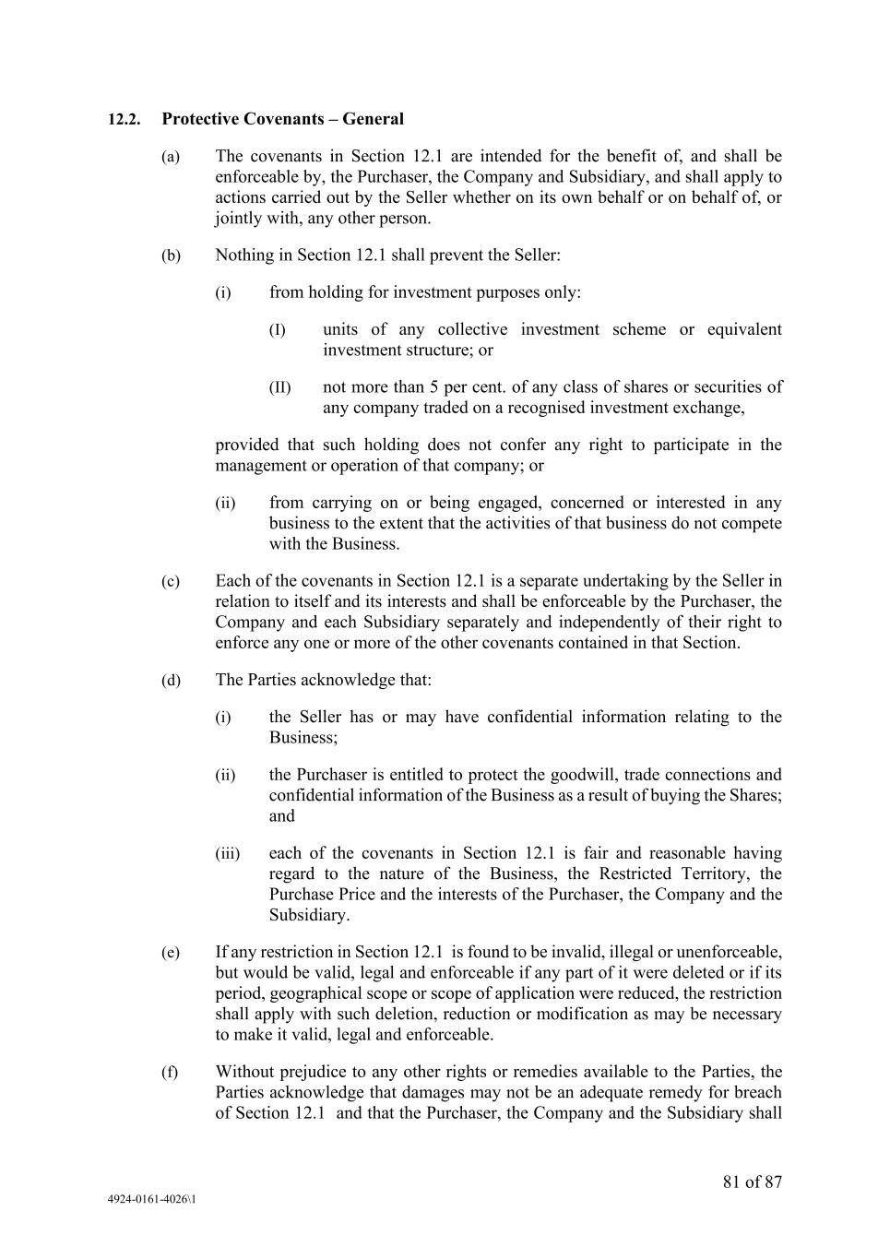
81 of 87 4924-0161-4026\1 12.2. Protective Covenants – General (a) The covenants in Section 12.1 are intended for the benefit of, and shall be enforceable by, the Purchaser, the Company and Subsidiary, and shall apply to actions carried out by the Seller whether on its own behalf or on behalf of, or jointly with, any other person. (b) Nothing in Section 12.1 shall prevent the Seller: (i) from holding for investment purposes only: (I) units of any collective investment scheme or equivalent investment structure; or (II) not more than 5 per cent. of any class of shares or securities of any company traded on a recognised investment exchange, provided that such holding does not confer any right to participate in the management or operation of that company; or (ii) from carrying on or being engaged, concerned or interested in any business to the extent that the activities of that business do not compete with the Business. (c) Each of the covenants in Section 12.1 is a separate undertaking by the Seller in relation to itself and its interests and shall be enforceable by the Purchaser, the Company and each Subsidiary separately and independently of their right to enforce any one or more of the other covenants contained in that Section. (d) The Parties acknowledge that: (i) the Seller has or may have confidential information relating to the Business; (ii) the Purchaser is entitled to protect the goodwill, trade connections and confidential information of the Business as a result of buying the Shares; and (iii) each of the covenants in Section 12.1 is fair and reasonable having regard to the nature of the Business, the Restricted Territory, the Purchase Price and the interests of the Purchaser, the Company and the Subsidiary. (e) If any restriction in Section 12.1 is found to be invalid, illegal or unenforceable, but would be valid, legal and enforceable if any part of it were deleted or if its period, geographical scope or scope of application were reduced, the restriction shall apply with such deletion, reduction or modification as may be necessary to make it valid, legal and enforceable. (f) Without prejudice to any other rights or remedies available to the Parties, the Parties acknowledge that damages may not be an adequate remedy for breach of Section 12.1 and that the Purchaser, the Company and the Subsidiary shall

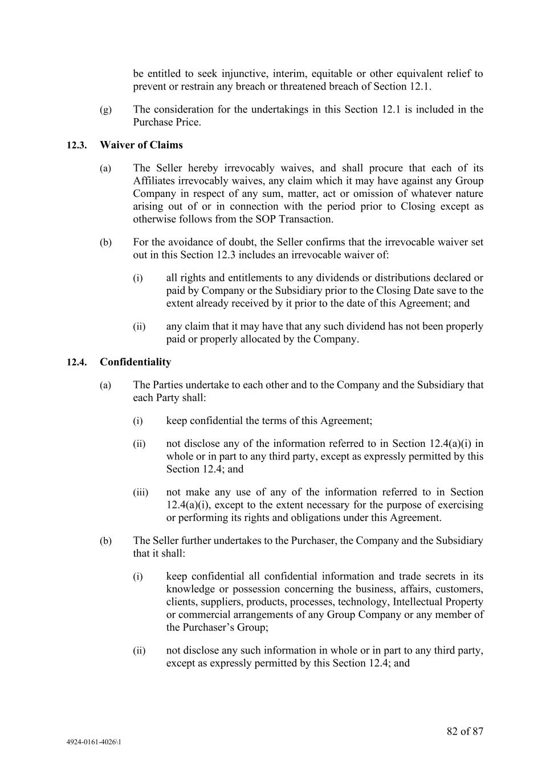
82 of 87 4924-0161-4026\1 be entitled to seek injunctive, interim, equitable or other equivalent relief to prevent or restrain any breach or threatened breach of Section 12.1. (g) The consideration for the undertakings in this Section 12.1 is included in the Purchase Price. 12.3. Waiver of Claims (a) The Seller hereby irrevocably waives, and shall procure that each of its Affiliates irrevocably waives, any claim which it may have against any Group Company in respect of any sum, matter, act or omission of whatever nature arising out of or in connection with the period prior to Closing except as otherwise follows from the SOP Transaction. (b) For the avoidance of doubt, the Seller confirms that the irrevocable waiver set out in this Section 12.3 includes an irrevocable waiver of: (i) all rights and entitlements to any dividends or distributions declared or paid by Company or the Subsidiary prior to the Closing Date save to the extent already received by it prior to the date of this Agreement; and (ii) any claim that it may have that any such dividend has not been properly paid or properly allocated by the Company. 12.4. Confidentiality (a) The Parties undertake to each other and to the Company and the Subsidiary that each Party shall: (i) keep confidential the terms of this Agreement; (ii) not disclose any of the information referred to in Section 12.4(a)(i) in whole or in part to any third party, except as expressly permitted by this Section 12.4; and (iii) not make any use of any of the information referred to in Section 12.4(a)(i), except to the extent necessary for the purpose of exercising or performing its rights and obligations under this Agreement. (b) The Seller further undertakes to the Purchaser, the Company and the Subsidiary that it shall: (i) keep confidential all confidential information and trade secrets in its knowledge or possession concerning the business, affairs, customers, clients, suppliers, products, processes, technology, Intellectual Property or commercial arrangements of any Group Company or any member of the Purchaser’s Group; (ii) not disclose any such information in whole or in part to any third party, except as expressly permitted by this Section 12.4; and

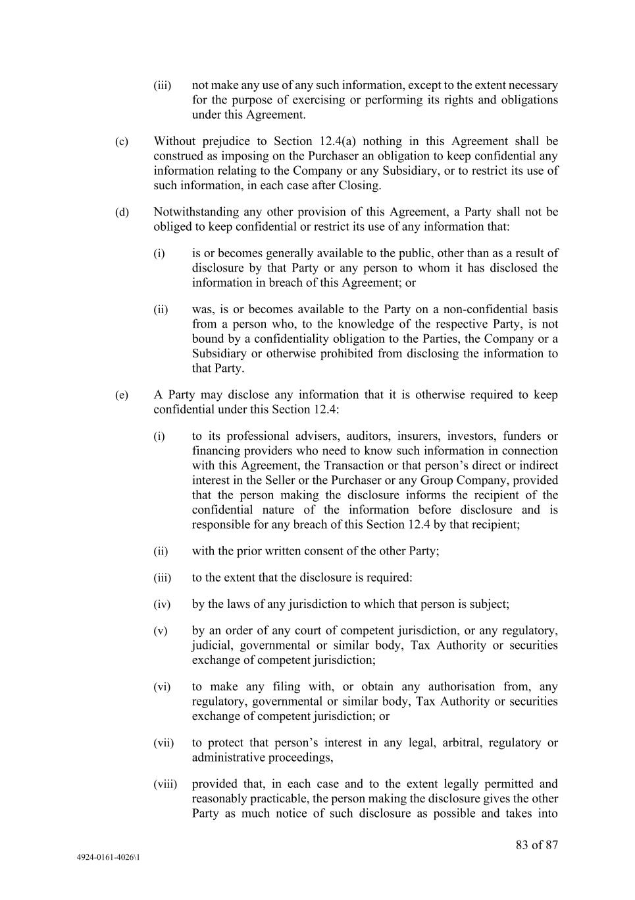
83 of 87 4924-0161-4026\1 (iii) not make any use of any such information, except to the extent necessary for the purpose of exercising or performing its rights and obligations under this Agreement. (c) Without prejudice to Section 12.4(a) nothing in this Agreement shall be construed as imposing on the Purchaser an obligation to keep confidential any information relating to the Company or any Subsidiary, or to restrict its use of such information, in each case after Closing. (d) Notwithstanding any other provision of this Agreement, a Party shall not be obliged to keep confidential or restrict its use of any information that: (i) is or becomes generally available to the public, other than as a result of disclosure by that Party or any person to whom it has disclosed the information in breach of this Agreement; or (ii) was, is or becomes available to the Party on a non-confidential basis from a person who, to the knowledge of the respective Party, is not bound by a confidentiality obligation to the Parties, the Company or a Subsidiary or otherwise prohibited from disclosing the information to that Party. (e) A Party may disclose any information that it is otherwise required to keep confidential under this Section 12.4: (i) to its professional advisers, auditors, insurers, investors, funders or financing providers who need to know such information in connection with this Agreement, the Transaction or that person’s direct or indirect interest in the Seller or the Purchaser or any Group Company, provided that the person making the disclosure informs the recipient of the confidential nature of the information before disclosure and is responsible for any breach of this Section 12.4 by that recipient; (ii) with the prior written consent of the other Party; (iii) to the extent that the disclosure is required: (iv) by the laws of any jurisdiction to which that person is subject; (v) by an order of any court of competent jurisdiction, or any regulatory, judicial, governmental or similar body, Tax Authority or securities exchange of competent jurisdiction; (vi) to make any filing with, or obtain any authorisation from, any regulatory, governmental or similar body, Tax Authority or securities exchange of competent jurisdiction; or (vii) to protect that person’s interest in any legal, arbitral, regulatory or administrative proceedings, (viii) provided that, in each case and to the extent legally permitted and reasonably practicable, the person making the disclosure gives the other Party as much notice of such disclosure as possible and takes into

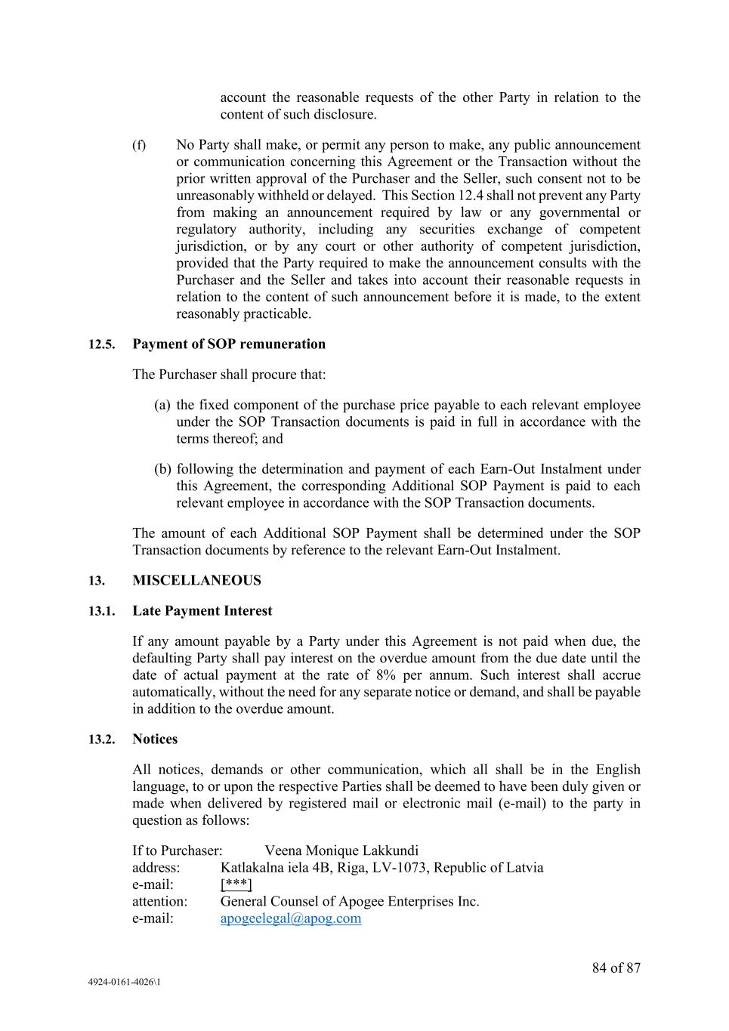
84 of 87 4924-0161-4026\1 account the reasonable requests of the other Party in relation to the content of such disclosure. (f) No Party shall make, or permit any person to make, any public announcement or communication concerning this Agreement or the Transaction without the prior written approval of the Purchaser and the Seller, such consent not to be unreasonably withheld or delayed. This Section 12.4 shall not prevent any Party from making an announcement required by law or any governmental or regulatory authority, including any securities exchange of competent jurisdiction, or by any court or other authority of competent jurisdiction, provided that the Party required to make the announcement consults with the Purchaser and the Seller and takes into account their reasonable requests in relation to the content of such announcement before it is made, to the extent reasonably practicable. 12.5. Payment of SOP remuneration The Purchaser shall procure that: (a) the fixed component of the purchase price payable to each relevant employee under the SOP Transaction documents is paid in full in accordance with the terms thereof; and (b) following the determination and payment of each Earn-Out Instalment under this Agreement, the corresponding Additional SOP Payment is paid to each relevant employee in accordance with the SOP Transaction documents. The amount of each Additional SOP Payment shall be determined under the SOP Transaction documents by reference to the relevant Earn-Out Instalment. 13. MISCELLANEOUS 13.1. Late Payment Interest If any amount payable by a Party under this Agreement is not paid when due, the defaulting Party shall pay interest on the overdue amount from the due date until the date of actual payment at the rate of 8% per annum. Such interest shall accrue automatically, without the need for any separate notice or demand, and shall be payable in addition to the overdue amount. 13.2. Notices All notices, demands or other communication, which all shall be in the English language, to or upon the respective Parties shall be deemed to have been duly given or made when delivered by registered mail or electronic mail (e-mail) to the party in question as follows: If to Purchaser: Veena Monique Lakkundi address: Katlakalna iela 4B, Riga, LV-1073, Republic of Latvia e-mail: [***] attention: General Counsel of Apogee Enterprises Inc. e-mail: apogeelegal@apog.com

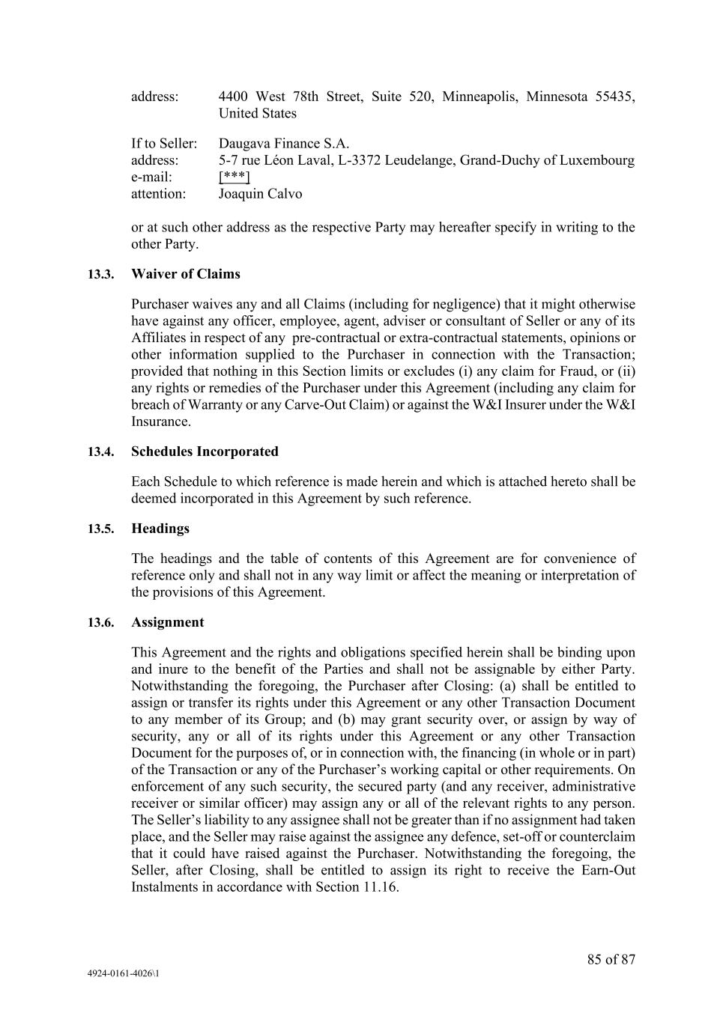
85 of 87 4924-0161-4026\1 address: 4400 West 78th Street, Suite 520, Minneapolis, Minnesota 55435, United States If to Seller: Daugava Finance S.A. address: 5-7 rue Léon Laval, L-3372 Leudelange, Grand-Duchy of Luxembourg e-mail: [***] attention: Joaquin Calvo or at such other address as the respective Party may hereafter specify in writing to the other Party. 13.3. Waiver of Claims Purchaser waives any and all Claims (including for negligence) that it might otherwise have against any officer, employee, agent, adviser or consultant of Seller or any of its Affiliates in respect of any pre-contractual or extra-contractual statements, opinions or other information supplied to the Purchaser in connection with the Transaction; provided that nothing in this Section limits or excludes (i) any claim for Fraud, or (ii) any rights or remedies of the Purchaser under this Agreement (including any claim for breach of Warranty or any Carve-Out Claim) or against the W&I Insurer under the W&I Insurance. 13.4. Schedules Incorporated Each Schedule to which reference is made herein and which is attached hereto shall be deemed incorporated in this Agreement by such reference. 13.5. Headings The headings and the table of contents of this Agreement are for convenience of reference only and shall not in any way limit or affect the meaning or interpretation of the provisions of this Agreement. 13.6. Assignment This Agreement and the rights and obligations specified herein shall be binding upon and inure to the benefit of the Parties and shall not be assignable by either Party. Notwithstanding the foregoing, the Purchaser after Closing: (a) shall be entitled to assign or transfer its rights under this Agreement or any other Transaction Document to any member of its Group; and (b) may grant security over, or assign by way of security, any or all of its rights under this Agreement or any other Transaction Document for the purposes of, or in connection with, the financing (in whole or in part) of the Transaction or any of the Purchaser’s working capital or other requirements. On enforcement of any such security, the secured party (and any receiver, administrative receiver or similar officer) may assign any or all of the relevant rights to any person. The Seller’s liability to any assignee shall not be greater than if no assignment had taken place, and the Seller may raise against the assignee any defence, set-off or counterclaim that it could have raised against the Purchaser. Notwithstanding the foregoing, the Seller, after Closing, shall be entitled to assign its right to receive the Earn-Out Instalments in accordance with Section 11.16.

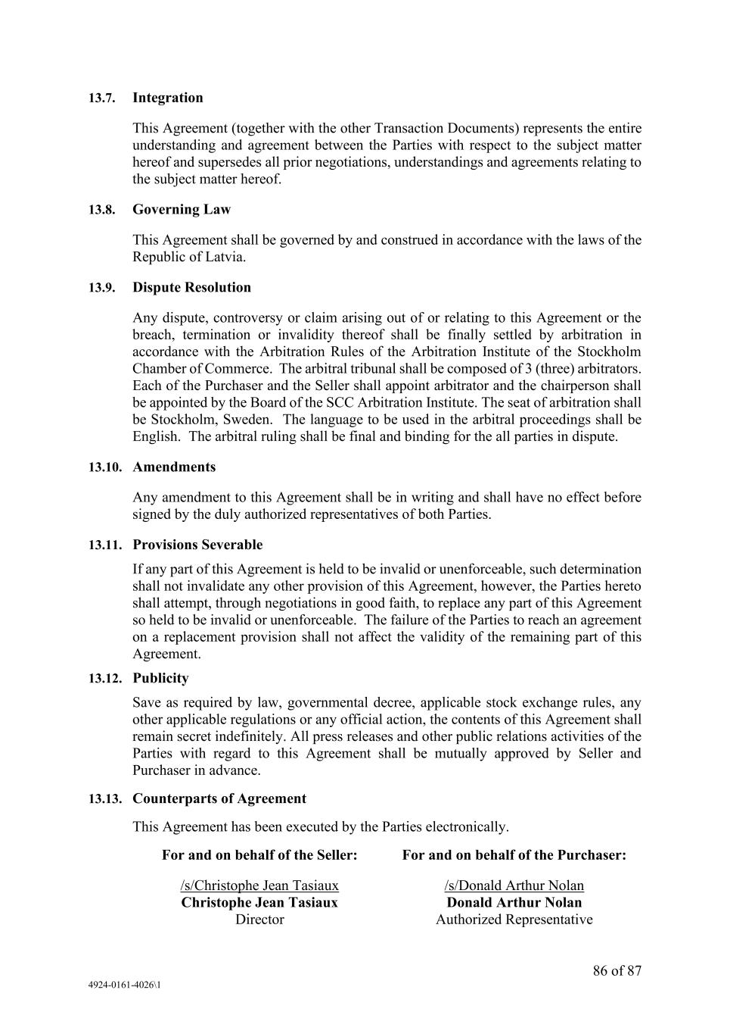
86 of 87 4924-0161-4026\1 13.7. Integration This Agreement (together with the other Transaction Documents) represents the entire understanding and agreement between the Parties with respect to the subject matter hereof and supersedes all prior negotiations, understandings and agreements relating to the subject matter hereof. 13.8. Governing Law This Agreement shall be governed by and construed in accordance with the laws of the Republic of Latvia. 13.9. Dispute Resolution Any dispute, controversy or claim arising out of or relating to this Agreement or the breach, termination or invalidity thereof shall be finally settled by arbitration in accordance with the Arbitration Rules of the Arbitration Institute of the Stockholm Chamber of Commerce. The arbitral tribunal shall be composed of 3 (three) arbitrators. Each of the Purchaser and the Seller shall appoint arbitrator and the chairperson shall be appointed by the Board of the SCC Arbitration Institute. The seat of arbitration shall be Stockholm, Sweden. The language to be used in the arbitral proceedings shall be English. The arbitral ruling shall be final and binding for the all parties in dispute. 13.10. Amendments Any amendment to this Agreement shall be in writing and shall have no effect before signed by the duly authorized representatives of both Parties. 13.11. Provisions Severable If any part of this Agreement is held to be invalid or unenforceable, such determination shall not invalidate any other provision of this Agreement, however, the Parties hereto shall attempt, through negotiations in good faith, to replace any part of this Agreement so held to be invalid or unenforceable. The failure of the Parties to reach an agreement on a replacement provision shall not affect the validity of the remaining part of this Agreement. 13.12. Publicity Save as required by law, governmental decree, applicable stock exchange rules, any other applicable regulations or any official action, the contents of this Agreement shall remain secret indefinitely. All press releases and other public relations activities of the Parties with regard to this Agreement shall be mutually approved by Seller and Purchaser in advance. 13.13. Counterparts of Agreement This Agreement has been executed by the Parties electronically. For and on behalf of the Seller: /s/Christophe Jean Tasiaux Christophe Jean Tasiaux Director For and on behalf of the Purchaser: /s/Donald Arthur Nolan Donald Arthur Nolan Authorized Representative


87 of 87 4924-0161-4026\1 /s/Hugo Edison Perrin Hugo Edison Perrin Director

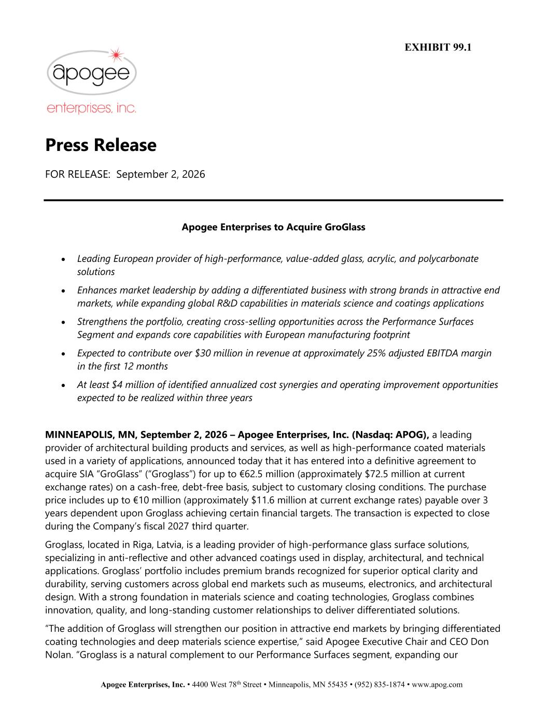
Apogee Enterprises, Inc. • 4400 West 78th Street • Minneapolis, MN 55435 • (952) 835-1874 • www.apog.com Press Release FOR RELEASE: September 2, 2026 Apogee Enterprises to Acquire GroGlass • Leading European provider of high-performance, value-added glass, acrylic, and polycarbonate solutions • Enhances market leadership by adding a differentiated business with strong brands in attractive end markets, while expanding global R&D capabilities in materials science and coatings applications • Strengthens the portfolio, creating cross-selling opportunities across the Performance Surfaces Segment and expands core capabilities with European manufacturing footprint • Expected to contribute over $30 million in revenue at approximately 25% adjusted EBITDA margin in the first 12 months • At least $4 million of identified annualized cost synergies and operating improvement opportunities expected to be realized within three years MINNEAPOLIS, MN, September 2, 2026 – Apogee Enterprises, Inc. (Nasdaq: APOG), a leading provider of architectural building products and services, as well as high-performance coated materials used in a variety of applications, announced today that it has entered into a definitive agreement to acquire SIA “GroGlass” (“Groglass”) for up to €62.5 million (approximately $72.5 million at current exchange rates) on a cash-free, debt-free basis, subject to customary closing conditions. The purchase price includes up to €10 million (approximately $11.6 million at current exchange rates) payable over 3 years dependent upon Groglass achieving certain financial targets. The transaction is expected to close during the Company’s fiscal 2027 third quarter. Groglass, located in Riga, Latvia, is a leading provider of high-performance glass surface solutions, specializing in anti-reflective and other advanced coatings used in display, architectural, and technical applications. Groglass’ portfolio includes premium brands recognized for superior optical clarity and durability, serving customers across global end markets such as museums, electronics, and architectural design. With a strong foundation in materials science and coating technologies, Groglass combines innovation, quality, and long-standing customer relationships to deliver differentiated solutions. “The addition of Groglass will strengthen our position in attractive end markets by bringing differentiated coating technologies and deep materials science expertise,” said Apogee Executive Chair and CEO Don Nolan. “Groglass is a natural complement to our Performance Surfaces segment, expanding our EXHIBIT 99.1

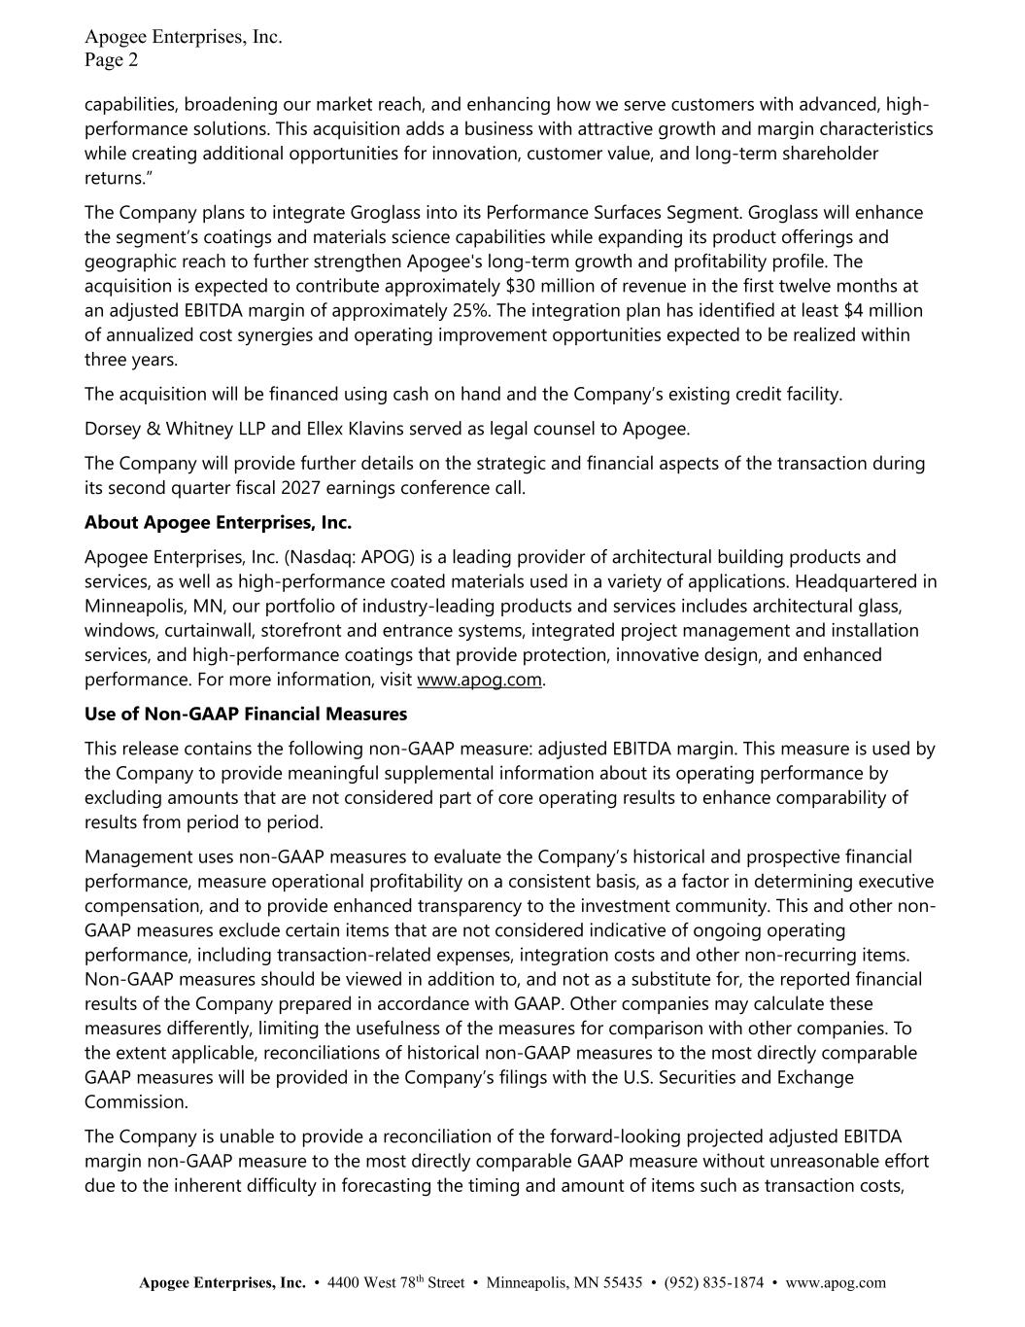
Apogee Enterprises, Inc. Page 2 Apogee Enterprises, Inc. • 4400 West 78th Street • Minneapolis, MN 55435 • (952) 835-1874 • www.apog.com capabilities, broadening our market reach, and enhancing how we serve customers with advanced, high- performance solutions. This acquisition adds a business with attractive growth and margin characteristics while creating additional opportunities for innovation, customer value, and long-term shareholder returns.” The Company plans to integrate Groglass into its Performance Surfaces Segment. Groglass will enhance the segment’s coatings and materials science capabilities while expanding its product offerings and geographic reach to further strengthen Apogee's long-term growth and profitability profile. The acquisition is expected to contribute approximately $30 million of revenue in the first twelve months at an adjusted EBITDA margin of approximately 25%. The integration plan has identified at least $4 million of annualized cost synergies and operating improvement opportunities expected to be realized within three years. The acquisition will be financed using cash on hand and the Company’s existing credit facility. Dorsey & Whitney LLP and Ellex Klavins served as legal counsel to Apogee. The Company will provide further details on the strategic and financial aspects of the transaction during its second quarter fiscal 2027 earnings conference call. About Apogee Enterprises, Inc. Apogee Enterprises, Inc. (Nasdaq: APOG) is a leading provider of architectural building products and services, as well as high-performance coated materials used in a variety of applications. Headquartered in Minneapolis, MN, our portfolio of industry-leading products and services includes architectural glass, windows, curtainwall, storefront and entrance systems, integrated project management and installation services, and high-performance coatings that provide protection, innovative design, and enhanced performance. For more information, visit www.apog.com. Use of Non-GAAP Financial Measures This release contains the following non-GAAP measure: adjusted EBITDA margin. This measure is used by the Company to provide meaningful supplemental information about its operating performance by excluding amounts that are not considered part of core operating results to enhance comparability of results from period to period. Management uses non-GAAP measures to evaluate the Company’s historical and prospective financial performance, measure operational profitability on a consistent basis, as a factor in determining executive compensation, and to provide enhanced transparency to the investment community. This and other non- GAAP measures exclude certain items that are not considered indicative of ongoing operating performance, including transaction-related expenses, integration costs and other non-recurring items. Non-GAAP measures should be viewed in addition to, and not as a substitute for, the reported financial results of the Company prepared in accordance with GAAP. Other companies may calculate these measures differently, limiting the usefulness of the measures for comparison with other companies. To the extent applicable, reconciliations of historical non-GAAP measures to the most directly comparable GAAP measures will be provided in the Company’s filings with the U.S. Securities and Exchange Commission. The Company is unable to provide a reconciliation of the forward-looking projected adjusted EBITDA margin non-GAAP measure to the most directly comparable GAAP measure without unreasonable effort due to the inherent difficulty in forecasting the timing and amount of items such as transaction costs,

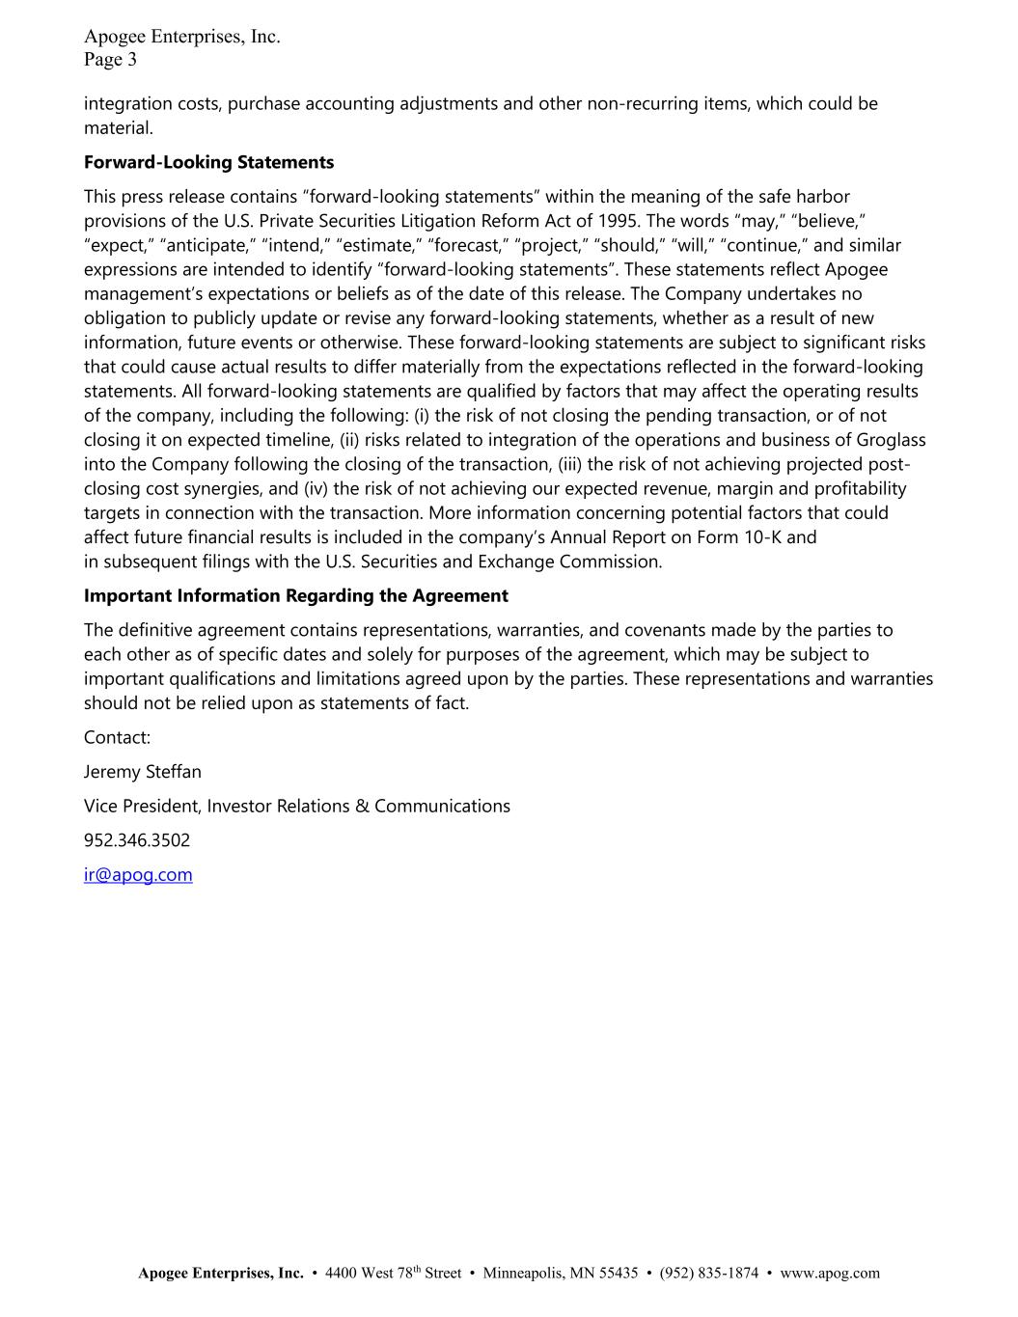
Apogee Enterprises, Inc. Page 3 Apogee Enterprises, Inc. • 4400 West 78th Street • Minneapolis, MN 55435 • (952) 835-1874 • www.apog.com integration costs, purchase accounting adjustments and other non-recurring items, which could be material. Forward-Looking Statements This press release contains “forward-looking statements” within the meaning of the safe harbor provisions of the U.S. Private Securities Litigation Reform Act of 1995. The words “may,” “believe,” “expect,” “anticipate,” “intend,” “estimate,” “forecast,” “project,” “should,” “will,” “continue,” and similar expressions are intended to identify “forward-looking statements”. These statements reflect Apogee management’s expectations or beliefs as of the date of this release. The Company undertakes no obligation to publicly update or revise any forward-looking statements, whether as a result of new information, future events or otherwise. These forward-looking statements are subject to significant risks that could cause actual results to differ materially from the expectations reflected in the forward-looking statements. All forward-looking statements are qualified by factors that may affect the operating results of the company, including the following: (i) the risk of not closing the pending transaction, or of not closing it on expected timeline, (ii) risks related to integration of the operations and business of Groglass into the Company following the closing of the transaction, (iii) the risk of not achieving projected post- closing cost synergies, and (iv) the risk of not achieving our expected revenue, margin and profitability targets in connection with the transaction. More information concerning potential factors that could affect future financial results is included in the company’s Annual Report on Form 10-K and in subsequent filings with the U.S. Securities and Exchange Commission. Important Information Regarding the Agreement The definitive agreement contains representations, warranties, and covenants made by the parties to each other as of specific dates and solely for purposes of the agreement, which may be subject to important qualifications and limitations agreed upon by the parties. These representations and warranties should not be relied upon as statements of fact. Contact: Jeremy Steffan Vice President, Investor Relations & Communications 952.346.3502 ir@apog.com

